Scope: Create a GitHub Actions workflow and view the results from running it.

1. Add workflow scope to personal access token
   1. Settings>developer settings > Personal access token>Check that workflow is selected
   2. 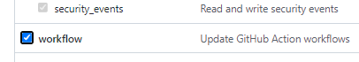
2. Create GitHub repository named workflows demo
3. Set up remote and local Git repository
   1. Create Git hub repository workflows demo
   2. Create local repository
      1. Create a folder in the root directory called workflows demo
      2. Run the following:
      3. 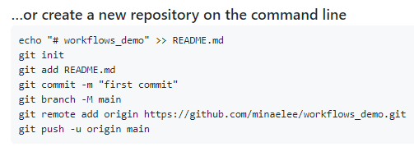
      4. In the root directory create a helloworld.py and put the following code:
      5. 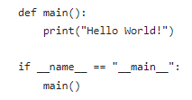
      6. Add and commit file to local repository, then push the commit to the remote Github repository
         1. CMD: git add .
         2. CMD: git commit -m “add helloworld.py”
         3. CMD:git push
      7. Setup a workflow
         1. Select “Actions” from the menu option
         2. 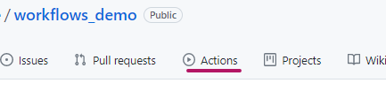
         3. Select “set up a workflow yourself”
         4. Insert the following code into the yml file
         5. ­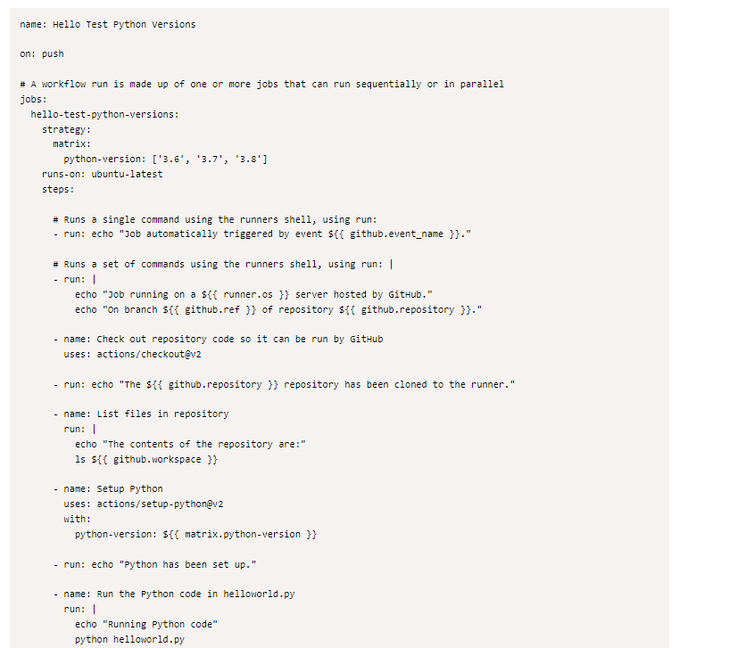
         6. Click the “start commit” button
         7. Select “commit new file”
         8. This will return you to the workflows folder in GitHub repository showing hello_test.yml file.
            1. Note creating this caused a push to the repository.
         9. Click on the “Actions”
         10. Then click on yml file below:
         11. 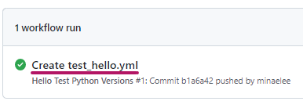
         12. Note that this summary shows 3 jobs have passed.
         13. 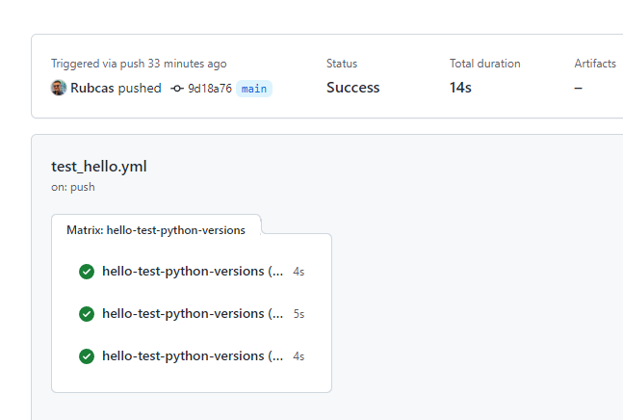
         14. Note the summary:
         15. 