Project: Secure AWS VPC with Public and Private Subnets

Objective
The goal of this project is to design and implement a secure AWS Virtual Private Cloud (VPC) with public and private subnets. The public subnets will host web servers accessible from the internet, while the private subnets will host databases and internal applications, isolated from the internet. The project will also include the setup of a NAT Gateway for private instances to access the internet, Security Groups and Network ACLs for enforcing least-privilege access, and thorough testing to ensure connectivity and functionality.
Design and implement a secure AWS VPC with:
- Public Subnets: For web servers accessible from the internet.
- Private Subnets: For databases and internal applications, isolated from the internet.
- NAT Gateway: To allow private instances to access the internet for updates.
- Security Groups and NACLs: To enforce least-privilege access.
- Testing: Verify connectivity and functionality.

- Step 1: VPC NAME: Secure-VPC-Architecture
It acts as a virtual data centre where you can launch AWS resources like EC2 instances, RDS databases, etc. The CIDR block 10.0.0.0/16 provides a large IP range for creating subnets.

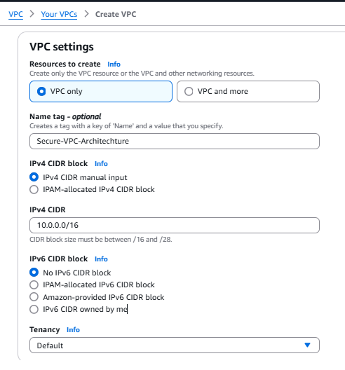
- Step 2: 4 subnets (2 public, 2 private) across 2 Availability Zones (AZs) for high availability.
Subnets are subdivisions of the VPC’s IP range. Public subnets are for resources that need internet access, while private subnets are for internal resources. Distributing subnets across AZs ensures high availability.

Subnet Name | Type | AZ | CIDR Block | Auto-Assign IP
Public-Subnet-A1 | Public | us-east-1a | 10.0.1.0/24 | Yes
Public-Subnet-B1 | Public | us-east-1b | 10.0.2.0/24 | Yes
Private-Subnet-A2 | Private | us-east-1a | 10.0.3.0/24 | No
Private-Subnet-B2 | Private | us-east-1b | 10.0.4.0/24 | No

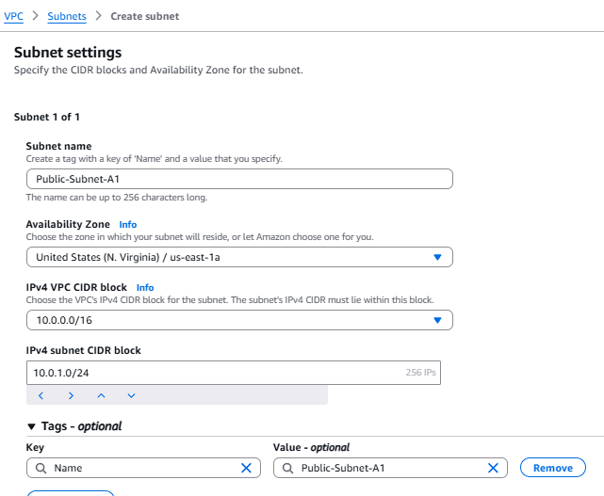
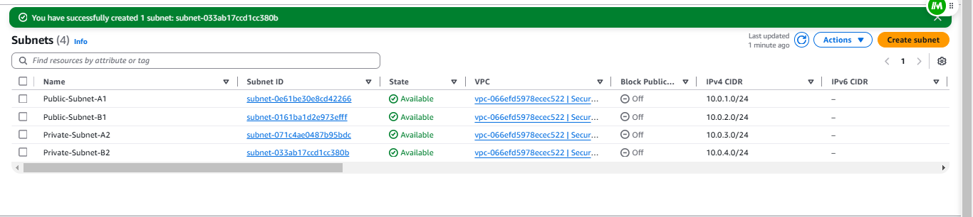

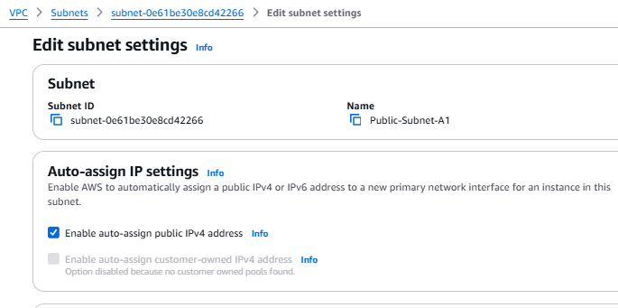
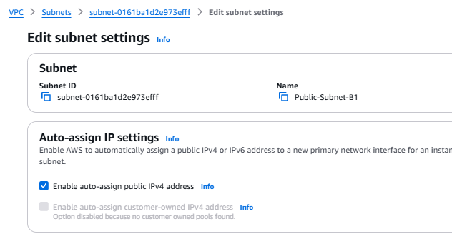
- Step 3: Internet Gateway (IGW) NAME: My-Dev-IGW (An Internet Gateway can only be attached to one VPC)
The IGW allows resources in public subnets to communicate with the internet. It is attached to the VPC to enable this functionality.

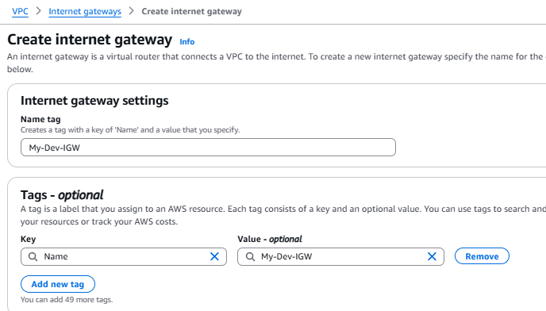

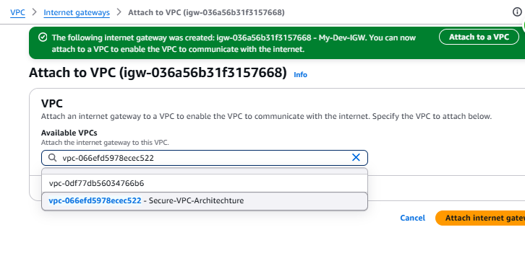
- Step 4: Network Address Translation Gateway (NAT GW) : Dev-NAT-GW attached to subnet: Public-Subnet-A1
The NAT Gateway allows instances in private subnets to access the internet for updates or patches while preventing the internet from initiating connections to them. It is placed in a public subnet because it needs internet access.

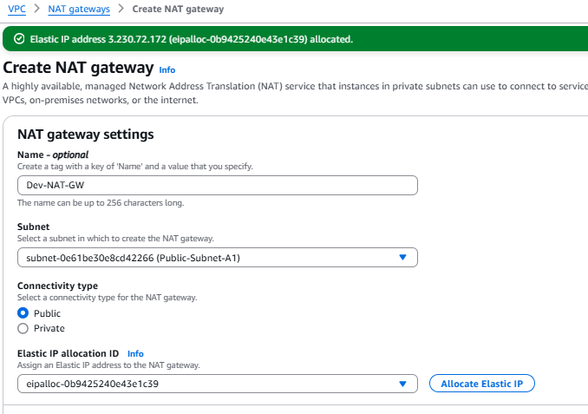
- Step 5: Configure Route Table:
Route tables control traffic flow within the VPC. The public route table directs internet-bound traffic to the IGW, while the private route table directs traffic to the NAT Gateway.
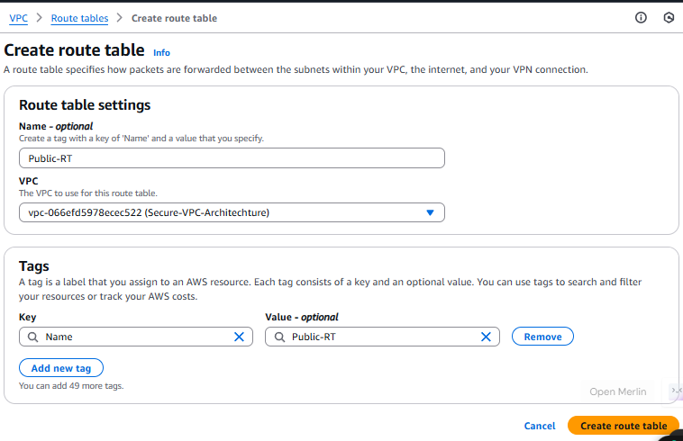
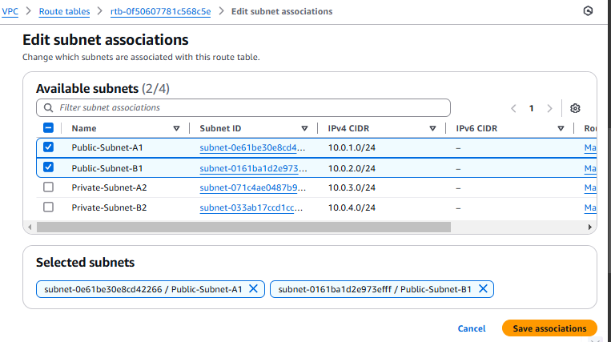

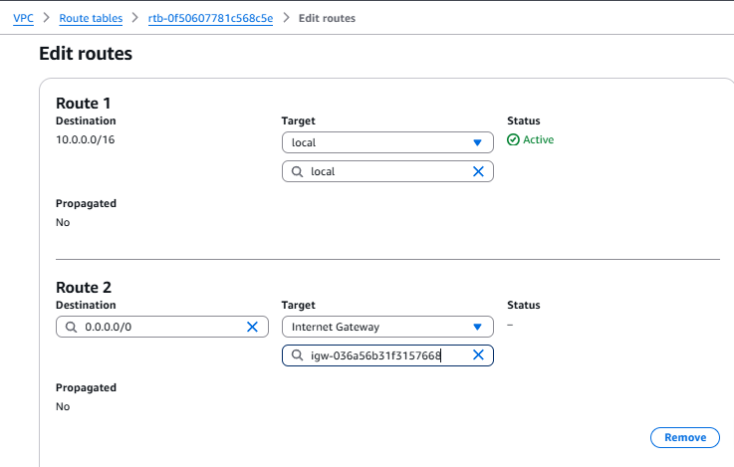
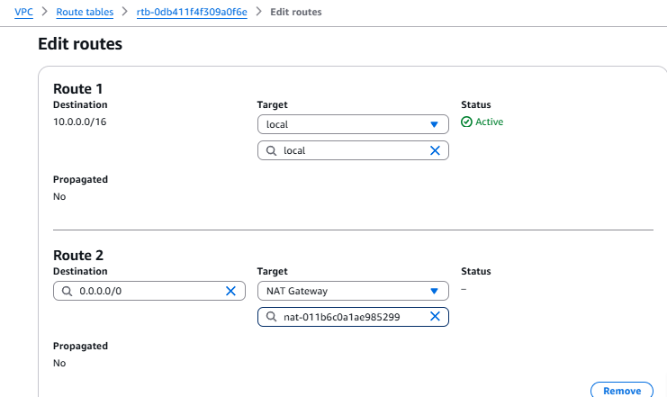
- Step 6: Configure Security Groups (Least Privilege):
Security Groups act as virtual firewalls for instances. The Web Server SG allows HTTP/HTTPS traffic from the internet and SSH access from your IP. The Database SG allows MySQL traffic only from the Web Server SG.
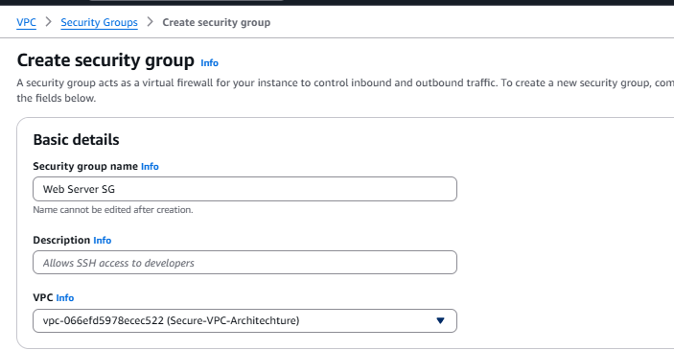
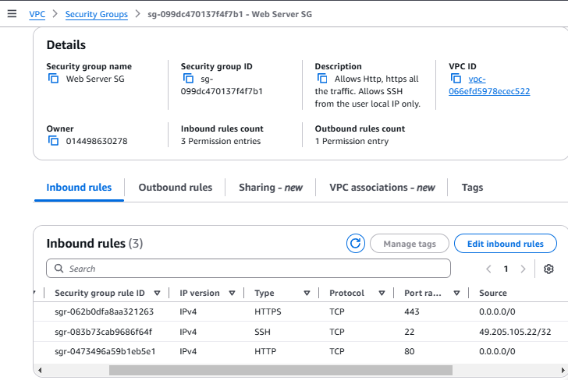
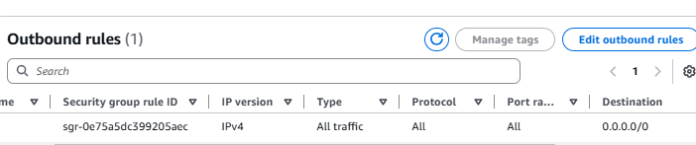
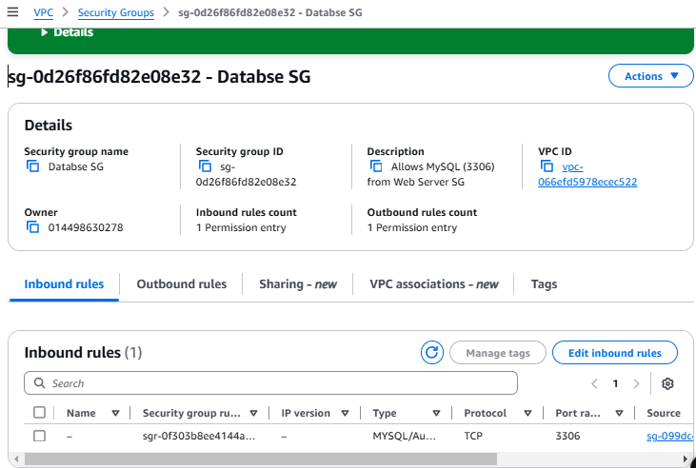
- Step 7: Configure NACL:
NACLs provide an additional layer of security at the subnet level. They are stateless, meaning you must explicitly allow return traffic.
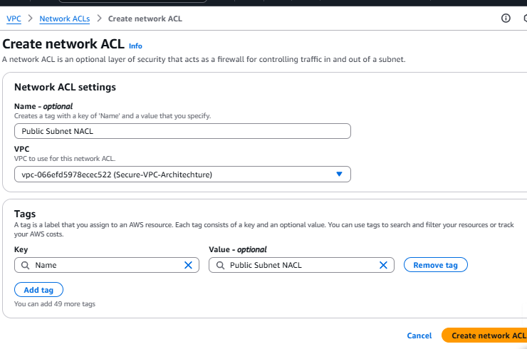
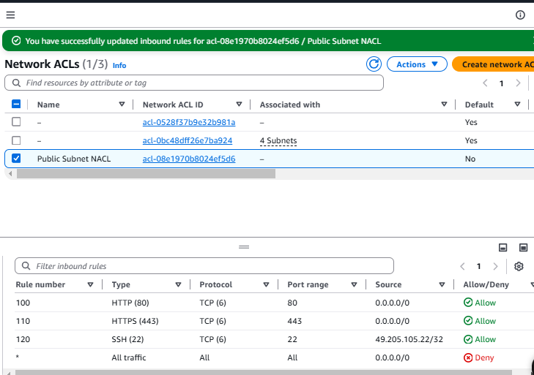
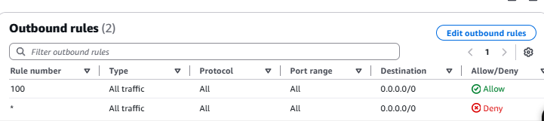
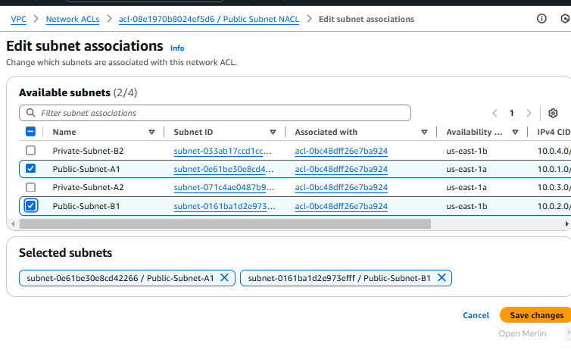
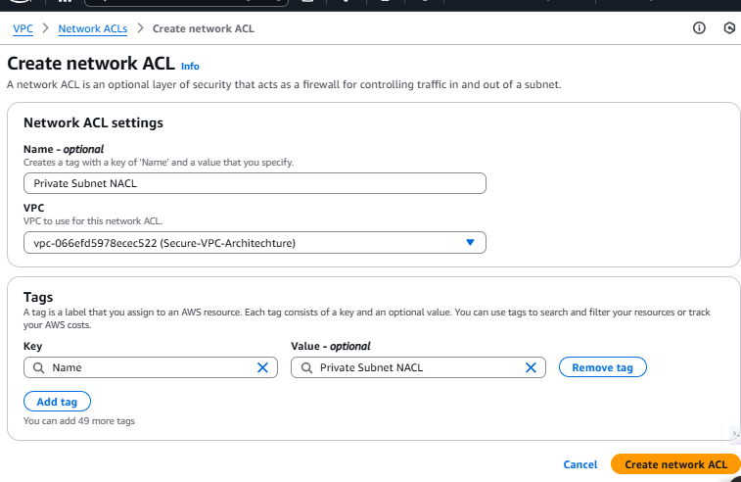
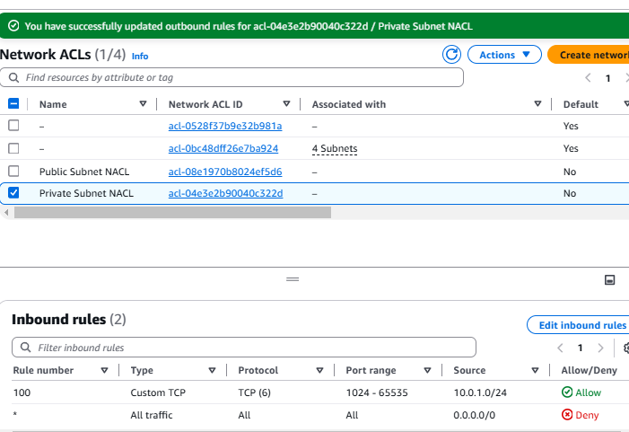
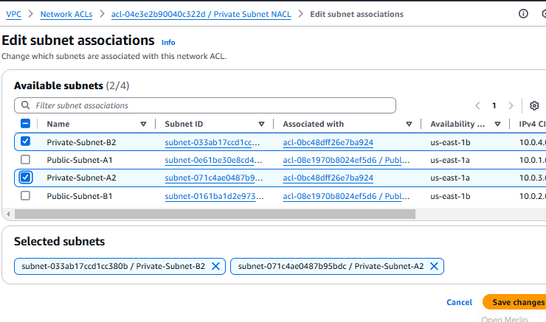
- Step 8: Launch EC2 Instances:
The public instance hosts a web server (NGINX), while the private instance simulates a database. The user data script installs and starts NGINX on the public instance.
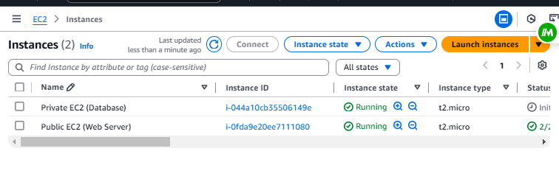
- Step 9: Test Connectivity:
Step | Where to Test | Command | Purpose
SSH into Public Instance | Local machine | ssh -i key.pem ec2-user@<public-ip> | Verify public instance accessibility.
Test Internet on Public | Public instance | curl https://example.com | Confirm internet access via IGW.
SSH into Private Instance | Public instance | ssh -i key.pem ec2-user@<private-ip> | Verify private instance accessibility.
Test NAT Gateway on Private | Private instance | sudo yum update -y | Confirm internet access via NAT Gateway.

Explanation:
Testing ensures that:
- The public instance can access the internet via the IGW.
- The private instance can access the internet via the NAT Gateway.
- The private instance is reachable only from the public instance.
Troubleshooting:
- Public Instance Not Reachable:
  - Check the Security Group of the public instance: Ensure it allows SSH (port 22) from your IP.
  - Verify the public IP is correctly assigned.
- Private Instance Not Reachable:
  - Check the Security Group of the private instance: Ensure it allows SSH (port 22) from the Web Server SG.
  - Verify the private IP is correct.
- NAT Gateway Not Working:
  - Check the route table of the private subnet: Ensure it has a route 0.0.0.0/0 → NAT Gateway.
  - Verify the NAT Gateway is in the public subnet and has an Elastic IP.
- Step 10: Cleanup
- Terminate EC2 instances.
- Delete NAT Gateway (to avoid $0.045/hr charges).
- Delete VPC (subnets, route tables, IGW, etc., will auto-delete).

Conclusion
This project demonstrates how to design and implement a secure AWS VPC with public and private subnets, NAT Gateway, and robust security measures. It is an excellent addition to your resume, showcasing your ability to architect secure and scalable cloud environments.

