RUBEN MURILLO  Theruben1212@gmail.com /770-203-5555/Conyers, Ga  Portfolio: https://ruben-murillo.github.io | 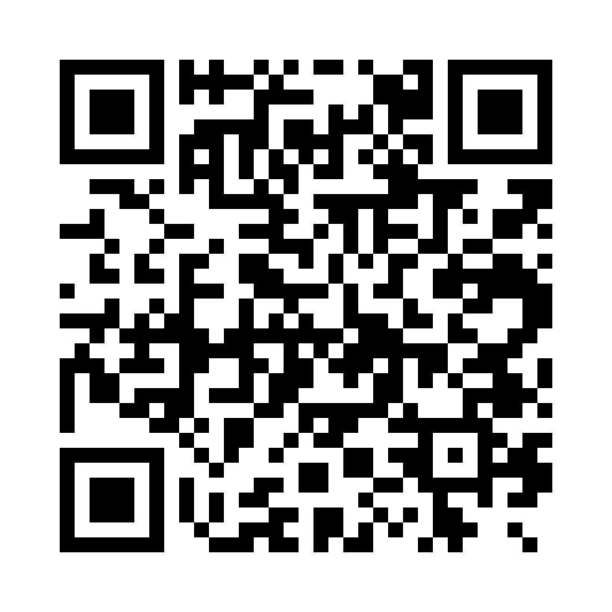
EXPERIENCE
12/2025 – PRESENT
SYSTEMS ENGINEER II, ROVISYS BUILDING TECHNOLOGIES
• Commission and troubleshoot complex electromechanical systems in hyperscale data centers across sensors, actuators, field wiring, industrial networks, controllers, and supervisory software.
• Develop Ignition HMI/SCADA functionality including tags/UDTs, alarms, historian/trending, expressions/transforms, Python/Jython scripting, and PLC-facing feedback/writeback behavior.
• Diagnose hardware/software integration problems through register maps, unit IDs, polling/timeout analysis, scaling, floating-point/word-order validation, and independent device testing.
• Coordinate multidisciplinary field testing and isolate faults across hardware, networking, and software layers for reliable system turnover.
08/2023 – 12/2025
SYSTEMS ENGINEER I, ROVISYS BUILDING TECHNOLOGIES
• Performed point-to-point verification, wiring and actuator troubleshooting, Modbus/BACnet integration, device checkout, Niagara 4 HMI development, and controls-network troubleshooting at hyperscale data centers.
• Supported L1-L5 commissioning and functional testing, bringing integrated electromechanical systems from installation through reliable operation.
05/2022 – 08/2022
SYSTEMS ENGINEER INTERN, ROVISYS BUILDING TECHNOLOGIES
• Configured Schneider Electric PLCs using Unity Pro/SCADA and troubleshot HVAC instruments and actuators, building practical industrial hardware-integration experience.
EDUCATION
Aug 2019 – MAY 2023
BACHELOR OF SCIENCE IN MECHATRONICS, KENNESAW STATE UNIVERSITY
Final GPA: 3.83 | President’s List: 5 semesters | Dean’s List: 2 semesters
SKILLS
• Robotics & Software: ROS / ROS2, C++, Python, MATLAB, wheel odometry, localization, autonomous systems, sensor/actuator integration, HMI/operator interfaces and system testing.
• Controls, Linux & Embedded: PLCs, Ignition, Niagara 4, Unity Pro, Linux, Docker, PostgreSQL, Arduino/AVR, Modbus TCP, BACnet, industrial communications and instrumentation.
• Design & Prototyping: Fusion 360, AutoCAD, additive manufacturing, rapid prototyping and multidisciplinary troubleshooting.
PROJECTS
• Voltron V3 - Autonomous Racing Go-Kart: Developed ROS2 functionality in Python and C++ and contributed to HMI development, wheel odometry, localization, system testing, and vehicle-level troubleshooting.
• Raspberry Pi 5 Linux Systems Lab: Built and administer a Linux server using Docker, PostgreSQL-backed services, Samba/SMB storage, Tailscale/VPN networking, and Bash/Python automation; manage services, storage, permissions, and remote troubleshooting.
• Languages: English (Native), Spanish (Fluent).

