Voltron Version 3
By: Ben Hall, Ruben Murrillo, Brighton Swales, Crockett Hensley
Project description: The Voltron version 3 project is going to be the newest iteration of KSU EVT’s autonomous racing go kart. Starting out as a senior project in 2018, the go kart has seen many changes over the past 4 years. The goal of our planned improvements is to make Voltron more reliable, faster and easier to use. Voltron is made up of a multitude of different sensors and actuators brought together with custom software and many different electrical sub-systems. Our project will cover improving a key sub-set of these systems, including a new electro-mechanical steering mechanism, improved model predictive controller, and a more continuous odometry estimator to improve the state estimation system, and an easier interface for making real-world testing faster.

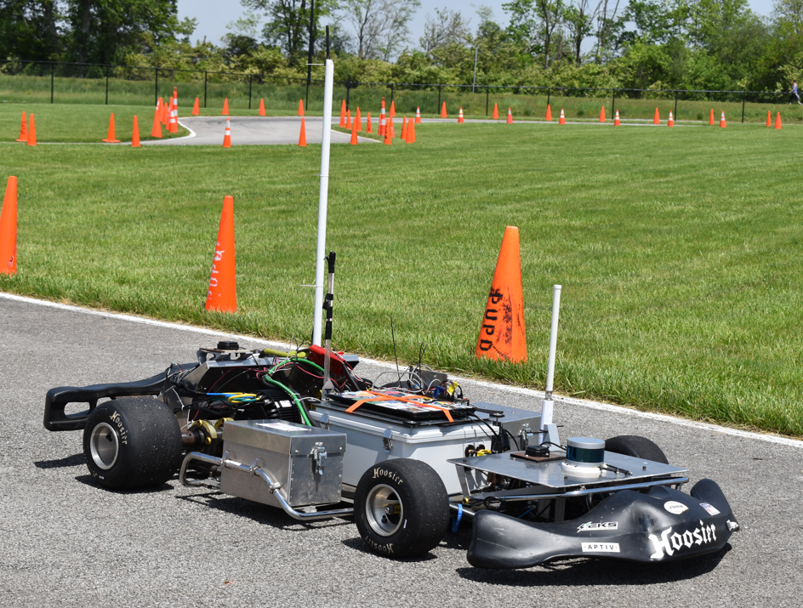
Image of Voltron on track
Improvements and additions:
  - Hardware improvements:
    - New custom replacement gearbox for more powerful BLDC motor
    - Mounting for replacement gearbox integration into go kart
  - Electrical additions:
    - Wiring of off the shelf motor controller to integrate the encoder and BLDC motor for the steering system
    - Integration of newly designed PCBs for improvements in the low level safety and control systems
  - Sensor additions:
    - Aforementioned encoder for BLDC motor within steering system
    - Hall-effect sensors for wheel odometry
    - New LiDAR integration for use in current and future software improvements
    - New depth camera integration
  - Software additions / improvements:
    - ROS 2 node for providing odometry input into existing ROS 2 node ecosystem
    - Firmware additions for integrating new motor controller
    - Improved GUI/TUI and required back-end systems for improved testing / user interface for kart
Specifications:
- Computer systems used (existing and planned components):
    - Hall effect wheel speed sensor data collection: Teensy 4.0/4.1
    - LiDAR data processing and integration with camera: Asrock 4x4 BOX-5800U
    - On-board Intel processor of Oak-D Pro depth camera
    - On-board microcontroller of the ODrive Pro motor controller
- Sensors used / integrated:
  - CUI AMT 102 encoder
    - https://odriverobotics.com/shop/cui-amt-102
  - Littelfuse M12 Geartooth Speed Sensor
    - https://www.digikey.com/en/products/detail/littelfuse-inc/55075-00-02-A/565509
  - Ouster Os-0 64 channel LiDAR
    - https://ouster.com/products/scanning-lidar/os0-sensor/
  - Oak-D pro
    - https://shop.luxonis.com/products/oak-d-pro

Requirements:
Minimum viable outline
- Steering system
  - Improve steering actuation time
  - Integrate into current system
- Wheel odometry system
  - Be able to provide odometry data given wheel speed sensor data over a ROS messaging interface
  - Create and use a new steering model to encompass the non-linearities of the new go kart steering system to give accurate wheel angles
- LiDAR and camera mounting
  - Integration of new LiDAR and camera sensors for use in cone / track detection
Technical requirements:
- Minimum success criteria:
    - Accurate and sufficiently fast publishing of ROS2 odometry message (~100hz)
    - Faster actuation time of steering than current design
    - Rigid and robust mounting for the LiDAR and camera
      - LiDAR and camera mount must also be able to be removed easily for independent testing
      - LiDAR and camera mount must be easily manufacturable with on-campus resources
      - Mount must protect camera and LiDAR sufficiently from on track dangers such as impacting cones / barriers
      - Mount must allow camera and LiDAR sufficient visibility of track
- Advanced success criteria:
  - Easy to use interface for monitoring and controlling the different autonomy software components remotely
  - LiDAR and camera sensor fusion leveraging a rigid transformation
  - LiDAR and camera based cone detection

Required Tasks / Work:
Minimum viable:
Steering system:
- Steering study for purposes of determining the current actuation time
- 3D model design of the gearbox and mounting
- Prototyping for determining various key measurements on existing frame structures
- Manufacturing:
  - Waterjetting of plates for the gearbox
  - Welding of the gears and pulleys to the idler shafts instead of using set screw for both reliability and reduce future maintenance
  - Various mill / lathe tasks for dependent mounts and gearbox features
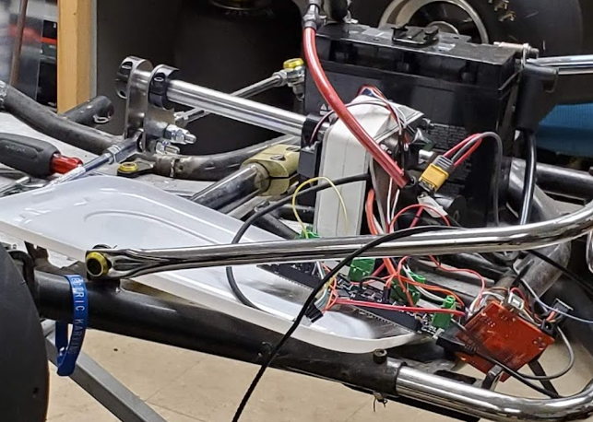
Picture of the steering system that we will be replacing
Wheel odometry system:
- Drawing of the slots that need to be milled from the shaft collars
  - Determine what size the slots need to be based on available screw hardware and available end mills
- Perform the steering identification experiment to develop model of input steering to
- Machine the slots in both the shaft collars and the slotted discs
- Mount the sensors themselves with correct spacing for activation of the sensors
  - The sensors have a range in which they will detect / not detect the spokes of the discs
- Wire hall effect sensors themselves to the teensy
  - 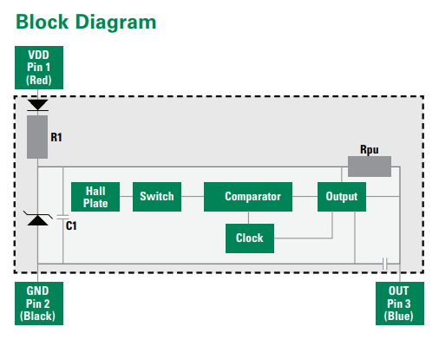
- Libfreqmeasure teensy library integration for measuring on the teensy
  - https://github.com/PaulStoffregen/FreqMeasureMulti
- Micro-ROS for communication for outputting the measured data to the computer over serial at first
- ROS2 odometry node development on PC side
- wheel orientation estimation from odrive feedback
LiDAR / camera mount:
- 3D model of mount design including the existing models of sensors
- Prototyping for determining various key measurements on existing frame structures
- Manufacturing of mount using aforementioned methods
Feasibility / Project Viability
Mentorship:
- Several mentors will be involved in guiding this project including Cameron McKinney and Timothy Gallion who originally started this project for their senior project. Their guidance will be within the areas of electrical and software respectively.
Resources leveraged:
- Steering model study: motion capture lab in Q
- Manufacturing: machine shop in Q and welder / tools existing within the EVT Wilder communication’s lab
- Funding: EVT pre-allocated budget and sponsorship for these projects
  - The sensors mentioned above have already been purchased
  - Most of the components for the gearbox have already been purchased
    - The only components that have not been yet purchased include only the raw materials for the gearbox such as the metal stock and affixing hardware
- Communication:
  - Code: EVT’s Gitlab organization for repository hosting
  - Solidworks / Grabcad for 3D modeling and assembly and part file sharing and management
  - Discord: general communication
  - Altium: for designing required schematics and PCBs
The project will be able to be accomplished in a semester with ample time to also progress through advanced and desired success criteria as largely the preparations for these projects have been handled, including procurement and plan ideation.
The project integrates what it means to be a Mechatronics engineer and touches on many of the technical skills such as firmware and software development, mechanical part design, electrical integration and cohesive project design within the realistic scenario of improving and making key additions to an existing system.

