User Manual

When we run the “CSI2300PROJECT.bat” file is opened, you will see this: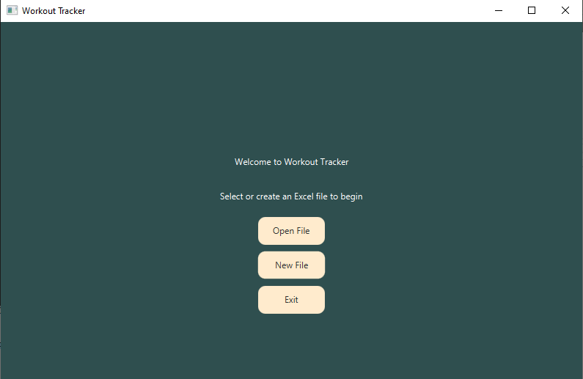

The program is prompting you to open a file or create one, when you create one it will look something like this: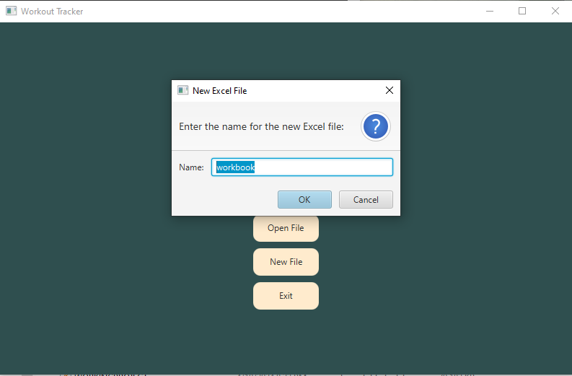

Once you do that you can open the file and it will send you to the data entry scene which you can input data into and press the save button to save it to the excel sheet.

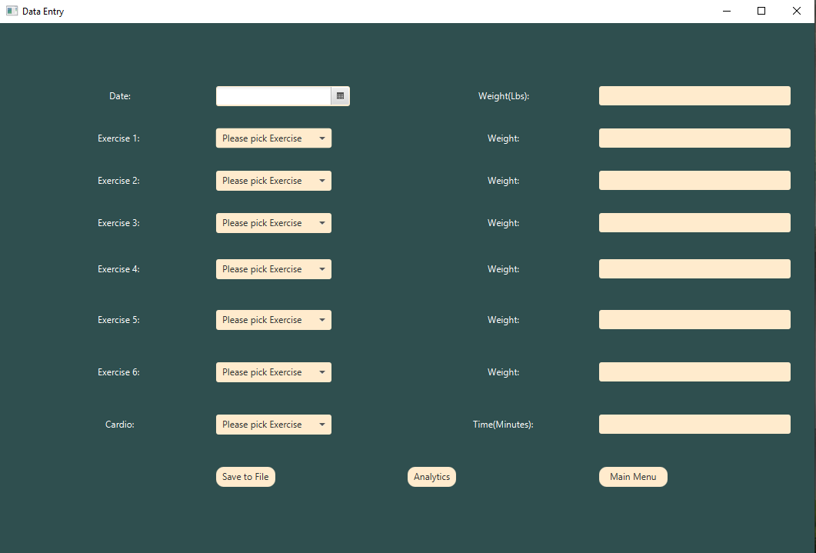

Once you are done, press save and press the analytics button it will lead you to this:

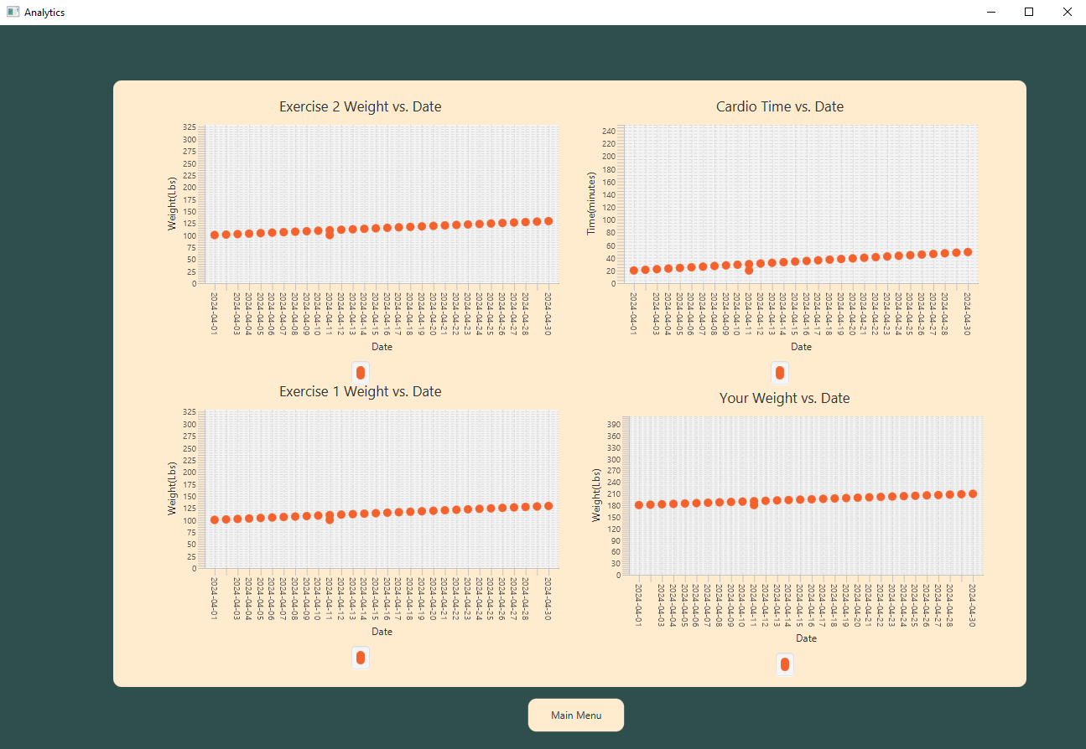

I didn’t include graphs for everything just because my program was acting weird and wouldn’t run so I had to make a few changes(even though it ran fine before, I changed nothing but when I opened the file again it just didn’t work).

This should be it. You can either press the x in the corner to exit or press mainmenu and exit.