**Please refer to the attached historical data and propose a portfolio of 1 to 5 of the Eurostoxx 50 constituents which would best hedge a position of long 1,000 shares of Pernod Ricard.**

**1) how you are defining what is the best hedge**

The best hedge is difficult to define in this case. As I understand the assignment, we need to hedge the long equity position using other long equity positions.

Since there is no data provided for tools that use leverage such as derivatives, the assignment as I understand it is to build an optimal portfolio that includes Pernod Ricard SA, while also trying to best offset the exposure to the price volatility of Pernod Ricard SA.

Without leverage, the hedge position would require a significant investment relative to our existing equity position, which basically forces me to build a diversified portfolio.

**2) an explanation of your approach compared with alternative methods**

**2.1) an explanation of your approach**

My approach was to first the correlation of the returns of all the stocks, using Pearson's, Sperman's, and Kendall's correlation coefficients. Then, I closely inspected the returns of the companies whose returns were negatively correlated to Pernod Ricard 's in any of these correlation metrics. Namely, these companies are Intesa Sanpaolo, BNP Paribas, ING Groep NV, and Societe Generale SA.

Following, I built a portfolio that maximizes the risk adjusted return ratio (Sharpe ratio) that included Pernod Ricard SA as well as the stocks whose returns were negatively correlated to Pernod Ricard SA in order to best hedge against its price volatility, while also getting the optimal balance of risk and returns.

**2.2) approach compared with alternative methods**

Starting off with the obvious, one of the other methods to decrease exposure would be to sell the initial equity position but that seems to defeat the purpose of the exercise.

In addition, the beginning of 2020 was a very tumultuous time. The risk-free rate was 12% according to the Fama-French library. As such, investing into government bonds was also a good hedge for our equity position. However, this is data external to the exercise, and with such a high-risk free return rate, we would not even consider investing into equity, making the exercise futile.

I also create a cluster map of the assets’ returns, and build dendrograms to visualize which stocks are most correlated and choose the ones least correlated, which is presented in Figure 1.

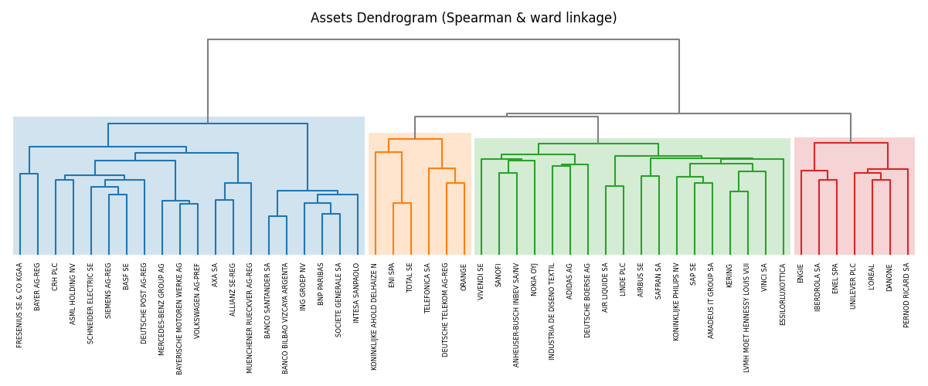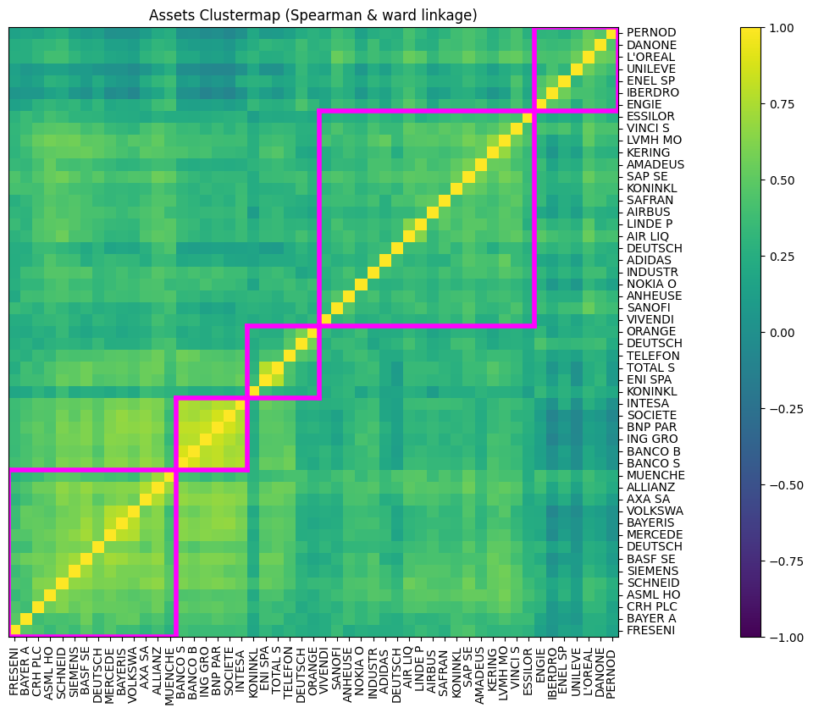

Figure 2 Dendrogram of the returns of all stocks

Figure Cluster map of the returns of all stocks

I could have hedged by choosing stocks from the clusters furthest away from the cluster in which Pernod Ricard SA can be found, or simply clusters which are not the same as the one Pernod Ricard SA is in. However, this method is also flawed since it the clusters are not Pernod Ricard SA-centric. In addition, the number of clusters is not set in stone. Also, it would be difficult to select a portfolio and to then claim that a select portfolio is optimal.

Similarly, another possibility to choose the candidates for the portfolio is to select equities of companies from several industries. For example, as Pernod Ricard SA is classed in the “Food, Beverage and Tobacco” industry, according to the EURO STOXX 50. We could have chosen companies from other sectors such as “Banks” or “Energy” to build a diversified portfolio. However, as we show, there can still be high correlation of returns between companies of different sectors, which would not provide the best hedge. Also, it is difficult to claim that the portfolio we built is optimal when we choose the stocks inside it based simply on industries.

Also, I only considered long positions for my portfolio, as it is how I understood the exercise. We could also however build a portfolio that includes short positions in stocks that have a high positive correlation of returns with Pernod Ricard SA. This does not change the methodology, except the initial selection of the stocks, where we chose the stocks with the highest absolute values of correlation and short them instead of choosing stocks with negative correlations and going long.

I could have also used a different risk measure for the construction of the optimal portfolio. I went with the standard deviation as it is the most widely-used and covers variation on both sides. However, if we err on the risk averse side in the creation of the portfolio, we could use downside risk measures such as semi standard deviation or value at risk to construct the portfolio.

**3) your selected hedges along with the number of shares of each**

My selected hedges are as follows:

|  |  |  |  |  |
| --- | --- | --- | --- | --- |
|  | % portfolio | Share Price | # of shares | Amount Invested |
| Pernod Ricard SA | 35.17% | 165.95 | 1000.00 | 165950.00 |
| BNP Paribas | 37.70% | 53.92 | 3299 | 177886.99 |
| Societe Generale SA | 13.88% | 32.03 | 2045 | 65511.63 |
| ING Groep NV | 0.00% | 10.79 | 0.00 | 0.00 |
| Intesa Sanpaolo | 13.24% | 2.50 | 24995 | 62487.16 |
|  | 100% |  |  | 471835.78 |

Figure 3 Hedge Portfolio.

Using the prices from 14.02.2020, the 35.17% share of the portfolio that Pernod Ricard SA takes up is then the 1000 shares at 165.95, as the problem statement sets out. From the other proportions in Figure 3, we can calculate the number of shares of each stock by looking at their respective share prices. The resulting portfolio contains 24995 shares of Intesa Sanpaolo, 3299 shares of BNP Paribas, and 2045 shares of Societe Generale SA. The portfolio with the highest Sharpe ratio, the one I consider optimal, excludes ING Groep NV.