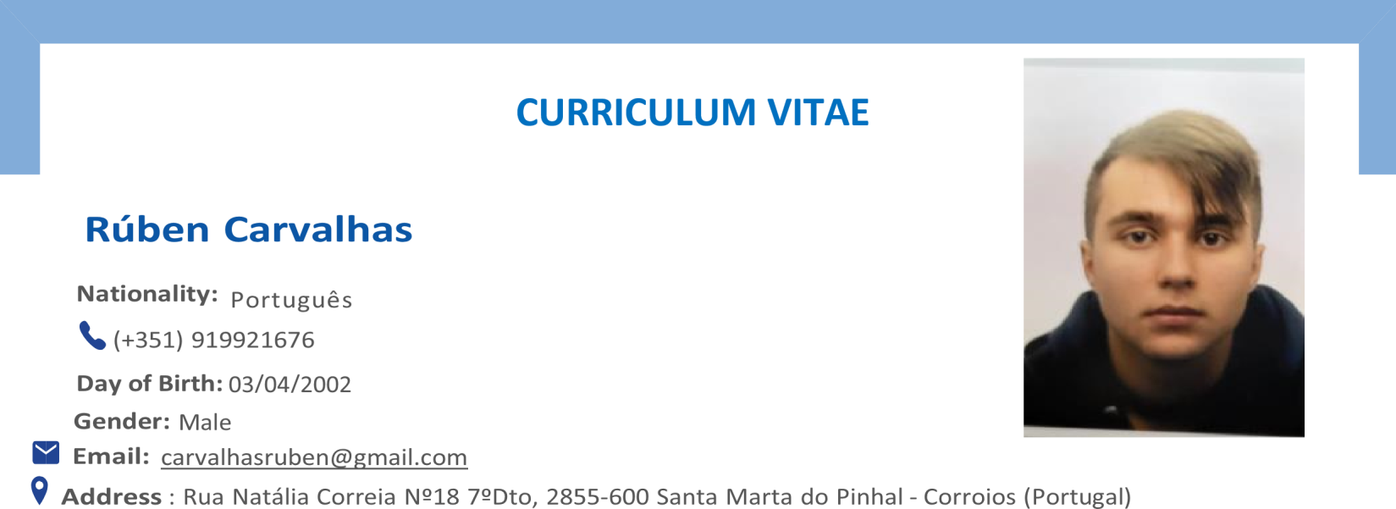

# EDUCATION AND TRAINING

## Conclusion of Secondary Education, Technical Course in Management and Programming of Computer Systems, in the field of Computer Science, with a final qualification of 17 out of 20 points.

<https://rubencarvalhas.github.io/Portfolio/>

Start and end of course: [13/09/2017 – 24/06/2020]

***Secondary School João de Barros***

**Email:** R. Dr. Manuel de Arriaga, 2855-098 Corroios <https://www.aejoaodebarros.pt/>

"Innovation Challenge"

## CTeSP Course at the Polytechnic Institute of Setúbal with a final qualification of 16 out of 20 points.

Development of Video Games and Multimedia Applications

## 6-month internship at KnowledgeBiz

[https://knowledgebiz.pt](https://knowledgebiz.pt/)

# LINGUISTIC SKILLS

Native Language (s):

Portuguese English

**LISTENING COMPREHENSION:** C2 **READING:** C2 **WRITTING:** C1 **SPEAKING:** C2 **SPOKEN INTERACTION:** C2





Proactive;

Initiative-driven; Autonomous;

# SOCIAL COMMUNICATION SKILLS

Communication Skills

Effective professional communication skills; Strong interpersonal skills;

# ORGANIZATIONAL SKILLS

Organizational Skills

Leadership ability;

Time management and organization skills; Strong conflict resolution skills;

# DIGITAL SKILLS

Reactjs, figma e ExpoGo - Utilized in the development of an application for android and IOS with the means of identifying the perfect vacation route for users.

CSS, HTML, PHP, JAVASCRIPT - Utilized to develop an online store for technology products. Used to develop a website for checking of prices.

MYSQL – Utilized in the development of the database used in the online store described above to create accounts, encrypt passwords, and log any purchases done by the users. Used to enable multiplayer functionality in games.

Blender, C# - Utilized in the making and development of both design and coding of games and websites. C++ - Utilized as an introduction to coding such as the making of small calculators.

Adobe Premiere Pro – Utilized in video editing.

# SCHOOL-RELATED PROJECTS

Professional Aptitude Test:

Development of a website for buying and selling electronic devices – 18 out of 20 points

**Internship:** Development of a mobile application – 19 out of 20 points PORTFOLIO

Creation of the website for Pétalas Catitas Unipessoal, LDA:

[https://guibela.site](https://guibela.site/)

Models Completed:

A Pilar:

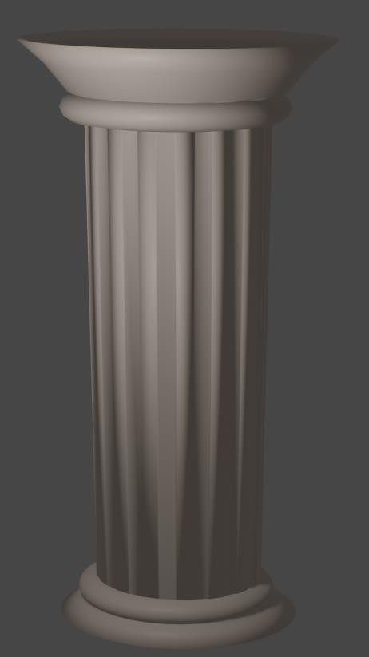

Cards created for a game developed within a school project:

