**Sofia Menacho Vargas**

**Problem 1 :6.7**

**differential equations**







**blocks diagram**

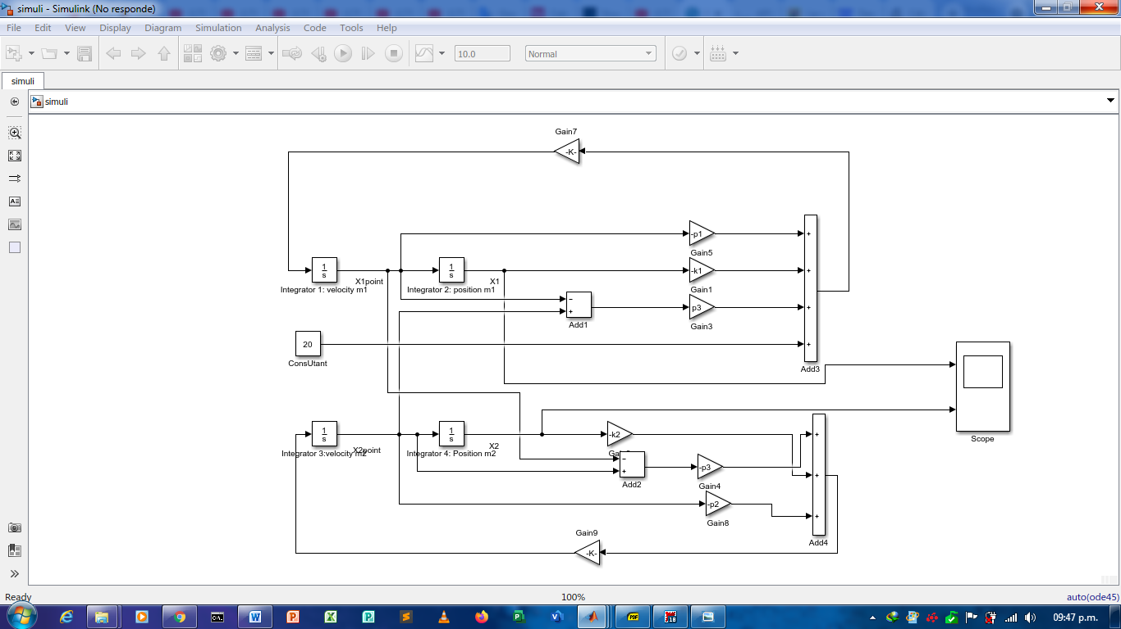

**Graphics**

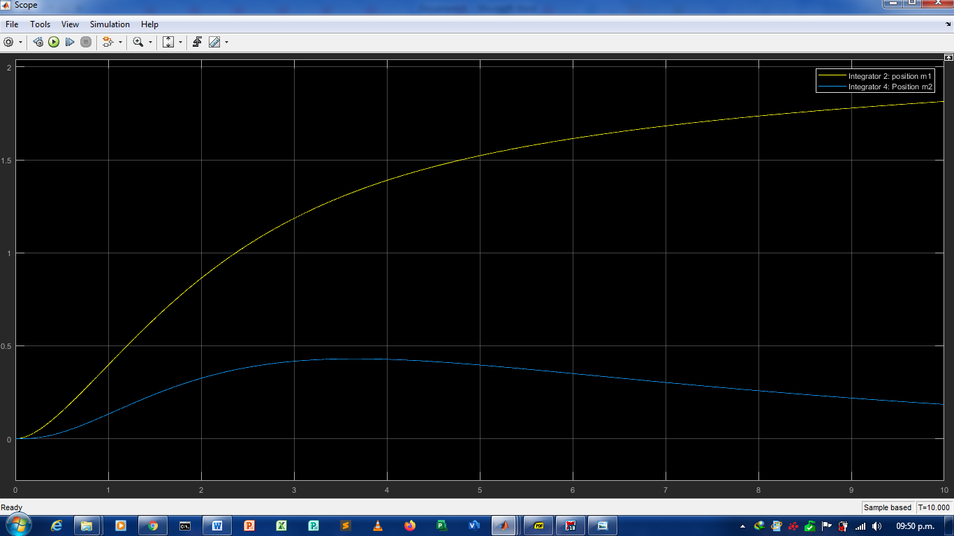

**analytical solution**

a system of 4-order differential equations



**Solution x1(t):**



values ​​of x1 (t) from t = 0 to t = 10:

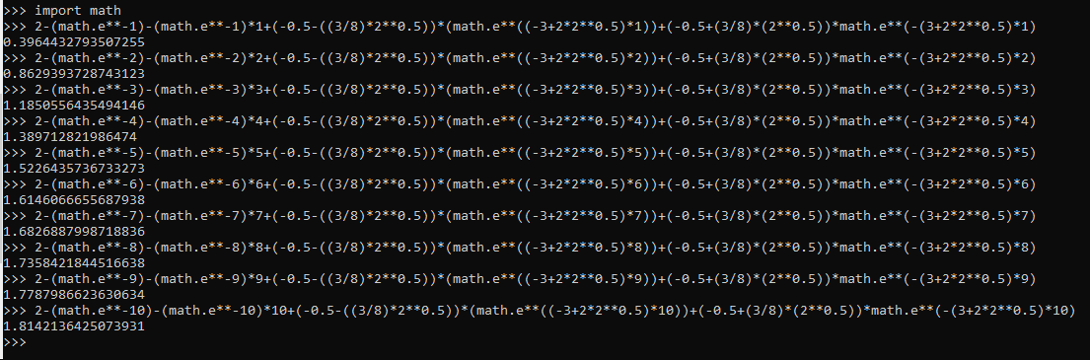

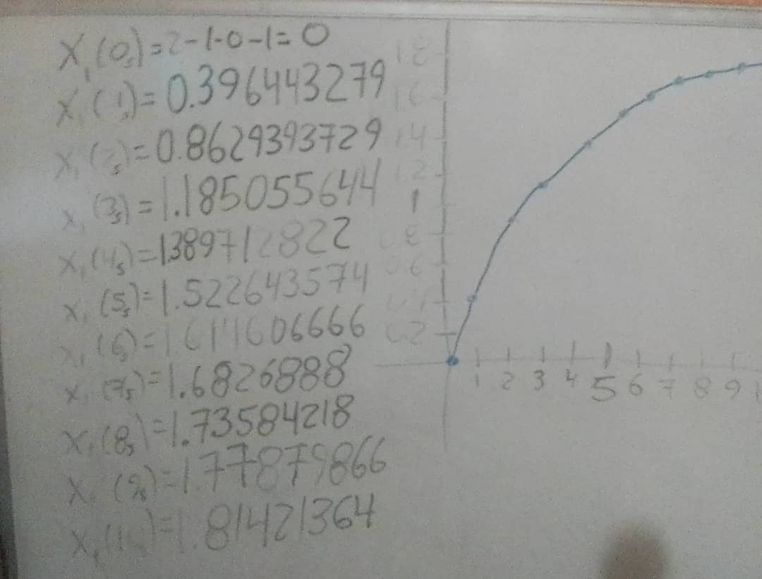

**Solution x2(t)**

 values ​​of x1 (t) from t = 0 to t = 10:

