Teacher Create Essay

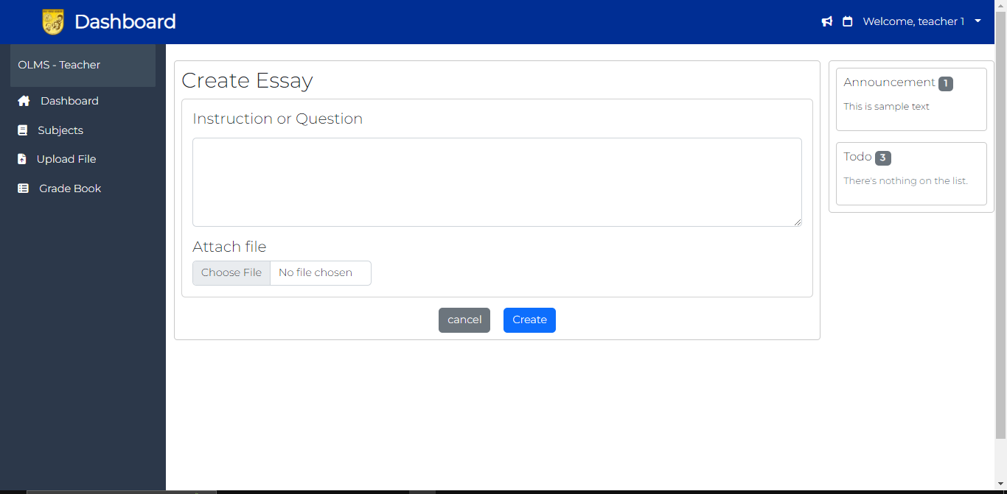

Teacher Edit Essay

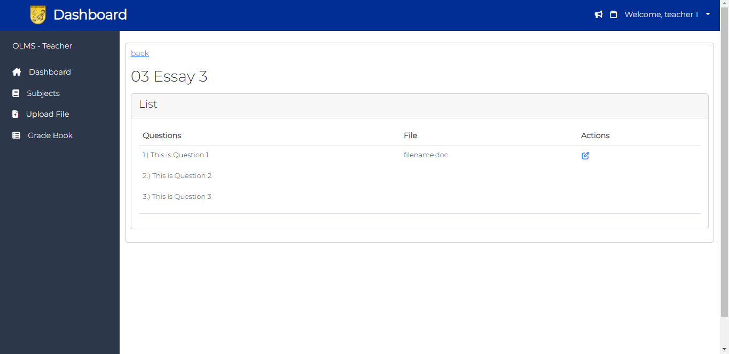

Teacher Edit Essay Modal (pag hindi kasama ung modal sa ibang task wag mo na to isama)

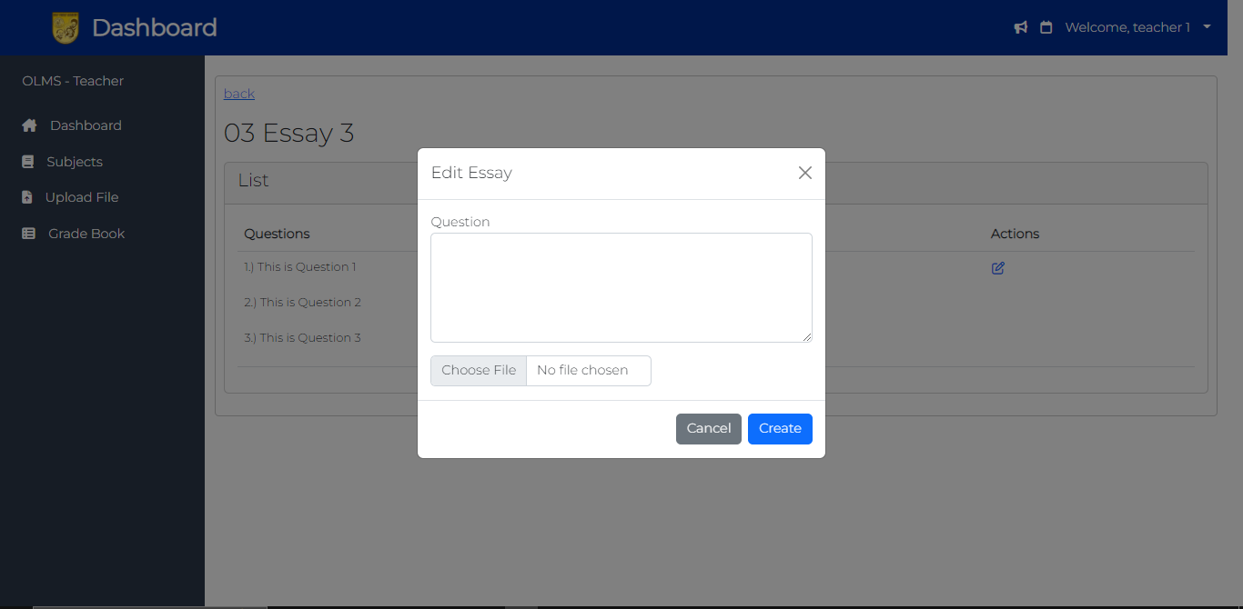

Student Answer essay

