@ Windows

1. User: group+(laptop number) eg. group33  
   Password: same as user name
2. Launch NX Clients for Windows  
   Login: ask   
   Password: same as Login   
   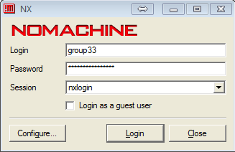

@ Linux

1. Open terminal
2. cd cadence
3. source setcadence6 s (note that adding “s” in the end means using student license)
4. virtuoso &
5. Tool >> Library Manager

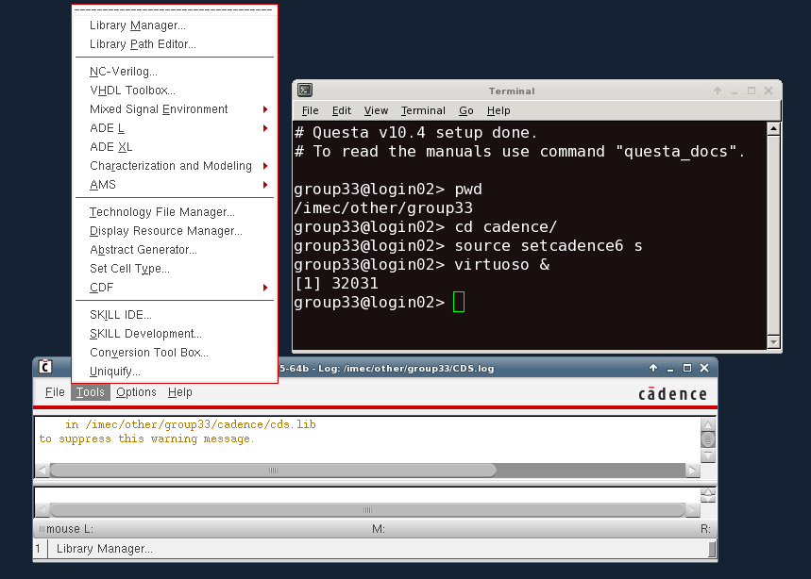

1. AE_project
2. Open testbench:   
   ota_testbench >> schematic_dc_ac
3. Launch ADE L

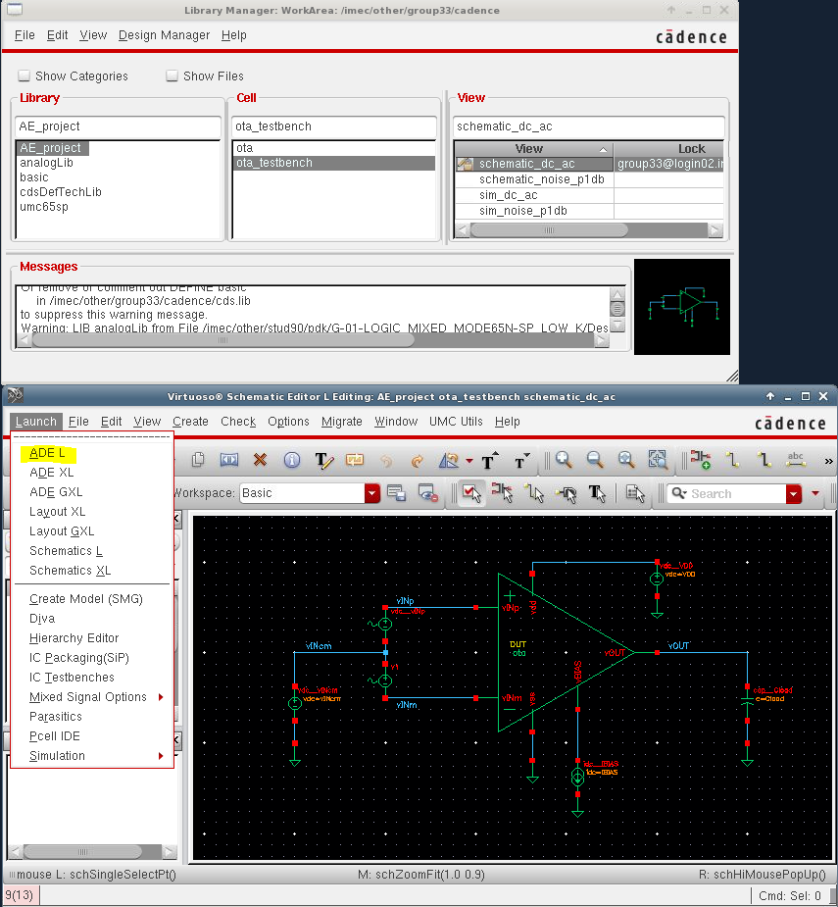

1. In ADE,   
   Session >> Load State >> Cellview(top of window) >> sim_dc_ac

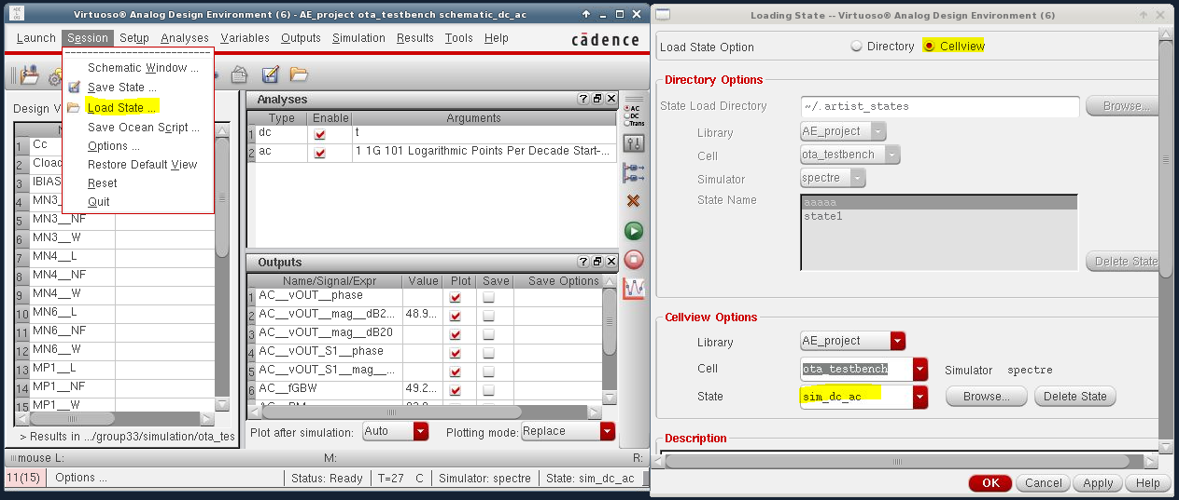

1. For noise simulation and P1dB (PART 2 in project)  
   redo 7~9 but choose another schematic: schematic_noise_p1db   
   and load state: sim_noise_p1db

Export waveform in csv format

Right click on waveform you want to save: Send to >> Export ...  
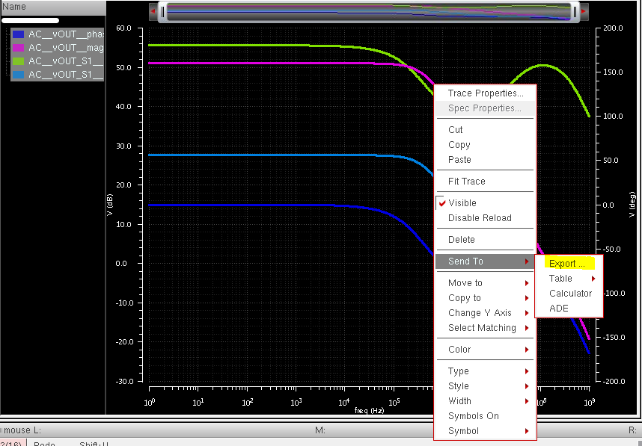  
  
Save everything under the “public” folder  
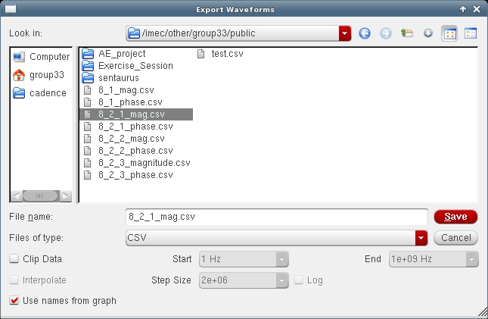

Retrieve from \\unix\group33\public @Windows  
