***SIS3P_Assignment1***

 Ričards Rubenis- Žeļeznovs MC2B 4614232

Aleksandrs Romanovskis MC2B 4609700

*Group number was not given*

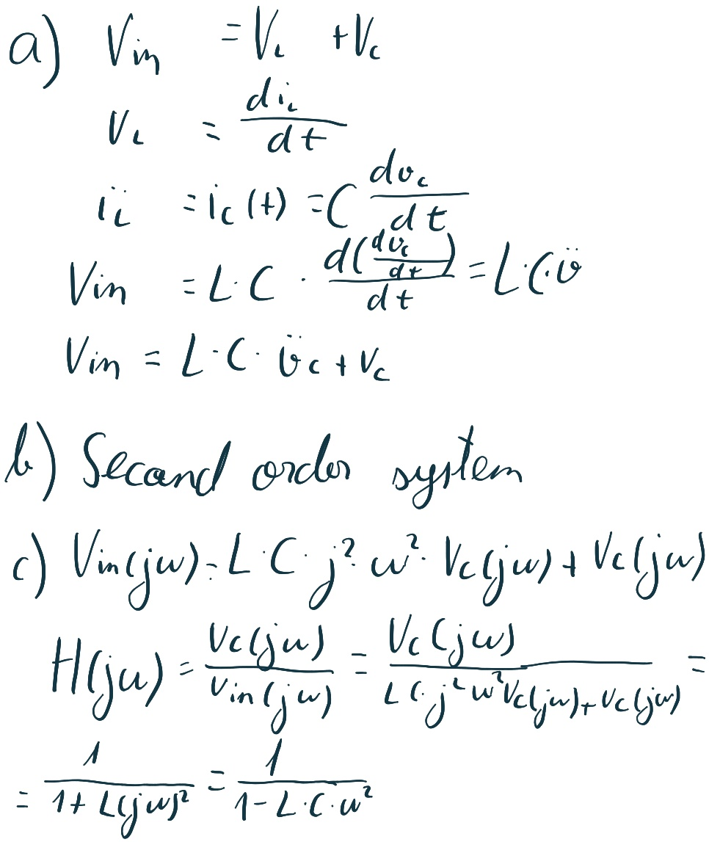

***MATLAB Tutorials***

***1.Writing a MATLAB program***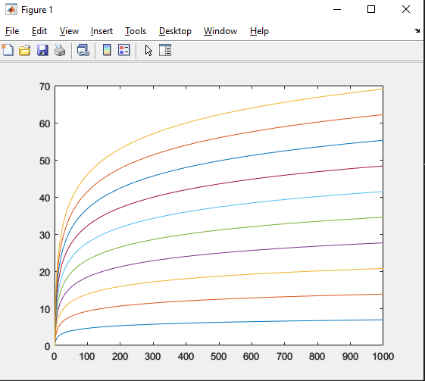

function y=Tutorial1(maxLoop)

x=(1:1000)'; %column vector

for k=1:maxLoop

y(:,k)=k*log(x);

end

plot(x,y)

***2.Working with arrays***

a = [1 2 3 4]

a = [1 2 ; 3 4]

a = 1:10

a = 1:2:10

a = 10:-2:1

a = linspace(1,20,7)

a = linspace(1,20,7)'

a = rand(6,4)

a(1,2)

a(1,[1 2])

a(1,[1 3])

a(1, :)

a(1,2:end)

a(1,2:end-1)

a(1,2:end-1) = [10 10]

a(1:2,:) = [];

a(5)

a(:)

a < 0.5

a(a < 0.5) = -1

ind = find (a < 0.5)

[r,c] = find (a < 0.5)

numel(a)

b = [a a]

b = [a ; a]

***3.Functions***

function out=tutorial3(in)

%test function bruv

intermediate=in+1

out=intermediate*10;

***4. For-Loops***

for loop_index=vector

code;

end

for ii = 1:10

ii

end

a= -5:5;

for ii = 1:length(a)

a(ii)

end

a = 1:10;

sum_a = 0;

for ii = 1:2:length(a)

sum_a = sum_a + a(ii)

end

disp(sum_a)

a = 1:10

ind = [1 4 9 3];

sum_a = 0;

for ii = ind

sum_a = sum_a + a(ii)

end

disp(sum_a)

a = 20:54;

sum_vec = zeros (1, length(a));

sum_a = 0

for ii = 1:length(a)

sum_a = sum_a + a(ii);

sum_vec(ii) = sum_a;

end

figure; plot(sum_vec )

bal = 1000;

num_years = 30;

bal_vec = zeros(1, num_years);

for year = 1:num_years

bal = 1.08 *bal;

bal_vec(year) = bal;

end

figure;plot(bal_vec)

