EXPT NO: 09                                                                         ROLL NO: 220701230

             INTRO TO LOG ANALYSIS

## AIM:

## Gain a foundational understanding of log analysis in cybersecurity by learning to investigate events using log data from various systems. This includes identifying anomalies and suspicious behavior using command-line tools, regular expressions, and platforms like CyberChef.

## PROCEDURE:

1. Begin with the theory of log types, timelines, and threat indicators.

2. Use Linux CLI tools like `cut`, `awk`, `grep`, and `uniq` for log filtering.

3. Decode obfuscated payloads with CyberChef (e.g., Base64, MACs).

4. Use regex patterns to extract specific values from logs.

5. Understand the function of Logstash Grok filters.

6. Write and understand detection rules using YARA and Sigma YAML format.

## TASK 1 – INTRODUCTION

- Introduces log analysis and its role in cybersecurity operations.

- Explains how logs help detect and investigate malicious activity.

- Describes various log types like system, application, and security logs.

- Sets the foundation for working with forensic tools and log files.

- Highlights how log trails are essential in incident response

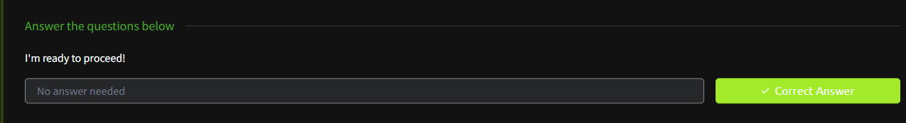- Encourages a mindset of curiosity and pattern recognition

## TASK 2 – TYPES OF LOGS

- Covers various types of logs used in analysis, such as Apache, DNS, Syslog.

- Explains the structure and purpose of each log type.

- Helps identify which logs are useful for which kind of threat or anomaly.

- Emphasizes reading timestamps, IPs, and method/status fields.

- Reinforces log relevance in real-world investigations.

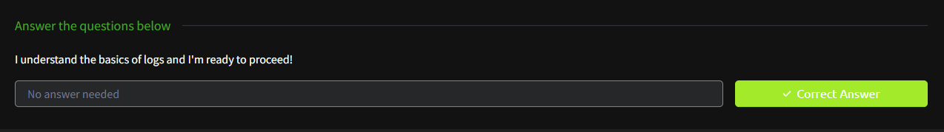- Forms the basis for choosing the right log during triage.

## TASK 3 – INVESTIGATION THEORY

- Introduces the concept of timelines and event correlation.

- Defines a "Super Timeline" for cross-system analysis.

- Discusses threat indicators like file hashes (MD5).

- Covers visualizing events and identifying intrusion patterns.

- Questions help reinforce understanding of analysis theory.

- Equips users to think systematically during log review.

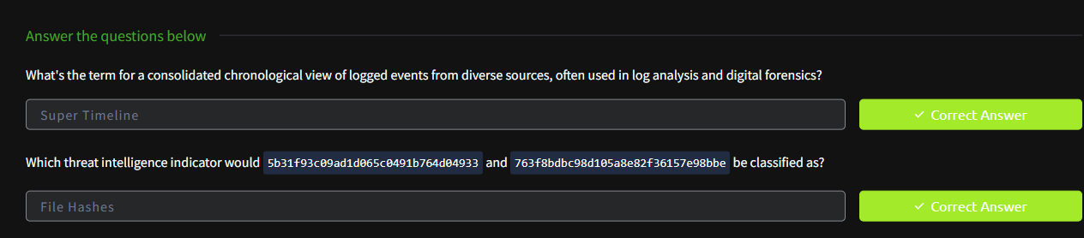

## TASK 4 – DETECTION ENGINEERING

- Focuses on identifying suspicious behavior in logs.

- Highlights default log locations, like `/var/log/nginx/access.log`.

- Teaches detection of encoded attacks like path traversal.

- Shows how to decode `%2E%2E/` and other encoded threats.

- Builds awareness of signature-based log indicators.

- Practical examples prepare users for real detection tasks.

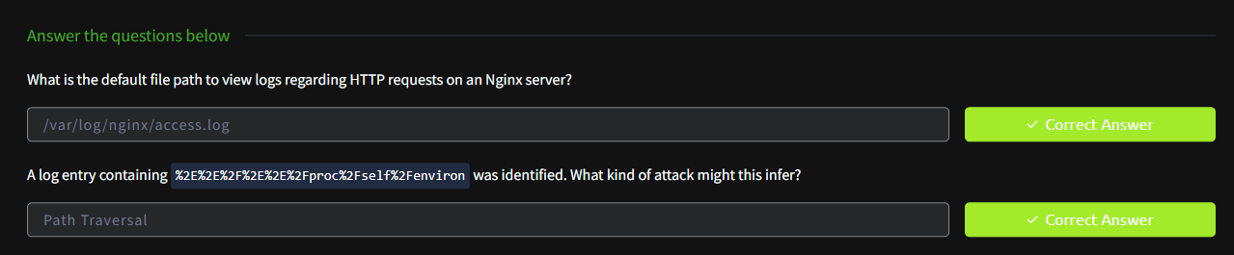

## TASK 5 – AUTOMATED VS. MANUAL ANALYSIS

- Compares automated log parsing with manual investigation.

- Shows when to use tools vs. human-led judgment.

- Demonstrates strengths and limits of both approaches.

- Promotes hybrid usage of automated detection and human insight.

- Reinforces how automation saves time, but humans catch context.

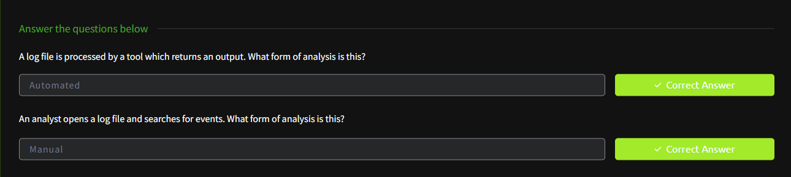- Simple Q&A makes the concept clear and applicable.

## TASK 6 – LOG ANALYSIS TOOLS: COMMAND LINE

- Uses CLI tools like `cut`, `awk`, `sort`, `uniq`, and `wc`.

- Extracts URLs, IPs, and counts response codes in Apache logs.

- Helps identify most active IPs or anomalies in logs.

- Tasks include timestamp extraction, pattern filtering.

- Encourages hands-on practice and efficient log handling.

- Reinforces Linux CLI as a primary skill for analysts.

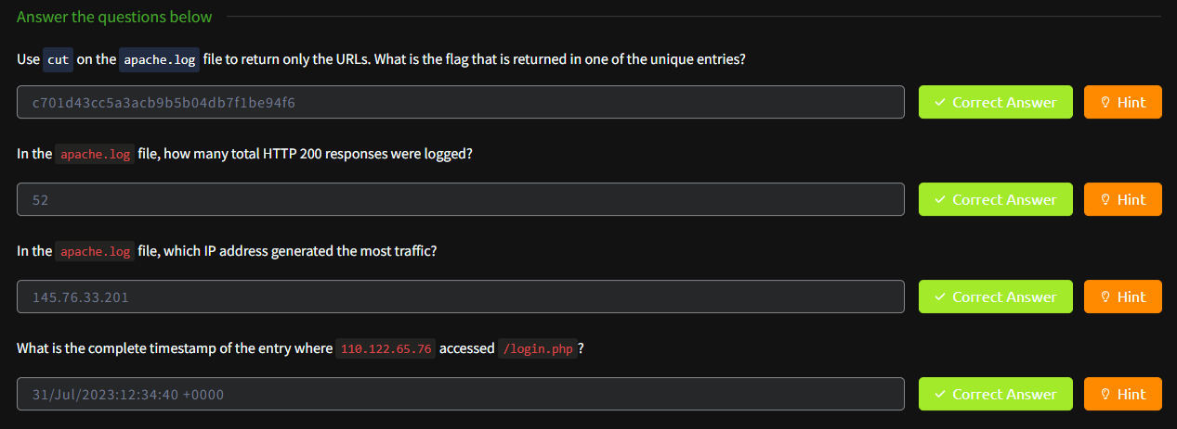

## TASK 7 – LOG ANALYSIS TOOLS: REGULAR EXPRESSIONS

- Introduces regex for log pattern extraction and filtering.

- Teaches matching ranges (e.g., post=2[2–6]) and wildcards.

- Shows how regex simplifies locating key data entries.

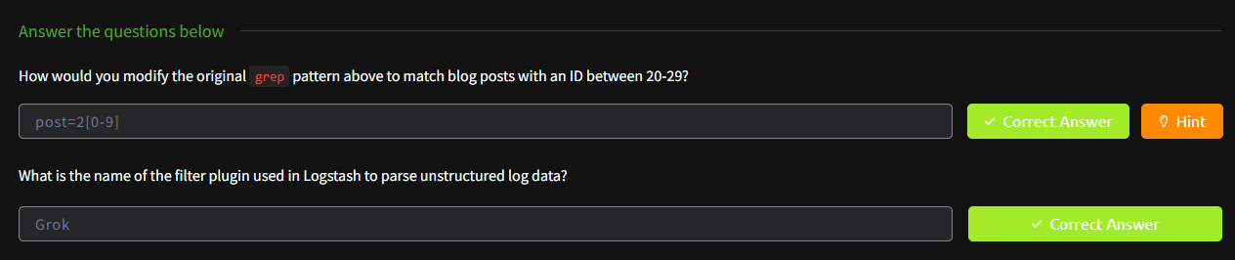- Explains the Grok plugin for parsing unstructured logs.

- Forms the base for automation in SIEM log parsing.

- Builds muscle memory in log filtering precision.

## TASK 8 – LOG ANALYSIS TOOLS: CYBERCHEF

- Demonstrates use of CyberChef for IP/MAC extraction and decoding.

- Shows regex matching for IPv4 and Base64 decoding.

- Uses filters to refine large datasets into actionable data.

- Tasks include decoding embedded flags and extracting patterns.

- Reinforces visual/logical chaining of transformations.

- Makes advanced parsing accessible for beginners.

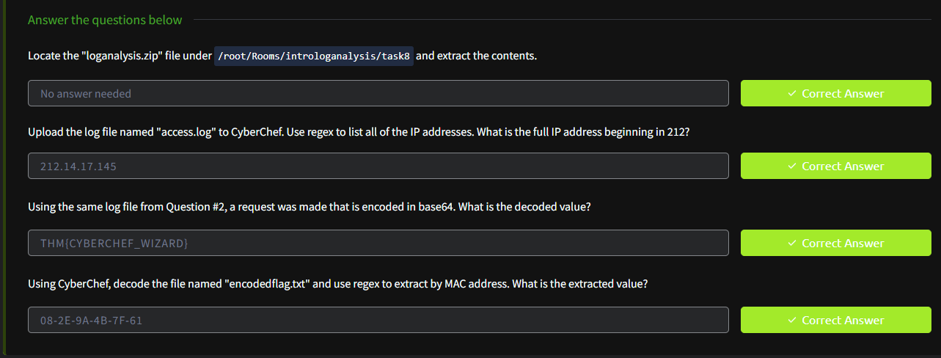

## TASK 9 – LOG ANALYSIS TOOLS: YARA AND SIGMA

- Introduces detection rule writing with YARA (malware) and Sigma (logs).

- Explains syntax like `rule` (YARA) and `title` (Sigma YAML).

- Demonstrates how Sigma helps standardize detection across platforms.

- Teaches rule readability and structure in threat detection.

- Builds a bridge between manual detection and automated alerts.

- Finalizes the room by integrating rules into practical use.

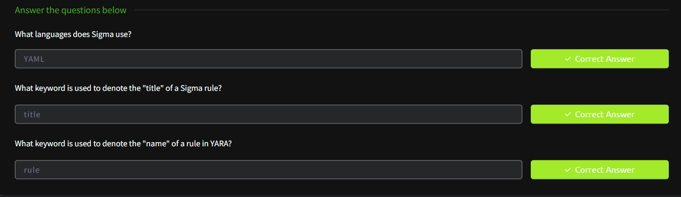

RESULT:

Successfully understood the principles of log analysis, practiced log filtering and decoding, and applied detection rule writing using industry tools, laying a strong foundation for real-world security operations.