AJAX

SITES: <https://getbootstrap.com/docs/4.5/getting-started/introduction/>

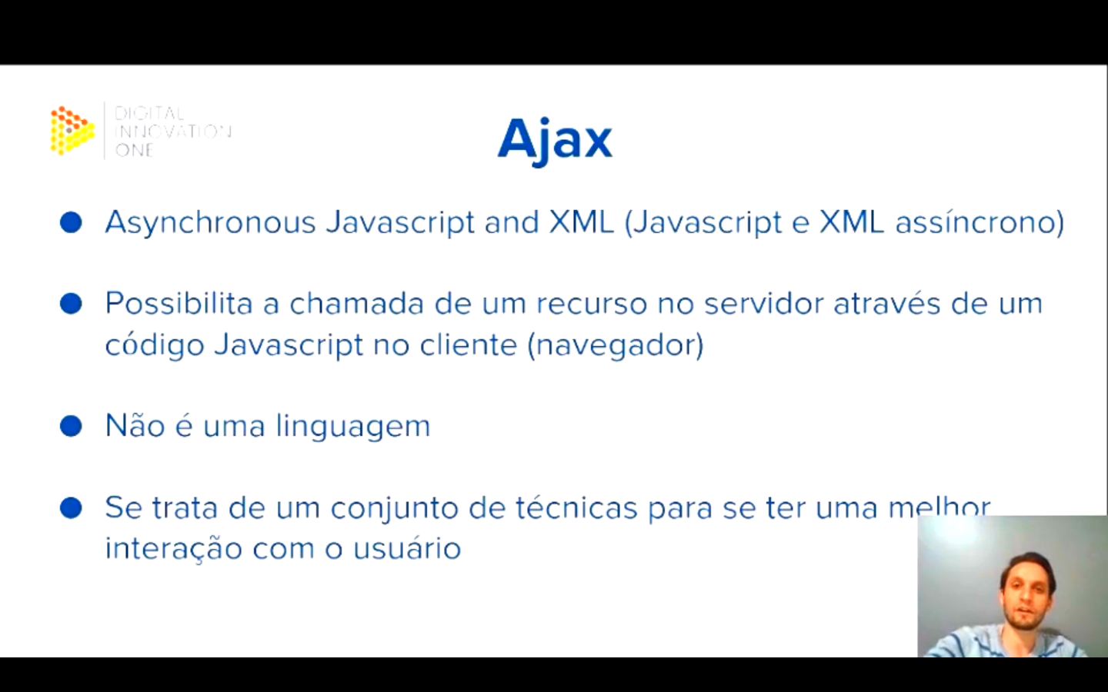

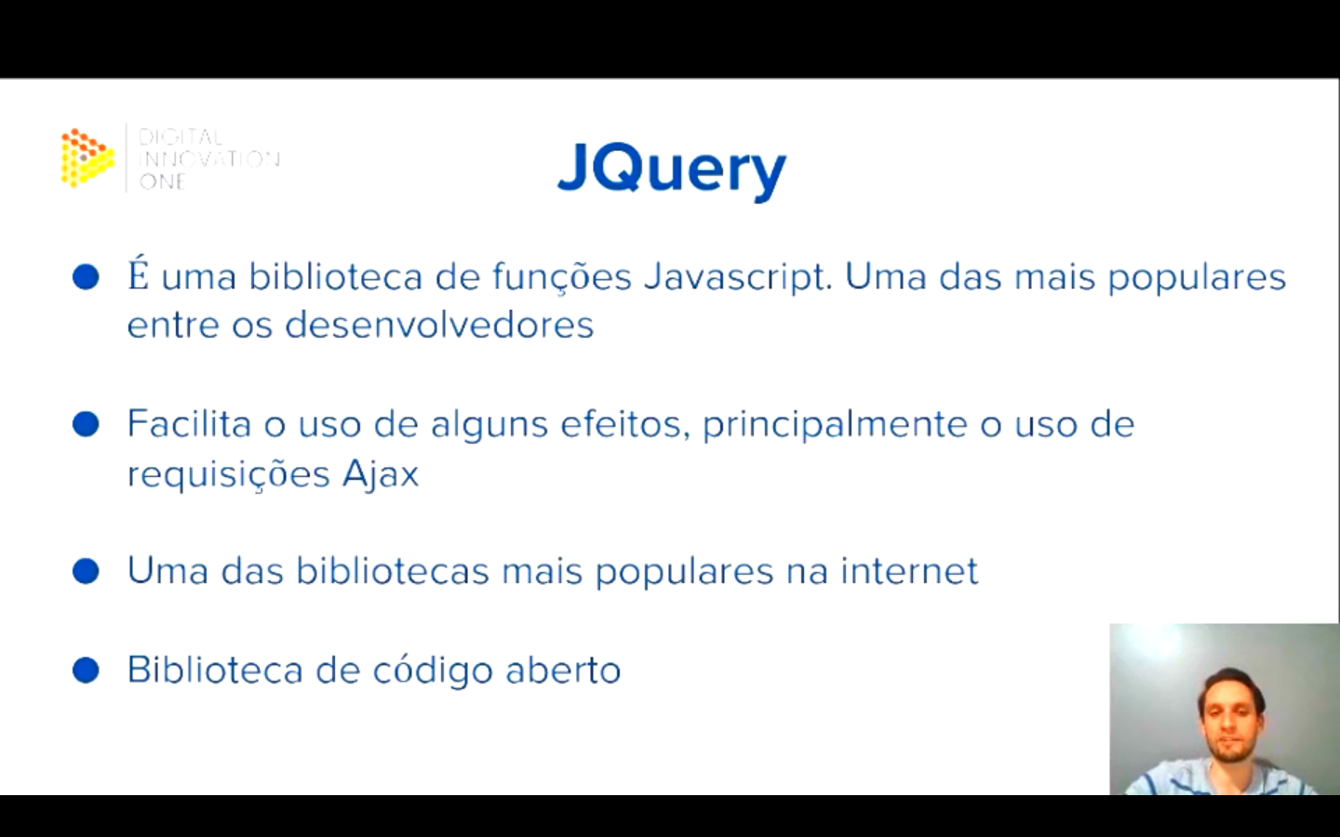

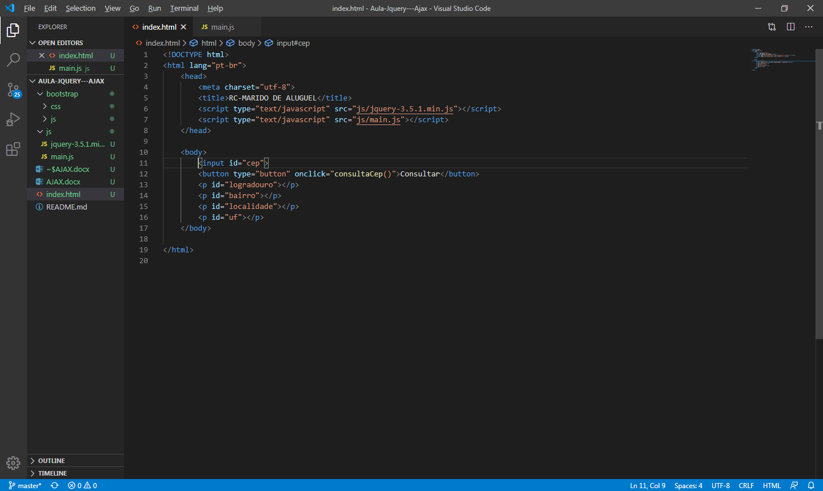

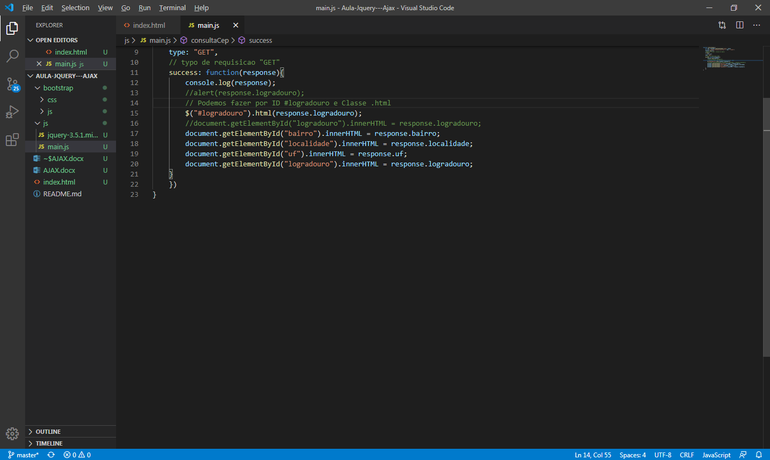

INDEX.HTML

<!DOCTYPE html>

<html lang="pt-br">

    <head>

        <meta charset="utf-8">

        <title>RC-MARIDO DE ALUGUEL</title>

        <script type="text/javascript" src="js/jquery-3.5.1.min.js"></script>

        <script type="text/javascript" src="js/main.js"></script>

        <link rel="stylesheet" type="text/css" href="bootstrap/css/bootstrap.min.css">

    </head>

    <body>

        <nav class="navbar navbar-dark bg-dark">

            <a class="navbar-brand">Consulta CEP</a>

            <div class="form-inline my-2 my-lg-0">

                <input class="form-control mr-sm-2" type="search" placeholder="CEP" id="cep">

                <button class="btn btn-outline-success my-2 my-sm-0" onclick="consultaCep()">Buscar</button>

            </div>

        </nav>

        <div class="container barra-progresso" style="margin-top: 80px;">

            <div class="progress">

                <div class="progress-bar progress-bar-striped progress-bar-animated" role="progressbar" aria-valuenow="75" aria-valuemin="0" aria-valuemax="100" style="width: 100%"></div>

            </div>

        </div>

        <div class="container cep" style="margin-top: 20px;">

            <div calss="row">

            <h3 id="tituloCep">CEP</h3>

            </div>

            <div class="row" style="margin-top:20px;">

                <table class="table">

                    <tbody>

                        <tr>

                            <td>Logradouro</td>

                            <td id="logradouro"></td>

                        </tr>

                        <tr>

                            <td>Bairro</td>

                            <td id="bairro"></td>

                        </tr>

                        <td>Localidade</td>

                            <td id="localidade"></td>

                        </tr>

                        <tr>

                            <td>UF</td>

                            <td id="uf"></td>

                        </tr>

                    </tbody>

                </table>

            </div>

        </div>

    </body>

</html>

MAIN.JS

function consultaCep(){

    $(".barra-progresso").show();

    var cep = document.getElementById("cep").value;

    var url = "https://viacep.com.br/ws/" + cep + "/json/";

    console.log(url);

    $.ajax({

        url: url,

    type: "GET",

    success: function(response){

        console.log(response);

        $("#logradouro").html(response.logradouro);

        $("#bairro").html(response.bairro);

        $("#localidade").html(response.localidade);

        $("#uf").html(response.uf);

        $("#tituloCep").html("CEP " + response.cep)

        $(".cep").show();

        $(".barra-progresso").hide();

    }

    })

}

$(function(){

    $(".cep").hide();

    $(".barra-progresso").hide();

});