Ruben Valenzuela
Professor Anna Devarakonda
ITAI 2277
06 September 2025

Module 02: Assignment – Basic Programming Modules – Python

1) File I/O Example
In this program, I created a text file where I wrote the names of Texas cities, appended new lines, and then read the file contents. The code demonstrates how to write, append, and read data from a text file using Python’s built-in open() function. This is useful for managing logs, saving user input, or processing text-based data.
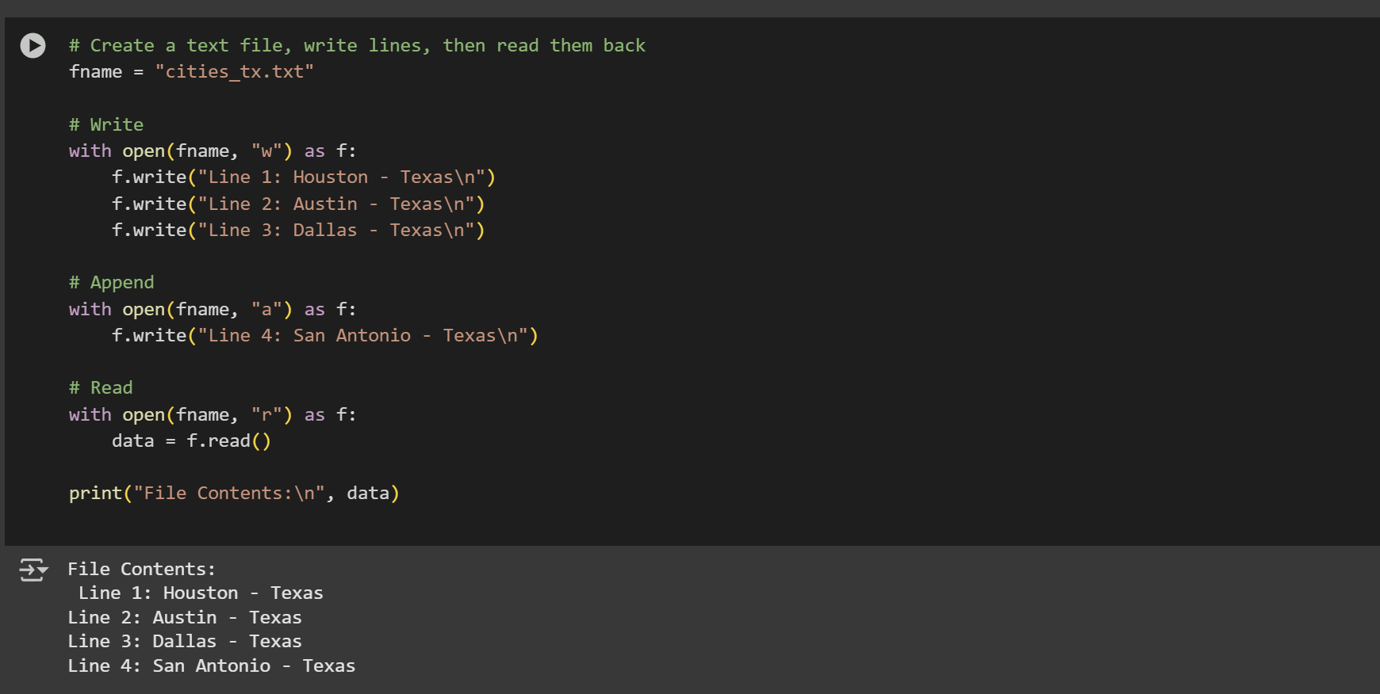2) Strings Example
This example shows how to manipulate strings in Python. I converted text to lowercase and uppercase, sliced part of the text, replaced words, and checked for the presence of specific words. String operations are essential when working with user input, text analysis, or cleaning data before using it in AI models.
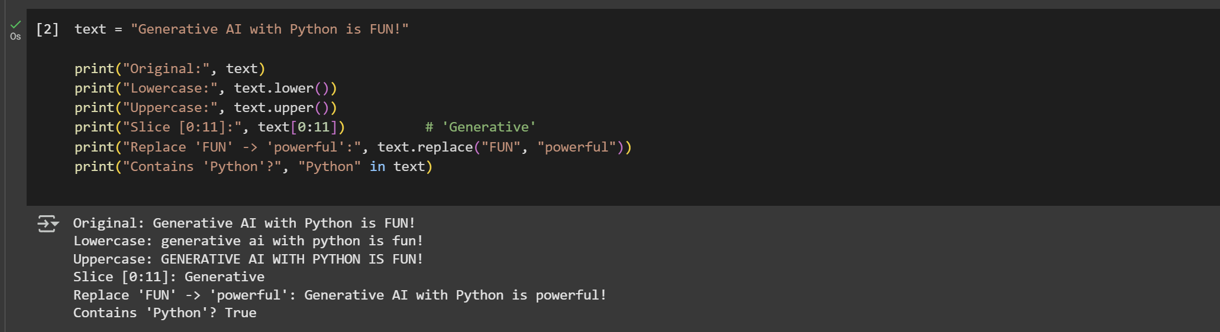3) Async Example
In this section, I used Python’s asyncio library to run multiple greeting tasks asynchronously. Each greeting runs after a different delay, showing how Python can handle concurrent tasks efficiently. This technique is useful for chatbots, web servers, and real-time AI systems that need to process multiple requests at once.
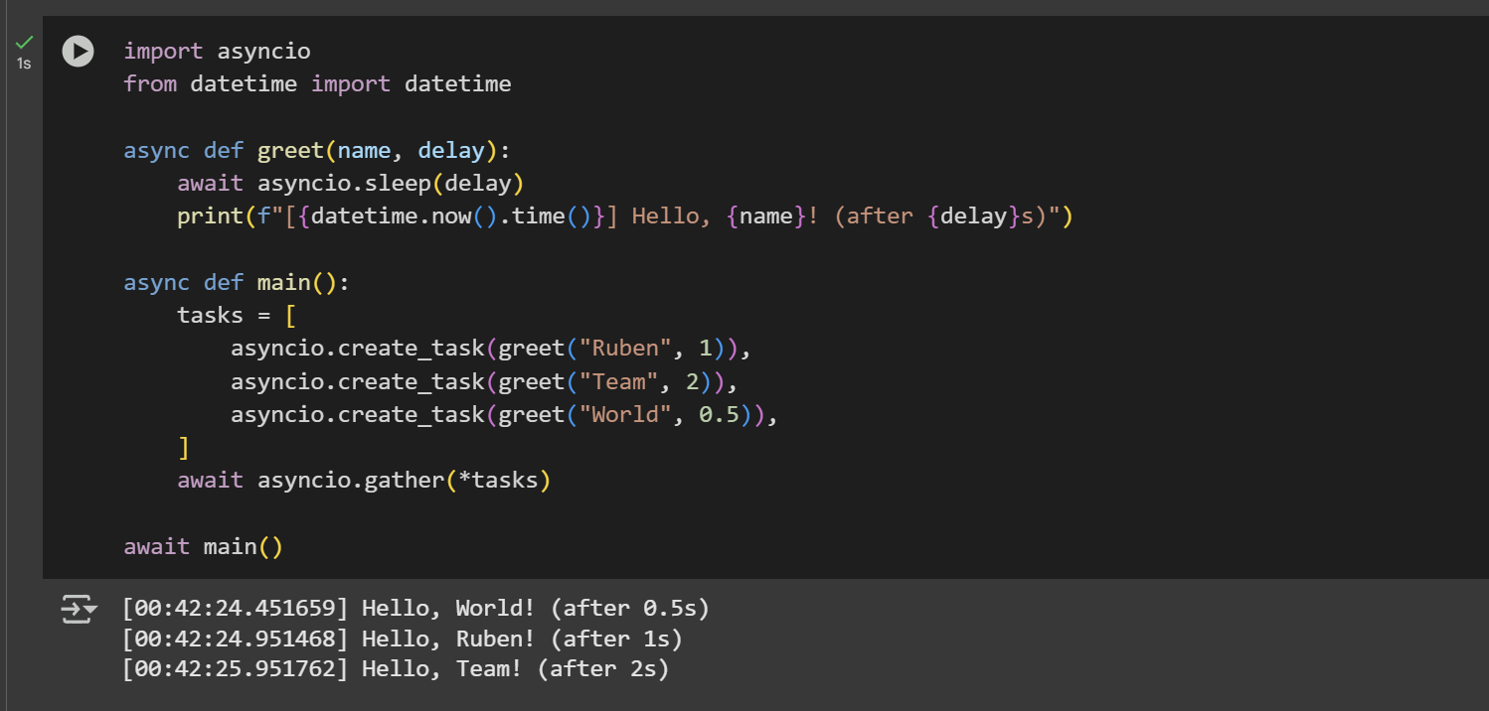4) HTTP Example
Using the requests library, I connected to the GitHub API and retrieved data about the Python repository. The program prints details such as the repository name, number of stars, and open issues. This example demonstrates how to work with APIs and web data, which is crucial when integrating AI models with real-world data sources.
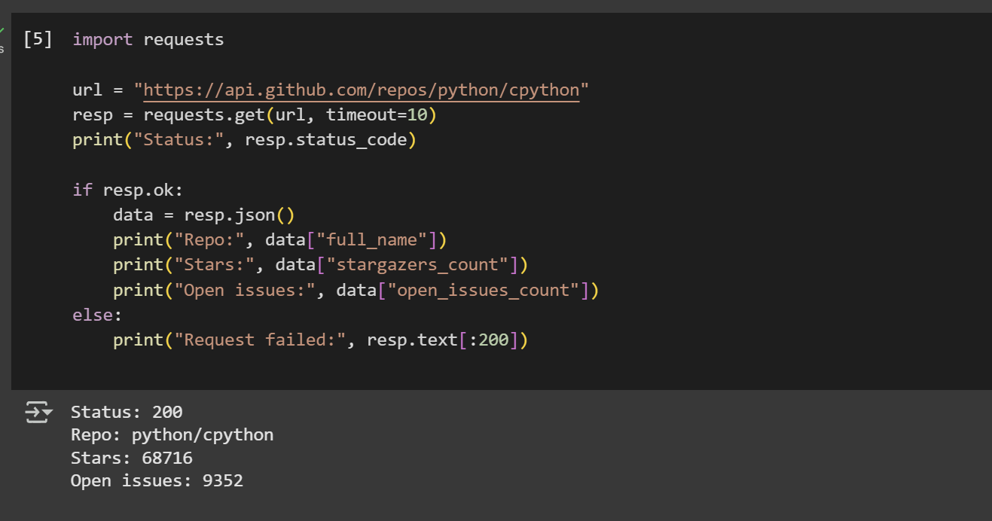5) Database Example (SQLite)
For this example, I used the sqlite3 library to create an in-memory database of students with their scores. The program inserts multiple rows and queries the top students with scores greater than or equal to 90. Databases are essential for storing structured information and are often used in AI projects to manage datasets efficiently.
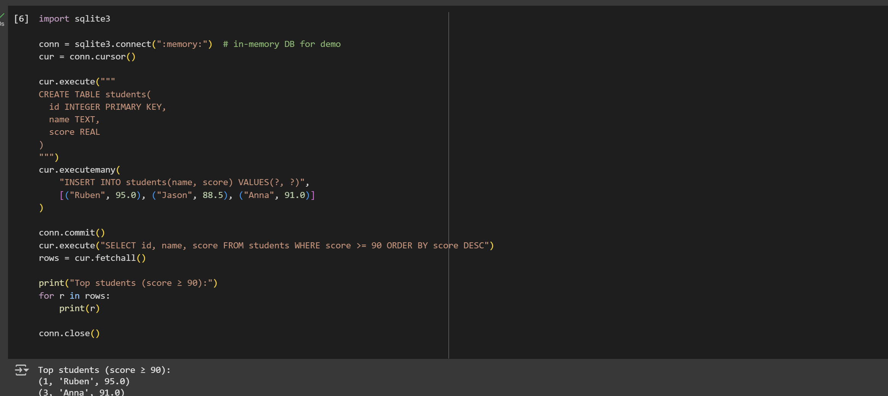6) NumPy Example
Here I used the NumPy library to perform mathematical operations on arrays. I demonstrated addition, multiplication, mean, and dot product. NumPy is a fundamental tool for numerical computing in AI, as it helps handle large datasets and perform matrix operations efficiently, which are critical for machine learning algorithms.
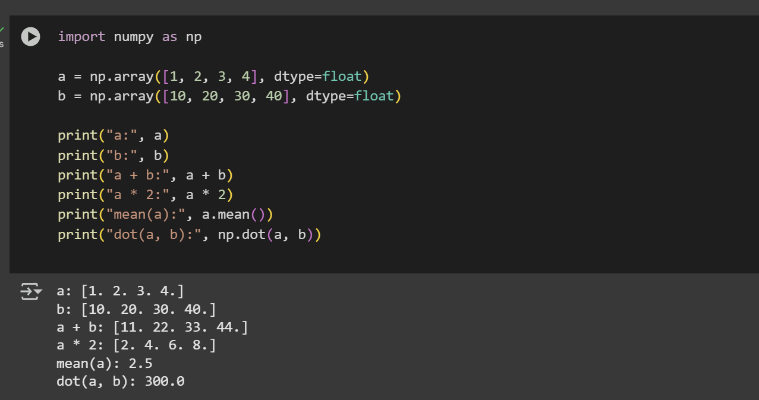7) Pandas Example
Finally, I created a simple DataFrame using Pandas to display chemical elements and their atomic numbers. The program shows how to analyze rows, count elements, and filter based on conditions. Pandas is widely used for data manipulation and preprocessing, making it one of the most important libraries for AI and data science.
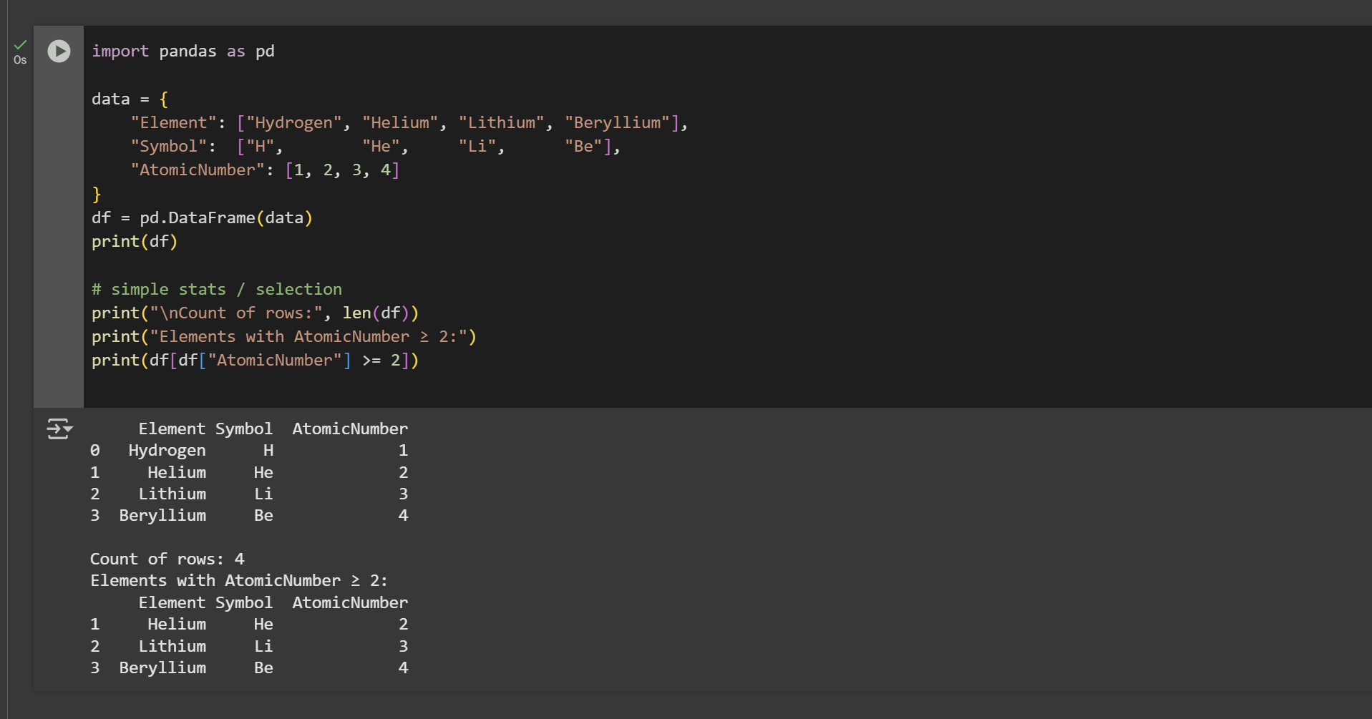Conclusion
This assignment gave me hands-on practice with essential Python modules: file handling, string manipulation, asynchronous programming, HTTP requests, databases, NumPy, and Pandas. Each module plays a unique role in programming and AI development. By combining them, I can build more advanced projects that involve data collection, processing, storage, and analysis. Overall, this work helped me strengthen my foundation in Python and understand how these modules connect to real-world AI applications.

