Ruben Valenzuela
Professor Sitaram Ayyagari
ITAI-3377
07 February, 2026

L03 – Deploying a Simple AI Model on a Simulated Edge Device
1. Environment Setup
For this lab, a Python-based development environment was used to simulate the deployment of an AI model on an edge device. The implementation was carried out using Google Colab, which provides Python, TensorFlow, and TensorFlow Lite support comparable to a local Visual Studio Code setup.
The required libraries included:
- TensorFlow
- NumPy
- Matplotlib
This environment allowed training, conversion, and inference testing without hardware constraints.
Figure 1. Python environment setup showing TensorFlow imports and successful loading of the MNIST dataset.
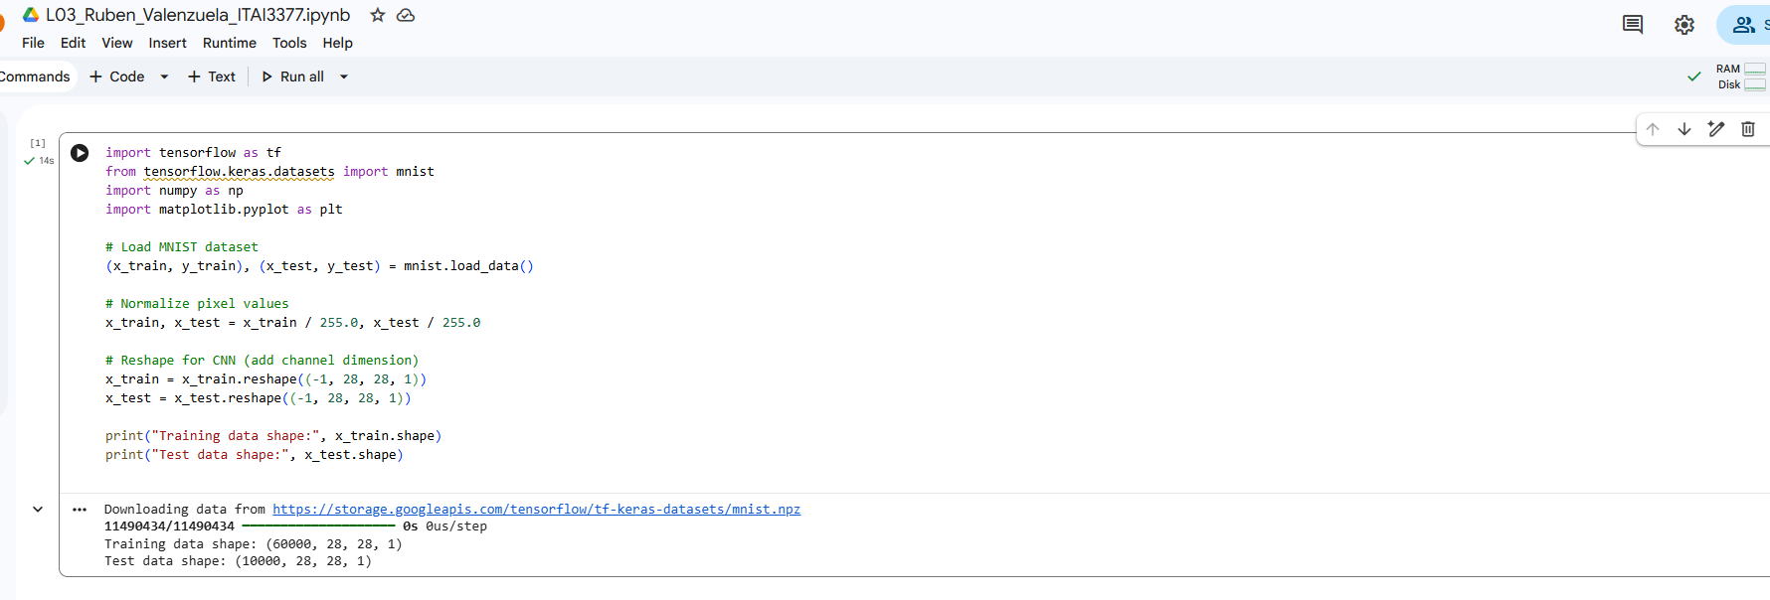
2. Dataset Preparation
The MNIST handwritten digits dataset was loaded using TensorFlow’s built-in dataset utilities. The images were normalized by scaling pixel values to the range [0,1], and reshaped to include a channel dimension suitable for CNN input.
This preprocessing step ensures consistent input formatting and improves model training stability.
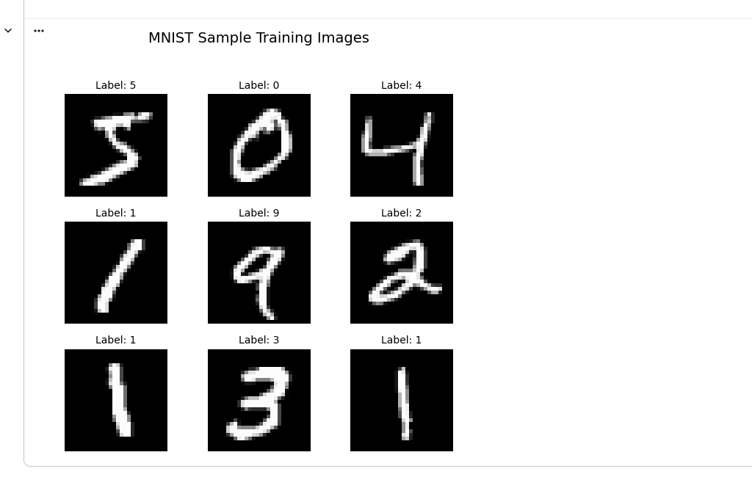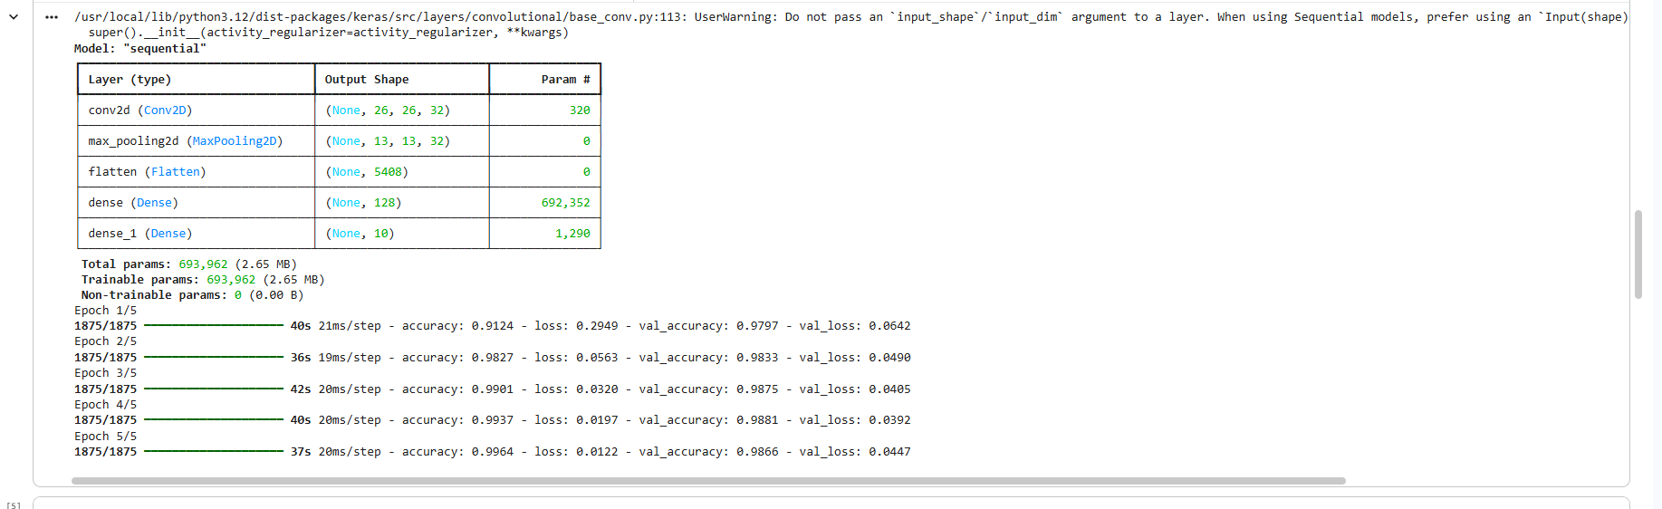
3. Model Training
A Convolutional Neural Network (CNN) was implemented to classify digits from 0 to 9. The model architecture included:
- One convolutional layer with ReLU activation
- A max pooling layer
- A fully connected dense layer
- A softmax output layer
The model was compiled using the Adam optimizer and trained for 5 epochs. Training and validation accuracy showed strong performance with minimal overfitting.
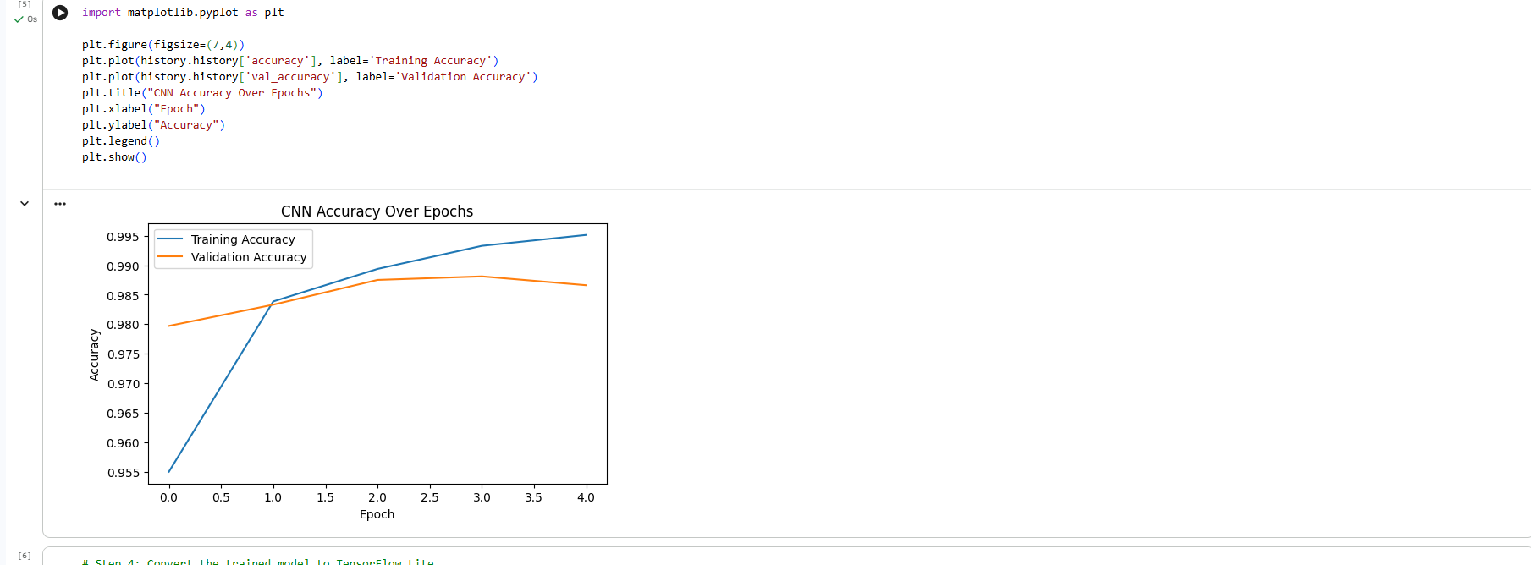4. Model Conversion and Edge Simulation
After training, the CNN model was converted to TensorFlow Lite format (.tflite) to simulate deployment on an edge device. The converted model was successfully saved and tested using the TFLite Interpreter.
A sample inference was run using a test image, correctly predicting the digit label. Inference latency was measured over multiple runs to simulate real-time edge performance.
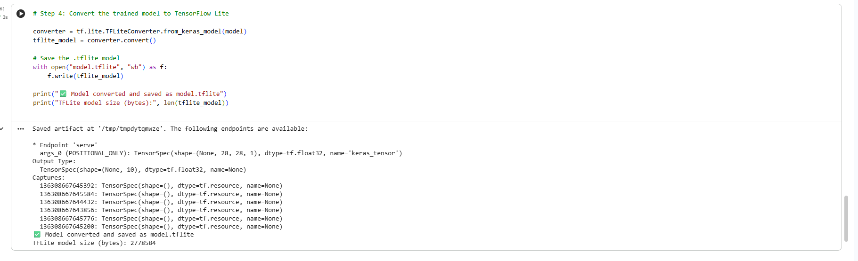
TFLite model conversion confirmation and model size.
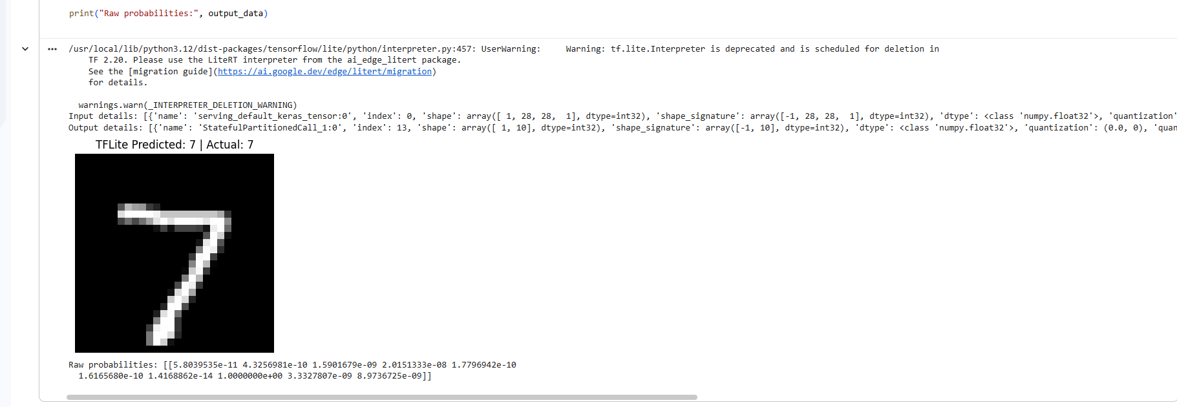
TFLite inference result showing predicted vs actual label.
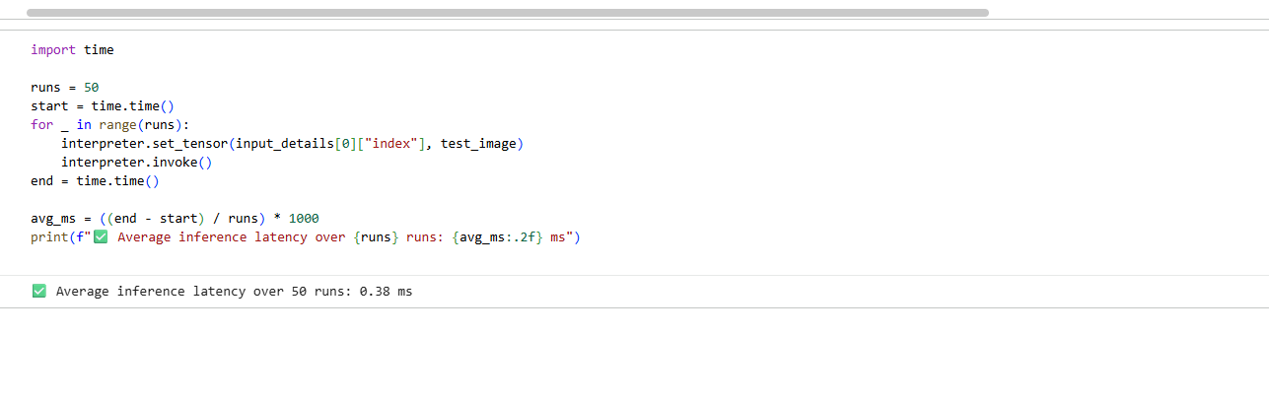
Latency measurement output.

5. Results Summary
- Training Accuracy: ~99.6%
- Validation Accuracy: ~98.6%
- Average Inference Latency: ~0.38 ms
- Model Format: TensorFlow Lite (.tflite)
These results demonstrate that the trained CNN model is efficient and suitable for deployment on resource-constrained edge devices.

