## 



Mobile Application Development Project Report

25.10.2024

**─**

**Project name**

Coffee Shop Flutter Application

**Project team members**

Rubesha 21sw072

Anjli Kumari 21sw118

Rizeen Yaseen 21sw147

**Project Assigned By**

Mam Mariam Memon

# 

# Real World Problem Identification

In today’s fast-paced world, coffee lovers often need to browse available products, customize their orders, and keep track of their shopping cart in real-time. A lack of streamlined digital solutions can lead to inefficient order management and user frustration, especially for small coffee businesses looking to establish a customer-friendly mobile presence.

**Identified Problems:**

* Limited ability to view, customize, and order coffee through a mobile platform.
* Users struggle with cart management, including adding, deleting, and tracking purchases.
* Need for clear billing information to reduce confusion at checkout.
* Difficulty in managing product information and user preferences efficiently.

# Proposed Solution

The proposed solution is a mobile application that allows users to:

* Browse and customize coffee orders easily.
* Add, modify, or delete items in their cart with real-time synchronization using **Firebase Firestore**.
* View total bill calculations directly within the app.
* Provide responsive and user-friendly interfaces to ensure seamless navigation.
* Maintain user data, shopping history, and cart status through secure cloud storage for future use.

This app provides small coffee businesses a scalable solution for enhancing customer engagement by offering an intuitive shopping experience.

# 

# Responsive User Interfaces

# Screenshots of the app on different screen sizes and orientation

**WEB SCREENSHOTS**



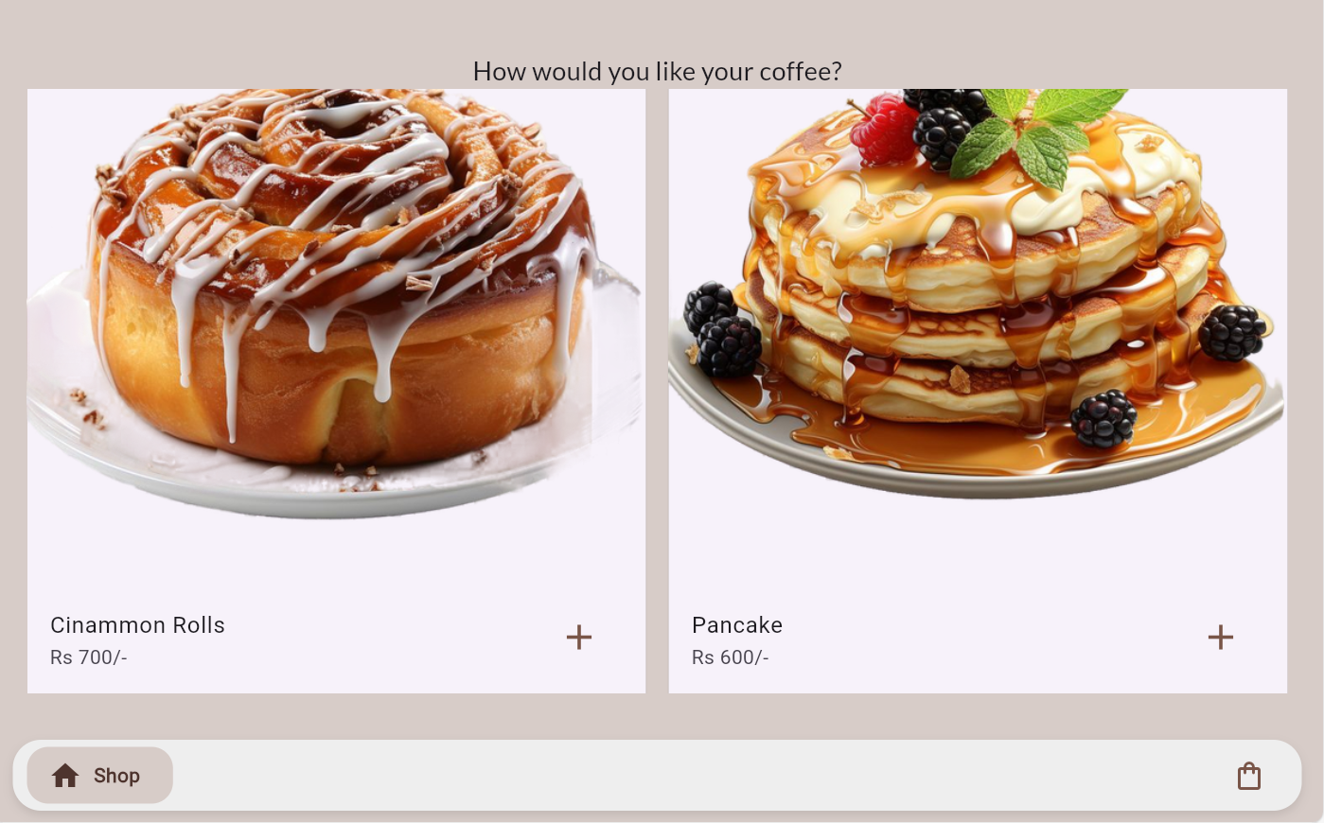

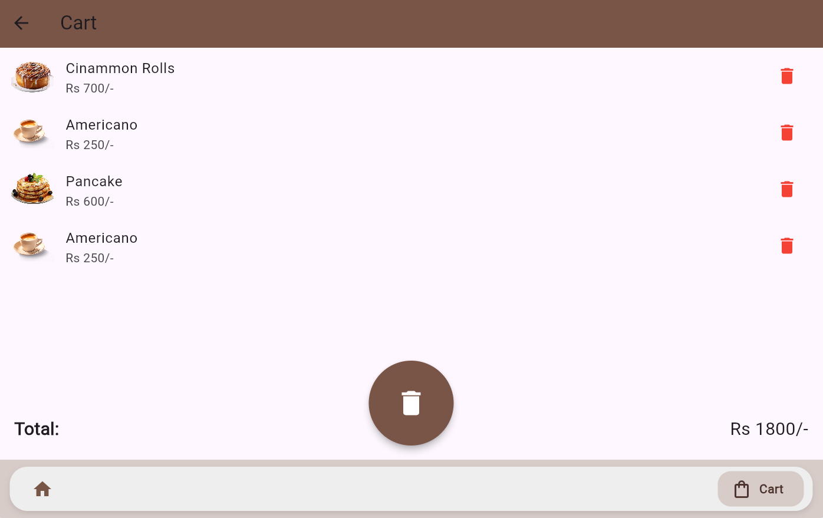

**PHONE SCREENSHOTS**

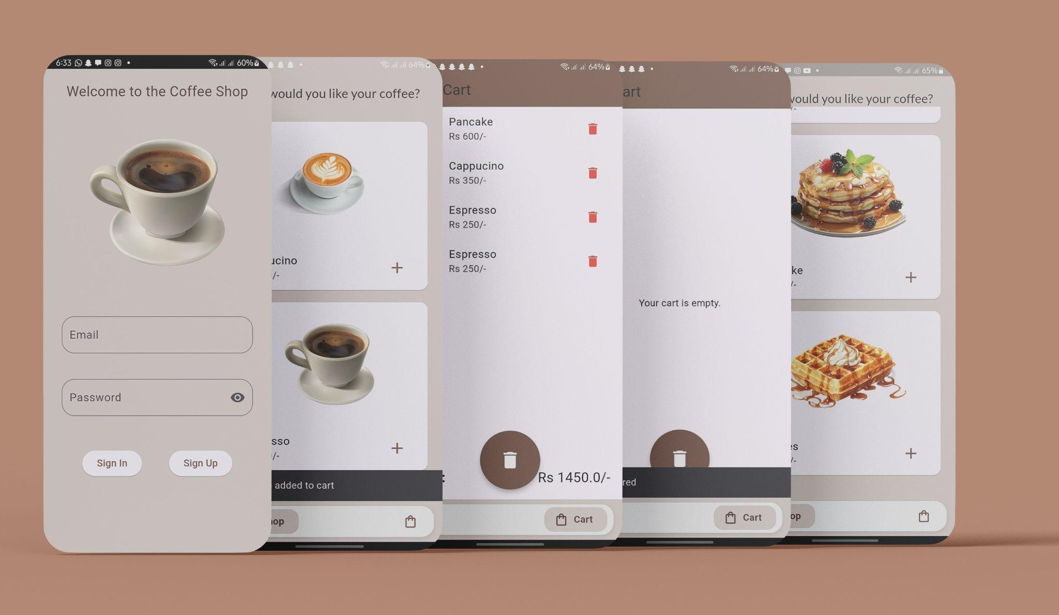

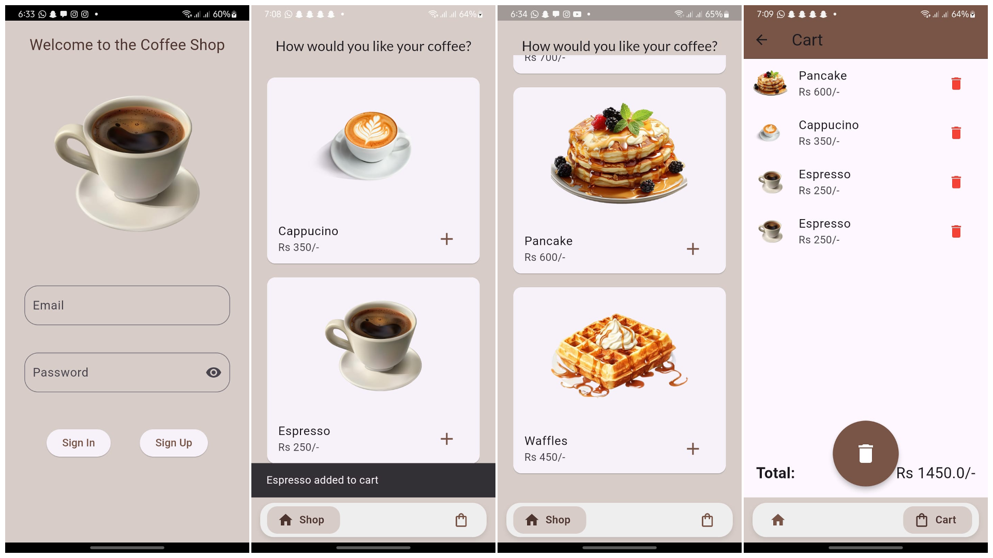

**LANDSCAPE ORIENTATION ADAPTATION**

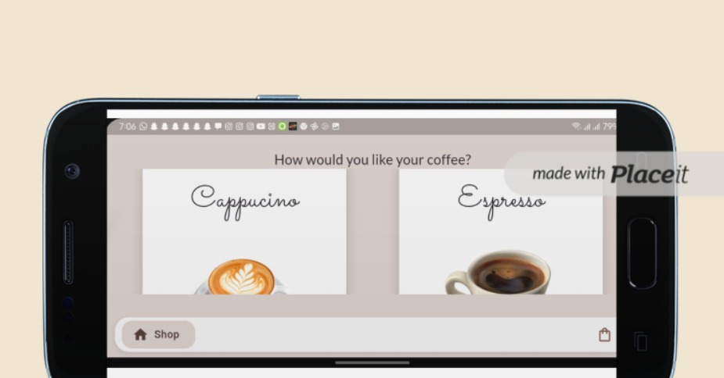

# Data Storage

We chose **Firebase Firestore** as the primary data storage solution for the following reasons:

* **Real-time synchronization:** Changes to the cart or product list reflect immediately across devices.
* **Scalability:** Suitable for small businesses with future growth in mind.
* **Offline Support:** Users can access the app even when temporarily offline, with automatic sync when reconnected.
* **NoSQL Database:** Flexible data structure that adapts well to product-based apps.

Firestore also integrates smoothly with Firebase Authentication, allowing easy user management and personalized cart storage.

# **Issues and Bugs Encountered and Resolved during Development**

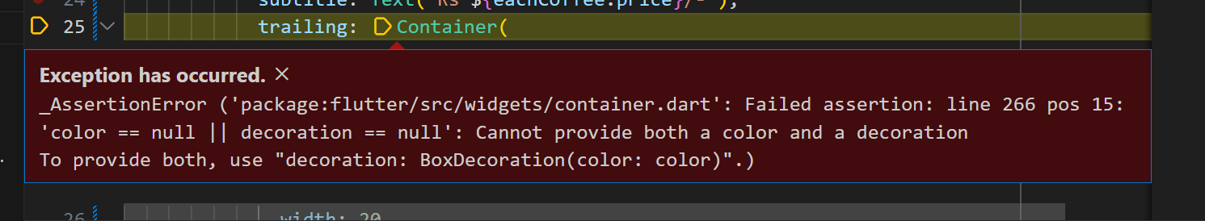

**ERROR:**

This bug arrived due to placing color argument outside the BoxDecoration widget.

**SOLUTION:**

When using decoration argument in a container do not place the color parameter outside the decoration widget.

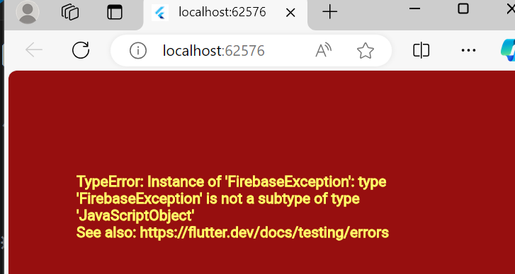

**ERROR:**

Firebase instance creation was giving an error.

**SOLUTION:**

Initializing the firebase instance correctly   
void main() async {

WidgetsFlutterBinding.ensureInitialized();

await Firebase.initializeApp();

runApp(MyApp());

}

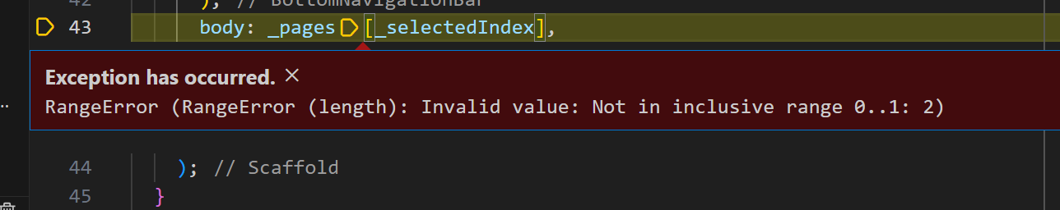

**ERROR:**

Bottom Navigation bar index was giving an error.

**SOLUTION:**

Correctly Update the selected index when a tab is tapped.

void _onTabTapped(int index) { setState(() { _currentIndex = index; }); }

# **APIs/Packages/Plug-ins**

**Screenshots from pubspec.yaml file:**

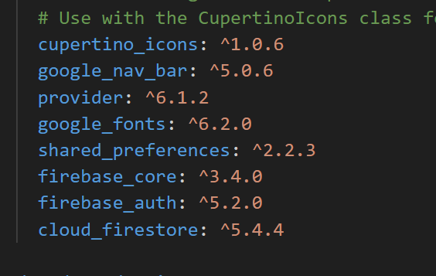

* **google_nav_bar: ^5.0.6**

A customizable, easy-to-use navigation bar widget.

**Reason for Use:** This package simplifies the creation of a beautiful bottom navigation bar, essential for apps with multiple screens requiring easy navigation, giving a modern UI feel.

* **provider: ^6.1.2**

A popular state management library in Flutter.

**Reason for Use:** It's used to manage and pass data across widgets efficiently. For example, it helps in managing cart state or user authentication state across the app without passing data manually through constructors.

* **google_fonts: ^6.2.0**

Provides access to Google Fonts in your Flutter app.

**Reason for Use**: If your app has a specific design requiring custom fonts, this package allows you to easily integrate a wide variety of fonts from Google Fonts, enhancing typography.

* **firebase_core: ^3.4.0**

The core Firebase plugin necessary for connecting ourFlutter app to Firebase services.

**Reason for Use**: Firebase is likely used in your app for services like authentication or database management, and this package ensures all Firebase plugins can communicate correctly with Firebase.

* **firebase_auth: ^5.2.0**

Provides Firebase Authentication services.

**Reason for Use**: If your app requires user login and authentication (via email, Google, etc.), this plugin helps integrate Firebase’s authentication system seamlessly.

* **cloud_firestore: ^5.4.4**

Provides access to Cloud Firestore, Firebase's real-time NoSQL database.

**Reason for Use**: Cloud Firestore is likely being used to store and retrieve data such as user information, cart items, or order history. It's highly scalable and great for apps with dynamic data needs.