**Interquartile Range - 1.5 Rule**

Interquartile range measures the spread or dispersion of the middle 50% of the data.

It is calculated as the difference between the third quartile (Q3) and the first quartile (Q1).

# IQR=Q3-Q1,

Q1- 1.5*IQR Q3+ 1.5*IQR

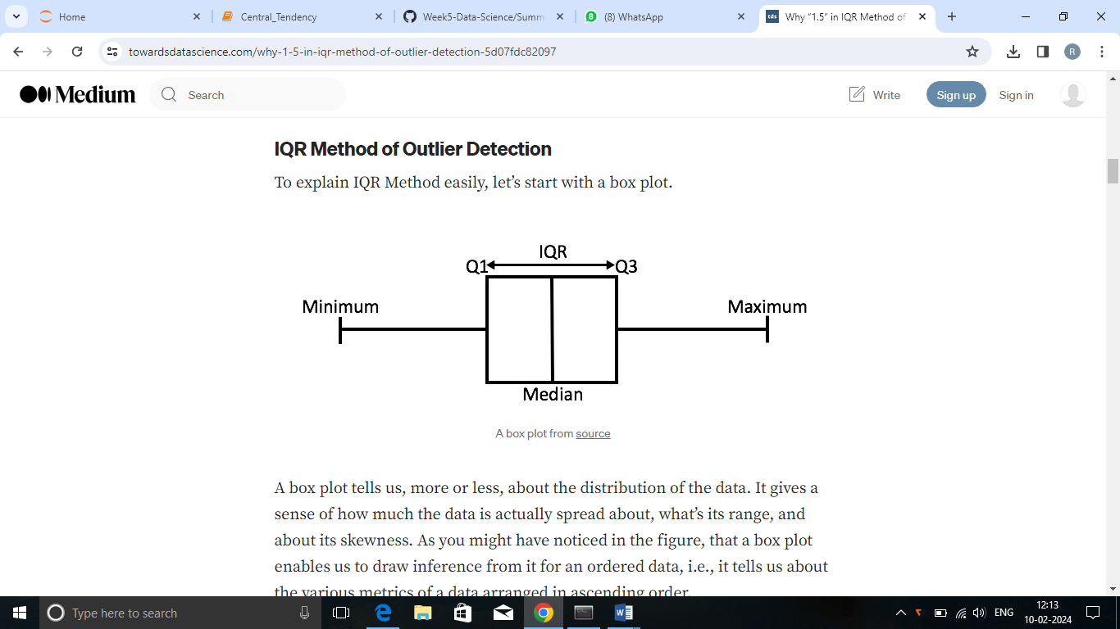

Any data point *less than the*Lower Bound(Q1) or *more than the*Upper Bound(Q3) is considered as an ***outlier***.

Why 1.5 rule? – **1 is too small and 2 is too large**

Gaussian Distribution(Normaldistribution) says that the first and the third quartiles, *Q1*and *Q3*, lies at 0.675**σ and -0.675σ from the mean, respectively.**

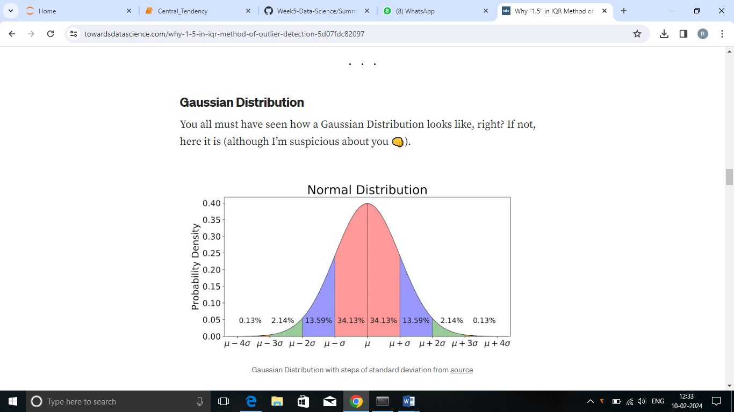

**The data points below and above this value is considered as an outlier.** An outlier is a data point which differs significantly from other observations.

When scale =1, the first and the third quartiles, *Q1*and *Q3*, lies at 2.025**σ and -2.025σ from the mean, respectively.**

**But, as known upto 3σ on either side of the data is useful. The smaller scale value considers some data points as outliers.**

**When scale=2,** the first and the third quartiles, *Q1*and *Q3*, lies at 3.375**σ and -3.375σ from the mean, respectively.**

**But, as known upto 3σ on either side of the data is useful. The larger scale value considers some outliers as data points.**

When scale is taken as 1.5, then according to IQR Method any data which lies beyond **2.7σ**from the mean (μ), on either side, shall be considered as outlier.

This makes the decision range closest to what Gaussian Distribution considers for outlier detection.