# Assignment

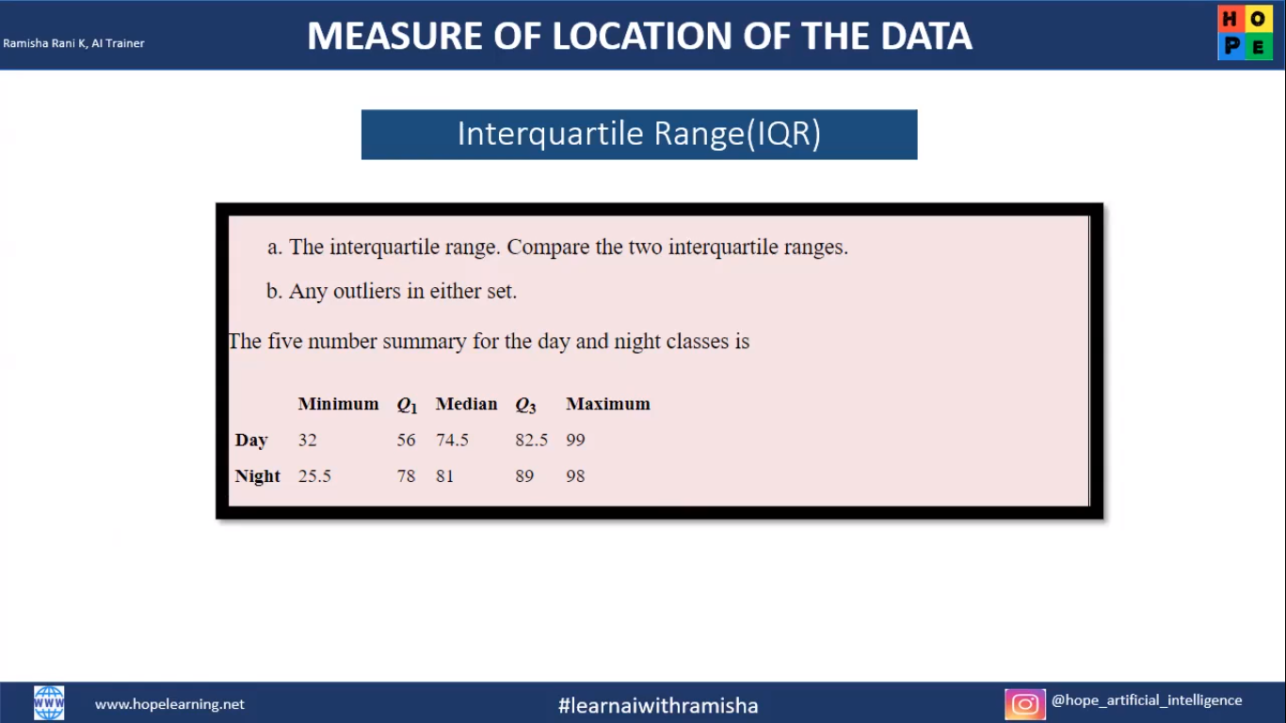

To find the IQR,

Class : Day

Q1= 56, Q3= 82.5, IQR=Q3-Q1 => 82.5-56 = 26.5

Lower Bound, Q1-1.5*IQR= 56-1.5*26.5 =>16.25 Q3+1.5*IQR= 82.5+1.5*26.5=>122.5

### Class : Night

### Q1= 78, Q3= 89, IQR=Q3-Q1=> 89-78

= 11

Upper Bound, Q1-1.5*IQR= 78-1.5*11= >61.5

## Q3+1.5*IQR=89+1.5*11=>105.5

1. In the Day class, all the data points are within the lesser and greater range. Hence, no outliers present.
2. In the Night class ,the minimum value is less than the lesser range and so it is considered as an outlier.

Remaining all the data points are within the range

### 

## 

.