Kurtosis and Skewness Report

Kurtosis measures the peakedness or flatness of a distribution.

Skewness describes how much a distribution differs from a normal distribution, either to the left or to the right.

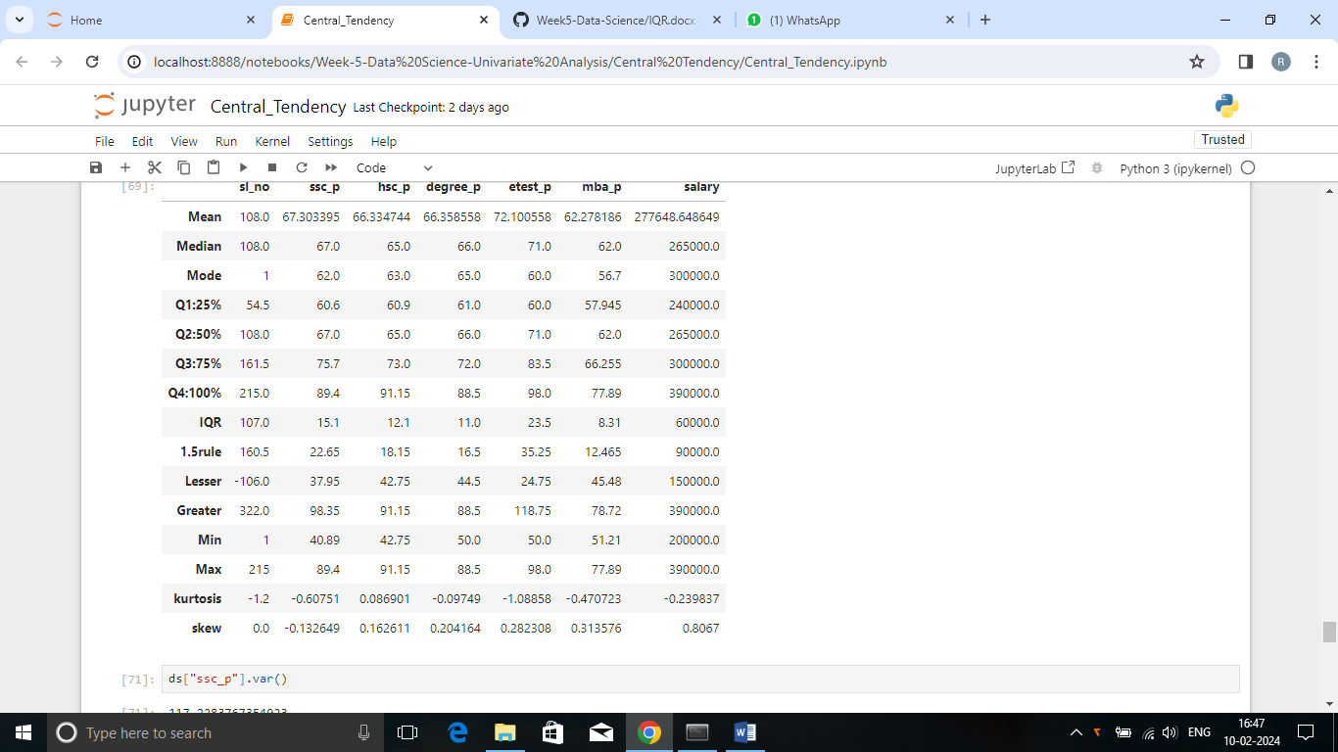

# Summary

**ssc_p**

* Skewness (-0.13264 - negatively skewed) says most students scored well in the ssc_p exam and few scored low.
* Kurtosis (-0.6075 - platykurtic(<3)) says that majority of the students have performed moderately in the exam.

**hsc_p**

* Skewness (0.16261 - positively skewed) says that some students have achieved high scores and most of the students scored low
* Kurtosis (0.0869 - platykurtic (<3)) states that only some students have performed well.

**Degree_p**

* Skewness (0.20416 - positively skewed) declares that most of the data points are clustered towards the low which shows the low performance in the exam.
* Kurtosis (-0.0974 - platykurtic(<3)) shows that average performers are high in this exam.

## Entrance_p

* Skewness (0.28230 - positively skewed) states that some students have achieved higher marks and most of the students scored low
* Kurtosis (-1.088 - platykurtic(<3)) shows the average performance of the students.

### Mba_p

* Skewness (0.31350 - positively skewed)defines most of the students scored low .Only few good performers.
* Kurtosis (-0.4707 – platykurtic (<3)) says that mostly there are average performers

**Salary**

* Skewness (0.8067 - positively skewed) shows that only few individuals earning higher salaries.
* Kurtosis (-0.2398 – platykurtic(<3)) only few are good performers and most of the students are average performers.