# **Summarization of Mean, Median and Mode**

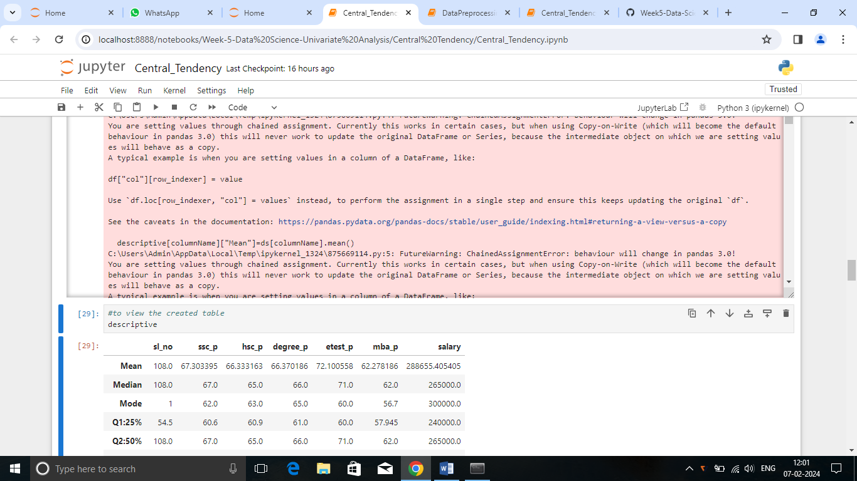

***Summary****:*

* Students tend to score above 60 on average earning Rs.2,88,655
* Scores between 62 to 71 typically earn Rs.2,65,000.
* Common marks are 62 in 10th, 63 in 12th, 65 in degree, 60 in entrance test and 56.7 in the MBA examination.
* Most common salary is Rs.3,00,000.