# **Summarization of Mean, Median and Mode**

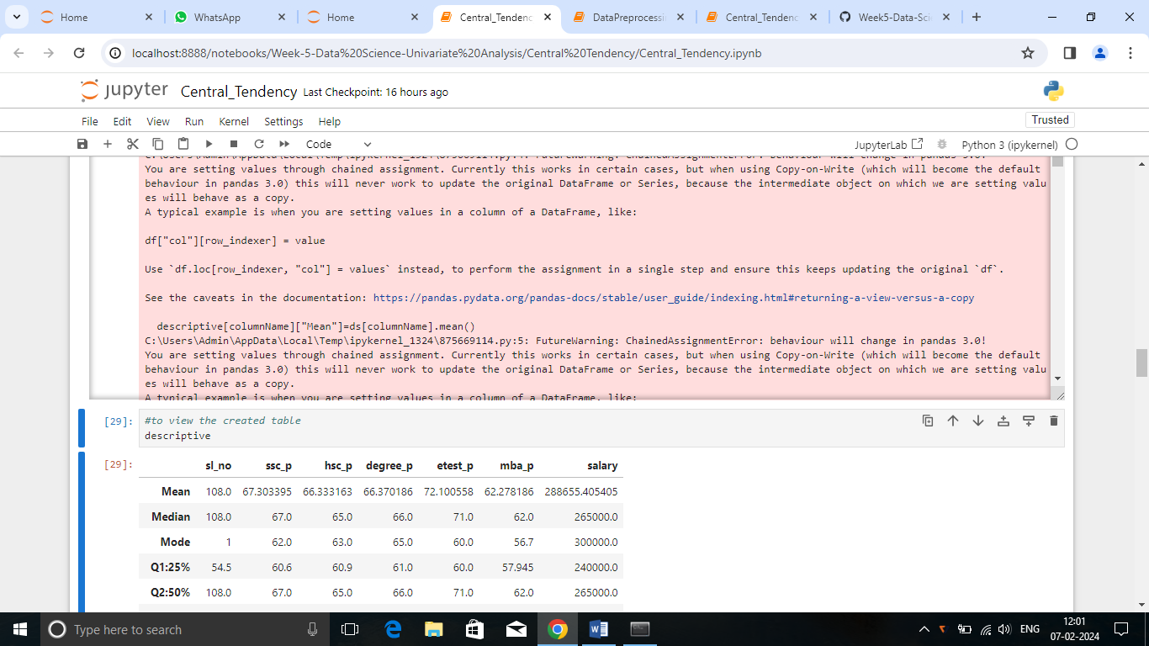

***Summary****:*

This is a placement dataset which contains the marks scored by the students in all the exams and their salary if they had placed in a job.

***Mean:***

* The average score of all the exams except entrance test is between 62 to 67
* The marks obtained in the entrance test is 71 which is above the average rate.
* The average score of ssc_p , hsc_p, degree are higher than the MBA_p average mark.
* The students average salary is Rs.288655.

***Median:***

* The median mark scored by the students in the

ssc_p exam is 67.

* The median mark scored by the students in the hsc_p exam is 65.
* The median mark scored by the students in the degree exam is 66.
* The median mark scored by the students in the entrance exam is 71.
* The median mark scored by the students in the MBA exam is 62.
* The median salary received by the students is Rs.265000 which is lesser than the students average salary. It shows the presence of outliers in the column values.

***Mode:***

* Most of the students scored 62 marks in their ssc_p exam.
* Most of the students scored 63 marks in their hsc_p exam.
* Most of the students had got 65 marks in their degree exam.
* Most of the students had got 60 marks in their entrance test.
* Most of the students scored 56 marks in their MBA exam.
* The salary that is earned most commonly is Rs.3,00,000