Percentile Report

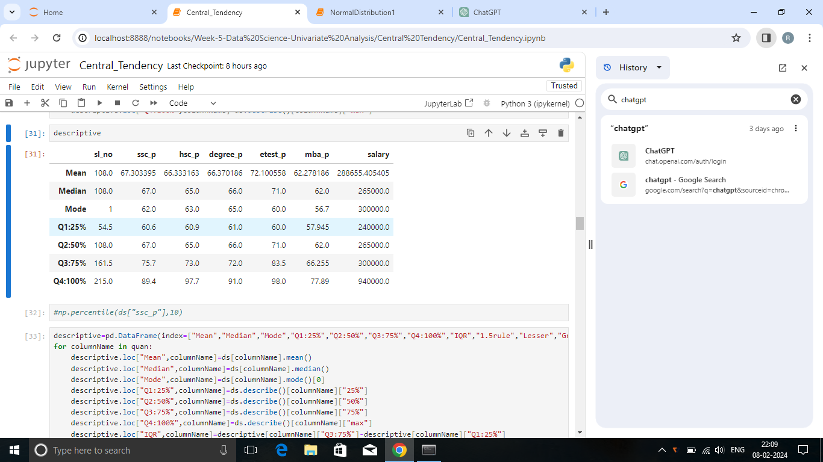

Summary:

Hsc_p:

* The 25th percentile of students mark exist within 60.6
* 50% students marks are higher than 65
* The 75th percentile of students mark exist within 73
* 24% improvement in marks is noted in the upper quartile range

Degree_p:

* 5% improvement is noted between the 25th and 50th percentile range
* 75% students mark falls below 72
* A greater improvement of 27% was observed within the upper quartile range

Entrance_Test:

* 25% of students scored below 61 marks
* 75% students mark are not higher than 83.5
* Steady progress has been noted in each quartile with a range of 10-15%

Mba_p:

* 57% better performance has been noted in the first quartile range
* The enchancement in students mark varied between 8 -15% across all percentiles

Salary:

* 25% of the salaries are lower than 2,50,000
* Salary rose steadily upto the 75th percentile
* Salaries within the upper quartile range have doubled