# **BOX PLOT**

Box plots are graphical tools to visualize key statistical measures, such as median, mean and quartiles.

The individual box plot is a visual aid to examining key statistical properties of a variable.

A box plot can handle and present a summary of a large amount of data. It consists of the median, which is the midpoint of the range of data; the upper and lower quartiles, which represent the numbers above and below the highest and lower quarters of the data and the minimum and maximum data values.

## Advantages

1. A box plot is a good way to summarize large amounts

of data.

1. A box plot is one of very few statistical graph methods that show outliers.

### Disadvantages

1. The box plot does not keep the exact values and details of the distribution results, which is an issue with handling such large amounts of data in this graph type.

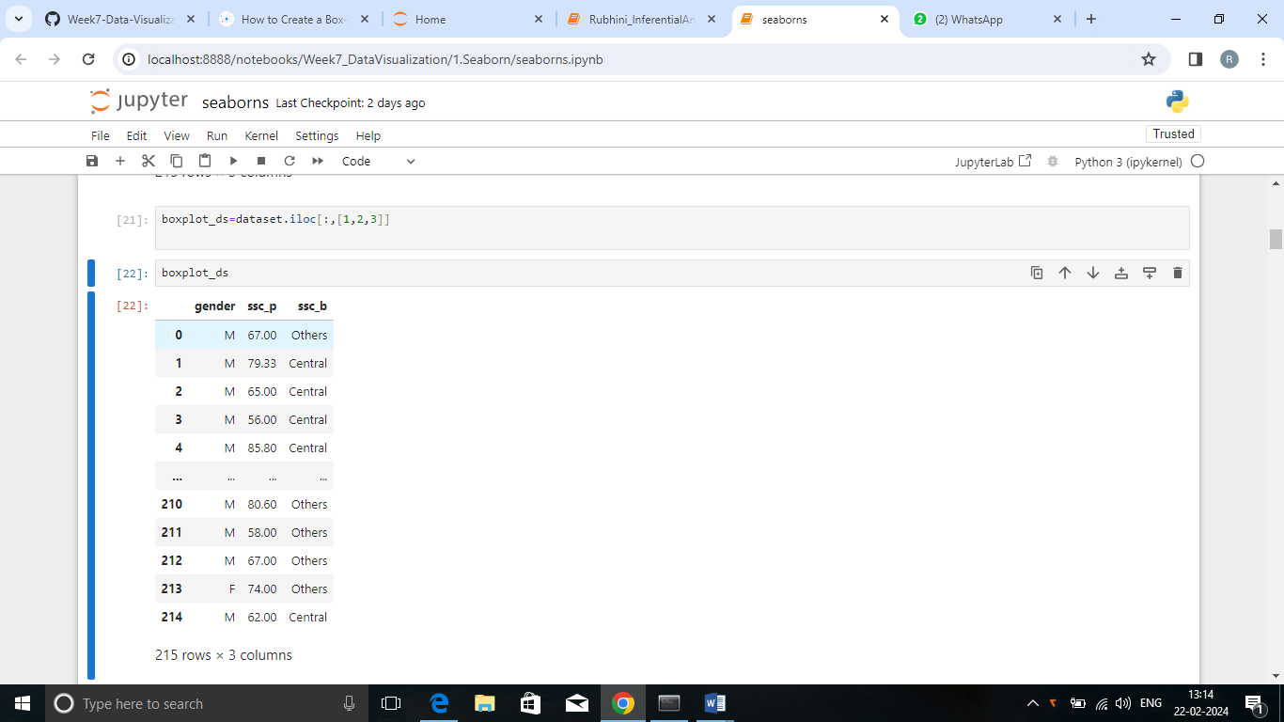

The data has been taken from a placement dataset which gives details of the students with their exam marks and their placement details with salary.

Here, ssc_b board column is taken as x-axis with respect to genders and ssc_p mark column is taken as y-axis to get the summary of the data.

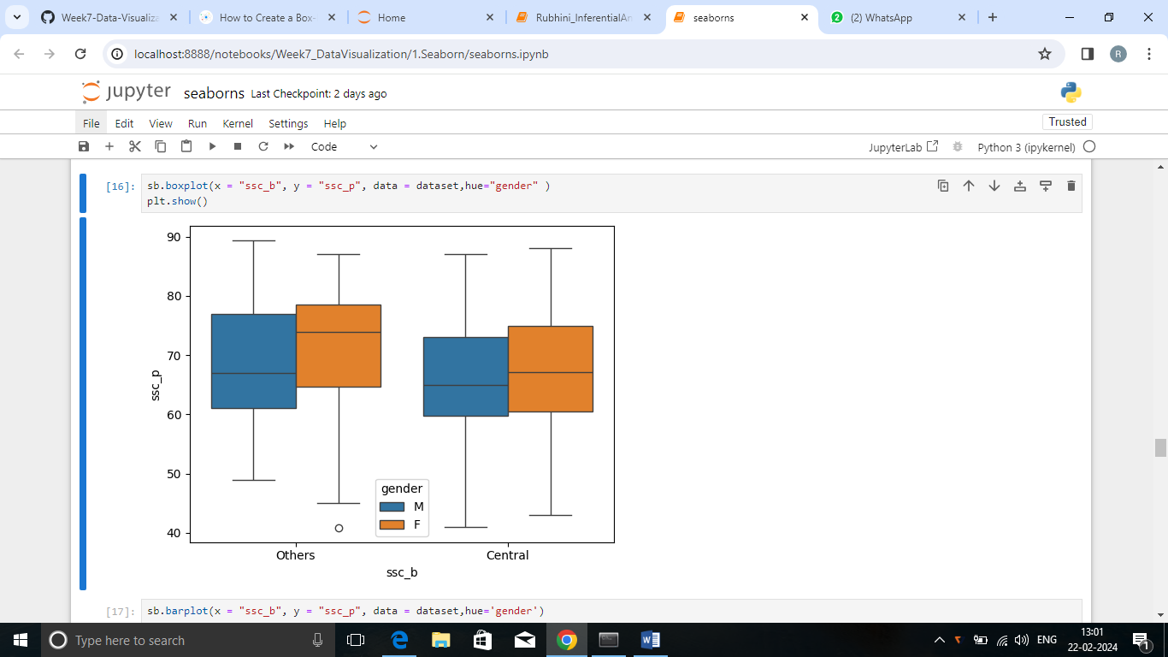

From the above plot, the performance of both ssc boards are summarized as follows

Central Board

* Male students scored above 40 in the exam
* Female students scored above 44 in the exam
* 50% of male students scored below 63 marks
* 50% of female students scored below 70 marks
* 25%-75% 0f male students scored between 60-75
* 25%-75% 0f female students scored between 61-78

Other Board

* Male students scored above 48 in the exam
* Female students scored above 45 in the exam
* 50% of male students scored below 67 marks
* 50% of female students scored below 75 marks
* 25%-75% of male students scored between 60-77
* 25%-75% of female students scored between 65-78

As a conclusion, other board students performance is good compared to the central board. Most of the female students performed well in both the boards.