Seaborn – Swarmplot

A Swarmplot is a powerful visualization tool in python that allow us to visualize the distribution of categorical data points in a dataset.In a swarmplot, each data point is represented as dot.

Swarmplots can be particularly useful when visualizing datasets with relatively small number of data points.

In swarmplot one attribute is continuous and the other one is categorical.

**Advantages**

1. Swarmplots are great for visualizing small to medium sized datasets.
2. They allow to see the distribution of points with categories.

**Disadvantages**

1. They can become cluttered and difficult to read large datasets.

Placement Dataset (Placement.csv)

In the dataset given below there is 215 rows and 15 columns which gives the record of students placement data. To analyse the ssc_p mark with respect to the gender of students(categorical value) swarmplot can be used.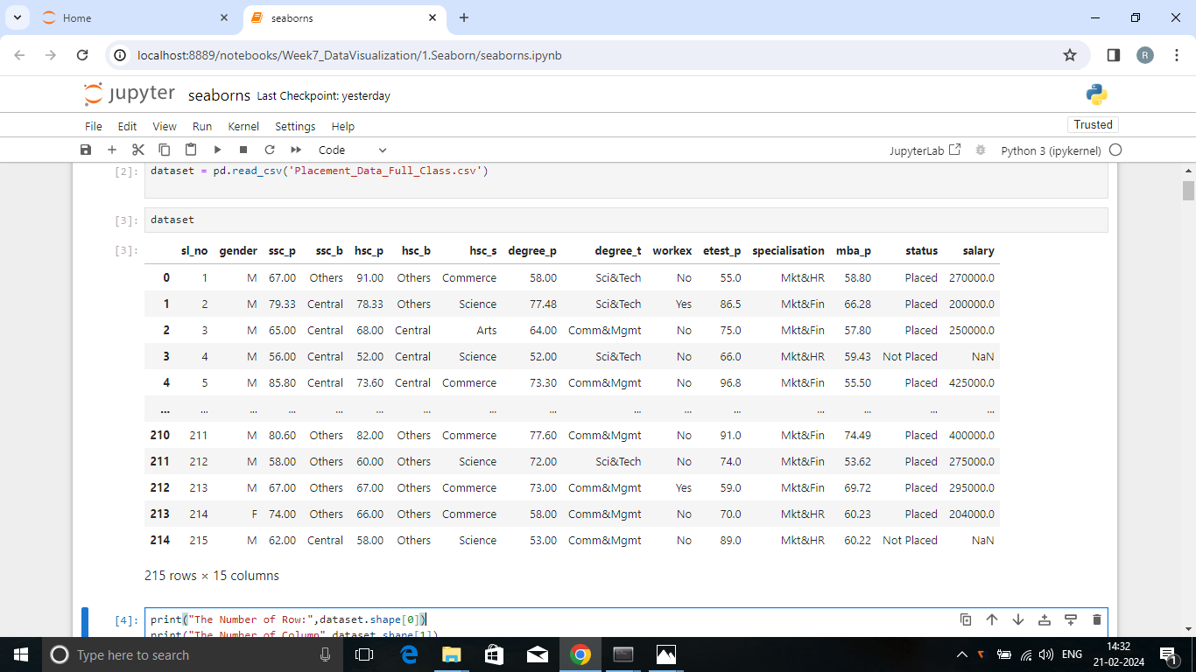

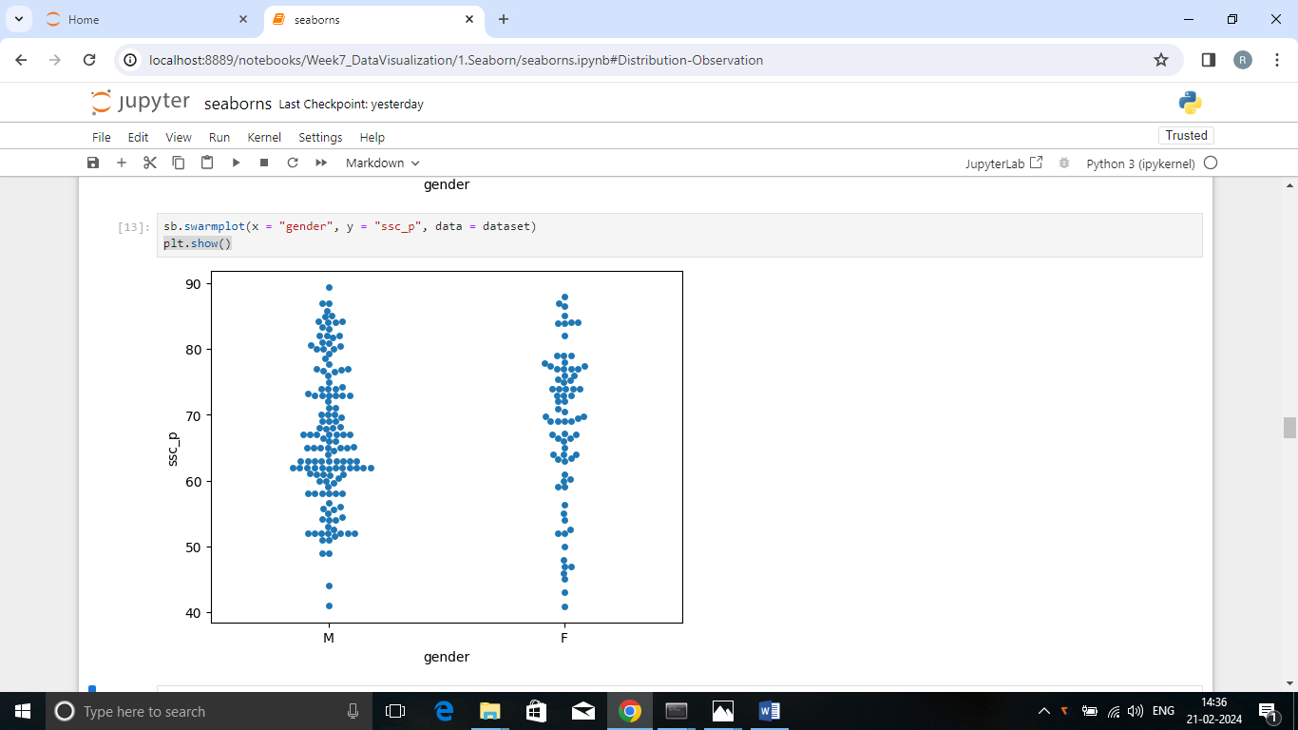

In this plot, we are visualizing the distribution of ssc_p marks across two different genders (M –male & F-female). The resulting swarmplot shows each individual data points as a dot, with non-overlapping points forming columns along the categorical axis.

**Summary**

* From the above plot, we analysed that the top most mark have been achieved by a male .
* Only two male got marks below average all others are above average marks.
* Female students performance are not good when compared to the male students academic performance.
* Nine Female students have got above 85 marks.
* Most of the female students obtained marks above 70.
* More number of male students got mark from 60-70.