# **VIOLIN PLOT**

A violin plot is a method of plotting numeric data and visualizing the probability density of the data at different values. It is similar to a box plot, which displays the distribution of data across different categories, but with a rotated kernel density plot on each side.

**Advantages**

1. Violin plots provide a clear visual representation of the distribution shape.
2. Violin plots offer a comprehensive view of the data's central tendency and spread.

**Disadvantages**

1. Violin plots may become cluttered and difficult to interpret when visualizing very large datasets or when there are too many categories or groups being compared.
2. Violin plot may be difficult to compare exact numerical values, especially if the plot is densely populated or if there are multiple overlapping violins.

**Placement Dataset**

Placement dataset gives details of the students with their exam marks and their placement details with salary.

In the below dataset, two columns “specialization” and “salary” has been chosen to visualize the distribution of salary across different categories (specialization with respect to gender).

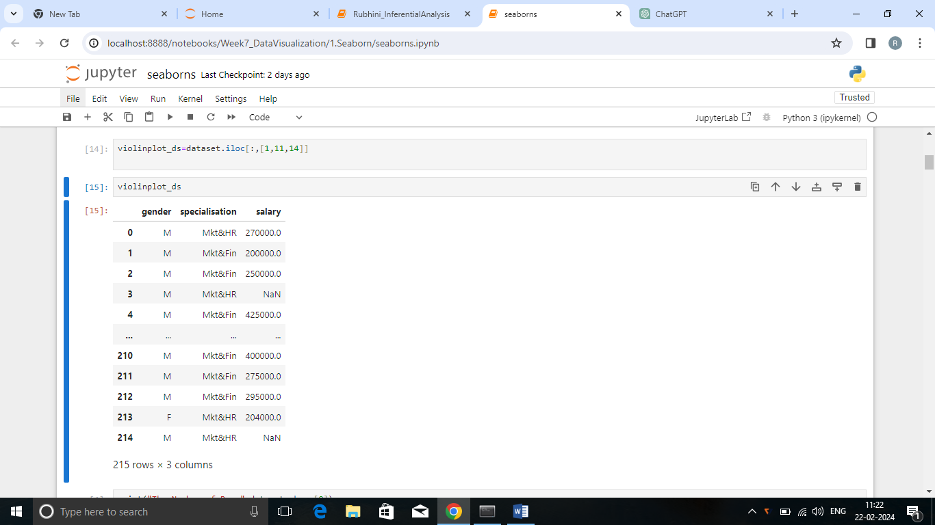

Here is the plot,

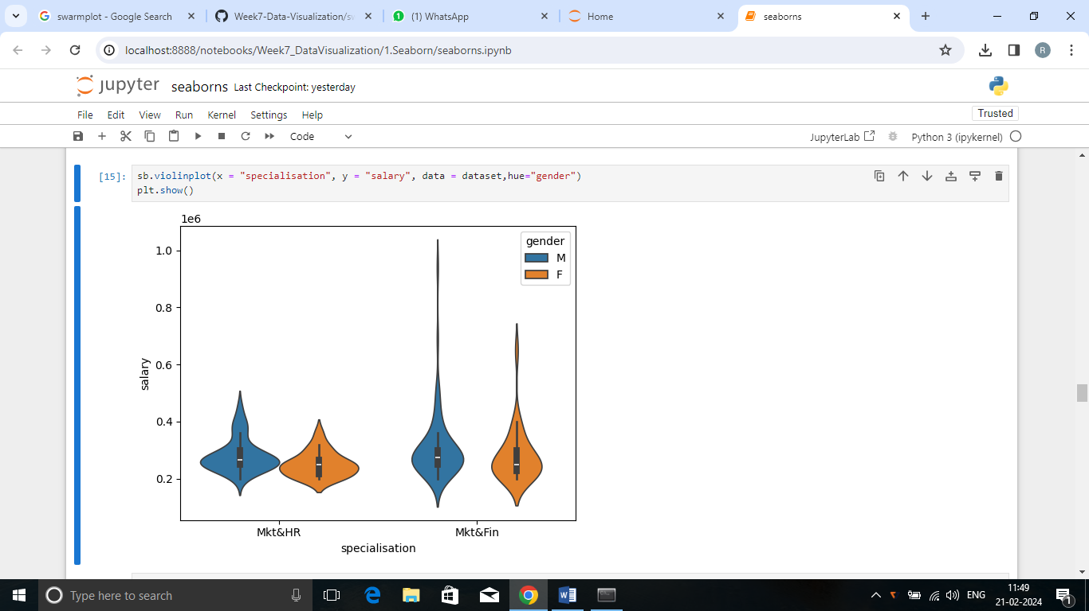

## Summary

## Marketing and Finance

* Male gender earned 10 lakhs which is the highest salary range.
* The highest salary range of female is nearly 7.8 lakhs
* Highest and lowest salary range has been earned by male.
* Most of the female earned salary between 2 lakhs to 3.5 lakhs.
* Most of the male earned salary between 2.5 lakhs to 3.5 lakhs
* In female, no one earned salary above 7.5 lakhs.

Marketing and HR

* Male gender earned 5 lakhs which is the highest salary range
* The highest salary range of female is nearly 4 lakhs
* Highest and lowest salary range has been earned by male.
* Most of the female earned salary between 2 lakhs to 3 lakhs.
* Most of the male earned salary between 2.5 lakhs to 3.5 lakhs
* In female, no one earned salary above 4 lakhs.

As a conclusion, some person in the Marketing and Finance domain earned higher salary and most of them earned lower salary .In the Marketing and HR category , all of them received lower level salary.