Recursive Feature Elimination Classification Report

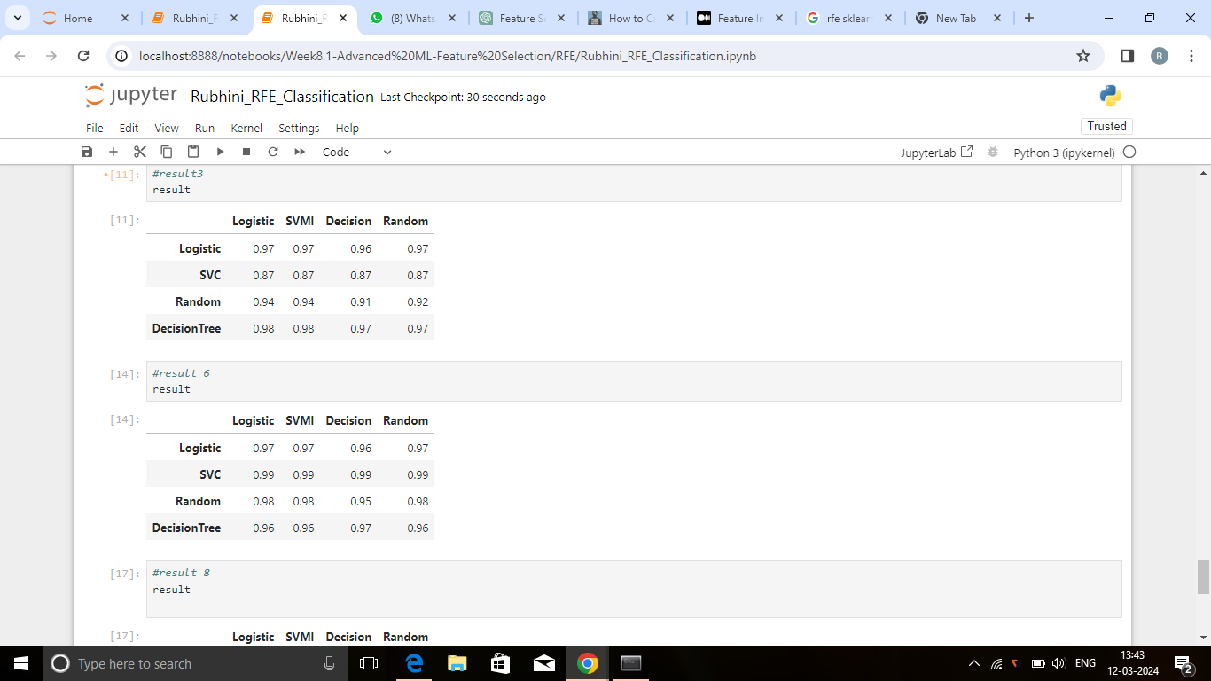

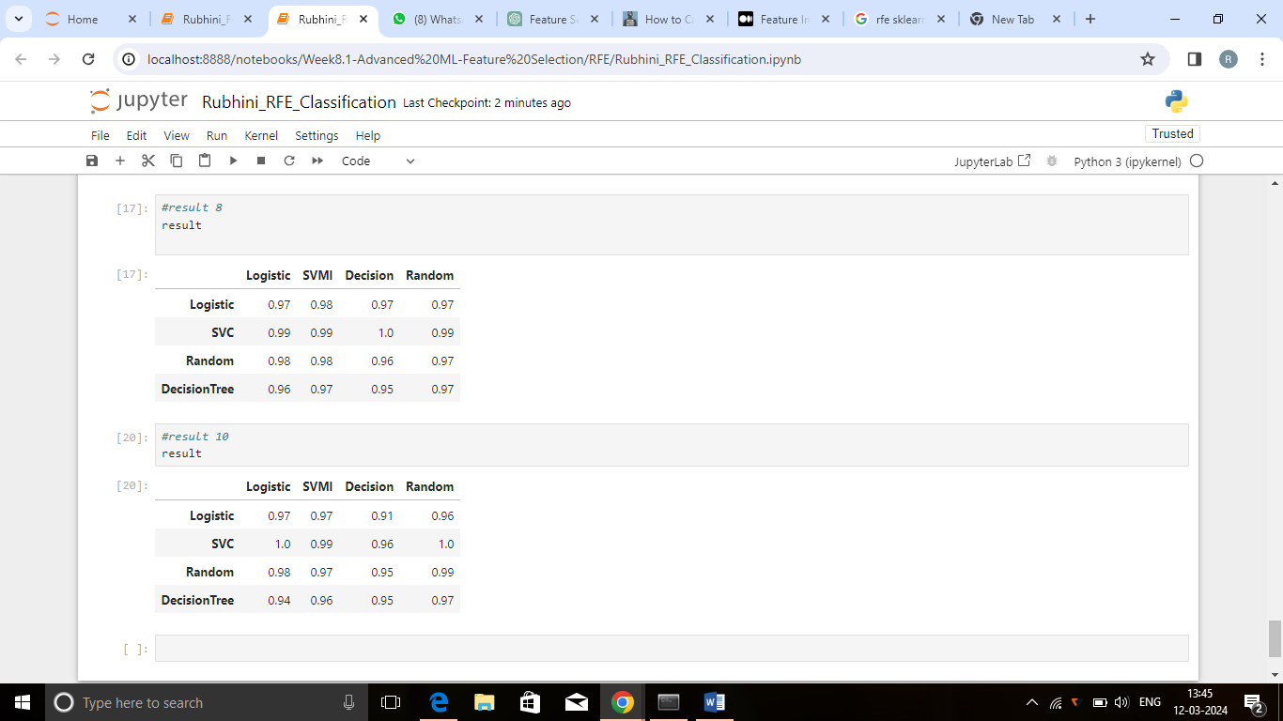

From the above report , the number of feature variables (n= 3, 6,8,10) are tested with the Recursive Feature Elimination function to get the top most features to predict the target variable.

Here, all the independent variables (27 columns) are tested and the top most features are retrieved to train the model and to get the predicted target .

The above report shows the accuracy of each algorithm in classification towards the target value. Hence, by analysing the accuracy of algorithms n=8 (ten input features) is chosen and all the remaining least important features are removed.

While choosing n=8 as the desired input features the accuracy scores are high compared to the other number of selected features such as n=3,5,6,10

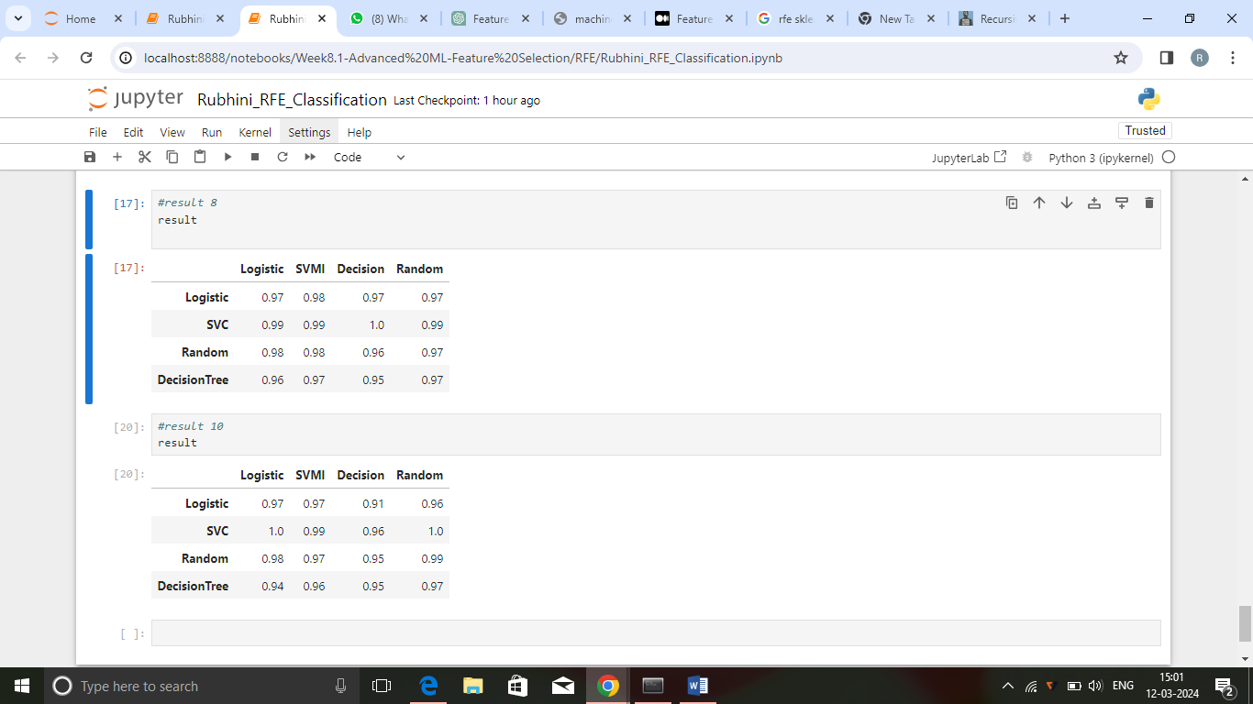

The accuracy score of Logistic Regression is 0.97, 0.98, 0.97, 0.97

The accuracy score of SVML is 0.99, 0.99, 1.0, 0.99

The accuracy score of Decision Tree is 0.96, 0.97, 0.95, 0.97

The accuracy score of Random Forest is 0.98, 0.98, 0.96, 0.97