**SENG 2050 – Programming Assignment**

Alex Rubin, c3486124

2 .…………………………………Requirements

3 ………………………….Sequence Diagrams

5 ……………………………………….. Outcome

7 ……………………………….Implementation

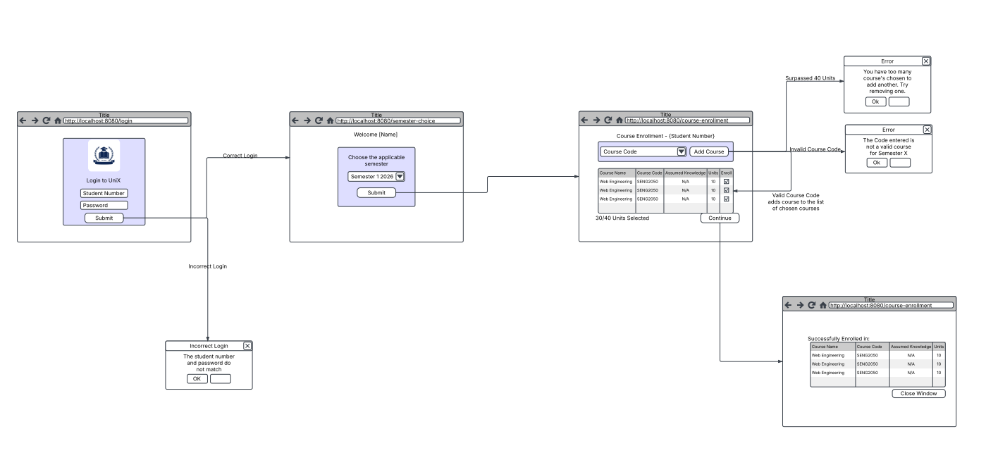**Requirements**

**Design**

* **Semester Sequence Diagram**
  + 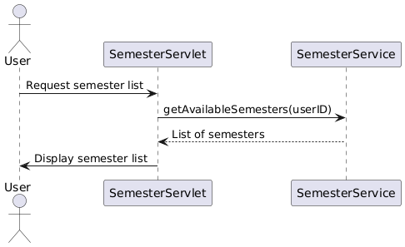
* **Confirm Enrollment Sequence Diagram**
  + 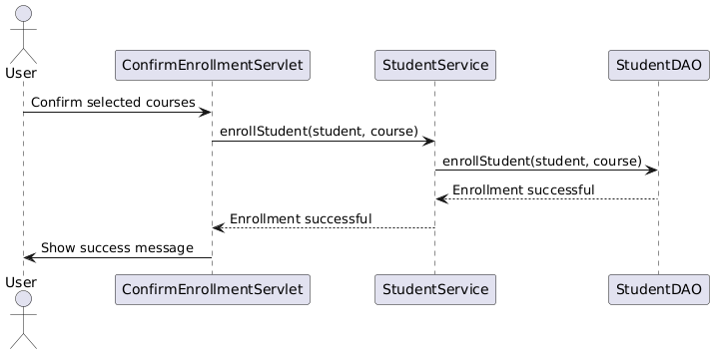
* **Login Sequence Diagram**
  + 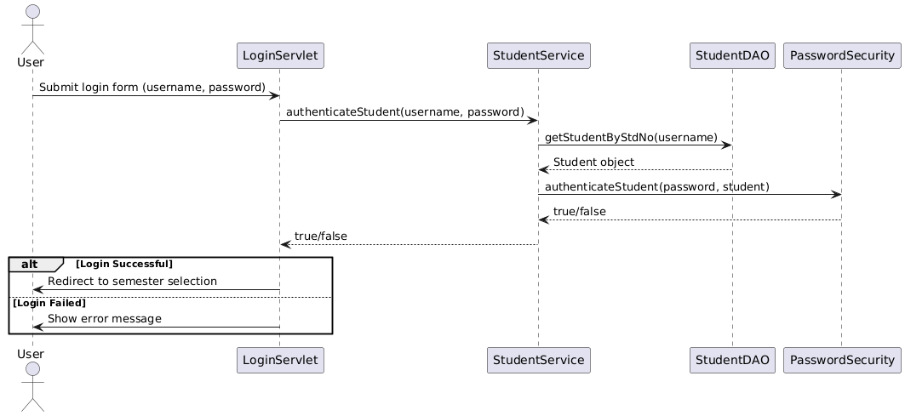

**Outcome: User Manual and GUI**

**Login Process (with addStudent included):**

1. Navigate to ./addStudent
2. Fill in details for student account
3. Press Submit
4. 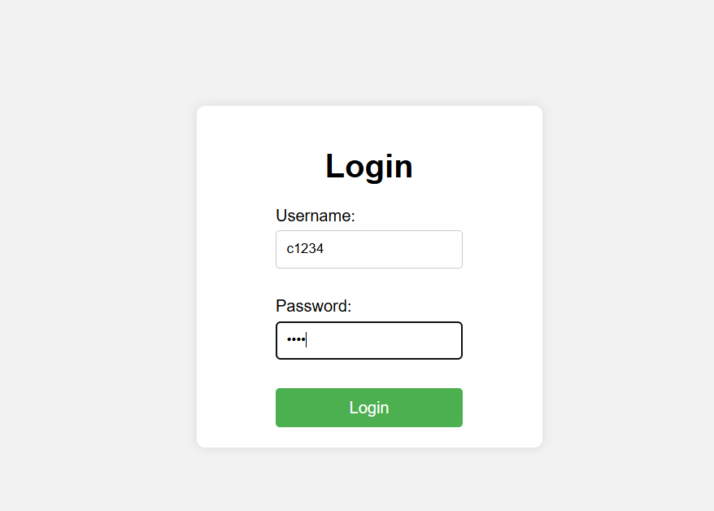Navigate to ./login
5. Fill in newly created Student Number and password
6. A white background with black text

   AI-generated content may be incorrect.If successful, application will automatically redirect, otherwise an error message will appear

**Semester Selection Process:**

1. Select a semester from the drop down box
2. Press continue
3. The application will automatically redirect you

**Course Selection Process:**

1. A white background with black text

   AI-generated content may be incorrect.Select a course from the drop down box or type in a course code
2. A screenshot of a computer error

   AI-generated content may be incorrect.Press the Add course button
3. If a course is full, an error message will appear
4. A white box with black text

   AI-generated content may be incorrect.If you do not meet pre-requisites, an error message will appear
5. A white background with black text

   AI-generated content may be incorrect.If you do not meet assumed knowledge, an error message will appear but the course will still be added
6. A screen shot of a course

   AI-generated content may be incorrect.If you have already exceeded the number of courses allowed, an error message will appear
7. Confirm by pressing the Submit button
8. The application will automatically redirect you to the confirmation page

**Implementation**

<https://github.com/SENG2050-Web-Engineering/programming-assignment-AlexRubin05>