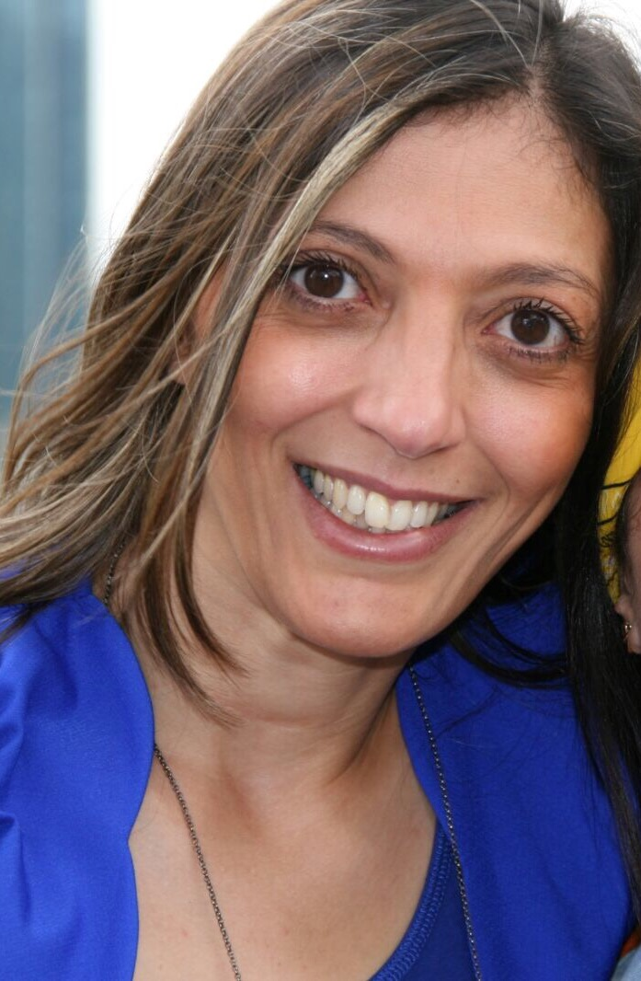
Zakia Draidi
Structural engineer

: (+33)616618106
E-mail:zakia.draidi@gmail.com
15, place nelson mandela, nanterre

FORMATION
2001-2005 PHD of INSA - Lyon speciality Civil Engineer : Structures
« Instability of the cylindrical shells multilayers (steel and composite)
  - Master 2 Reserche : PHD institut MEGA at INSA - Lyon
« Expirimental and FE studys :buckling of cylindrical shells under combined loads ».
1998-2000 Master 1 Civil engineer : FST Tanger Maroc

FORMATIONS 2016
- Formation RCC-M 2012 : Comprehension of the code of constructution RCC-M
- Conception rules – Dimensionning according to code RCC-M - Materials niv. 2 et 3 - Edtion 2012
- Quality Management System of SOFINEL, Nuclear Safety Culture Awareness» (QMS-SC)
- EPR safty
- Significance of "Activités Importantes pour la Protection" and Quality Related Activities » (AIP-QRA)
- Welding formation
- CDM Regulations Training
- UK Context Awareness
- Introduction to the principes of quality and safty of nuclear
COMPETENCES
- Ancorage methodologie definitions
- Vessels ancarage calculations
- FPSO ancorage calculations
- Structure calculation (Standards and EF)
- Management of the projets,
- Client interface,
- Planification,
- Supliers management
- Supliers qualifications
- ATER in the university INSA-Lyon
EXPERIENCES
Oct2019 to dec 2019 Saipem 3months
Structural engineer Asset
FE and standards calculations of the asset equipements
Abaqus and isymost software
Calculation notes writing

Jun2018 to Feb 2019 Technip-FMC 8months
Structural engineer offshore project Karish
Volumic conception of the cast-lug by isymost
In-place, buckling, transport and lifting calculation of the suction pile
Calculation notes writing

Dec2015 to Nov 2016 SofinelY 1year
Expert Engineer for vessels ancorage EPYC
Ancorage methodologie definitions for projet HPC,
FE calculation and calculation note writing
PDMS interface use
Nov 2014 to janv2015 FMC-TECHNOLOGIE 3months Structural engineer
FE analysis of the structure of the wellhead using workbench
Calculations note review
Mars t o aug 2014 Saipem 6months
Structural engineer Subsea
Conception with Abaqus CAE of the anchoring
Review of technical requests
Calculations note writing
Matis technologie (2010-2013) 3 years
Study engineer
Expertise and review of technical requests for PSA , BMW, air liquide, Hamendant PG-PEME- GOURDIN
FE analiysis using Abaqus
Calculations note and procedures writing

Veolia-Water (2009-2010) 1 year
Developement and standardisation engineer
Technical specifications writing for data base of PDMS interface

Technip (2007-2008) 1.2 years
Study Engineer subsea- projects AKER MAD6 and Azurite
Realisation of the technical specifications,clients qualifications,FE calculations, team and supliers management

Acergy (2006-2007) 1 year
Project engineer – offshore-project grater plotonio
FE analysis with ABAQUS for rgide pipe line, response to bid, standards use for hand calculations.

INSA-Lyon (2001-2005 4years
Reserche Engineer
Conception and calculation FE of the cylindrical shells multilayers(steel composite).
Buckling study of the cylindrical shells under combined loads, experimental and numérical approch.
Attaché Temporaire d’Enseignement et de Recherche ATER in the university INSA-Lyon
de Lyon 2004-2005.

TECHNICALS SKILLS
- Standards : ASME, API, RCCM2012, DNV and AISC
- FE sofware : Abaqus, CAE, Hypermesh et Ansys workbench Isymost, PDMS( consultation)
- Anglais : Good level
- Espagnol : Notions
OTHERS
Swiming, danse, jogging, theatre and travels.

.

