First name: SAADA
Name: OUMAR DARAR

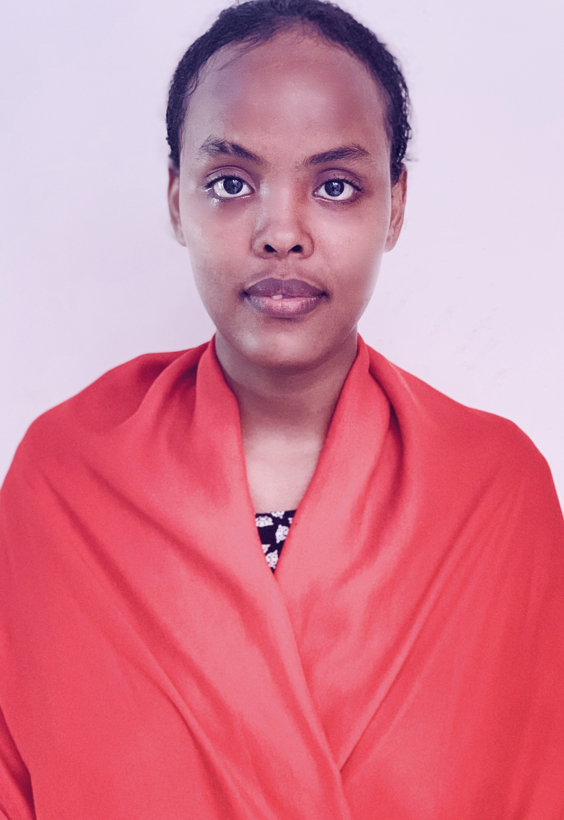

E-mail: Ousaada6@gmail.com
Tel: 21 34 54 59 or 77 28 60 69
Adresse: Djibouti-Ville

©AZURIUS – Modelos-de-curriculum.com

P R O F I LE
Skills
Graduated from a university in computer science and telecommunication, in Senegal in Dakar. I have already done a lot of internship in banks as well as in the only telecommunications company in Djibouti. These internships were renumerated. I am currently looking for a new experience in this field and your agency is a goal for me.
- Stagiaires

DJIBOUTI TELECOM - Djibouti
Sept. 2022 – Dec. 2022
à ce jour
à ce jour

EXIM BANQUE Djibouti - ville
Du 02 fev – 10 Juillet 2019
à ce jour
à ce jour

Education

- Licence professionnelle (LP) Informatique

Université d’ESTIM (école supérieure télécommunication d’informatique et de management), SENEGAL/Dakar
SKILLS
Aout 2019 – Aout 2022
- Microsoft (Excel, Word, PowerPoint, Outlook etc…)
- Teamwork, effective time management, leadership.
- Computer skills
- Quick-learning adaptabilities
- Sciences Economie et Sociales

Septembre 2017 – juin 2018
LYCEE DE GABODE Djibouti-ville

- Laureat Institute (Certificate in English)
Date Mai 2016

Benevola
L A N G U E S
Center of interest

Programming

Sports & Reading

- Benévola in the center for entrepreneurship in Djibouti
02 JUIN 2019 au 19 Decembre 2019
French: High level
English: Intermedaite level
Arabic: Intermédiate level.

- The Références
“Les miserables” by Víctor Hugo
“L etranger” by Albert Camus
"Intouchables" directed by Olivier Nakache et Éric Toledano
"La Haine" directed by Mathieu Kassovitz

