MERCHANT MARINE OFFICER  (MASTER MARINER F.G UNLIMITED LICENSE )  ADDRESS: 3 Ibrahim Fathy Street, Gleem, Alexandria, Egypt.  CONTACT NO:  +201224280742/  +201008478431  Email: captain_ahmed34@yahoo.com | 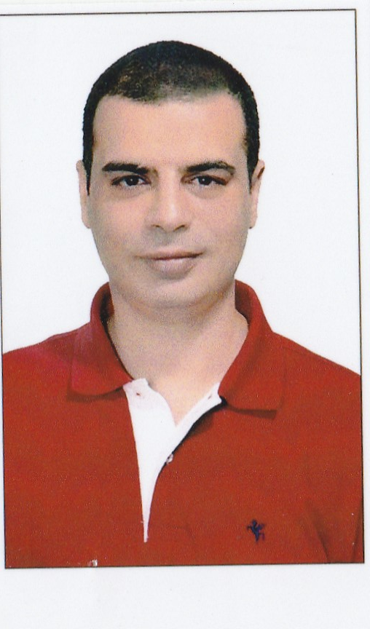  NAME:  AHMED ALY ISMAIL MOHAMED  POSITION APPLIED FOR:  2ND OFFICER
PERSONNEL INFORMATION  NATIONALITY: EGYPTIAN  DATE OF BIRTH: 08/11/1976  Status: Single  Languages:  Arabic: Mother Tongue  English: V. Good  NEAREST AIRPORT:  (HBE) ALEXANDRIA BORG EL ARAB AIRPORT | - SEAMAN PASSPORT:  - NO: S00025716  - ISSUED:29/09/2022  - DATE OF EXPIRY: 08/08/2027  - PASSPORT: NO: A23170042  - ISSUED:07/08/2018  - DATE OF EXPIRY: 06/08/2025
EDUCATION & COURSES & CERTIFICATES  GRADUATED FROM ARAB ACADEMY FOR MARITIME TRANSPORT IN ALEXANDRIA 2 YEARS NAUTICAL STUDIES WITH MERIT EXCELLENT (GPA:3.82/4.00).  - MASTER MARINER LICENSE F.G UNLIMITED (2008).  - CERTIFICATE IN SHIP MANAGEMENT FROM LLOYDS MARITIME ACADEMY “UK”.  - CERTIFICATE IN MARINE SURVEYING (CONDITION SURVEY HULL & MACHINERY).  - CERTIFICATE IN DPA INCLUDING CYBER SECURITY AND AUDITS OF SAFETY MANAGEMENT SYSTEM.  - ALL STCW CERTIFICATES & ALL PASSENGER/RORO CERTIFICATES.  - DP INDUCTION CERTIFICATE. | SEA EXPERIENCE:  - 21 MONTH AS 2ND OFFICER ON BOARD PRODUCT TANKER (OWNER “ KOTC”)  - 17 MONTH AS 2ND OFFICER ON BOARD VLCC (OWNER KOTC)  - 25 MONTH AS 2ND OFFICER ON BOARD LPG “FULLY REFRIGERATED SHIPS” (OWNER KOTC)  - 4 MONTH AS CHIEF OFFICER ON BOARD CEMENT CARRIER (OWNER VOLOS SHIPPING SERVICES)  - 12 MONTH AS 2ND/3RD OFFICER ON BOARD RORO VESSEL (OWNER DEM LINE EGYPT)  - 9 MONTH AS 2ND OFFICER ON BOARD BULK CARRIER (OWNER CNAN GROUP)  - 4 MONTH AS 2ND OFFICER ON BOARD CONTAINER SHIP (OWNER CMA-CGM )  - MY LAST EMPLOYER KOTC”KUWAIT OIL TANKER COMPANY”  FROM 2009 TO 2022.

