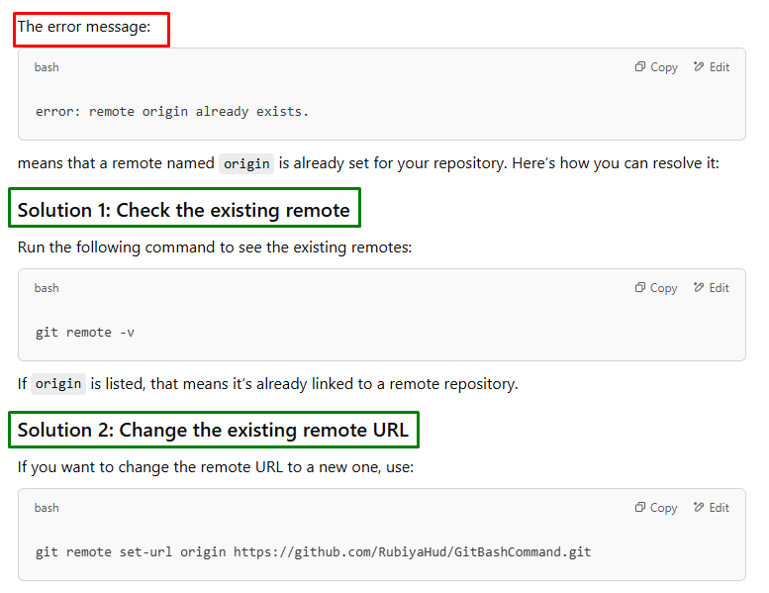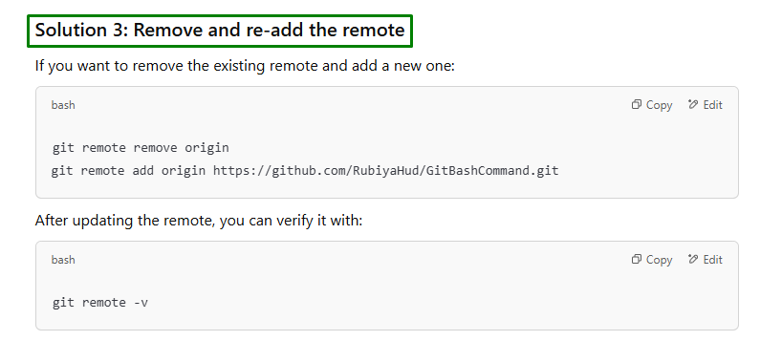

The error message:

error: remote origin already exists.

means that a remote named origin is already set for your repository. Here’s how you can resolve it:

**Solution 1: Check the existing remote**

Run the following command to see the existing remotes:

git remote -v

If origin is listed, that means it’s already linked to a remote repository.

**Solution 2: Change the existing remote URL**

If you want to change the remote URL to a new one, use:

git remote set-url origin https://github.com/RubiyaHud/GitBashCommand.git

**Solution 3: Remove and re-add the remote**

If you want to remove the existing remote and add a new one:

git remote remove origin

git remote add origin https://github.com/RubiyaHud/GitBashCommand.git

After updating the remote, you can verify it with:

git remote -v

Let me know if you need further help! 🚀