how to add a document file in a github repo

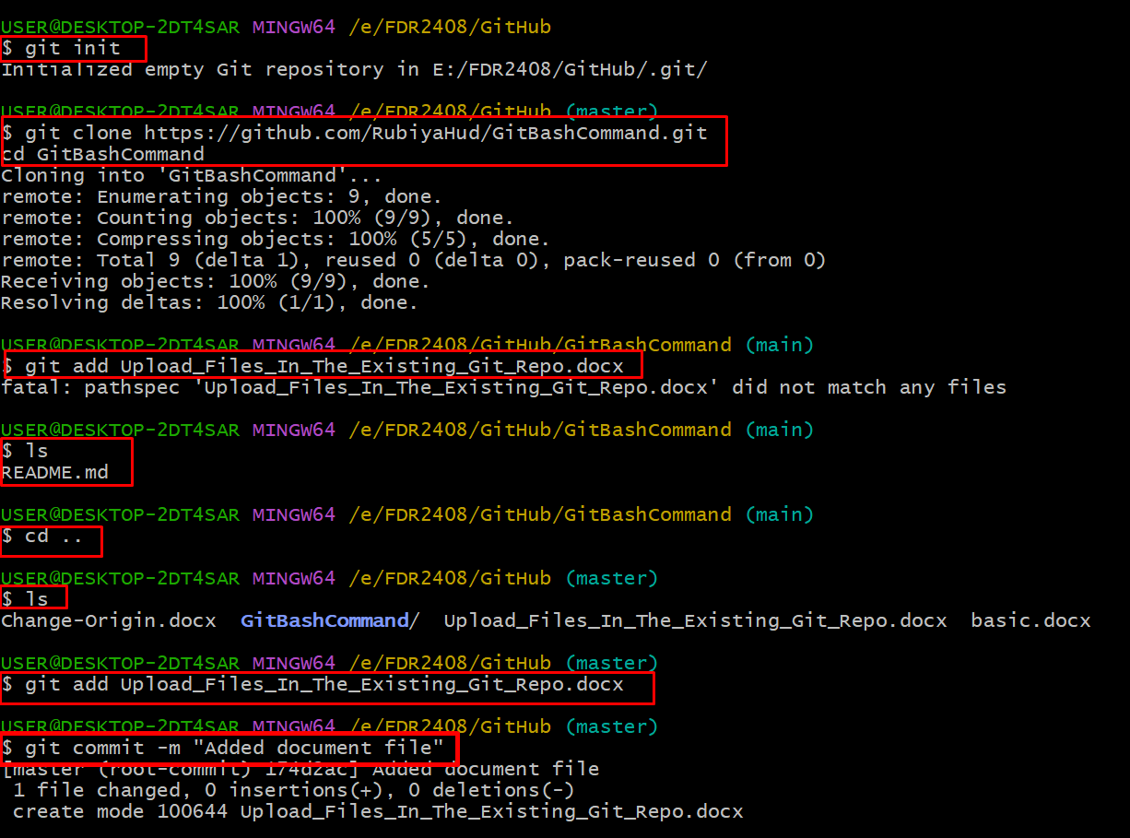

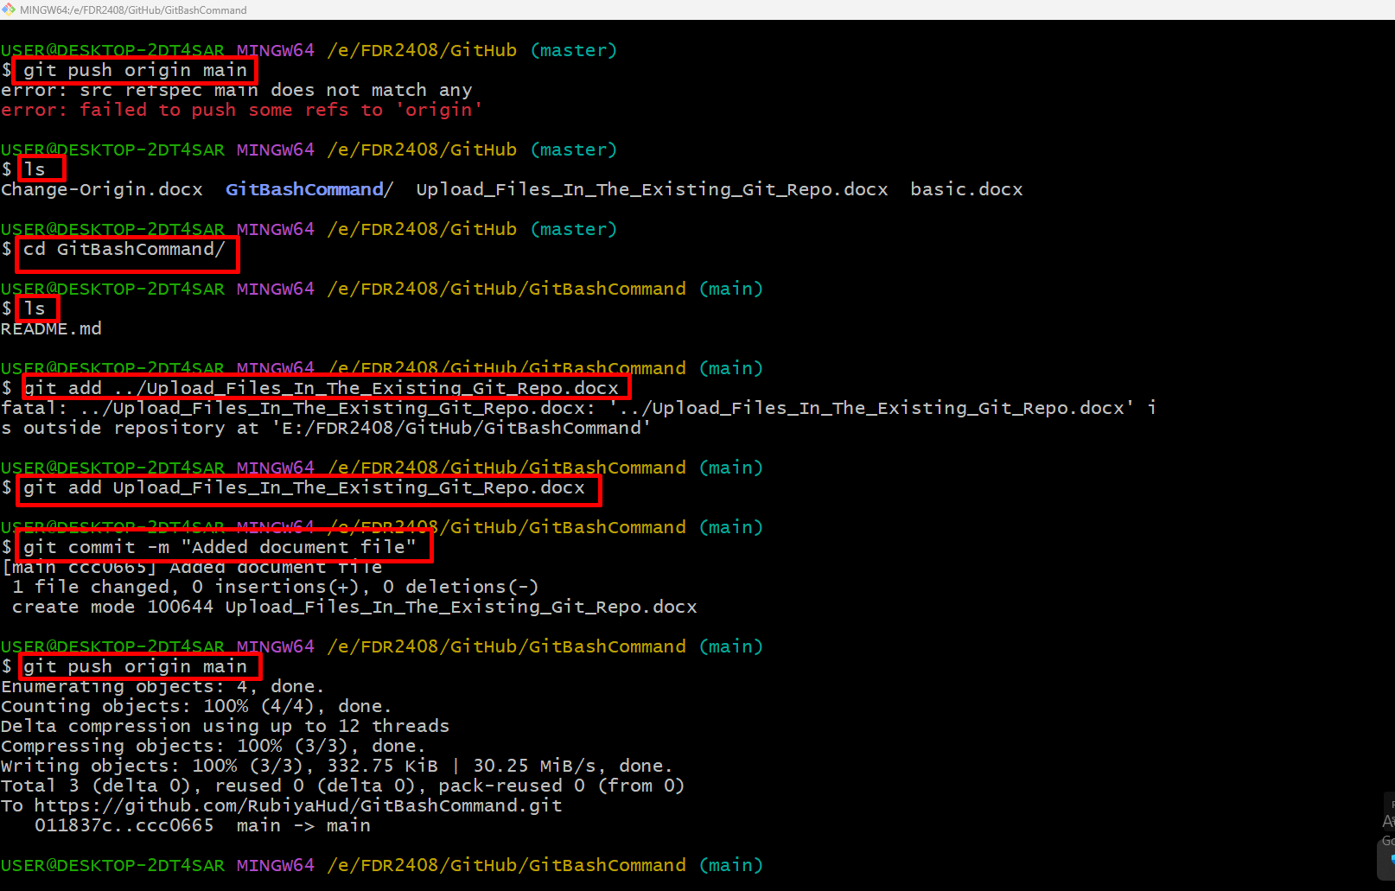

To add a document file to a GitHub repository, follow these steps:

**Method 1: Using GitHub Website**

1. **Go to Your Repository**: Open your GitHub repository in a web browser.
2. **Click "Add file"**: On the repository's main page, click the **"Add file"** button.
3. **Upload the File**:
   * Choose **"Upload files"**.
   * Drag and drop your document file or click **"choose your files"** to select it from your computer.
4. **Commit the File**:
   * Scroll down, add a commit message (e.g., "Added document file").
   * Click **"Commit changes"**.

**Method 2: Using Git Command Line**

**1. Clone the Repository (if not already cloned)**

Open a terminal (or Command Prompt) and run:

git clone https://github.com/your-username/your-repo.git

cd your-repo

**2. Add the Document File**

Copy the document file into the repository folder, then run:

git add your-document-file.ext

**3. Commit the Change**

git commit -m "Added document file"

**4. Push the Changes**

git push origin main

*(Replace main with your branch name if different.)*

**Method 3: Using GitHub Desktop**

1. Open **GitHub Desktop** and select your repository.
2. Copy and paste the document file into the local repo folder.
3. In GitHub Desktop, you’ll see the file listed under "Changes".
4. Add a commit message and click **"Commit to main"**.
5. Click **"Push origin"** to upload the file.

Let me know if you need further help! 🚀