How to upload files in the existing GitHub repository using Git Bash commands?

1. Sign in to the GitHub account
2. Open Git Bash in the project folder
3. Then Type the following commands:

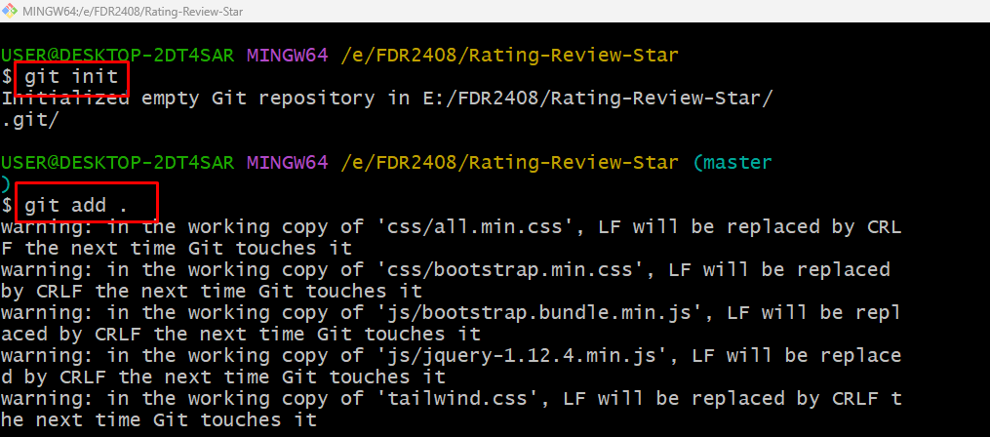

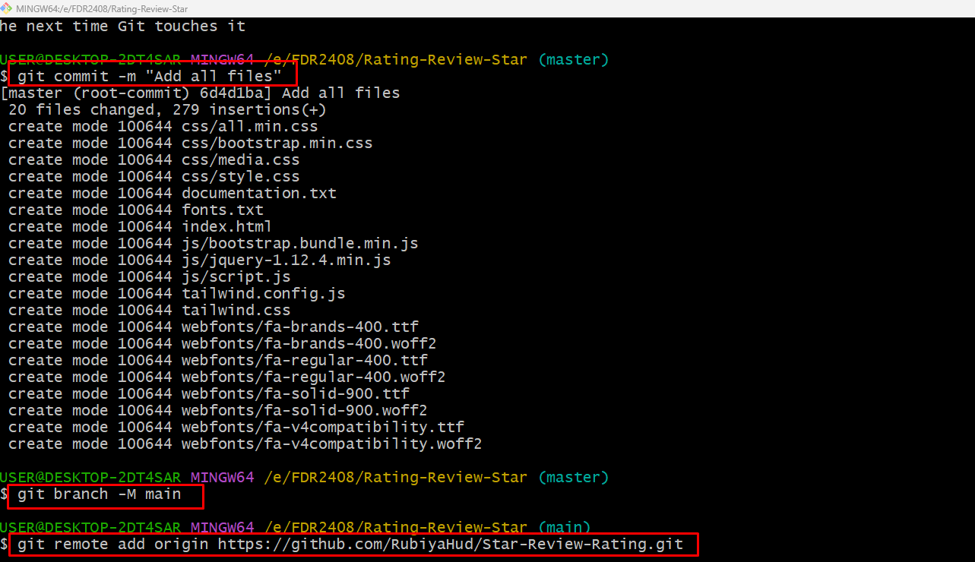

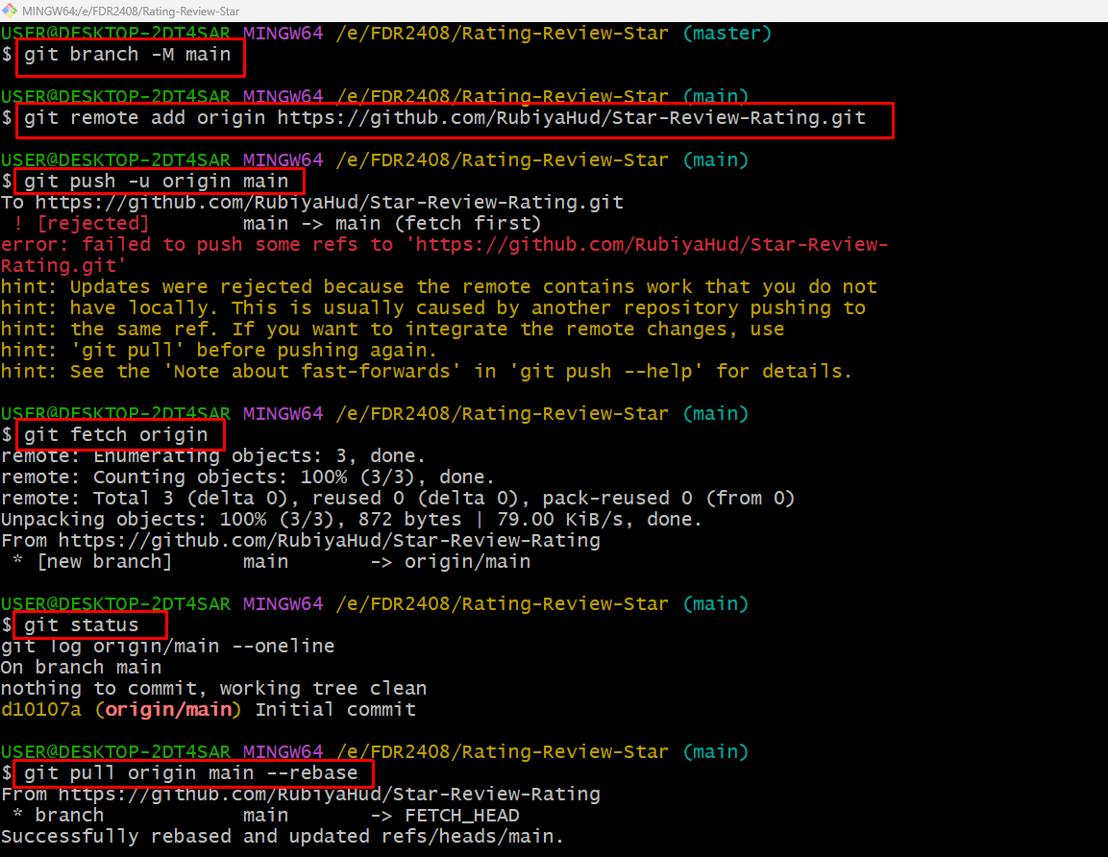

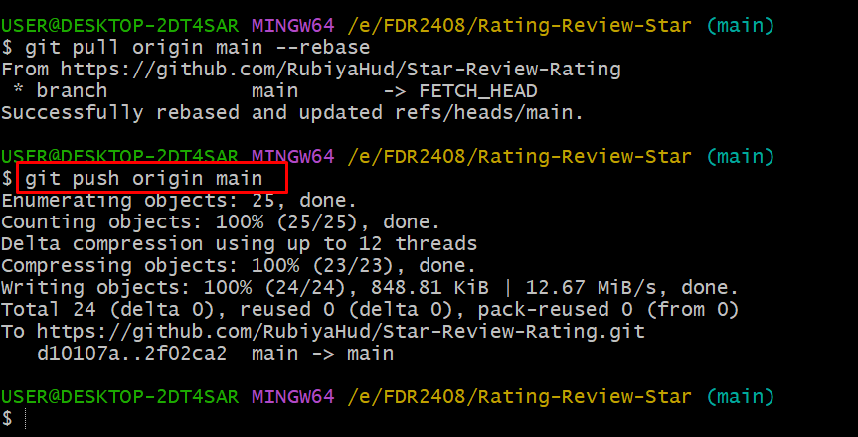

GitHub Problem:

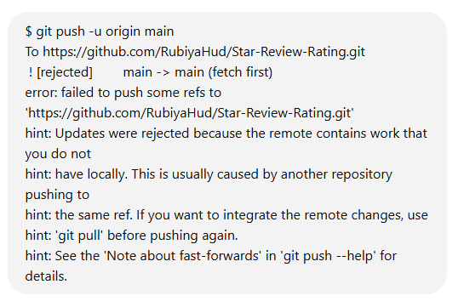

**Solution:**

The error message indicates that your local main branch is out of sync with the remote main branch. This usually happens when there are changes in the remote repository that you don’t have locally.

**Steps to Fix the Issue**

**1️⃣ Fetch the latest changes from the remote repository**

git fetch origin

This downloads the latest changes without merging them.

**2️⃣ Check the differences**

git status

git log origin/main --oneline

This helps you understand what new commits are in the remote repository.

**3️⃣ Merge the remote changes into your local branch**

Try pulling the latest changes before pushing:

git pull origin main --rebase

This fetches the changes and applies your local changes on top of them.

**4️⃣ Resolve merge conflicts (if any)**

If Git reports conflicts, open the affected files, resolve the conflicts, then run:

git add .

git rebase --continue

**5️⃣ Push your changes**

Once everything is merged and conflicts are resolved, push your changes:

git push origin main

If you still get errors, try forcing the push (⚠️ only if you're sure no important changes will be lost):

git push --force origin main