Team 2

IT 492

Assignment 4-T

Prof. Rudin

10/11/22

|  |  |
| --- | --- |
| Qualitative | Quantitative |
| how the client wants the website redesign to look like. | What the intended budget of this project is. |
| where to store the scheduler and how to update it. | What the total cost of this project will be. |
| Chatbot will automatically update to the scheduler. | how much data will be needed. |
| Obtaining client information to store to the database | How much server space will be needed. |
| Where the database will be stored. | How much time will be spent working on this. |

2. Client meetings.

After looking at how much more detailed information we need on the qualitative and quantitative data we hope to set up a minimum of 4 meetings with our sponsor. If possible we would like to be in contact with our sponsor on a weekly or bi-weekly basis through email updating them on our progress and any questions we will have.

3. Information we need confirmed

The information we will need confirmed to start this project is the client's budget, meeting dates,access to data and web services.

4. Meeting Agenda

Our first meeting we will gain information on topics we will need to further improve our knowledge on what needs to be done. The second meeting will consist of us having a detailed timeline of when certain milestones will be met. The third meeting will consist of us updating the client on our progress. The fourth meeting would be similar to the last meeting with just updating the client on our progress.

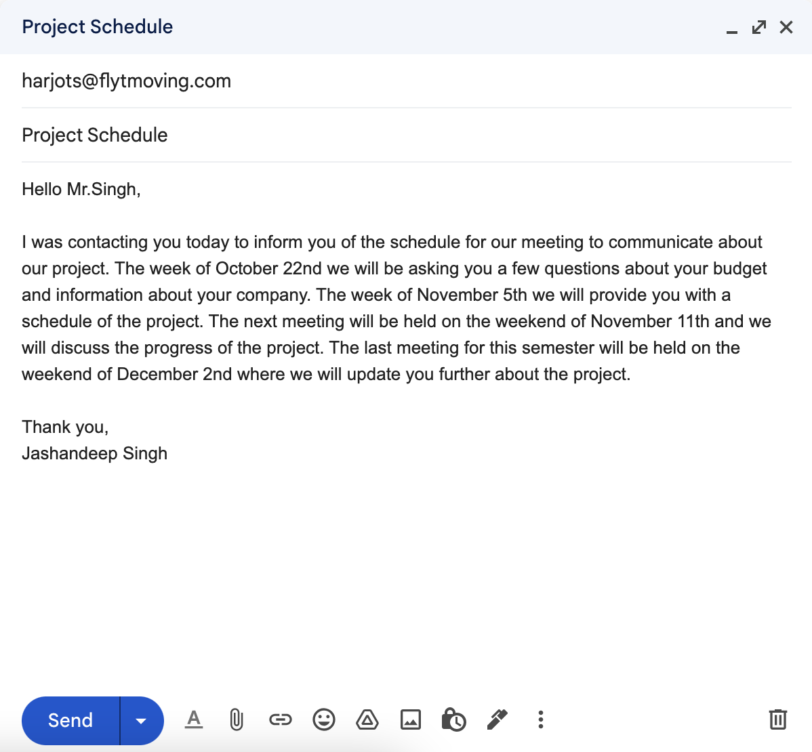

6. Updated Project Plan

* Meet with the sponsor on October 22nd to learn more about budget and company.
* Start planning with team on where to start on project
* Update the sponsor with progress and ask any questions we will have.
* Meet with sponsor on November 5th: asking about the design of the project
* Meet with the sponsor on November 11th: update the sponsor.
* Meet with the sponsor on December 2nd : final meeting with sponsor this semester show them all progress and tell them any concerns we are experiencing.