Supply Chain Management

Software Requirements Specification

Team
Portfolio

Team Members
Ananda.P
Arjun.U.S
Umesh Krishnamurthy Kurdekar
Bhanuprakash.T.M

Project Guide
Mrs. Mamatha

State name: Karnataka

Index & Tables

1) Introduction: ...................................................................................................................3
1.2) Purpose: . . ......................................................................................................................3
1.2) Scope:..............................................................................................................................4
1.3) Abbreviations:.................................................................................................................5

2) References: .......................................................................................................................6

3) Technologies:....................................................................................................................6

4) Process Logic:..................................................................................................................7

5) Software Interface:...........................................................................................................8

6) Hardware Interface: ........................................................................................................8

7) Use-case diagram: ...........................................................................................................9

8) Class Diagram...................................................................................................................10

9) Architecture diagram:...................................................................................................11

10)Database:………...............................................................................................................13

1. Introduction

Supply chain is a generic term incorporates a set of business solutions, many of which are also relevant to business situations which Indian businesses face almost everyday because of infrastructure and communication constraints. Normally product development and test-marketing is a long process as a objectives and the considerations of the design, purchase and engineering departments are different and it is difficult to co-ordinate with the vendors for new parts. A solution may enable the designer to now the cost of different components so that a more cost-effective product may be design or lesser time taken for development by improving interaction between designer and vender.
Sell side solutions may improve distribution net work planning by enabling simulated scenarios for factory and distribution centre locations forecast collaboration, promotion planning campaign management and ordered management can be done through a sell improved root and container load planning. A ‘bye side’ solution enables superior supplier commodity and contract management, material rationalisation, catalogues and contain service.

1.1 Purpose :
Supply chain management the main purpose is to achieve twin goals i.e. cost reduction and service enhancement can be achieved. Business organization will come to recognize the vital impact that logistic management can have in the achievement of competitive advantage. The logistic management increases efficiency, productivity and hence reduced unit costs. The main purpose of this design is to give the proper user interface for supply chain management.

1.2 Scope:

- Market maturity combined with global commutations new sources of global commutations has led to over capacity in many industries leading to an inevitable pressure on price
- Price as always been an critical competitive variable in many markets and the signs are that it will become even more of an issue as commoditization of a market continuous
- Better management of a pipe line means that customer are served more efficiently and at the costs of providing that service are reduced
- Need for supply chain management is to achieve cost reduction twin goals i.e cost reduction and service enhancement can be achieved business organization have come to recognizes the vital impact that logistic management can have in the achievement of competitive advantage
- The participant in supply chain need information about goads movement, order placed and order delivered and payables and receivables
- Supply chain management effectiveness depends on supply chain design i.e evolving structure of production units and their locations, suppliers, Warehouses, and locations, distributors-dealer-retailer channels and customers

1.3 Abbreviations:
- SCM: Supply Chain Management. Supply chain consists of all stages involved in servicing the customer to fulfill the expectation. A supply chain not only includes the manufacture and suppliers but also transporters, warehouse, retailers, and customers themselves.
- EDI: Electronic Data Interchange. EDI is used to link supply chain participants through electronic exchange of documents from one stage to other. The benefit of EDI paperless exchange of information, quick access to accurate in formation and reduced cycle times.
- CRM: Customer Relationship Management with rapid globalization of business and product differentiation becoming less relevant and competitive, customer relationship now is key enabler for moving the business ahead..
- TQM: Total Quality Management. The objective of the TQM in the information systems design is to assure the quality the information.
- ERP: Entrprise Resource planning. The system deals with the planning and use of recourses used in business. The recourses are finance materials manufacturing capacity and human resource.
- J2EE: Java 2 Enterprise Edition is a programming platform— part of the Java Platform—for developing and running distributed multitude architecture Java applications, based largely on modular software components running on an application server.
- DB2: DB2 Database is the database management system that delivers a flexible and cost-effective database platform to build robust on demand business applications.
- EMS: Enterprise Management Systems, It is an integrated ERP, SCM and CRM is also advanced that most of the operational decisions are automated.
- ROI: Return on Investment .It is a rate of return on the invested amount in the business.

- WWW: World Wide Web. It is used to store and information useful for supply chin participants. Web site or portal of the organization has product catalogues, magazines, Pictures, contents and other documents for viewer to access and use in application of the interest.

2. References:

IEEE SRS Format
Supply Chain Management Strategy planning & operation
3rd edition by Sunil Chopra & Peter Meindl

3.Project Development Tools:

J2EE: Application Architecture
DB2: Database
WSAD: Development Tool
WAS: Web Server
RAD: Rational Application Developer
Rational ROSE

4. Process Logic:

Web Client
Web components
HTTP Servlet
Request

HTTP Servlet
Response

Database
HTTP
Request
HTTP
Response
1.
6.
2.
3
5.
Web Server
4.

1. Web client request the web server through a protocol called HTTP (Hyper Text Transfer Protocol) which contains the Servlet that is server side programming sent to the server.
2. HTTP Servlet request sent by the client will be processed by the server and further sent to the web components such as beans.
3. Web components process the Servlet request to the database where the requested data will be fetched or processed from the database.
4. Processed data or fetched data will be combined in the web components by the database.
5. Further the web components sends the data or store the data in form of Servlet called HTTP Servlet response which contains client request.
6. In the final process the HTTP Servlet response will be sent to or served to the client.

5. Software Interface:
Operating System: WindowsXP/Vista, Windows 7
Technologies used: JAVA, J2EE, XML, JavaScript.
Database: DB2

6. Hardware Interface:

Client Side

 | Processor | RAM | Disk Space
Internet Explorer  6.0 | Pentium II at 500  MHz | 64 MB | 1 GB
Server Side

Web sphere  application server  V5.0 | Pentium III at 1  GHz | Pentium III at 1  GHz | 2 GB
DB2 V8.1 | Pentium III at 1  GHz | 512 MB | 1GB (Excluding  data size)

7. Use-case diagram:

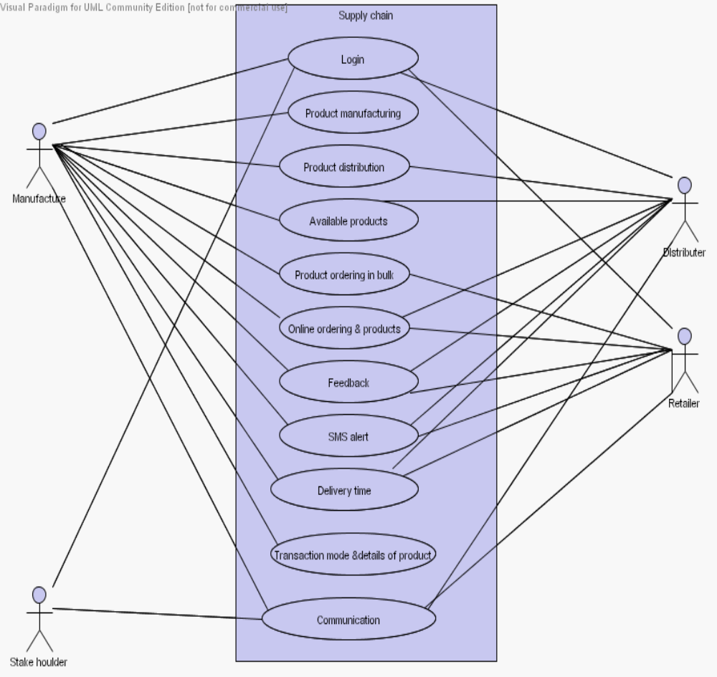

8. Class Diagram:
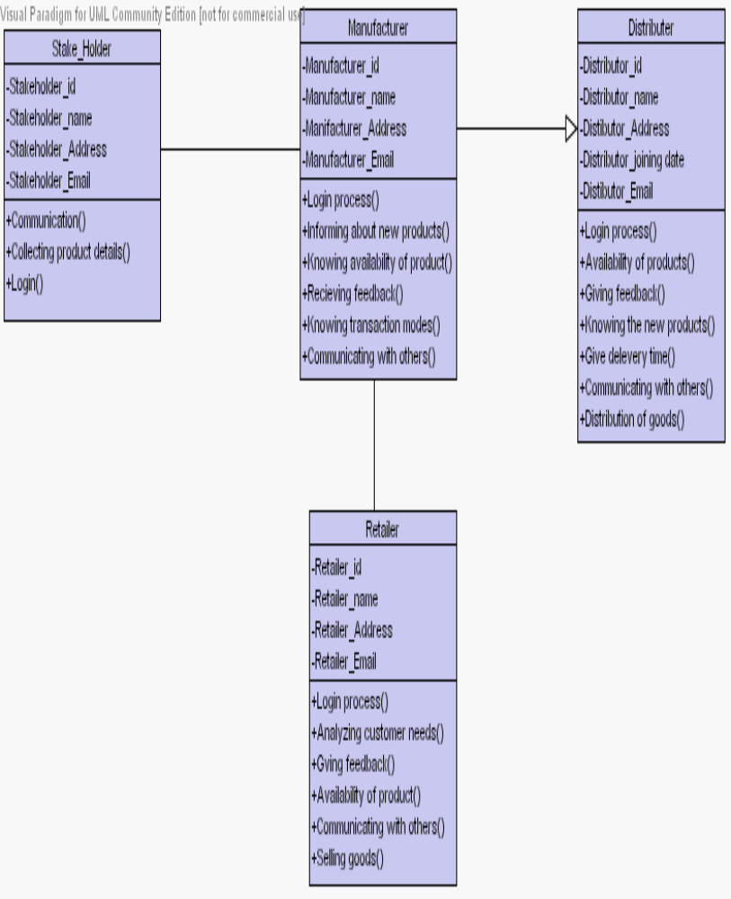

9. Architecture diagram:
Application Layer  User_UI  Role_UI  Permission_UI  Task_UI  Log_UI  Role_UI  Role_UI  Role_UI  Manufacture_UI  Role_UI  Role_UI  Retailers_UI  Product _UI  Distributor_UI  District_UI  Sales_UI  Transaction_UI | Business Layer  Log  User  Role  Permission  Task  Retailers  District  Product  Manufacture  Distributor  Sales  Transaction | Data Layer  Task  Log  User  Role  Permission  Log  Manufacture  Distributor  Product  Retailers  District  Sales  Sales  Transaction

Manufacture
Distributor

Add
products
Feed back
Availability
Price of
products
Transaction
Retailers details
Logout

Transaction
Add and removal of product
Update
View sales details
Price of all items
Logout
Login
Bulk orders
d
No of retailers
Place Orders

Distributor

View price and products
Logout
Login
Feed back
Bulk orders

10. Database:
Manufacture

Manufacture_id
Manufacture_name
Manufacture_addres
Manufacture_joining date
Manufacture_email-id
Manufacture_phone
Manufacture_city
Manufacture_state
Manufacture_country
Manufacture_Zip code
Manufacture_website

District

District_name
Stae_name
Country_name

Have
Transaction

Manufacture_id
Distributor_id
Date
Time
Subject
Imitator
Areasales_manger
Regionalsales_manger
Mode of _transaction
Distributor

Distributor_id
Products_id
Manufacture_id
Distributor_nam
Distributor_addres Distributor_joining date Distributor_email-id
Distributor_ District
Distributor_phone Distributor_city Distributor_state Distributor_country Distributor_Zip code
Distributor_website

Service

Service_id
Service_Description
Service_price
Service_Duration
Service_support facility

Retailer

Retailer_id
Distributor_id
Retailerr_nam
Retailer_addres Retailer_joining date Retailer_email-id Retailer_ District Retailer_phone Retailer_city Retailer_state Retailer_country Retailer_Zip code
Retailer_website

Products

Products_id
Manufacture_id
Products_name Products_type Products_quantity Products_price
Products_Discription
Products_guaranty Products_status Products_launching date

Have
SLA_Service

Service_id
Manufacture_id

