**Flowchart**

Flowcharts are graphical representation of data or algorithm for better understanding of code visually. It displays step by step solutions to a problem or algorithm.

|  |  |
| --- | --- |
| **Name** | **Representation** |
| Terminal |  |
| Process |  |
| Decision |  |
| Input / Output |  |
| Flow Arrow |  |
| Connector |  |

Problem 1: Finding whether a number is Palindrome

START

Reverse=0 tempNum=num

t

tem

te

Read num

Num !=0

NO

STOP

palindrome

Reverse=tempnum

nm

Rem=num%10

Reverse *=10+rem

Num =num/10

YES

YES

NO

Not palindrome

**PSEUDOCODE :**

BEGIN

READ number to check as num

SET s=0

SET t=n

WHILE num!=0 DO

r=num%10

s=s*10 +r

num=num /10

ENDWHILE

IF num==t

DISPLAY num is palindrome

ELSE

DISPLAY num is not a palindrome

ENDIF

END

2. Binary Search Algorithm

Array[mid]==key?

Key is found at indexmid of array

Start=mid +1

End =mid-1

Mid=(start+end)/2

Start<=end?

Start=0

End=size of the array

no

yes

yes

Array[mid]>key?

yes

no

2.PSEUDOCODE:

BEGIN

* *Divide the search space into t*

Divide the search space into two halves

Compare the middle element of the search space with the key.

If the key is found at middle element, the process is terminated.

If the key is not found at middle element, choose which half will be used as the next search space.

If the key is smaller than the middle element, then the left side is used for next search.

If the key is larger than the middle element, then the right side is used for next search.

This process is continued until the key is found or the total search space is exhausted.

END

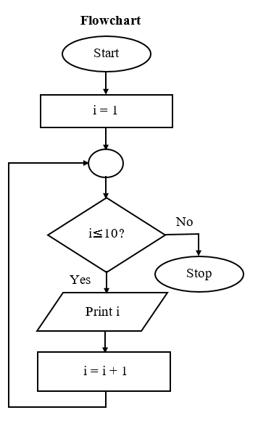

3.Sum of series

3.PSEUDOCODE

Start

Let i=1

If (i ≤ 10), then go to step-4,

          Otherwise go to step-6

Print value of i

i=i+1 and again go to step-3

Stop

4.FLOWCHART

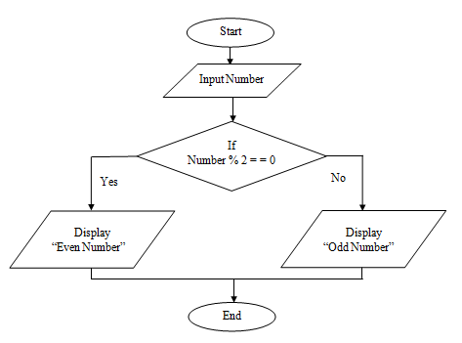

4.Pseudocode

START

DISPLAY "Enter the Number - "

READ number.

IF number MOD 2 = 0 THEN.

DISPLAY "Number is Even"

ELSE.

DISPLAY "Number is Odd"

END IF

5.Reverese the string

 Convert the input string into character array by using the toCharArray() built in method of the String Class .  
 In this method we will scan the character array from both sides , that is from the start index (left) as well as from last index(right) simultaneously.  
 Set the left index equal to 0 and right index equal to the length of the string -1.  
Swap the characters of the start index scanning with the last index scanning  one by one .After that  increase the left index by 1 (left++) and decrease the right by 1 i.e (right--) to move on to the next characters in the character array .

Continue till left is less than or equal to the right .

5.FLOWCHART

