**Supplementary Information - 1**

**Multi-Objective Modeling framework for Environmental flow optimization**

**in a River-Reservoir system using Histogram Comparison Approach**

**for estimation of Hydrologic Alteration**

**Ruby Jose1and Srinivasan K2**

1Research Scholar, 2Professor (Retd.), Department of Civil Engineering, Indian Institute of Technology Madras, Chennai – 600036.

Corresponding author: Ruby Jose. J ([rubyphdwork@gmail.com](mailto:rubyphdwork@gmail.com))

Address: Department of Civil Engineering, IIT Madras, Chennai 600036, India.

**Case Example**

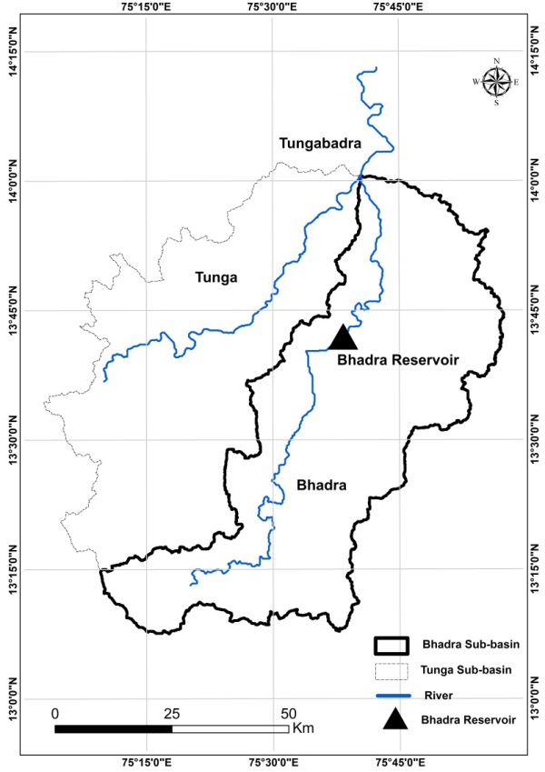

Fig. S-1.1: Location map of the Bhadra river-reservoir system

(Delineated from SRTM DEM using ARC-GIS 10.2.2)

Table S-1.1: Mean monthly inflows and monthly Irrigation target demands (×106m3).

|  |  |  |  |  |  |  |  |  |  |  |  |  |
| --- | --- | --- | --- | --- | --- | --- | --- | --- | --- | --- | --- | --- |
|  | *Jun* | *Jul* | *Aug* | *Sep* | *Oct* | *Nov* | *Dec* | *Jan* | *Feb* | *Mar* | *Apr* | *May* |
| *Mean Monthly*  *Inflow* | 243 | 771 | 820 | 323 | 209 | 100 | 48 | 27 | 15 | 10 | 11 | 18 |
| *Irrigation Target Demand* | 12 | 65 | 185 | 159 | 126 | 156 | 31 | 125 | 142 | 216 | 173 | 70 |

Table S-1.2: Selected PCs and indicators chosen from each PC of PCA based on the simulation results from HCA.

| **Indicator of HA** | **PCs with λ > 1** | | | | |
| --- | --- | --- | --- | --- | --- |
| **PC 27** | **PC 28** | **PC 29** | **PC 30** | **PC 31** |
| *Eigen values (λ)* | *1.10* | *1.46* | *2.16* | *9.14* | *13.35* |
| MM of June | 0.15 | 0.05 | 0.06 | 0.16 | 0.23 |
| MM of July | 0.29 | 0.01 | 0.11 | 0.10 | 0.21 |
| MM of August | 0.39 | 0.25 | 0.01 | 0.27 | 0.05 |
| MM of September | 0.01 | 0.00 | 0.03 | 0.01 | 0.26 |
| MM of October | 0.00 | 0.00 | 0.02 | 0.01 | 0.27 |
| MM of November | 0.13 | 0.10 | 0.02 | 0.07 | 0.25 |
| MM of December | 0.01 | **0.62** | 0.25 | 0.04 | 0.14 |
| MM of January | 0.06 | 0.10 | 0.06 | 0.03 | **0.27** |
| MM of February | 0.10 | 0.02 | 0.12 | 0.04 | 0.27 |
| MM of March | 0.01 | 0.27 | 0.18 | 0.27 | 0.08 |
| MM of April | 0.08 | 0.10 | 0.01 | 0.19 | 0.22 |
| MM of May | 0.21 | 0.13 | 0.09 | 0.25 | 0.15 |
| AMin of 1-day means | 0.00 | 0.08 | 0.14 | 0.13 | 0.23 |
| AMax of 1-day means | 0.06 | 0.23 | 0.32 | 0.27 | 0.02 |
| AMin of 3-day means | 0.09 | 0.10 | 0.03 | 0.22 | 0.17 |
| AMax of 3-day means | 0.16 | 0.15 | 0.34 | 0.19 | 0.14 |
| AMin of 7-day means | 0.13 | 0.03 | 0.04 | 0.15 | 0.24 |
| AMax of 7-day means | **0.45** | 0.08 | 0.06 | 0.29 | 0.00 |
| AMin 30-day means | 0.17 | 0.09 | 0.10 | **0.31** | 0.04 |
| AMax 30-day means | 0.20 | 0.24 | 0.31 | 0.11 | 0.18 |
| AMin 90-day means | 0.34 | 0.09 | 0.11 | 0.25 | 0.12 |
| AMax 90-day means | 0.05 | 0.35 | 0.20 | 0.20 | 0.15 |
| Base flow index | 0.03 | 0.09 | **0.38** | 0.07 | 0.21 |
| Date of minimum | 0.21 | 0.13 | 0.36 | 0.26 | 0.01 |
| Date of maximum | 0.00 | 0.00 | 0.00 | 0.00 | 0.00 |
| Low pulse count | 0.07 | 0.05 | 0.12 | 0.00 | 0.27 |
| Low pulse duration | 0.23 | 0.27 | 0.09 | 0.01 | 0.22 |
| High pulse count | 0.01 | 0.05 | 0.14 | 0.10 | 0.25 |
| High pulse duration | 0.05 | 0.16 | 0.35 | 0.24 | 0.07 |
| Rise rate | 0.34 | 0.10 | 0.15 | 0.30 | 0.01 |
| Fall rate | 0.00 | 0.00 | 0.00 | 0.00 | 0.00 |
| Number of reversals | 0.00 | 0.00 | 0.00 | 0.00 | 0.00 |

*MM – Monthly Median

*AMin-Annual Minima

*AMax – Annual Maxima

Table S-1.3: Selected PCs and indicators chosen from each PC of PCA based on the simulation results from RVA.

| **Indicator of HA** | **PCs with λ > 1** | | | | | |
| --- | --- | --- | --- | --- | --- | --- |
| **PC 27** | **PC 28** | **PC 29** | **PC 30** | **PC 31** | **PC 32** |
| *Eigen values (λ)* | *1.50* | *1.68* | *3.31* | *3.64* | *7.72* | *11.81* |
| MM of June | 0.18 | 0.19 | 0.04 | 0.00 | 0.17 | 0.22 |
| MM of July | 0.03 | 0.03 | 0.13 | 0.41 | 0.19 | 0.00 |
| MM of August | 0.02 | 0.08 | 0.25 | 0.10 | 0.14 | 0.22 |
| MM of September | 0.34 | 0.12 | 0.19 | 0.06 | 0.10 | 0.20 |
| MM of October | 0.05 | 0.37 | 0.08 | 0.21 | 0.15 | 0.13 |
| MM of November | 0.02 | 0.11 | 0.09 | 0.14 | 0.17 | 0.22 |
| MM of December | 0.16 | 0.00 | 0.04 | 0.28 | 0.17 | 0.15 |
| MM of January | 0.13 | 0.04 | 0.15 | 0.09 | 0.14 | 0.21 |
| MM of February | 0.01 | 0.03 | 0.06 | 0.16 | 0.22 | 0.20 |
| MM of March | 0.03 | 0.11 | 0.07 | 0.12 | 0.23 | 0.19 |
| MM of April | 0.18 | 0.21 | 0.26 | 0.05 | 0.03 | 0.23 |
| MM of May | 0.44 | 0.31 | 0.22 | 0.13 | 0.05 | 0.11 |
| AMin of 1-day means | 0.02 | 0.02 | 0.12 | 0.16 | 0.24 | 0.16 |
| AMax of 1-day means | 0.08 | 0.15 | 0.32 | 0.31 | 0.04 | 0.14 |
| AMin of 3-day means | 0.34 | 0.11 | 0.10 | 0.01 | 0.28 | 0.11 |
| AMax of 3-day means | 0.10 | 0.03 | 0.31 | 0.10 | 0.13 | 0.20 |
| AMin of 7-day means | 0.13 | 0.06 | 0.02 | 0.04 | 0.26 | 0.19 |
| AMax of 7-day means | 0.11 | 0.01 | 0.34 | 0.08 | 0.05 | 0.21 |
| AMin 30-day means | 0.00 | 0.03 | 0.01 | 0.22 | 0.21 | 0.19 |
| AMax 30-day means | 0.12 | 0.09 | 0.27 | 0.08 | 0.06 | 0.23 |
| AMin 90-day means | 0.04 | 0.08 | 0.26 | 0.10 | 0.19 | 0.19 |
| AMax 90-day means | 0.11 | 0.16 | 0.05 | 0.09 | 0.32 | 0.08 |
| Base flow index | 0.12 | 0.03 | 0.05 | 0.29 | 0.20 | 0.16 |
| Date of minimum | 0.32 | 0.27 | 0.07 | 0.15 | 0.26 | 0.09 |
| Date of maximum | 0.04 | 0.06 | 0.23 | 0.38 | 0.16 | 0.05 |
| Low pulse count | 0.10 | 0.09 | 0.24 | 0.06 | 0.03 | 0.25 |
| Low pulse duration | 0.17 | 0.13 | 0.04 | 0.19 | 0.12 | 0.23 |
| High pulse count | 0.35 | 0.03 | 0.15 | 0.22 | 0.22 | 0.13 |
| High pulse duration | 0.07 | 0.05 | 0.18 | 0.20 | 0.06 | 0.20 |
| Rise rate | 0.15 | 0.62 | 0.10 | 0.13 | 0.04 | 0.12 |
| Fall rate | 0.19 | 0.08 | 0.20 | 0.02 | 0.26 | 0.10 |
| Number of reversals | 0.23 | 0.26 | 0.10 | 0.07 | 0.15 | 0.21 |

*MM – Monthly Median

*AMin-Annual Minima

*AMax – Annual Maxima