**Supplementary Information - 2**

**Multi-Objective Modeling framework for Environmental flow optimization**

**in a River-Reservoir system using Histogram Comparison Approach**

**for estimation of Hydrologic Alteration**

**Ruby Jose1and Srinivasan K2**

1Research Scholar, 2Professor (Retd.), Department of Civil Engineering, Indian Institute of Technology Madras, Chennai – 600036.

Corresponding author: Ruby Jose. J ([rubyphdwork@gmail.com](mailto:rubyphdwork@gmail.com))

Address: Department of Civil Engineering, IIT Madras, Chennai 600036, India.

**S-2.1 Deriving optimal E-flow targets using HCA**

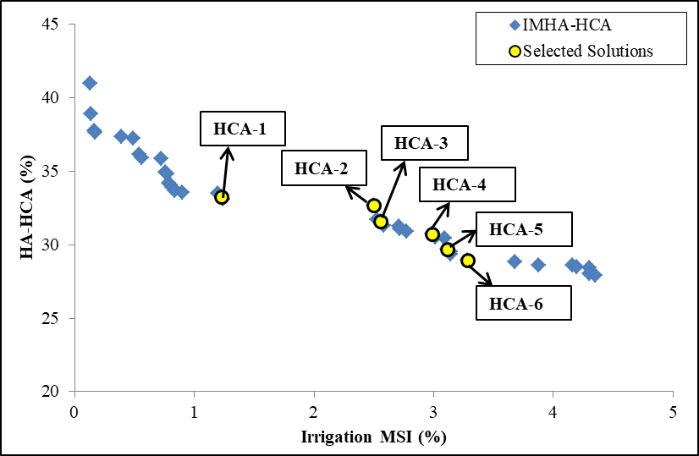

Fig. S-2.1: Pareto-front of the multi-objective optimization run IMHA-HCA

The Pareto-front between Irrigation MSI and HA-HCA of IMHA-HCA is shown in Fig. S-2.1, which covers a wide range of HA-HCA values (28% to 41%) for a relatively narrow range of Irrigation MSI (0.13% to 4.3%). The P-O solutions with HA-HCA between 28.95% and 33.33%, are considered for further analysis on the basis of implementable E-flow targets from the deficit performance consideration and low alteration category of HA proposed by Richter et al. (1998), respectively. The optimal monthly E-flow targets of six selected P-O solutions (shown as yellow coloured circles in Fig. S-2.1) falling within this preferable range of HA-HCA are presented in Table S-2.1.

Table S-2.1: Optimal monthly E-flow targets for the six selected P-O solutions of IMHA-HCA

|  |  |  |  |  |  |  |  |  |  |  |  |  |  |  |  |
| --- | --- | --- | --- | --- | --- | --- | --- | --- | --- | --- | --- | --- | --- | --- | --- |
| **Sol.** | **Irr**  **MSI**  **(%)** | **HA-HCA (%)** | **Year type** | **Optimal monthly E-flow targets (×106m3)** | | | | | | | | | | | |
| **J** | **J** | **A** | **S** | **O** | **N** | **D** | **J** | **F** | **M** | **A** | **M** |
| HCA-1 | 1.22 | 33.28 | D | 78 | 254 | 246 | 132 | 63 | 30 | 14 | 27 | 15 | 10 | 11 | 18 |
| N | 73 | 231 | 246 | 97 | 63 | 30 | **24** | 27 | 15 | 10 | 11 | 18 |
| W | **114** | 231 | **631** | 97 | 63 | 30 | 14 | 27 | 15 | 10 | 11 | 18 |
| HCA-2 | 2.50 | 32.67 | D | 73 | 231 | **451** | 97 | 63 | 30 | 14 | 27 | 15 | 10 | 11 | 18 |
| N | 73 | 239 | 246 | 100 | 67 | 30 | **25** | 27 | 15 | 10 | 11 | 18 |
| W | 73 | **648** | 271 | 107 | 77 | 40 | **22** | 27 | 15 | 10 | 11 | 18 |
| HCA-3 | 2.55 | 31.62 | D | 73 | 231 | **451** | 97 | 63 | 30 | 14 | 27 | 15 | 10 | 11 | 18 |
| N | 73 | 231 | 246 | 97 | 63 | 30 | **39** | 27 | 15 | 10 | 11 | 18 |
| W | 73 | **655** | 271 | 97 | **105** | **51** | 17 | 27 | 15 | 10 | 11 | 18 |
| HCA-4 | 2.99 | 30.72 | D | 73 | 247 | **451** | 97 | 63 | 30 | 14 | 27 | 15 | 10 | 11 | 18 |
| N | 78 | 231 | 246 | 97 | 63 | 30 | **40** | 27 | 15 | 10 | 11 | 18 |
| W | 75 | 293 | **607** | 97 | **121** | **42** | 14 | 27 | 15 | 10 | 11 | 18 |
| HCA-5 | 3.12 | 29.7 | D | 85 | 231 | **459** | 97 | 63 | 30 | 14 | 27 | 15 | 10 | 11 | 18 |
| N | 73 | 231 | 279 | 97 | 63 | 30 | **39** | 27 | 15 | 10 | 11 | 18 |
| W | 75 | 278 | **590** | 116 | 71 | **53** | 14 | 27 | 15 | 10 | 11 | 18 |
| HCA-6 | 3.28 | 28.95 | D | 85 | 231 | **451** | 97 | 77 | 30 | 14 | 27 | 15 | 10 | 11 | 18 |
| N | 73 | 231 | **369** | 97 | 63 | 30 | **39** | 27 | 15 | 10 | 11 | 18 |
| W | 75 | 285 | 287 | 116 | 77 | **48** | 14 | 27 | 15 | 10 | 11 | 18 |

* D – dry year; N-normal year; W- wet year

It may be observed from Table S-2.1 that the optimal E-flow targets for HCA-1 (HA-HCA = 33.28%) are quite moderate throughout, resulting in low Irrigation MSI. But, with decreasing HA-HCA along the P-O front (HCA-2 to HCA-6), the E-flow targets are found to be high in August during dry flow years (10 out of 38 years) and moderately high in one or two months during October – December. The E-flow targets of wet years (8 out of 38 years) are found to be high in July or August for five P-O solutions (HCA-1 to HCA-5), while for the solution HCA-6, the July month targets are high during normal years (22 out of 38 years).

The operational performances of the six selected P-O solutions are presented in supplement Table S-2.2 in terms of Irrigation MSI and average monthly Irrigation deficits. With decreasing HA-HCA along the P-O front, the average monthly Irrigation deficits of April and May and Irrigation MSI are found to increase, but are reasonable. Moreover, for all the six solutions, the average E-flow deficits during the months, June and July are at 20% (being limited by the maximum average deficit constraint), whereas the same are nominal during the next six months.

Table S-2.2: Performance of the six selected P-O solutions of IMHA-HCA in terms of Irrigation MSI and average monthly Irrigation deficits.

|  |  |  |  |  |  |  |  |  |  |  |  |  |  |  |
| --- | --- | --- | --- | --- | --- | --- | --- | --- | --- | --- | --- | --- | --- | --- |
| **Solution** | **HA-HCA** | **Irrigation MSI** | **Average monthly Irrigation deficits** | | | | | | | | | | | |
| J | J | A | S | O | N | D | J | F | M | A | M |
| **HCA - 1** | 33.28 | 1.22 | 8 | 9 | 7 | 9 | 10 | 3 | 3 | 3 | 9 | 9 | 12 | 12 |
| **HCA - 2** | 32.67 | 2.50 | 12 | 12 | 5 | 4 | 4 | 3 | 4 | 3 | 10 | 12 | 15 | 19 |
| **HCA - 3** | 31.62 | 2.55 | 12 | 13 | 5 | 6 | 5 | 3 | 4 | 3 | 11 | 12 | 17 | 17 |
| **HCA - 4** | 30.72 | 2.99 | 13 | 13 | 4 | 7 | 8 | 4 | 4 | 4 | 12 | 13 | 18 | 17 |
| **HCA - 5** | 29.70 | 3.12 | 12 | 12 | 4 | 11 | 10 | 4 | 5 | 4 | 12 | 14 | 18 | 20 |
| **HCA - 6** | 28.95 | 3.28 | 14 | 14 | 5 | 12 | 10 | 5 | 6 | 4 | 12 | 15 | 18 | 20 |

*All figures are in %

**S-2.2 Effectiveness of Reservoir Operation**

The discussion is presented only for HCA-1 and HCA-2, since there is no significant difference either in the decision parameters or the deficits performances for HCA-2, HCA-3, HCA-4, HCA-5 and HCA-6. To facilitate the discussion the rule curve diagram containing the carry-over storage rule curve, Irrigation Rule Curve (${IRC}_{j}$) and E-flows rule curve (${ERC}_{j}$) and the respective decision parameters (rule curve parameters and release factors) corresponding to Irrigation and E-flows, are shown in Fig. S-2.2. In addition, the Table S-2.3 of supplement may also be referred.

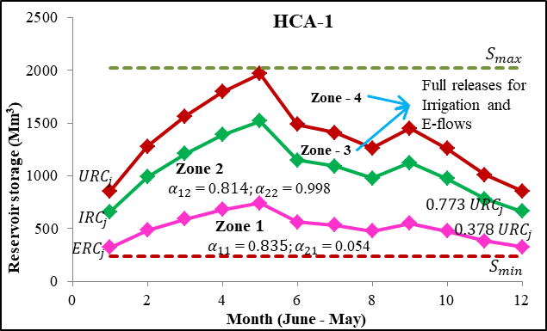

(a)

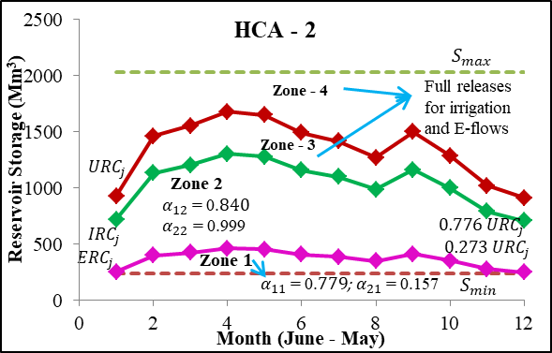

(b)

Fig. S-2.2: Zone-wise Rule Curves of IMHA-HCA model run corresponding to the P-O solutions: (a) HCA – 1 and (b) HCA – 2 (rule curve parameters and release factors of Irrigation and E-flow are indicated within the Figure)

It may be observed from Fig. S-2.2 that in case of HCA-HA-33.28 (HCA-1), the widths of zone-1 and zone-2 are significant, with the release factor for Irrigation being quite high in both these hedging zones, giving rise to high number of mild Irrigation deficits, resulting in low MSI and average monthly deficits (Table S-2.2). On the other hand, E-flow releases do not seem to undergo any hedging in zone-2, whereas in zone-1, the release factor is dismally low. As a result, 87% of the periods in the operation horizon do not face any E-flow deficit, whereas most of the remaining periods experience moderate to very severe deficits (Table S-2.3). When compared with HCA-1, in case of HCA-2, there is a significant increase in zero Irrigation deficit periods and drastic reduction in mild deficit periods, when the storage is in zones 3 and in the transition zone 2-3. However, this is more than offset by a high increase in the number of moderately severe and very severe deficit periods (Table S-2.3), as the storage drops to zone-1, resulting in a significant increase in Irrigation MSI and dry season deficits (Table S-2.2). In case of E-flows, from HCA-1 to HCA-2, there is a high increase in very severe deficits, owing to an increase in the number of resident periods in zone-1 (Table S-2.3), despite a lesser width of zone-1 and a better E-flow release factor (Fig. S-2.2).

Table S-2.3: Distribution of deficits in various storage zones during the simulation period for two selected solutions from the P-O front of IMHA-HCA.

|  |  |  |  |  |  |  |  |  |  |  |  |
| --- | --- | --- | --- | --- | --- | --- | --- | --- | --- | --- | --- |
|  | | **E-flows** | | | | | **Irrigation** | | | | |
| **IMHA-HCA-33.28 (HCA - 1)** | | | | | | | | | |
| Initial storage zone | Number of periods  (456) | Number of zero deficit periods | Distribution of deficit periods | | | | Number of zero deficit periods | Distribution of deficit periods | | | | |
| Mild | Moderate | Severe | Very severe | Mild | Moderate | Severe | Very severe | |
| 4 | 9 | 9 | 0 | 0 | 0 | 0 | 9 | 0 | 0 | 0 | 0 | |
| 3 | 74 | 74 | 0 | 0 | 0 | 0 | 74 | 0 | 0 | 0 | 0 | |
| 2 to 3 | 313 | 313 | 0 | 0 | 0 | 0 | 45 | 268 | 0 | 0 | 0 | |
| 2 | 0 | 0 | 0 | 0 | 0 | 0 | 0 | 0 | 0 | 0 | 0 | |
| 1 to 2 | 28 | 3 | 3 | 15 | 2 | 5 | 3 | 25 | 0 | 0 | 0 | |
| 1 | 32 | 0 | 2 | 0 | 1 | 29 | 0 | 28 | 2 | 1 | 1 | |
|  | | **IMHA-HCA-32.67 (HCA - 2)** | | | | | | | | | |
| Initial storage zone | Number of periods (456) | Number of zero deficit periods | Distribution of deficit periods | | | | Number of zero deficit periods | Distribution of deficit periods | | | | |
| Mild | Moderate | Severe | Very severe | Mild | Moderate | Severe | Very severe | |
| 4 | 0 | 0 | 0 | 0 | 0 | 0 | 0 | 0 | 0 | 0 | 0 | |
| 3 | 126 | 126 | 0 | 0 | 0 | 0 | 126 | 0 | 0 | 0 | 0 | |
| 2 to 3 | 263 | 263 | 0 | 0 | 0 | 0 | 30 | 233 | 0 | 0 | 0 | |
| 2 | 2 | 2 | 0 | 0 | 0 | 0 | 0 | 2 | 0 | 0 | 0 | |
| 1 to 2 | 12 | 1 | 2 | 9 | 0 | 0 | 1 | 11 | 0 | 0 | 0 | |
| 1 | 53 | 1 | 0 | 0 | 0 | 52 | 1 | 0 | 43 | 2 | 7 | |

*very severe (≥70%); severe (50%-70%); moderate (20%-50%) and mild (>0 and <20%)