**Supplementary Information – 3**

**Multi-Objective Modeling framework for Environmental flow optimization**

**in a River-Reservoir system using Histogram Comparison Approach**

**for estimation of Hydrologic Alteration**

**Ruby Jose1and Srinivasan K2**

1Research Scholar, 2Professor (Retd.), Department of Civil Engineering, Indian Institute of Technology Madras, Chennai – 600036.

Corresponding author: Ruby Jose. J ([rubyphdwork@gmail.com](mailto:rubyphdwork@gmail.com))

Address: Department of Civil Engineering, IIT Madras, Chennai 600036, India.

**Deriving optimal E-flow targets using RVA**

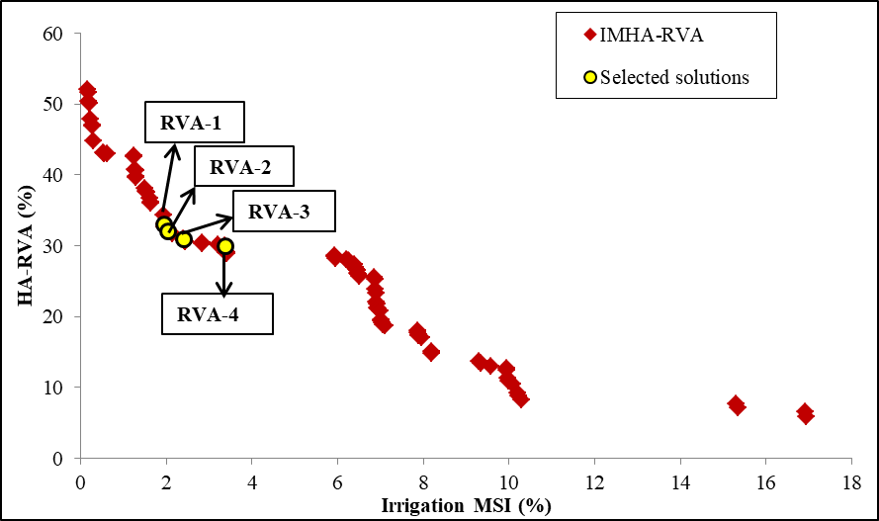

Fig. S-3.1: Pareto-front of the multi-objective optimization run IMHA-RVA

Table S-3.1: Optimal monthly E-flow fractions for the four selected P-O solutions of IMHA-RVA

|  |  |  |  |  |  |  |  |  |  |  |  |  |  |  |  |
| --- | --- | --- | --- | --- | --- | --- | --- | --- | --- | --- | --- | --- | --- | --- | --- |
| **Solution** | **Irrigation MSI**  **(%)** | **HA-RVA (%)** | **Year type** | **Optimal monthly E-flow targets (×106m3)** | | | | | | | | | | | |
| **J** | **J** | **A** | **S** | **O** | **N** | **D** | **J** | **F** | **M** | **A** | **M** |
| RVA-1 | 1.95 | 33.12 | D | 73 | 239 | 246 | 97 | 63 | 30 | 18 | 27 | 15 | 10 | 11 | 18 |
| N | 73 | **563** | 246 | 97 | 63 | 30 | 14 | 27 | 15 | 10 | 11 | 18 |
| W | 73 | 278 | 246 | 116 | 63 | 30 | 15 | 27 | 15 | 10 | 11 | 18 |
| RVA-2 | 2.03 | 32.1 | D | 73 | 231 | 246 | 97 | 63 | 30 | **25** | 27 | 15 | 10 | 11 | 18 |
| N | 73 | **563** | 246 | 97 | 63 | 30 | 14 | 27 | 15 | 10 | 11 | 18 |
| W | 75 | 293 | **492** | 110 | 63 | 30 | 14 | 27 | 15 | 10 | 11 | 18 |
| RVA-3 | 2.40 | 31 | D | 73 | 231 | 246 | 97 | 63 | 30 | 25 | 27 | 15 | 10 | 11 | 18 |
| N | 73 | **555** | 246 | 97 | 63 | 30 | 14 | 27 | 15 | 10 | 11 | 18 |
| W | 73 | 254 | **435** | 97 | 63 | **50** | 14 | 27 | 15 | 10 | 11 | 18 |
| RVA-4 | 3.38 | 30.02 | D | 73 | 231 | 246 | 97 | 63 | 30 | 16 | 27 | 15 | 10 | 11 | 18 |
| N | 73 | **648** | 246 | 97 | 63 | 30 | 14 | 27 | 15 | 10 | 11 | 18 |
| W | 73 | 239 | 246 | 97 | 63 | 42 | 15 | 27 | 15 | 10 | 11 | 18 |

* D – dry year; N-normal year; W- wet year

It may be observed from Table S-3.1 that the optimal monthly E-flow targets of dry years are lower than those of normal and wet years. The E-flow targets of July during normal years are consistently high, which can be attributed to the significance of high flow pulses emphasized by four of the six PCA selected indicators. Thus, similar to IMHA-HCA, introducing a constraint on the maximum average monthly E-flow deficit is found to enable IMHA-RVA also in deriving realistic E-flow targets (Table S-3.1). The performances pertaining to Irrigation of the four selected P-O solutions are presented in supplement Table S-3.2, from which it is observed that Irrigation MSI and average monthly Irrigation deficits increase with decreasing HA value.

Table S-3.2: Performance of the four selected P-O solutions of IMHA-RVA in terms of Irrigation MSI and average monthly Irrigation deficits.

|  |  |  |  |  |  |  |  |  |  |  |  |  |  |  |
| --- | --- | --- | --- | --- | --- | --- | --- | --- | --- | --- | --- | --- | --- | --- |
| **Solution** | **HA- RVA** | **Irrigation MSI** | **Average monthly Irrigation deficits** | | | | | | | | | | | |
| J | J | A | S | O | N | D | J | F | M | A | M |
| **RVA-1** | 33.12 | 1.95 | 7 | 12 | 5 | 9 | 12 | 9 | 8 | 10 | 5 | 11 | 12 | 13 |
| **RVA-2** | 32.1 | 2.03 | 8 | 12 | 6 | 10 | 13 | 9 | 8 | 10 | 5 | 11 | 15 | 12 |
| **RVA-3** | 31 | 2.40 | 11 | 15 | 8 | 13 | 12 | 12 | 11 | 12 | 6 | 10 | 11 | 10 |
| **RVA-4** | 30.02 | 3.38 | 17 | 21 | 14 | 16 | 13 | 13 | 12 | 11 | 6 | 14 | 15 | 11 |

*All figures are in %