CSIDRS v1.0 – CAMECA Stable Isotope Data Reduction Software – Guide for users

Table of Contents

CSIDRS v1.0 – CAMECA Stable Isotope Data Reduction Software – Guide for users 1

Software background and user guide motivation 3

Starting the software 4

Selecting the stable isotope method. 5

Selecting data files 5

Selecting reference materials 6

Data processing results screen 6

Basic data check 7

Cycle data and extracting raw data 7

Drift correction 8

Quality control 10

Corrected data 10

Sulphur CAP graphs 11

Further work 11

References 11

Appendix I 12

Oxygen - zircon 12

Sulphur - pyrite 12

Sulphur - pyrrhotite 12

Sulphur - pentlandite 12

Sulphur - apatite 12

Chlorine - apatite 12

Appendix II 13

Table of Figures

Figure 1: Screenshot of the CSIDRS v0.1.8 github assets webpage located from the CSIDRS main Github page – the purple box shows where to download the .exe files from. 3

Figure 2: CSIDRS Windows .exe as it appears on the desktop 4

Figure 3: Command line and program window on software start up. 4

Figure 4: Selecting the stable isotopes and material before data import. 5

Figure 5: Warning for isotope not occurring in data file 5

Figure 6: Selecting primary and secondary reference material pop-up 6

Figure 7: Data processing results window 7

Figure 8: Cycle data window 8

Figure 9: Drift correction tab, red box highlights the option buttons for implementing drift correction or not. 9

Figure 10: Residuals and statsmodels statistics summary window 9

Figure 11: Quality control tab - Time vs delta tab 10

Figure 12: Corrected data tab 10

Figure 13: Sulphur CAP graph tab - delta33 vs delta34 tab 11

# Software background and user guide motivation

CSIDRS v1.0 is the software accompanying Marsden et al (in prep.) which communicates detailed uncertainty propagation for stable isotope data reduction as well as integrates the whole stable isotope data reduction workflow into an open-source python code and user-friendly GUI which visualises the process. CSIDRS source software and most recent version is available on Github at <https://github.com/RubyMarsden/CSIDRS> (Figure 1).

Currently, CSIDRS can be run as a .exe on a Windows (Figure 2) or as an equivalent executable file on an Ubuntu operating system, but unfortunately not on a Mac operating system. To run the .exe only the windows.exe file is required to be downloaded. If you want to change the program it is possible to clone the python code from Github, to make updates to the code on Github you will need to use a pull request (<https://docs.github.com/en/pull-requests>).

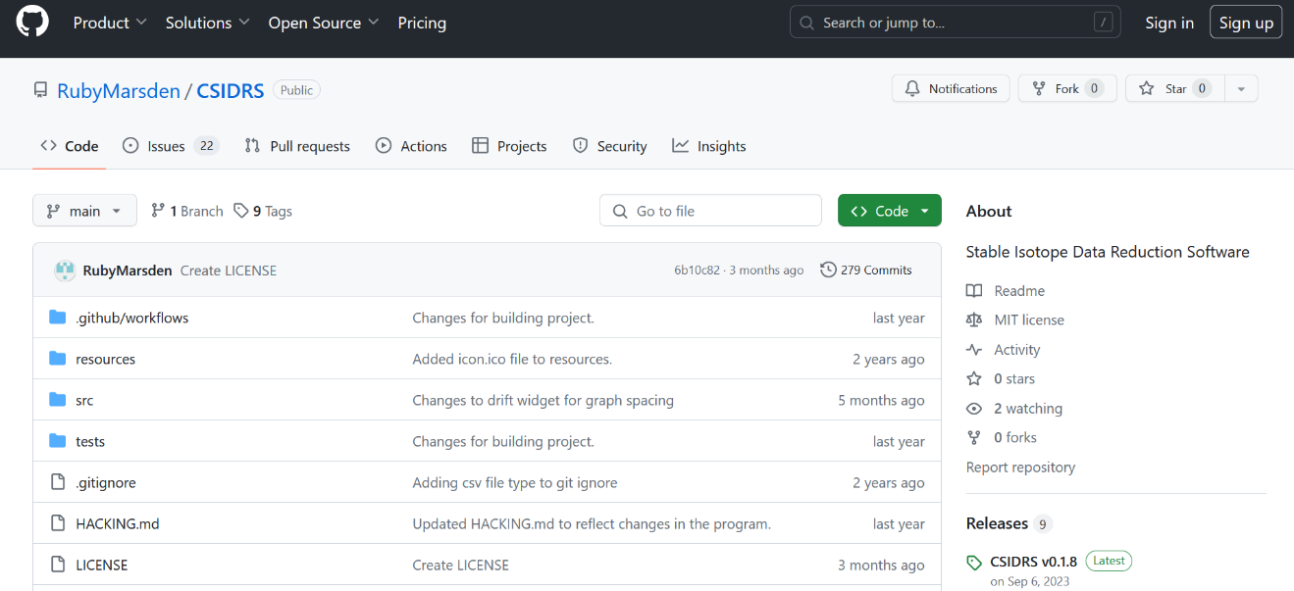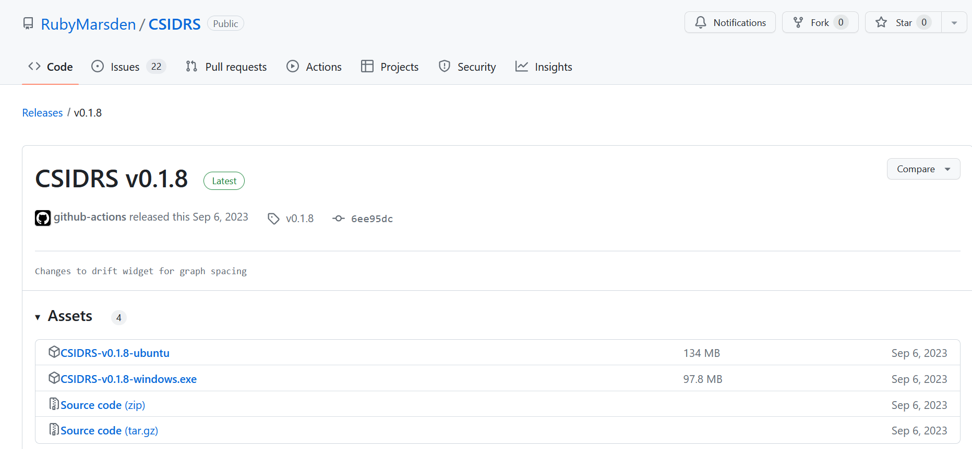

Figure 1: Screenshot of the CSIDRS v0.1.8 github assets webpage located from the CSIDRS main Github page – the purple box shows where to download the .exe files from.

This user guide supports the use of these executables with images from the Windows .exe run on a x64 Windows 11 machine. This user guide aims to enable users who are not routine CAMECA operators reduce their own data and visualise their data.

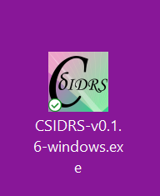

Figure 2: CSIDRS Windows .exe as it appears on the desktop

# Starting the software

On starting the software, a black command line box will appear on a windows machine and it may take some time for the program view to open (Figure 3). Additionally, admin permission may be required to run the program. Closing the command line or the program window will cause the program to exit. 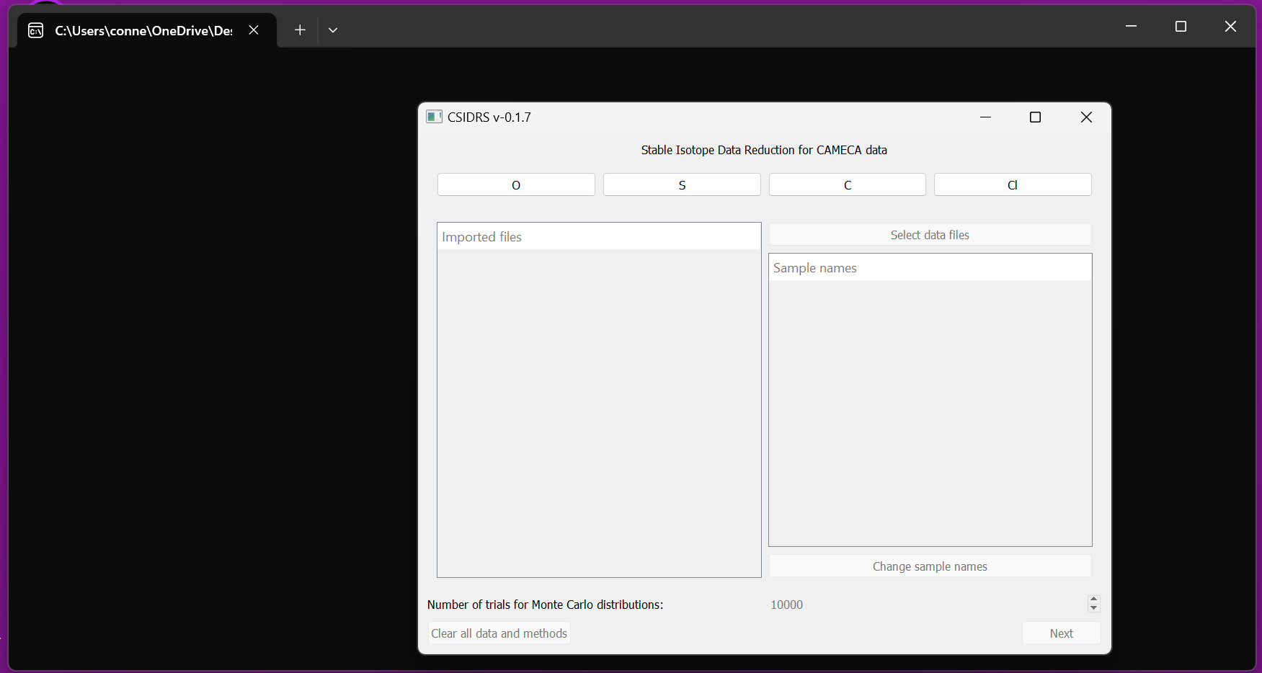

Figure 3: Command line and program window on software start up.

# Selecting the stable isotope method.

Currently there are three elements available (O, S and Cl) for which CSIDRS can reduce the data (Figure 4), these three elements have different methods available as different stable isotopes may be measured. The stable isotope method must be selected before data import. Currently there is a C button, but no C methods as it is not used at the point, however this will be updated as methods are added.

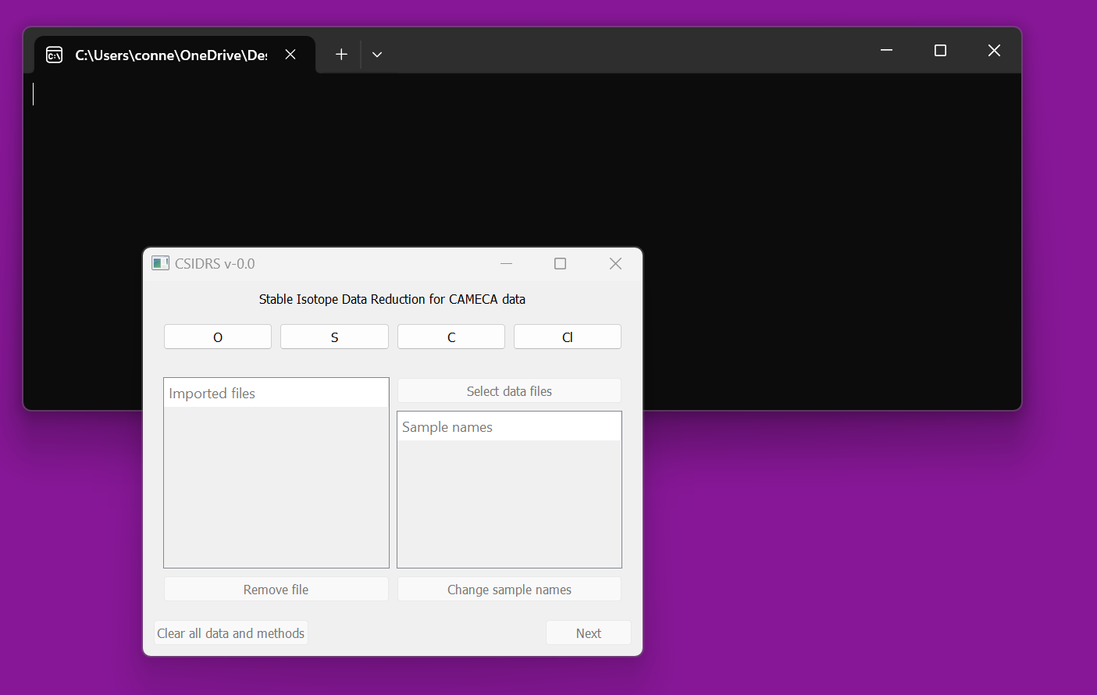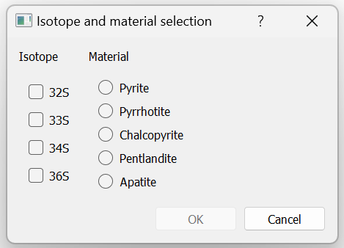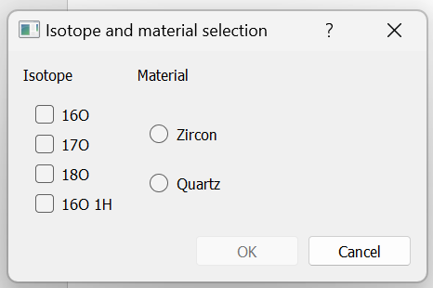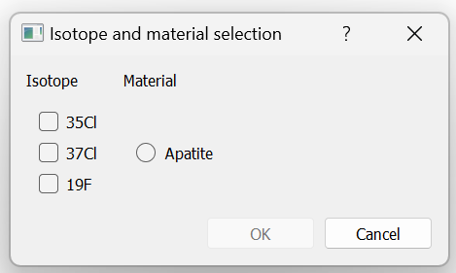

Figure 4: Selecting the stable isotopes and material before data import.

# Selecting data files

The data files which are produced by the CAMECA software (updated 2023) are .asc files which have a single ‘spot’ data per file. All files from a single run, including both standards and unknowns, should be selected for a single data reduction process. If the isotopes selected in your method are not found in the data files selected a warning will occur and the data will not be reduced (Figure 5).

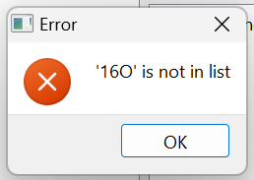

Figure 5: Warning for isotope not occurring in data file

# Selecting the Monte Carlo number

The user can change the number of Monte Carlo trials run by the program, it is suggested that starting with 10,000 trials for the first check of the data is sufficient and then running at 1,000,000 for the final data for publishing is an appropriate workflow. Running at > 1,000,000 trials may crash the program and <10,000 trials may lead to significant loss of accuracy.

# Selecting reference materials

For each stable isotope method, a selection of reference materials becomes available and pops up on clicking the Next button (Figure 6). A primary reference material must be selected and a secondary reference material can be selected. These data are pre-entered into CSIDRS as the primary reference material is required for the SIMS alpha correction (CITE). Current reference materials are listed and referenced in Appendix I.

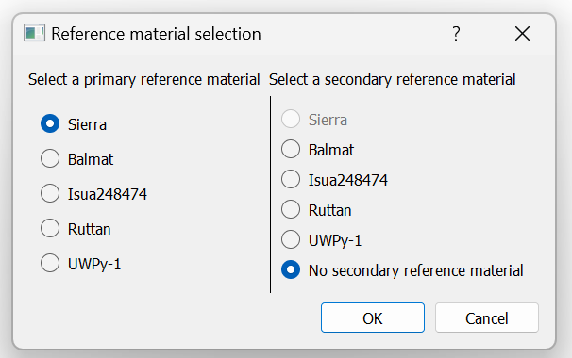

Figure 6: Selecting primary and secondary reference material pop-up

# Data processing results screen

The data processing results screen is show in Figure 7. Currently, for all isotope systems there are 4 tabs, basic data check, drift correction, quality control, and corrected data, with an extra tab for sulphur isotopes showing sulphur Δ graphs. Additionally, there is a sample list on the right where spots can be excluded from calculations and a isotope graph selection button group. The individual tabs will be detailed below.

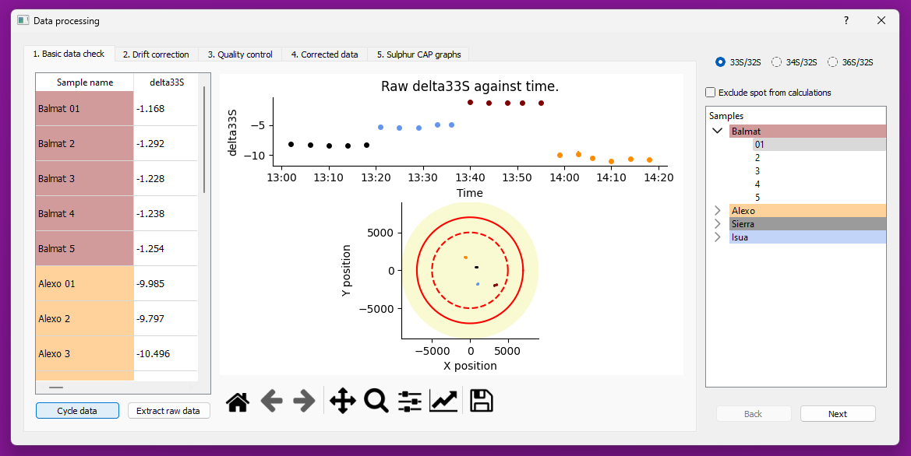

Figure 7: Data processing results window

## Basic data check

The basic data check tab (Figure 7) shows the raw delta measurement against time on a graph as well as the data in table format. It shows the x and y position of the measurement on a stylised mount graph with the red dashed line showing the inner 1cm diameter area and the bold red line showing the inner 1.4cm diameter line. Sample colours are randomly selected, except for the primary reference material which is black and the secondary reference material (not selected in the example) which is grey. Selecting ‘export raw data’ gives raw averages selected for each spot.

## Cycle data and extracting raw data

Every spot analysis contains a number of cycles, where the CAMECA instrument measures the counts for that spot over a user determined number of cycles sequentially. For each ratio selected by the user in the method dialog (Figure 4) the ratio is calculated for each cycle. The mean and standard error of this uncertainty is then used in further calculation.

The cycle data button, when selected, causes the cycle data window to pop up (Figure 8). In this window all cycles composing a single spot analysis can be visualised. If necessary, single cycle data can be removed. All the cycle data that need to be removed should be selected and then ‘Recalculate data’ should be selected. Then the ‘ok’ button should be selected. Additionally, all cycle data can be exported by selecting ‘Export cycle data’.

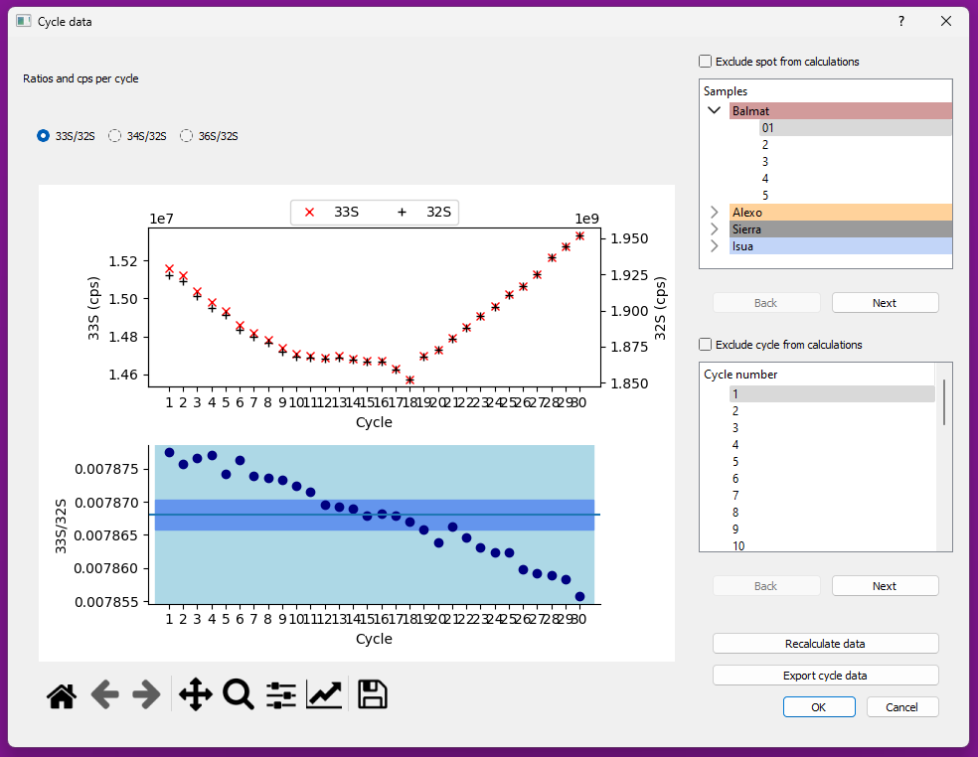

Figure 8: Cycle data window

## Drift correction

The second tab (Figure 9) contains a graph of the raw delta of the primary reference material with a best fit linear model, a graph of the drift corrected primary reference material, and if there is a selected secondary reference material a graph of the secondary material which can be used to check if the primary drift correction reduces the spread in the secondary material. Using the option buttons the user can choose to implement or not implement a drift correction on the whole dataset. Additionally, the residuals of the primary linear model can be investigated through the residuals button, which causes the residuals window to open (Figure 10). Residuals are the difference between the observed and mean value predicted by the model for that observation (Cox and Snell, 1968). If the model accounts for the variation in the data there should be no correlation between the residual and the mean value predicted by the model – this means this residual plot can be used to check if the model of time drift accounts for the variation in a qualitative manner. It is a simply designed visual test and does not guarantee that time is the only parameter controlling drift.

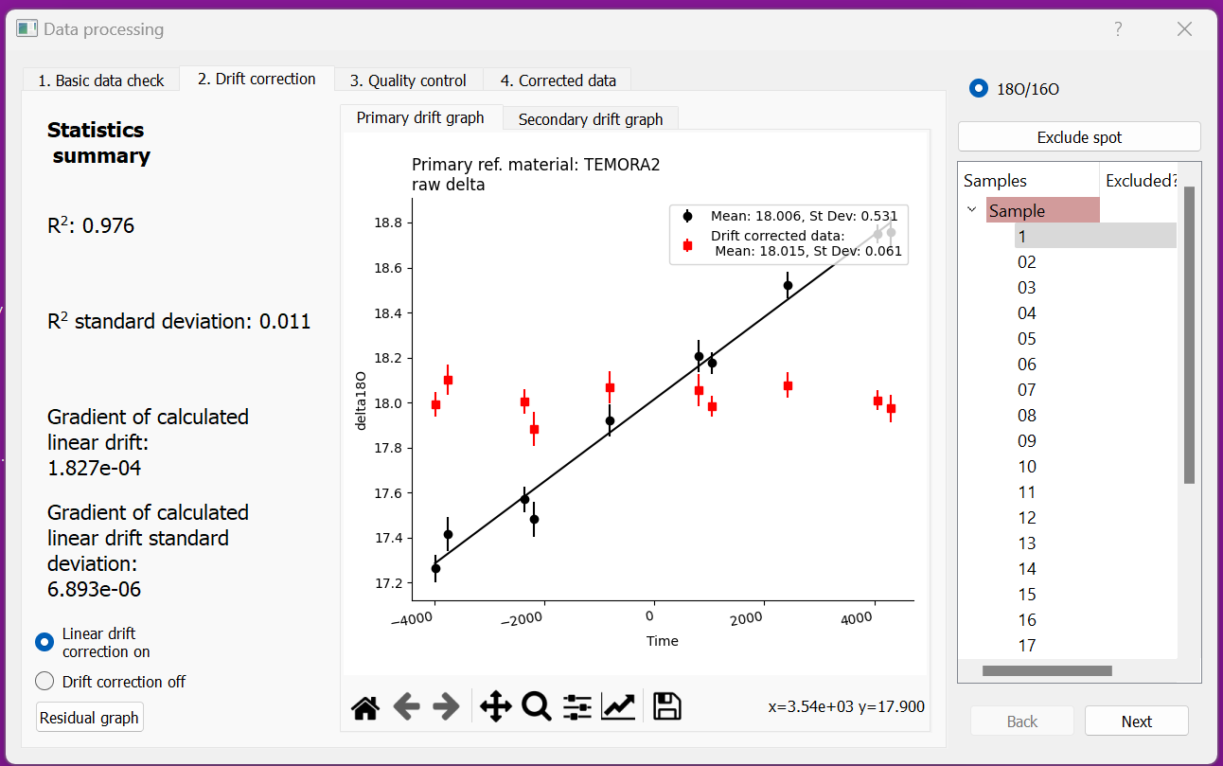

Figure 9: Drift correction tab, red box highlights the option buttons for implementing drift correction or not.

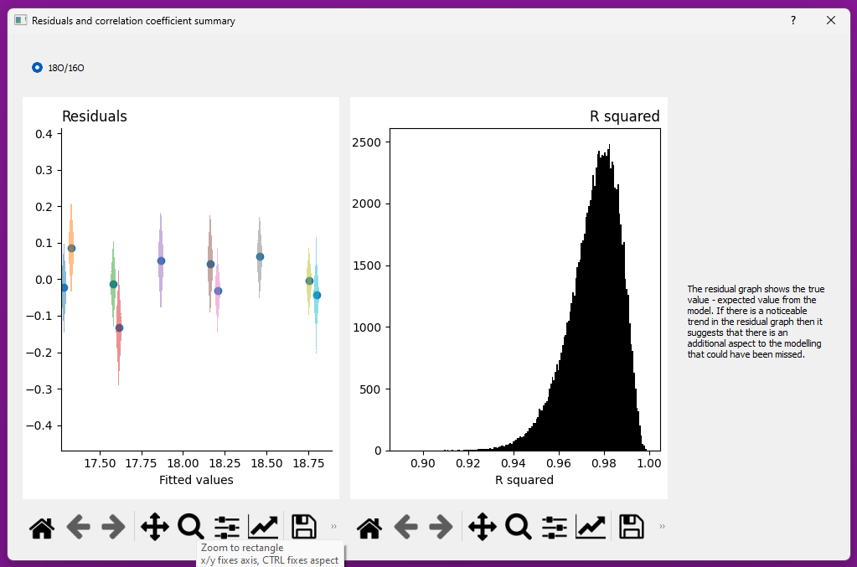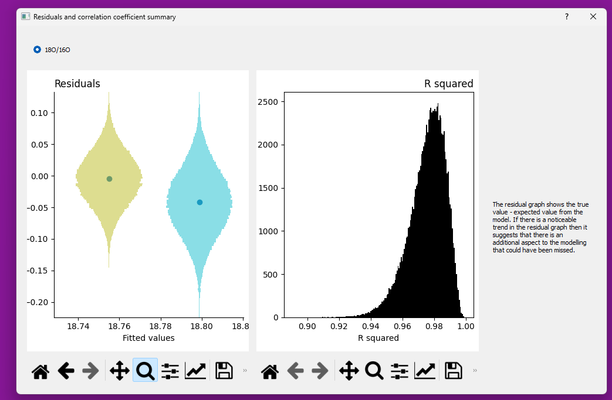

Figure 10: Residuals and R2 summary window – the number of measurements in each histogram is the Monte Carlo number entered by the user (section 6).

## Quality control

The quality control tab (Figure 11) has five individual tabs within it, where the corrected delta values of all samples can be compared to the following parameters: time, secondary ion yield, distance to mount centre, dtfa-x and dtfa-y. The x and y position of the samples in the mount are also graphically represented here.

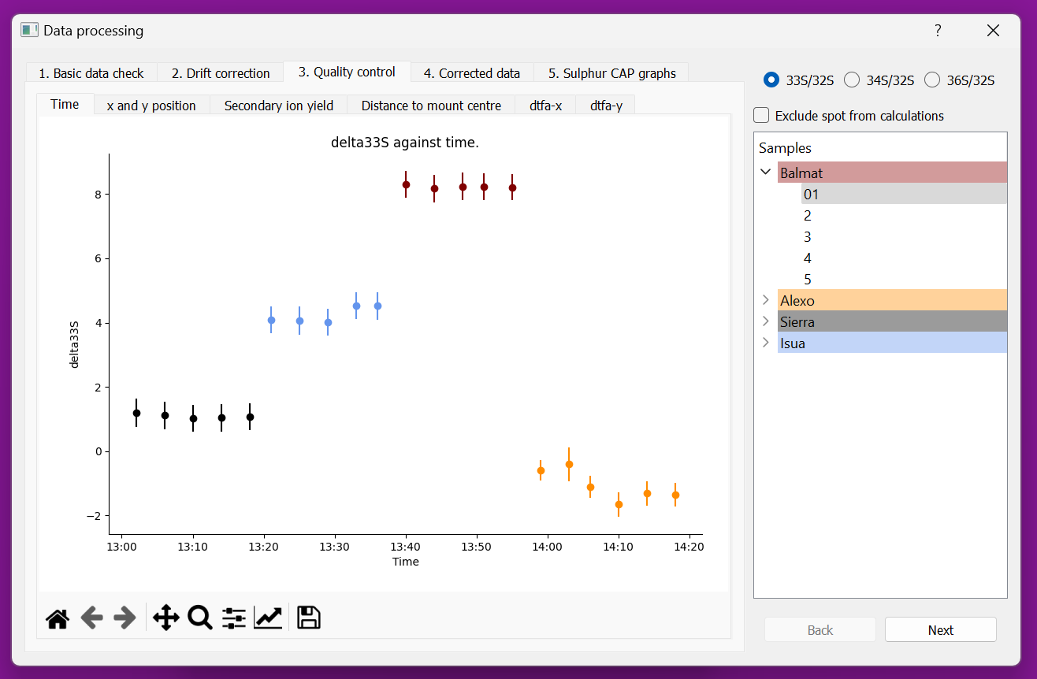

Figure 11: Quality control tab - Time vs delta tab

## Corrected data

The corrected data tab contains a table of corrected data and buttons to export this corrected data and the analytical conditions file.

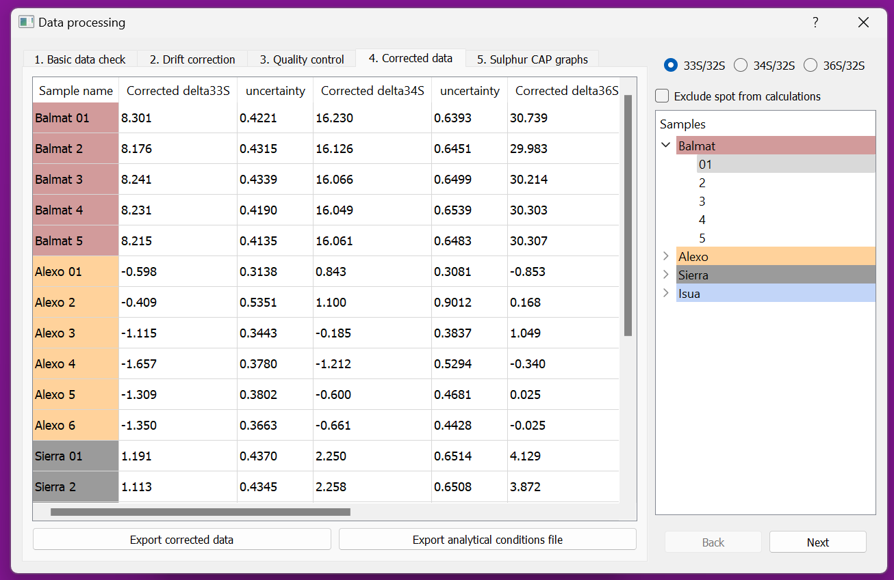

Figure 12: Corrected data tab

## Sulphur CAP graphs

This tab displays δ33 vs δ34, Δ33 vs δ34, δ36 vs δ34 and Δ36 vs Δ33 graphs.

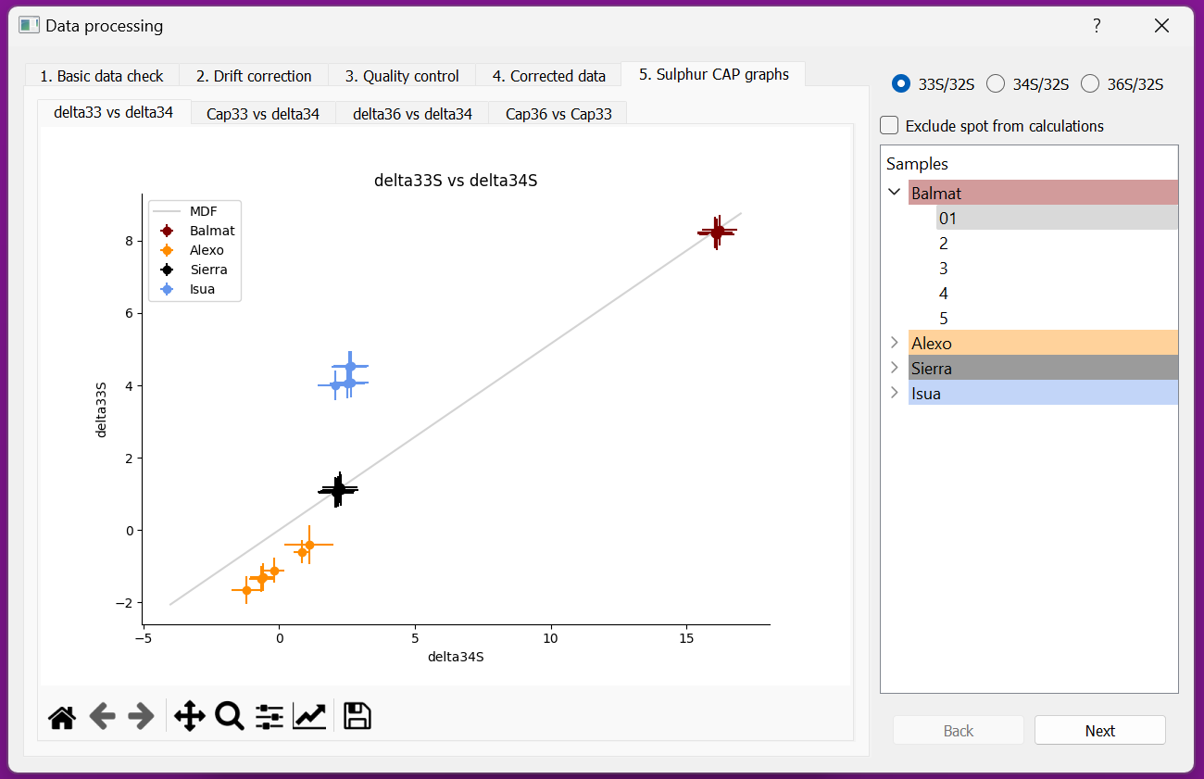

Figure 13: Sulphur CAP graph tab - delta33 vs delta34 tab

# Further work

CSIDRS is designed so it is easy to add methods in Python for other isotope systems, for a user with a little Python experience this should take approximately 30 minutes (setting up Python on a machine might take considerably longer!). For information on this, please go to the CSIDRS Github page HACKING.md file: <https://github.com/RubyMarsden/CSIDRS/blob/main/HACKING.md>, this file is also attached in Appendix II. If you are unable to program in Python, please feel free to add requests and bug reports to <https://github.com/RubyMarsden/CSIDRS/issues> with the appropriate labels and they will be addressed as soon as possible.

# References

Cox, D. R., and E. J. Snell. “A General Definition of Residuals.” *Journal of the Royal Statistical Society. Series B (Methodological)* 30, no. 2 (1968): 248–75. http://www.jstor.org/stable/2984505.

# Appendix I

Reference material directory (found in the code here: /src/model/settings/isotope_reference_materials.py)

## Oxygen - zircon

91500: δ18: (9.94, 0.2), Wiedenbeck et al., 2004,

M257: δ18: (13.93, 0.22), Nasdala et al. 2008,

TEMORA2 δ18: (8.2, 0.02), Black, et al., 2004,

Penglai: δ18: (5.31, 0.12), Li et al. 2010,

*Standards below have NOT been analysed in bulk by LF, better to be used as secondary*

OGC: δ18: (5.88, 0.06), Petersson et al., 2019,

CZ3: δ18: (15.4, 0.4), Cavosie et al., 2011,

## Sulphur - pyrite

Sierra: δ33: (1.09, 0.30), δ34: (2.17, 0.28), δ36: (3.96, 0.6): Laflamme et al. 2016,

Balmat: δ34: (15.1, 0.4): Crowe & Vaughan 1996, Only 34/32 reported in Crowe & Vaughan

Isua248474: δ33: (4.33, 0.38), δ34: (1.09, 0.30): Whitehouse2013, Baublys et al. 2004, SIMS data and rock source described in Whitehouse, bulk from Baublys, large d34S variability reported by Whitehouse2013 (0.86 2SD)

Ruttan: δ34: (1.2, 0.2): Crowe & Vaughan 1996, only 34/32 reported in Crowe & Vaughan 1996

UWPy-1: δ33: (8.4, None), δ34: (16.39, 0.4): Williford et al., 2011, This is also from Balmat locality. 34/32 defined in Kozdon et al. 2010 and no-MIF in Williford et al. 2011

## Sulphur - pyrrhotite

Alexo: δ33: (1.73, 0.20), δ34: (5.23, 0.40), δ36: (10.98, 0.59): Laflamme et al. 2016, All isotope ratios were measured

## Sulphur - pentlandite

VMSO: δ33: (1.66, 0.24), δ34: (3.22, 0.51), δ36: (6.37, 0.83): Laflamme et al. 2016, All isotope ratios were measured

## Sulphur - apatite

Big1: δ33: (7.22, 0.20), δ34: (14.02, 0.40): Hammerli et al. 2021, All isotope ratios were measured, NO 36S data on Big1

## Chlorine - apatite

Tubaf50: δ37: (0.32, 0.25): Wurarska et al. 2021

Big1: δ37: (0.63, 0.14): In-house collated data, n=53

# Appendix II

This is the HACKING.md file as found at <https://github.com/RubyMarsden/CSIDRS/blob/main/HACKING.md>

