**Ruby Off the Rails Iteration 0 Report**

**Team roles:**

Scrum Master: Francesco Romano

Product Owner: Tanay Patankar

Front End Specialists: Ruofei Xu, Shreyas Kasetty

Back End Specialists: Brian Munoz, Meetansh Gupta

**Customer Meeting:**

Date: September 5th

Time: 1pm-2pm

Place: PETR 214

**Summary:**

The main purpose of our application is to streamline the PhD application review process. This process includes adding candidate information, allowing faculty to review the applications, and then to generate a report compiled of all reviews. More specifically, once a candidate is in the system, a committee chair will do a initial review and create a committee of faculty assigned to review the application. The reviews will constitute a text review and a numeric score from 1-5.

In addition to the main process the system is designed to aid, other features to improve user experience will be added. Theses include: a search page that will allow a faculty member to find all candidates that meet a specified criteria, a user friendly home page that will display unreviewed assigned candidate for a faculty to review at a high priority, and a candidate add page that will take a csv file (or other format... to be determined) and add the candidate to the system.

**User Interface:**

*User Stories:*

Feature: Login with CAS

As a user

So that I can access the PHD Review Application

I want to be able to log in through TAMU CAS

Feature: Add reviews to the application

As a faculty member

So that I can add my feedback about the candidate

I want to add a text review to an application and give them a score from 1 to 5.

Feature: Creating a committee

As a committee chair

So that I can have a committee review an applicant

I want to add faculty members to a committee

Feature: Search for an applicant

As a faculty member

So that I can find a particular applicant

I want to specify the criteria for searching the applicant

Feature: Generating a Report

As a faculty

So that the grad office can make a decision on the applicant

I want to generate a report of the reviews of a PHD applicant

Feature: Notify committee members about a review

As a committee member

So that the applicant gets reviewed promptly

I want to see notifications about applicants I need to review

*LoFi Mockup:*

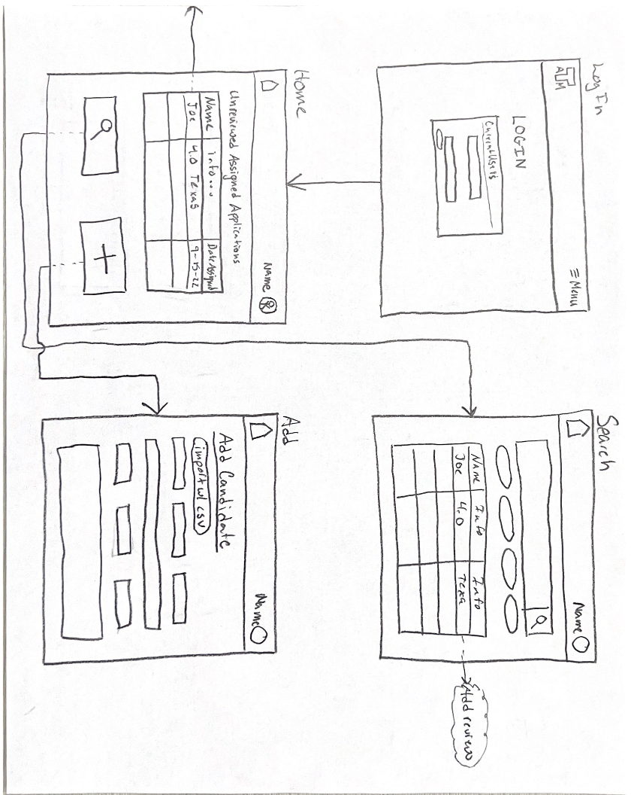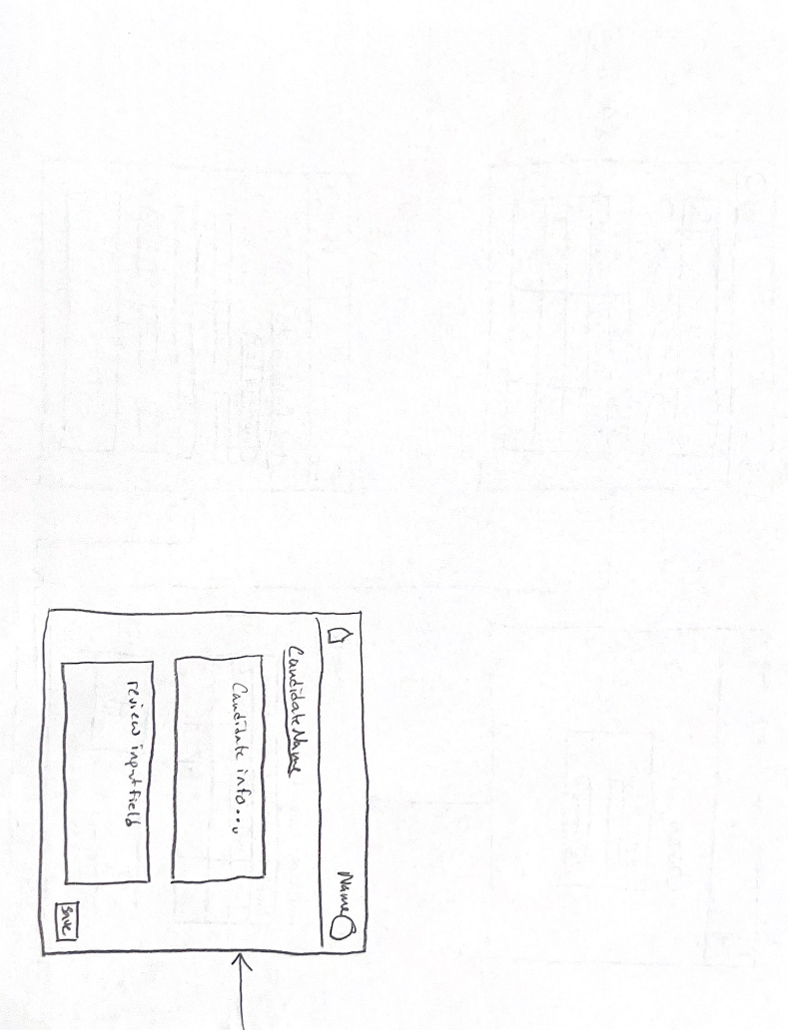

**Links:**

Deployed Application: https://applicationapp-7378da3e3864.herokuapp.com/

GitHub Repo: https://github.com/RubyOffTheRailsTAMU/PhD-Application-Review-System

Project Management Page: https://github.com/orgs/RubyOffTheRailsTAMU/projects/1

Slack Channel: phdapplicatio-buc1202.slack.com