Parallelism Theory

Report

Jacobi iteration

Fedotov Dmitriy, 21930

05.03.2023

Work aims:

Compare the time and results of the program for calculating the heat equation on different processors: CPU, GPU, CPU in multi-core mode.

Compiler: PGC++

Profiler: C/C++ clock() function

Time measurements were taken with clock() function. CPU multicore results are divided by the number of cpu cores(80), because the clock() function takes time separately on each core.

CPU-onecore

| Grid size | Computation time | Accuracy | Iterations |
| --- | --- | --- | --- |
| 128 * 128 | ~0.7 | ~9.84*10^-6 | 22600 |
| 256 * 256 | ~9.9 | ~9.96*10^-6 | 72600 |
| 512 * 512 | ~119.8 | ~10^-5 | 217800 |

CPU-multicore

| Grid size | Computation time | Accuracy | Iterations |
| --- | --- | --- | --- |
| 128 * 128 | ~2.9 | ~9.844*10^-6 | 22600 |
| 256 * 256 | ~7.6 | ~9.957*10^-6 | 72600 |
| 512 * 512 | ~33.1 | ~9.992^-6 | 217800 |
| 1024 * 1024 | ~178.2 | ~9.998^-6 | 578400 |

GPU optimization

grid: 512 * 512, iterations: 100

| Stage | Computation time | Accuracy | Comment |
| --- | --- | --- | --- |
| 1 | ~0.055 | 1.38396 | Initial test |
| 2 | ~0.026 | 1.38396 | collapse(2) added (Line 103) |
| 3 | ~0.025 | 1.38396 | independent added |

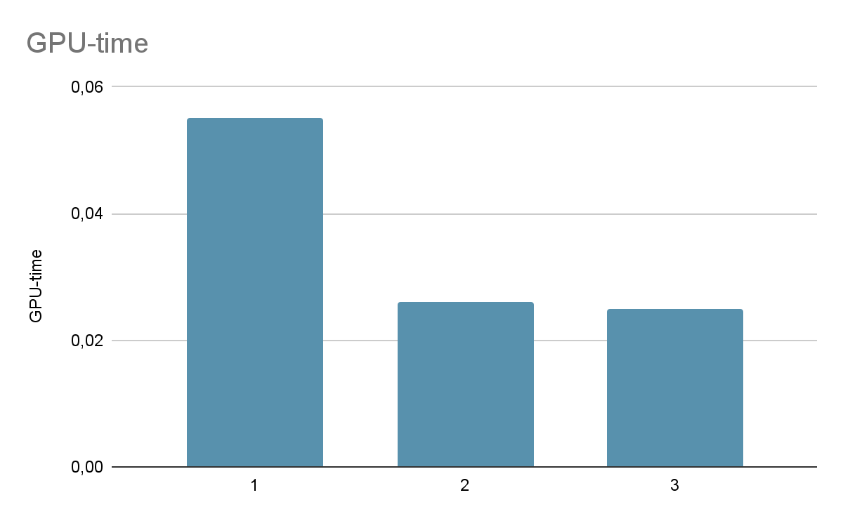

GPU-optimized

| Grid size | Computation time | Accuracy | Iterations |
| --- | --- | --- | --- |
| 128 * 128 | ~5.8 | ~1.374 | 1000000 |
| 256 * 256 | ~6.4 | ~1.377 | 1000000 |
| 512 * 512 | ~9 | ~1.379 | 1000000 |
| 1024 * 1024 | ~31.9 | ~1.38 | 1000000 |

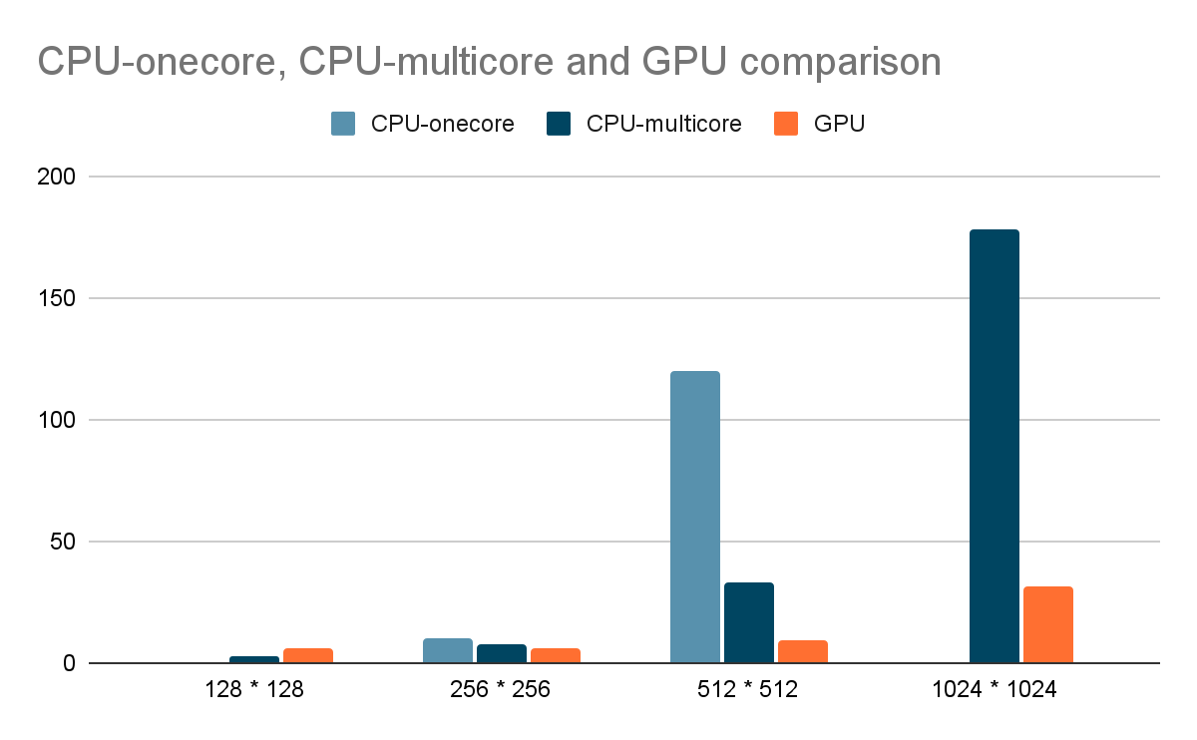

Summary:

Firstly, CPU computations are more accurate. They need a lesser number of iterations to get the required accuracy than GPU computations.

However, GPU computes larger grids and does more iterations much faster. But the accuracy of computations leaves much to be desired.

To sum up, GPU should be used to do a lot of computations/iterations, while CPU should be used to compute accurately.

* <https://github.com/RubyRode/Parallel_Theory_repo/tree/master/Task1>
* Code:

