Univeristy of brighton
School of Architecture, Technology and Engineering
Final year project report
Submission date:
Student Name: Ruby Davies
Student ID: 5515
Course BSc computer science
CI601
Cinescope: A web-based movie discovery and logging application

Declaration of authorship

I hereby declare that this report titled “CineScope: A Web-Based Movie Discovery and Logging Application” and the work presented within it are my own.

I confirm that:
- This work was completed wholly or mainly while in candidature for a degree at the University of Brighton.
- Where I have consulted the work of others, this is always clearly referenced.
- Where I have quoted from the work of others, the source is always given.
- This report has not been submitted for any other qualification at this or any other institution.

Student Name: Ruby Davies
Student ID: 23812820
Date: May 2026

Abstract

This project presents the design and development of CineScope, a client-side web application for movie discovery and personal film management. The application enables users to search for films via the OMDb API, view detailed film metadata, log viewed films with timestamped diary entries, assign personal star ratings, write reviews, and manage a personal watchlist. Additional features include an analytics dashboard with interactive Chart.js visualisations providing insights into viewing habits, a side-by-side movie comparison tool, a streaming availability checker, and a social profile system with friend connections and an activity feed.
The application was developed using HTML, CSS, and vanilla JavaScript, following a client-side single-page architecture with localStorage for data persistence. The OMDb API serves as the primary data source for film metadata, supplemented by the TMDb API for trailer retrieval. An iterative Agile development approach using Feature-Driven Development was adopted to manage project progression, enabling core functionality to be delivered early and progressively refined throughout the development lifecycle.
Functional testing confirmed that 100% of Must-Have and Should-Have requirements were implemented and passed successfully. HTML validation via the W3C Markup Validation Service and CSS validation confirmed compliance with web standards. Google Lighthouse audits returned a Performance score of 100/100 on both desktop and mobile, alongside an Accessibility score of 86/100 and a Best Practices score of 96/100.
The final outcome demonstrates a functional, responsive, and well-tested software artefact. The report documents the project's research, requirements analysis, design decisions, implementation, testing, and a critical evaluation reflecting on technical choices, development challenges, and opportunities for future improvement including server-side authentication, cross-device data synchronisation, and automated testing.

Table of contents
Introduction

This report presents the design, development, and evaluation of CineScope, a web-based movie discovery and logging application developed as a final-year project. CineScope enables users to search for films via a third-party movie database API, log watched films with personal ratings and reviews, manage watchlists, and explore viewing analytics.

The report documents the project’s research context, requirements analysis, design decisions, implementation, testing, and a critical evaluation of the final outcome. The following sections describe the problem context, proposed solution, and scope of the project.

1.1 Problem Statement

With the increasing number of digital streaming platforms and movie databases, users often struggle to manage film discovery and personal viewing records within a single system. Existing platforms typically focus on either providing movie information or supporting basic tracking features, but many lack a unified, personalised experience that combines discovery, logging, and user-driven organisation. As a result, users may rely on multiple applications to search for films, track watched content, and maintain watchlists, leading to fragmented workflows and reduced usability.

Additionally, many movie discovery platforms provide limited personalisation and do not allow users to easily record personal ratings, written reviews, or structured viewing histories in one centralised location. This highlights an opportunity to develop a lightweight, user-focused solution that integrates movie discovery with personal film management features within a single web application.

1.2 Solution Approach

To address the problems identified in Section 1.1, this project focuses on the development of CineScope, a web-based movie discovery and logging application. The system enables users to search for films through a third-party movie database API and view detailed movie information, including titles, posters, release dates, and descriptions.

In addition to discovery features, CineScope provides functionality for users to record watched films, assign personal ratings, write reviews, and maintain customised watchlists. The application is designed as a responsive single-page web application using HTML, CSS, and vanilla JavaScript, allowing dynamic content updates without requiring full page reloads. By combining discovery and personal tracking features, CineScope aims to provide a streamlined and user-friendly experience that supports both exploration and organisation of films.

1.3 Project Scope

The scope of this project is limited to the design and development of a client-side web application focused on movie discovery and personal film logging. The system integrates with a third-party movie database API to retrieve film information and stores user-generated data locally within the browser to support personal tracking features.

To ensure feasibility within the available project timeframe, several limitations have been defined. The application does not include a backend database or user authentication system, and therefore does not support cross-device synchronisation or social networking features. Additionally, the project does not include video streaming capabilities or direct integration with commercial streaming platforms. The primary focus remains on delivering a functional, usable, and well-structured movie discovery and logging application that meets the defined project requirements.

2. Aims and Objectives

2.1 Aim

The aim of this project is to design and develop a web-based movie discovery and logging application, named CineScope. The application will enable users to search for films, access detailed movie information, and manage a personalised watchlist and viewing history. The project focuses on delivering a usable and responsive client-side web application that integrates with a third-party movie database API, while remaining within a realistic and manageable scope.

2.2 Objectives

In order achieve this aim, the project will address the following objectives:
- Investigate existing movie discovery and logging platforms to inform feature selection and usability decisions.
- Define and prioritise functional and non-functional requirements aligned with the project scope and technical constraints.
- Design an accessible and intuitive user interface and application structure.
- Develop a single-page web application using HTML, CSS, and vanilla JavaScript.
- Integrate a third-party movie database API to retrieve and display film data.
- Implement client-side data storage to support watchlists and logged films.
- Test and evaluate the system against defined requirements and usability goals.
- Critically review the development process and identify areas for future improvement.

2.3 Project Deliverables
The deliverables provide tangible outputs required to achieve the project’s aim and
objectives.

Web Application: A functional client-side web application for discovering, logging, rating, and reviewing films, with supporting features including a personal film diary, viewing analytics, movie comparison, and a social profile system.
Wireframe User Interface Designs: Low-fidelity UI designs created to guide the development of key application pages (Appendix D).
Technical Documentation: System architecture documentation, implementation details, API integration references, and local setup instructions (documented throughout the report and in Appendix E).
Testing Documentation: Test cases, results, and validation of functional and non-functional requirements (documented in Section 7 and Appendix G).
Final Project Report: A comprehensive report documenting the research, design, development, testing, and critical evaluation of the project.

3. Requirements
This section presents the functional and non-functional requirements for the CineScope project. Requirements can be defined as specifications that a system must satisfy to fulfil business objectives and user expectations (Wiegers & Beatty, 2013).

3.1 Requirement Gathering and Prioritisation
To ensure that the requirements aligned with the project's aim, the Minimum Viable Product (MVP) model was applied to define the critical functionality for the web application. The MVP focuses on delivering core functionality that meets the essential needs of users, allowing for early validation of the product with minimal resources (Ries, 2011). In this project, the MVP specifically focuses on delivering the features required for users to search, log, and rate films, as well as enabling social interactions and personalised recommendations.
The MoSCoW prioritisation technique was applied alongside the MVP model to categorise the functional and non-functional requirements into prioritised groups based on their importance for the project's success (Clegg and Barker, 1994). This assures the implementation of the most critical requirements first, with additional requirements addressed if time and other resources permit (Stapleton, 2003). The four MoSCoW prioritisation categories are defined as follows (Ahmad et al., 2017):
- Must-Have: Requirements that must be included in the final software product.
- Should-Have: High-priority requirements that should be included, if possible, within the delivery time frame.
- Could-Have: Desirable or nice-to-have requirements that could be included without incurring too much effort or cost.
- Won't-Have: Requirements that stakeholders want to have, but that will not be implemented in the current version.
The requirements were derived through an analysis of existing movie discovery and logging platforms, including Letterboxd, IMDb, and Rotten Tomatoes, alongside consideration of the project's overall aim and technical constraints. Common features and usability patterns from these platforms were reviewed to inform the baseline functionality of CineScope. Core features were prioritised to ensure the project remains achievable within the available timeframe, while more complex or higher-risk features were deliberately scoped as optional.
The Must-Have requirements represent the MVP, while the Should-Have and Could-Have requirements constitute valuable enhancements if time and resources allow. The Won't-Have requirements identify features that fall outside the current scope, but would be suitable in future iterations of the web application.

3.2 Business Requirements
The business requirements for CineScope are listed below, prioritised using MoSCoW.

Requirement ID | Description | MoSCoW Priority | Linked Objective(s)
BR1 | Online Platform: The system must function as an online movie logging and rating platform accessible on and off-site. | Must-Have. | N/A
BR2 | Multi-Device Support: The system must support multiple devices (mobile, tablet, desktop). | Must-Have. | N/A
BR3 | Film Search: The system must provide a clear way for users to search for films. | Must-Have. | N/A
BR4 | Social Engagement: The system should increase user engagement by allowing social interactions (likes, comments, following). | Should-Have. | N/A
BR5 | Personalised Recommendations: The system should offer personalised recommendations. | Should-Have. | N/A
BR6 | Consistent User Experience: The system could provide a simple and consistent user experience for searching, logging, and rating films. | Could-Have. | N/A
Table 3.1: Business Requirements with MoSCoW Priorities

3.3 User Requirements
The user requirements for CineScope are listed below, prioritised using MoSCoW.

Requirement ID | Description | MoSCoW Priority | Linked Objective(s)
UR1 | Movie Search: Users must be able to search for movies using a title or keyword. | Must-Have. | BR3
UR2 | Log Movies: Users must be able to log movies they have watched. | Must-Have. | BR1
UR3 | Rate Movies: Users must be able to rate movies (e.g., 1–5 stars or similar system). | Must-Have. | BR1
UR4 | Write Reviews: Users must be able to write reviews for movies they have logged. | Must-Have. | BR1
UR5 | Film Diary: Users should be able to view a personal diary/history of films they have logged. | Should-Have. | BR1
UR6 | Follow Users: Users should be able to follow other users and see their activity. | Should-Have. | BR4
UR7 | Account Management: Users must be able to create an account and log in securely. | Must-Have. | BR1
UR8 | Likes and Comments: Users should be able to like or comment on other users' reviews. | Should-Have. | BR4
UR9 | Custom Lists: Users may be able to create lists (e.g., "Top 10 Horrors", "Films I Loved This Month"). | Could-Have. | BR1
UR10 | Watchlist: Users may be able to save films to a personal watchlist. | Could-Have. | BR1
Table 3.2: User Requirements with MoSCoW Priorities

3.4 Functional Requirements
The functional requirements for CineScope are listed below, prioritised using MoSCoW.

Requirement ID | Description | MoSCoW Priority | Linked Objective(s)
FR1 | External API Integration: The system must retrieve film data from an external movie database API. | Must-Have. | BR1, BR3
FR2 | Film Detail Display: The system must display detailed film information (poster, description, year, cast, rating). | Must-Have. | BR1, BR3
FR3 | Watch Logging: The system must allow users to log a movie as "watched" and timestamp the entry. | Must-Have. | BR1
FR4 | Film Rating: The system must allow users to rate a film using a star/score system. | Must-Have. | BR1
FR5 | Film Reviews: The system must allow users to write reviews for movies they have logged. | Must-Have. | BR1
FR6 | Film Diary View: The system should display a user's film diary/history. | Should-Have. | BR1
FR7 | Follow/Unfollow: The system should allow users to follow/unfollow other users. | Should-Have. | BR4
FR8 | Account Management: The system should allow users to create, view and update user accounts (register, login, logout). | Should-Have. | BR1
FR9 | Likes and Comments: The system should allow users to like or comment on reviews. | Should-Have. | BR4
FR10 | Recommendations: The system could generate personalised recommendations based on user activity. | Could-Have. | BR5
FR11 | Custom Lists: The system could allow users to create and manage custom film lists. | Could-Have. | BR1
FR12 | Watchlist: The system could allow users to add/remove films from a watchlist. | Could-Have. | BR1
Table 3.3: Functional Requirements with MoSCoW Priorities

3.5 Quality Requirements
The quality (non-functional) requirements for CineScope are listed below, prioritised using MoSCoW.

Requirement ID | Description | MoSCoW Priority | Linked Objective(s)
QR1 | HTML5 Standards: All pages must validate to HTML5 standards. | Must-Have. | N/A
QR2 | Responsive Design: The interface must be fully responsive across mobile, tablet and desktop. | Must-Have. | BR2
QR3 | Data Security: User data must be stored securely and follow relevant data protection principles for any personal data stored. | Must-Have. | BR1
QR4 | Performance: The system should load all pages within 3 seconds on standard broadband. | Should-Have. | BR1
QR5 | Consistent UI/UX: The interface should maintain a consistent style and follow UI/UX best practices. | Should-Have. | BR6
QR6 | Scalability: The platform may support up to 1,000 concurrent users without performance issues. | Could-Have. | BR1
Table 3.4: Quality Requirements with MoSCoW Priorities

4. Methodology

4.1 Project Management Approach
Selecting an appropriate project management methodology is essential to ensure a project is completed successfully and within the available timeframe (Project Management Institute, 2010). Two widely used software development methodologies, Waterfall and Agile, were compared to evaluate their suitability for CineScope.
Waterfall, introduced by Royce (1970), is a linear, sequential approach to project management in which each phase — requirements, design, implementation, verification, and maintenance — must be completed before the next begins. This structured nature provides clear documentation and milestones; however, it offers limited flexibility to accommodate changes once a phase is complete (Royce, 1970; Atlassian, 2024b).
Agile, by contrast, emphasises iterative and incremental delivery, designed to be adaptable to evolving requirements while producing functional outputs throughout the project lifecycle (Agile Alliance, 2001; Atlassian, 2024a). Rather than committing to a fully defined plan upfront, Agile development cycles allow requirements and solutions to evolve through collaboration and continuous reflection.
Agile was selected as the project management approach for CineScope, as it is better suited to the project's context for several reasons. First, as a solo developer working within a fixed academic deadline, an iterative approach enables core functionality to be delivered early and progressively refined, reducing the risk of incomplete delivery (Highsmith, 2009). Second, working with an external third-party API (TMDb) introduces uncertainty — Agile's iterative nature allows the impact of API limitations or unexpected behaviour to be identified and addressed quickly, rather than discovered late in a sequential process (Dybå and Dingsøyr, 2008). Third, CineScope's requirements evolved throughout the project as competitor analysis and user research provided new insights, making Agile's flexibility in reprioritising features between cycles particularly well-suited (Cohn, 2009). The sequential rigidity of Waterfall would have amplified the impact of these challenges, making it unsuitable for this project.

4.2 Sprint Planning and Project Plan
Following the selection of Agile as the project management methodology, development was structured into iterative sprints following the Feature-Driven Development (FDD) approach. FDD is an iterative method that focuses on delivering frequent, fully functional client-facing features rather than completing entire system components at once (Coad, Lefebvre and De Luca, 1999). This approach was selected because it aligns with Agile principles and is well-suited to solo development, emphasising the delivery of working, demonstrable functionality as quickly as possible (Stanke, 2024).
Functional and non-functional requirements identified in Sections 3.3 and 3.5 were grouped by feature area and mapped to individual sprints. Each sprint contained a mix of Must-Have, Should-Have, and Could-Have requirements, enabling the de-scoping of lower-priority items should time or technical constraints arise. Must-Have requirements representing the MVP were prioritised in early sprints to ensure core functionality was delivered even in the event of delays. Each sprint was structured to last one to two weeks, providing regular intervals for reviewing progress and adjusting priorities.
Development and progress tracking were managed using a Gantt chart, which decomposed requirements into specific development tasks, estimated effort, and tracked completion status. A contingency buffer was incorporated into each sprint to accommodate technical challenges and delays. The full project plan and Gantt chart are presented in Section 6.

4.3 Technology Choices
This section documents the evaluation and selection of technologies used to build CineScope, assessing their suitability against the project's requirements, technical constraints, and development timeframe.

4.3.1 Programming Language
JavaScript and TypeScript are two of the most widely used programming languages for web development, consistently ranking within the top five amongst professional developers in the Stack Overflow 2024 Developer Survey (Stack Overflow, 2024). TypeScript is a syntactic superset of JavaScript that adds optional static typing, enabling type errors to be caught at compile time rather than at runtime (TypeScript, 2025).
JavaScript (vanilla) was selected as the programming language for CineScope. While TypeScript provides advantages in larger, more complex projects through improved code predictability and early error detection, these benefits come with an increased learning curve and additional build configuration overhead (Microsoft, 2025). Given that CineScope is a client-side single-page application of limited scope, developed by a solo developer within a constrained timeframe, the additional complexity of TypeScript was not justified. Vanilla JavaScript provides sufficient expressiveness for the application's requirements and avoids the overhead of TypeScript compilation, enabling faster iteration and a more manageable development workflow.

4.3.2 Frontend Approach
Modern JavaScript frameworks and libraries such as React and Angular are popular choices for building web applications and are ranked first and second respectively in the State of JavaScript 2024 survey (State of JavaScript, 2024). React enables the creation of user interfaces via reusable components with a virtual Document Object Model (DOM), while Angular is a fully-fledged framework enforcing a Model-View-Controller (MVC) architecture with two-way data binding (Siddhpara, 2025).
Vanilla HTML, CSS, and JavaScript were selected over a framework such as React or Angular for the CineScope frontend. Although frameworks offer component reusability and state management benefits for large-scale applications, they introduce dependency management, build tooling, and a steeper learning curve that is disproportionate to the scope of this project (Siddhpara, 2025). CineScope is designed as a lightweight single-page application (SPA) with dynamic content updates achieved through DOM manipulation and the Fetch API, making a framework unnecessary. This approach reduces complexity and allows development to focus on delivering core functionality aligned with the project's Must-Have requirements (FR1–FR5, QR1, QR2).
CSS is used to manage layout, visual styling, and responsive behaviour across device sizes, satisfying QR2. A mobile-first design approach was followed, ensuring usability on smaller screens before progressive enhancement for larger viewports. Consistent typographic and visual styling conventions were maintained throughout the interface to satisfy QR5.

4.3.3 Client-Side Data Storage
CineScope does not implement a server-side backend or database, in line with the project's scope and the constraints identified in Section 1.3. Two client-side storage mechanisms available in modern browsers were considered: the Web Storage API (localStorage and sessionStorage) and IndexedDB.
IndexedDB is a low-level, transactional database built into the browser that supports storing large volumes of structured data and complex queries (MDN, 2024). However, its asynchronous API is considerably more complex to implement and is better suited to applications requiring offline functionality or storing large datasets. sessionStorage provides temporary, session-limited storage that is cleared when the browser tab is closed, making it unsuitable for persisting user data such as logged films and watchlists across sessions.
localStorage was selected as the data persistence mechanism for CineScope. It provides a simple, synchronous key-value store that persists across browser sessions without requiring a backend, directly aligning with the project's client-side scope (MDN, 2024). Whilst localStorage is limited in storage capacity (approximately 5MB per origin) and does not support cross-device synchronisation, these limitations are acceptable within the defined project scope. User data including logged films, ratings, reviews, and watchlists is serialised as JSON and stored within localStorage, satisfying FR3, FR4, FR5, and FR12. Data protection principles are observed by avoiding the storage of sensitive personal information (QR3).

4.3.4 External Movie Database API
CineScope depends on a third-party API for retrieving film metadata, including titles, posters, release dates, descriptions, cast information, and ratings. Several candidate APIs were evaluated, as summarised in the research conducted in Section 6.3.
The Open Movie Database (OMDb) API was selected as the primary data source for CineScope. OMDb provides a straightforward RESTful interface well-suited to client-side fetch requests in vanilla JavaScript, returning comprehensive film metadata including titles, poster imagery, synopses, release dates, cast and crew information, runtime, genre classifications, and aggregated ratings from IMDb, Rotten Tomatoes, and Metacritic. The API's JSON response structure is simple to parse and render, and its free developer tier provides sufficient request capacity for the project's requirements (FR1, FR2).
OMDb was preferred over TMDb for primary data retrieval due to its simpler integration pattern — a single API key appended as a URL parameter, without requiring authentication headers or multi-step endpoint chains. This reduced integration complexity and supported faster iterative development within the project's constrained timeframe.
The Movie Database (TMDb) API is used as a secondary data source, specifically for retrieving movie trailer videos. TMDb's video endpoint provides access to YouTube trailer links that are not available through OMDb. The integration uses TMDb's find endpoint to locate a film by its IMDb ID, then queries the videos endpoint to retrieve the official trailer. This dual-API approach ensures that CineScope benefits from OMDb's comprehensive metadata for core functionality while leveraging TMDb's richer media assets for the trailer feature.
The OMDb API key is stored as a JavaScript constant within the client-side code. This is acknowledged as a limitation appropriate to the project's client-side scope; in a production environment, API requests would be proxied through a server-side route to protect credentials (Section 8.3).

4.3.5 Development Environment and Tooling
CineScope was developed within a local development environment using Visual Studio Code (VS Code) as the primary code editor. VS Code was chosen for its broad ecosystem of extensions, integrated terminal, Git support, and widespread adoption in web development (Stack Overflow, 2024). Live Server, a VS Code extension, was used throughout development to serve the application locally and automatically reload the browser upon file changes, enabling rapid iterative feedback.
Version control was managed through Git, with the project repository hosted on GitHub. Committing regularly to the repository ensured that incremental progress was preserved and recoverable in the event of data loss or file corruption, directly addressing the data loss risk identified in Section 4.4. GitHub also serves as a central backup, accessible from multiple devices.
Google Chrome DevTools was used throughout development for debugging JavaScript, inspecting the DOM, monitoring network requests to the TMDb API, and evaluating responsive layout behaviour across simulated device sizes. This tooling supports the delivery of QR2 (responsive design) and QR4 (page load performance).

4.3.6 Testing and Evaluation Approach
The testing strategy for CineScope focused on validating that functional requirements were correctly implemented and that quality requirements were met. Testing was conducted across two main categories: functional testing and quality/usability evaluation.
Functional testing was carried out manually against the defined requirements (FR1–FR12), verifying that each feature behaved as expected across a range of inputs and scenarios, including edge cases such as empty API responses and absent localStorage data. Test cases and results are documented in Section 7.
HTML validation was performed using the W3C Markup Validation Service to ensure all pages conform to HTML5 standards, satisfying QR1. CSS was validated using the W3C CSS Validation Service. Page performance and accessibility were evaluated using Google Lighthouse, which provides automated audits for performance, accessibility, best practices, and SEO. These metrics directly address QR2, QR3, QR4, and QR5. Responsive behaviour was tested manually using Chrome DevTools' device simulation mode across mobile, tablet, and desktop viewport sizes.
Basic usability evaluation was conducted by observing representative users completing key tasks — searching for a film, logging a watched movie, writing a review, and managing a watchlist — to identify usability issues and assess alignment with user requirements (UR1–UR10).

4.4 Risk Analysis
Risk analysis is the process of identifying, measuring, and mitigating adverse events that may negatively affect a project's success. Its purpose is to quantify a project's risks, promoting better-informed decisions and enabling contingency planning before issues arise (Hayes, 2025; Thomson Reuters, 2024).
A risk matrix was employed within this project to assess and prioritise risks. Each identified risk was assigned a severity score, reflecting the gravity of potential consequences, and a likelihood score, reflecting the probability of the risk occurring. These scores inform an overall impact rating — categorised as High, Medium, or Low — enabling risks to be prioritised accordingly and ensuring that the most critical risks receive the most attention throughout the development lifecycle. Table 4.1 presents the identified risks, their classification, and the corresponding mitigation strategies
Risk | Risk type | Countermeasures | Action plan
API unavailability | Technical | Cache sample data locally and design the app to operate in offline mode for testing | Switch to a backup API if primary service becomes unavailable
Running out of time | Schedule | Break tasks into small sprints with weekly review points | Reduce non-essential features and focus on most important features (search, rate, watchlist) if deadlines approach.
Data loss (project corruption / deleted files) | Technical | Use GitHub for version control and cloud storage backups | Restore previous work; keep daily backups in case of unexpected failure
Device or browser compatibility issues | Technical | Test regularly on multiple devices and browsers | Apply fallback UI style or simplified layouts
Security concerns (storing user data) | Security | Avoid storing personal details; use temporary or dummy accounts for testing | If storing sessions is required, use local Storage only and clear data before demonstrations

5. Product Description
This section presents the developed CineScope web application, beginning with a system overview before detailing the application's structure, key features, and implementation decisions.

5.1 Introduction to Software Artefact
CineScope is a client-side single-page web application that enables users to discover films, record viewing history, assign personal ratings, write reviews, and manage a personalised watchlist. The application retrieves film data from the TMDb API and persists all user-generated content within the browser using localStorage, removing the need for a server-side backend.
The application is structured across six core pages, each accessible via a persistent navigation bar:
- Search Results Page: Displays film results returned from a TMDb API query based on a user-submitted search term.
- Film Detail Page: Presents detailed information about a selected film, including its poster, synopsis, release year, cast, and TMDb rating, alongside controls for logging, rating, reviewing, and watchlisting.
- Film Diary / History Page: Lists all films the user has marked as watched, presented in reverse chronological order with associated ratings and reviews.
- Watchlist Page: Displays films the user has saved for future viewing, with options to remove entries or navigate to the film detail page.
- Profile / Account Page: Displays the user's account details, viewing statistics, and provides access to account management.
- Social / Feed Page: Displays activity from demo accounts that the user has chosen to follow, including logged films and reviews.
The following subsections describe each major feature area in detail, covering implementation decisions and alignment with the project's defined requirements.

5.1.1 Authentication and Account Management
User authentication within CineScope is implemented entirely on the client side, in line with the project's scope of a localStorage-based application without a backend. When a user registers, their chosen username and password are stored as a JSON object within localStorage. Upon subsequent login attempts, the submitted credentials are compared against the stored values to authenticate the user (FR8, UR7).
A logged-in session state is maintained in localStorage, allowing the application to persist the user's authenticated status across page refreshes without requiring repeated sign-in. The navigation bar and page content update conditionally based on the user's authentication status — for example, the log, rate, and watchlist controls on the film detail page are only accessible to signed-in users, prompting unauthenticated users to register or log in first.
It is important to note that this approach is appropriate within the defined project scope — CineScope is a client-side prototype not intended for production deployment. Storing credentials in localStorage provides no server-side security guarantees and would not be appropriate in a production environment. This limitation is acknowledged in Section 7.3. All password handling follows the principle of not storing sensitive personal data beyond what is strictly necessary for the application's local functionality, in keeping with QR3.

5.1.2 Film Search and Discovery
The search functionality is the primary entry point for film discovery within CineScope. A prominent search bar is presented within the navigation bar and on the application's landing view, allowing users to enter a film title or keyword. Upon submitting the query — either by pressing Enter or clicking the search button — a GET request is made to the TMDb search endpoint using the Fetch API (FR1, UR1).
The TMDb API returns a structured JSON response containing matching film records. Results are dynamically rendered into the search results page as a grid of film cards, each displaying the film's poster image, title, and release year retrieved from the API response. If no matching results are found, a user-friendly message is displayed rather than an empty page, improving the experience for edge cases (QR5). Error handling is implemented to manage scenarios such as API unavailability or network failure, displaying an appropriate message without disrupting the application's state (FR1, NFR risk mitigation).
Selecting a film card navigates the user to the film detail page for that title, passing the TMDb film ID as a URL parameter to enable the correct film data to be fetched and displayed.

5.1.3 Film Detail Page
The film detail page serves as the central hub for interacting with an individual film. On page load, a second API request is made to the TMDb film details endpoint using the film ID extracted from the URL, retrieving comprehensive metadata for the selected title. The page renders the film's poster, full title, release year, synopsis, primary cast, and the TMDb community rating (FR2, UR1).
Beneath the film information, authenticated users are presented with three primary action controls:
- Log this film: Marks the film as watched and records a timestamped entry to the user's film diary stored in localStorage (FR3, UR2).
- Rate: Presents a star rating interface allowing the user to assign a score of 1 to 5 stars to the film. The selected rating is stored in localStorage against the film's TMDb ID (FR4, UR3).
- Write a Review: Displays a text input form enabling the user to compose and submit a written review for the film. The review is stored in localStorage alongside the rating and log entry (FR5, UR4).
- Add to Watchlist: Saves the film to the user's watchlist in localStorage. The button state updates visually to reflect whether the film is already on the watchlist, preventing duplicate entries (FR12, UR10).
All interactions on the film detail page update the application's localStorage state immediately, ensuring that changes are reflected across the diary, watchlist, and profile pages without requiring a page reload.

5.1.4 Film Diary and Watchlist
The film diary page provides users with a chronological record of all films they have logged as watched (FR6, UR5). Each diary entry displays the film poster, title, the date it was logged, and the user's associated star rating and review where provided. Entries are rendered in reverse chronological order, with the most recently logged film appearing first, mirroring the diary-style layout observed in competitor platforms such as Letterboxd (Section 7.1).
The watchlist page displays all films the user has saved for future viewing (FR12, UR10). Each entry presents the film poster and title, with an option to remove the film from the watchlist or navigate directly to its detail page. Both the diary and watchlist pages retrieve their content by reading from the relevant localStorage keys on page load, ensuring that the displayed data always reflects the current stored state.
Where a user has not yet logged any films or added any watchlist entries, a contextual empty state message is displayed with a prompt to begin searching for films, guiding users towards the core application flow rather than presenting a blank page (QR5).

5.1.5 Analytics Dashboard
The analytics dashboard provides users with visual insights into their viewing habits, accessible via the Analytics page. The page retrieves data from the user's locally stored film diary and ratings to generate interactive charts and summary statistics using the Chart.js library.
Four summary statistics are displayed at the top of the page: total films viewed, watchlist count, favourite genre (calculated by frequency), and average runtime across all viewed films. These metrics are derived directly from the localStorage data and update dynamically as the user's viewing history grows.
The dashboard includes four chart visualisations: a doughnut chart showing genre distribution across viewed films, a line chart displaying the viewing timeline by month, a bar chart presenting the distribution of IMDb ratings, and a bar chart breaking down viewed films by release decade. Additionally, ranked lists display the user's top-rated films, most frequently occurring directors, and most common actors.
An export feature allows users to download their viewing data in either JSON or CSV format, supporting data portability and personal record-keeping. The analytics page directly supports the project's aim of providing a personalised film management experience, offering value beyond basic logging by enabling users to reflect on and explore patterns in their viewing behaviour.
5.1.6 Movie Comparison
The comparison feature enables users to evaluate two or three films side-by-side, accessible via the Compare page. Users search for films using autocomplete-enabled input fields, which query the OMDb API as the user types. Upon selecting films and clicking the compare button, the application renders a responsive card-based layout displaying key metadata for each selected film, including year, IMDb rating, runtime, genre, director, actors, box office earnings, awards, and Metascore.
A quick compare feature is also provided, allowing users to select films directly from their watchlist for comparison without requiring a new search. This integration between the watchlist and comparison features supports a fluid user experience in which previously saved films can be evaluated against one another.
Error handling ensures that failed API requests or incomplete data are managed gracefully, displaying user-friendly messages rather than allowing the interface to break silently.
5.1.7 Streaming Availability
The streaming availability page enables users to check where a selected film is available to stream, addressing the content fragmentation challenge identified in the literature review (Section 6.1.1). The page integrates with the Streaming Availability API via RapidAPI, providing data on which streaming services (Netflix, Prime Video, Disney+, and others) offer a given title.
Users search for a film using the autocomplete-enabled search bar, which queries the OMDb API for film identification before passing the IMDb ID to the streaming availability endpoint. Results are displayed as a grid of service cards indicating the service name and access type (subscription, rental, or purchase).
The feature includes a batch check option that evaluates streaming availability for all films in the user's watchlist simultaneously, and a service filter that enables browsing by individual streaming platform. A demo mode is implemented for cases where the user has not configured an API key, displaying sample data and clear setup instructions.
As the Streaming Availability API requires an external API key obtained from RapidAPI, this feature operates as an optional enhancement. The API key is stored in localStorage and is never transmitted to any server controlled by the application.

5.1.8 Social Features
CineScope implements a simulated social layer to satisfy Should-Have requirements FR7, FR9, UR6, and UR8 within the constraints of a client-side architecture. Rather than requiring real users to register and interact across separate sessions — which would necessitate a shared backend — the social feature is implemented using a set of pre-loaded demo accounts stored within the application's JavaScript. Each demo account contains a username, a profile description, and a pre-populated activity feed of logged films and reviews.
The social feed page presents a list of available demo accounts that the user can choose to follow. Follow relationships are stored in localStorage, persisting the user's chosen follows across sessions. Once following an account, that account's film activity — including recently logged films, star ratings, and written reviews — appears within the user's social feed, aggregated and displayed in reverse chronological order (UR6, UR8).
Users can also like and comment on review entries displayed within the feed. Like counts and comment data are stored in localStorage against the relevant review identifier, allowing interactions to persist across page loads (FR9, UR8).
This approach is acknowledged as a simulated implementation appropriate to the project's client-side scope. In a production environment, social features would require a shared
backend database to synchronise activity between real user accounts. This is identified as a future improvement in Section 7.3, with server-side account management scoped as a Won't-Have requirement (Appendix H.1).

5.2 Application Structure and Implementation
This section details the structural and technical implementation decisions underpinning CineScope, covering page architecture, styling, API integration, and data management.

5.2.1 Page Structure and Navigation
CineScope is structured as a multi-page web application, with each page implemented as a separate HTML file. Shared structural elements — including the navigation bar and footer — are injected dynamically via JavaScript on page load, avoiding duplication of markup across pages and supporting maintainability. This approach mirrors a component-based pattern without the overhead of a JavaScript framework, aligning with the project's vanilla JavaScript approach (Section 4.3.2).
Navigation between pages is handled via standard HTML anchor links and JavaScript-driven redirects, with the target film's IMDb ID appended as a URL query parameter where required. This enables the film detail page to identify and fetch the correct film data on load, without requiring a session-level state management solution.

5.2.2 CSS and Responsive Design
The application's visual styling is implemented in CSS, with a dedicated stylesheet per page supplemented by a shared global stylesheet for typographic and colour conventions. This separation maintains modularity and avoids unintended style conflicts across pages, supporting long-term maintainability (QR5).
A mobile-first design approach was adopted throughout development, establishing baseline styles for smaller viewports before applying media queries to progressively enhance the layout for tablet and desktop screen sizes. This ensures that the core user experience is functional and readable on mobile devices, with wider layouts introduced at defined breakpoints. Fluid units, including percentages and viewport-relative units (vw, vh), are used in preference to fixed pixel values where layout scaling is required, supporting consistent presentation across a range of device sizes (QR2, NFR1).
The navigation bar collapses into a hamburger menu on smaller viewports to avoid cluttering the interface, preserving usability on mobile devices. This is a pattern observed across the competitor platforms reviewed in Section 7.1 and represents a well-established mobile UX convention (Nielsen Norman Group, 2023).

5.2.3 API Integration
All film data displayed within CineScope is retrieved from the OMDb API at runtime using the browser's native Fetch API. The integration spans two primary endpoint types: the search endpoint, queried when a user submits a search term, and the film details endpoint, queried when a user navigates to a film detail page (FR1, FR2).
API requests are constructed by appending query parameters — including the search term or film ID and the developer API key — to the base OMDb endpoint URL. Responses are received as JSON and parsed within JavaScript before being used to populate the page's DOM elements with film data. The API key is stored as a JavaScript constant within the application code; this is noted as a limitation appropriate to the client-side scope of the project, as storing API credentials in client-side code is not appropriate for production deployment (Section 8.3).
Asynchronous request handling is implemented using the async/await pattern, ensuring that the page remains responsive whilst awaiting API responses. Error handling wraps each fetch call, catching both network failures and non-successful HTTP status codes. In either case, a descriptive error message is rendered within the relevant page section rather than allowing the application to break silently, maintaining a consistent and informative user experience (QR4, QR5).
In addition to the primary OMDb integration, CineScope utilises the TMDb API as a secondary data source for retrieving movie trailers. When a user clicks the "Watch Trailer" button within the film detail modal, the application performs a two-step lookup: first, the film's IMDb ID is passed to TMDb's find endpoint to retrieve the corresponding TMDb identifier, then a second request is made to TMDb's videos endpoint to retrieve available YouTube trailer links. The application prioritises official trailers, falling back to teasers or other video types if no official trailer is available. If no trailer is found, or if the user has not configured a TMDb API key, a setup guide is displayed with instructions for obtaining a free key. The TMDb API key is stored in localStorage and managed independently from the OMDb key, allowing the trailer feature to operate as an optional enhancement without affecting core application functionality.

5.2.4 Client-Side Data Storage
All user-generated data within CineScope is persisted using the browser's localStorage API. Each category of data is stored under a dedicated localStorage key as a serialised JSON string, and retrieved and deserialised on page load as required. The following localStorage keys are used within the application:
The recent key stores an array of viewed film objects, each including full film metadata retrieved from the OMDb API alongside a viewedDate timestamp recording when the film was viewed. This data populates both the Recently Viewed section on the home page and the Film Diary page (FR3, FR6).
The watchlist key stores an array of film objects that the user has saved for future viewing (FR12). The movieRatings key stores an object mapping IMDb IDs to user-generated rating and review data, including the star rating (1–5), written review text, and a timestamp (FR4, FR5).
The userProfile key stores the user's profile information, including their chosen username, bio, avatar emoji, unique share code, and a generated user ID. The friends key stores an array of friend connections, each containing the friend's share code, username, and the date the connection was created (FR7, FR8). The activityFeed key stores an array of recent activity entries, such as film ratings and friend additions, limited to the most recent 50 entries (FR9).
The darkMode key stores a boolean value representing the user's theme preference, which is applied consistently across all pages on load. Two categories of cached data are also stored: movie_[imdbID] keys cache individual film detail responses from the OMDb API, and search_[query]_[page] keys cache search results. Both cache types implement a 7-day expiry to reduce redundant API requests while ensuring data freshness. Additionally, streamingApiKey and tmdbApiKey store optional API keys for the Streaming Availability and TMDb trailer features respectively.
The use of localStorage provides straightforward, synchronous data persistence without requiring a backend, directly aligning with the defined project scope. However, it introduces inherent limitations: data is bound to a single browser and device, is not encrypted, and is accessible to any JavaScript executing within the same origin. These limitations are acceptable within the context of a client-side prototype and are discussed further in Section 8.3. User data is handled in keeping with the principles outlined in QR3, avoiding the storage of sensitive personal information beyond what is required for local application functionality.

5.2.5 Validation
The effectiveness of the CineScope implementation was validated through a combination of automated tooling and manual testing, the results of which are detailed in Section 7.
HTML validation was performed across all pages using the W3C Markup Validation Service, confirming conformance to HTML5 standards and the absence of structural errors (QR1). CSS was validated using the W3C CSS Validation Service. Page performance, accessibility, and best practice compliance were evaluated using Google Lighthouse, which provides automated audit scores across performance, accessibility, SEO, and best practices metrics (Google Developers, 2016). These audits were run for both desktop and mobile configurations to assess responsiveness (QR2, QR4).
Responsive behaviour was tested manually using Chrome DevTools' device emulation mode across mobile (375px), tablet (768px), and desktop (1280px) viewport widths, verifying that layout, typography, and navigation rendered correctly at each breakpoint (QR2). Functional testing was conducted against each requirement in the functional requirements table (Section 3.3), with results documented in Section 7.

6. Research
This section presents the research undertaken to inform and validate the CineScope project. It encompasses a literature review of the current digital film discovery and logging landscape, a competitor analysis of existing platforms, an evaluation of candidate movie data APIs, and an annotated bibliography of key sources. Collectively, this research shaped the project's feature priorities, technology choices, design decisions, and risk mitigation strategies.

6.1 Literature Review: The Digital Film Discovery and Logging Landscape
This literature review examines the current state of digital film discovery and personal media tracking, exploring the fragmentation of streaming platforms, the growing demand for centralised logging tools, and the role of user-generated content in modern film culture. It aims to contextualise and validate the development of CineScope as a solution that unifies film discovery and personal tracking within a single, user-focused web application.

6.1.1 Fragmentation of the Streaming Landscape
The proliferation of subscription video-on-demand (SVOD) platforms over the past decade has fundamentally altered how audiences discover and consume film content. By 2024, the average UK household subscribed to 4.5 streaming services, representing a significant increase from 1.6 in 2018 (Ofcom, 2024). Major platforms including Netflix, Amazon Prime Video, Disney+, Apple TV+, and MUBI each maintain distinct catalogues, creating a fragmented ecosystem in which desired content is dispersed across multiple services (Cunningham and Craig, 2019).
This fragmentation presents a considerable challenge for users seeking to discover and track films. A 2023 survey by Whip Media found that 47% of streaming subscribers reported difficulty finding content to watch across multiple services, with 35% stating they had abandoned a viewing session due to an inability to locate a specific title (Whip Media, 2023). The absence of a unified discovery layer across platforms means users frequently rely on external tools, social recommendations, or manual records to manage their viewing activity (Lobato, 2019).
The scale of content available compounds this challenge. Netflix alone added over 2,000 titles to its UK catalogue in 2023, while the total number of films available across UK streaming platforms exceeded 35,000 unique titles (Reelgood, 2023). With such volume, the ability to search, filter, and record personal viewing history has become an increasingly important user need, one that streaming platforms themselves do not fully address through native functionality (Tryon, 2013).

6.1.2 The Growing Demand for Personal Film Logging
In response to the fragmented streaming landscape, dedicated film logging and social cataloguing platforms have experienced substantial growth. Letterboxd, the most prominent film diary platform, reported surpassing 10 million registered users in 2023, with user activity increasing by over 70% between 2020 and 2023 (Letterboxd, 2023). This growth reflects a broader trend towards the "quantified self" in media consumption — users increasingly seek to document, reflect upon, and share their viewing histories as a form of personal identity expression (Lupton, 2016).
Academic research supports the value of personal media tracking tools. Zhao et al. (2020) found that users who actively maintain a film diary report higher levels of engagement with film content and a greater sense of ownership over their media consumption compared to passive viewers. Similarly, Bown et al. (2017) identified that the ability to record and revisit personal ratings significantly improves the perceived value of recommendation systems, as users develop more nuanced preferences through the act of reflection and documentation.
Despite this demand, many mainstream platforms offer limited native logging functionality. Netflix provides a basic "Continue Watching" list but does not support personal ratings, written reviews, or searchable viewing history (Netflix Help Centre, 2024). Amazon Prime Video similarly lacks a personal diary feature, restricting users to a rudimentary watch history accessible only via account settings (Amazon, 2024). This gap between user demand and platform provision represents the core opportunity that CineScope addresses.

6.1.3 User-Generated Reviews and Social Discovery
User-generated content, including personal ratings and written reviews, has become a significant driver of film discovery and purchasing decisions. A 2022 study by Fandango found that 79% of moviegoers consult user reviews before selecting a film, with peer recommendations rated as more influential than professional critic scores for audiences aged 18–34 (Fandango, 2022). This reflects a broader shift in how audiences engage with cultural products, with horizontal, peer-to-peer recommendation increasingly displacing vertical, expert-driven criticism (Rotten Tomatoes, 2024).
Platforms that integrate social features alongside personal tracking have demonstrated measurably higher user engagement. Letterboxd's social discovery features — including the ability to follow other users, browse activity feeds, and like reviews — are cited by users as a primary motivation for continued engagement with the platform (Letterboxd, 2023). Trakt.tv, which focuses on cross-device watch history tracking, similarly reports that users with at least one follower log films at three times the rate of isolated users, suggesting that social context significantly reinforces logging behaviour (Trakt, 2022).
However, the implementation of social features introduces complexity that is proportionate to the scale of the platform. Moderation, spam prevention, and the management of user-generated content require infrastructure that is beyond the scope of a solo-developed prototype. CineScope therefore treats social features as Should-Have requirements, implementing a simulated social layer using pre-loaded demo accounts to demonstrate the concept within the project's client-side constraints.

6.1.4 Conclusion and Influence on CineScope
The literature consistently highlights a fragmented digital film landscape in which users lack a unified solution for film discovery, personal logging, and social engagement. With over 35,000 titles available across UK streaming platforms, 47% of users struggling to find content, and Letterboxd's growth to 10 million users demonstrating clear demand for dedicated logging tools, the case for a centralised, user-focused film management application is well evidenced (Ofcom, 2024; Whip Media, 2023; Letterboxd, 2023).
These findings directly shaped the project's aim and objectives. The emphasis on search clarity and detailed film information (FR1, FR2) responds to the content discovery challenge identified in the literature. The prioritisation of logging, rating, and review functionality (FR3, FR4, FR5) reflects the documented demand for personal media tracking. The inclusion of social features as Should-Have requirements (FR7, FR9) acknowledges the engagement benefits of social discovery while remaining realistic about the constraints of a client-side prototype. The literature review therefore provides both validation for CineScope's core purpose and a principled basis for the prioritisation of requirements.

6.2 Competitor Analysis
A competitor analysis was conducted across four established film discovery and logging platforms to identify user expectations, common features, design patterns, and gaps in existing solutions. The analysis informed feature selection, interface design, and technology decisions within CineScope. Full platform assessments are available in Appendix K.1.

6.2.1 IMDb
IMDb (Internet Movie Database) is the world's largest online database of film and television information, attracting over 200 million unique monthly visitors globally (IMDb, 2024). The platform offers comprehensive film metadata including cast and crew listings, synopses, release dates, technical specifications, user ratings, and editorial reviews. Its search functionality is highly capable, supporting queries across titles, people, genres, and keywords.

6.2.1.1 Influence on CineScope:
- Film Detail Page: IMDb's film pages established a benchmark for the breadth and organisation of metadata presented per title. The inclusion of poster imagery, synopsis, cast information, release year, and aggregate rating informed the data fields retrieved via the TMDb API and displayed within CineScope's film detail page (FR2).
- Search Functionality: IMDb's keyword-based search demonstrated the importance of fast, accurate results for driving user engagement. CineScope's search implementation prioritises immediate result loading and clear film card presentation to replicate this experience within the project's scope (FR1, BR3).
- UI Complexity: IMDb's interface is feature-dense and can overwhelm casual users, particularly on mobile devices. This highlighted an opportunity for CineScope to differentiate through a cleaner, more focused interface that surfaces core functionality without cognitive overload, informing the design principles applied in Section 5.2.2 (QR5).

6.2.2 Rotten Tomatoes
Rotten Tomatoes is a film review aggregation platform that presents a dual-score rating system, distinguishing between critic consensus (the Tomatometer) and audience scores. The platform enables users to browse reviews, view trailers, and purchase cinema tickets, but offers limited personal tracking functionality (Rotten Tomatoes, 2024).

6.2.2.1 Influence on CineScope:
- Rating Presentation: Rotten Tomatoes' dual-score format demonstrated the importance of presenting ratings in a clear, immediately interpretable format. Whilst CineScope does not replicate critic aggregation, this analysis reinforced the value of a simple, readable rating display, informing the star-based rating system implemented in FR4 and the presentation of TMDb community ratings on the film detail page (FR2).
- Scope Boundaries: Rotten Tomatoes' focus on critic aggregation and cinema ticketing highlighted features that fall outside CineScope's scope, supporting the decision to treat critic review integration as a Won't-Have requirement and focus development resource on personal logging and discovery (Appendix H.1).

6.2.3 Letterboxd
Letterboxd is a social film discovery platform centred on personal film logging, diary-style watch history, ratings, and reviews. With over 10 million registered users, it represents the closest direct competitor to CineScope's core purpose (Letterboxd, 2023). The platform supports following other users, browsing activity feeds, creating curated lists, and engaging with community reviews.

6.2.3.1 Influence on CineScope:
- Film Diary Design: Letterboxd's reverse-chronological diary layout validated the value of presenting logged films as a time-ordered personal record. This directly informed the design of CineScope's film diary page, which displays entries in reverse chronological order with associated ratings and reviews (FR6, UR5).
- Watchlist Functionality: Letterboxd's watchlist feature, enabling users to save films for future viewing, confirmed this as a high-priority user need. CineScope implements equivalent functionality through FR12 and UR10.
- Social Features: Letterboxd's social layer — including following, activity feeds, likes, and comments — demonstrated strong user engagement benefits. However, analysis of the platform also highlighted the backend infrastructure required to support genuine multi-user social interaction, reinforcing CineScope's decision to implement social features through a simulated demo account approach appropriate to a client-side prototype (FR7, FR9, Section 5.1.5).
- Feature Scope: Letterboxd's complexity — including list creation, advanced statistics, and extensive social moderation — provided a clear picture of Won't-Have features for CineScope's current scope, enabling focused development on Must-Have and Should-Have requirements (Appendix H.1).

6.2.4 Trakt.tv
Trakt.tv is a cross-device media tracking platform that automatically synchronises watch history across streaming services and media players. It provides detailed statistics on viewing habits, supports social features, and exposes a developer API for third-party integrations (Trakt, 2022).

6.2.4.1 Influence on CineScope:
- Personalised Recommendations: Trakt.tv's statistics and recommendation features illustrated the long-term value that can be derived from stored user activity. This supports CineScope's inclusion of personalised recommendations as a Could-Have requirement (FR10), whilst acknowledging that the complexity of recommendation logic places full implementation beyond the current project scope.
- API Complexity: Trakt.tv's API requires OAuth 2.0 authentication, adding significant integration complexity for a client-side application. This finding directly contributed to the exclusion of the Trakt API as a candidate data source (Section 7.3) and the decision to scope cross-device synchronisation as a Won't-Have requirement.
- Architecture Limitations: Trakt.tv's reliance on server-side account management and cross-device data synchronisation highlighted the architectural constraints of a client-side-only approach. This reinforced the importance of clearly communicating CineScope's localStorage-based storage model and its implications for data persistence (Section 5.2.4, Section 7.3).

6.2.5 Summary of Competitor Analysis
Across the platforms reviewed, the most consistent user expectations include fast and accurate film search, accessible and detailed film information, the ability to record watched films in a personal diary, and simple tools for saving films to a watchlist. These features are validated by the growth of Letterboxd and the documented user demand identified in Section 7.1, and collectively form the backbone of CineScope's Must-Have requirements (FR1–FR6, FR12).
Social features — including following other users, liking and commenting on reviews — are present across multiple platforms and demonstrably increase user engagement, but require backend infrastructure that exceeds the scope of a client-side prototype. CineScope addresses this by implementing a simulated social layer whilst scoping full social infrastructure as a Won't-Have for future iterations. Table 7.1 summarises the key features observed and their treatment within CineScope.

6.3 Movie Data API Evaluation
CineScope depends on a third-party API to retrieve film metadata, including titles, poster imagery, synopses, release dates, cast information, and aggregate ratings. Four candidate data sources were evaluated against criteria including data richness, image quality, documentation quality, rate limits, and integration complexity.

6.3.1 The Movie Database (TMDb) API
TMDb is a community-maintained database providing structured film and television metadata, high-quality poster and backdrop imagery, search endpoints, and genre and cast information. The API is freely available under a developer account and is extensively documented, with an active developer community and a well-maintained changelog (TMDb, 2024). TMDb is widely adopted across both educational and commercial projects, with over 300,000 registered API users as of 2024 (TMDb, 2024).

6.3.2 OMDb API
The Open Movie Database (OMDb) API provides text-based film metadata sourced from IMDb, including titles, year, plot summaries, and aggregated ratings from IMDb, Rotten Tomatoes, and Metacritic. The API is simpler in structure than TMDb and well-suited to lightweight metadata requests; however, it is less comprehensive in visual assets and extended data fields. The free tier imposes a limit of 1,000 daily requests, which may constrain usage under active development and testing (OMDb API, 2024).

6.3.3 Trakt.tv API
The Trakt API provides watch history, ratings, and recommendation data tied to user accounts. Integration requires OAuth 2.0 authentication flows, which add substantial complexity for a client-side application without a backend to securely handle token exchange. The API is better suited to applications with server-side infrastructure and was therefore assessed as inappropriate for CineScope's client-side architecture (Trakt, 2022).

6.3.4 MovieLens Datasets
MovieLens, maintained by the GroupLens research group at the University of Minnesota, provides large-scale datasets of film ratings and tags widely used in recommendation system research (Harper and Konstan, 2015). Whilst appropriate for offline experimentation with recommendation logic, MovieLens is a static dataset rather than a live API, does not provide poster imagery or rich metadata, and would require significant additional integration work to align with a real-time film browsing application. It was therefore assessed as unsuitable as a primary data source.

6.3.5 Selected API and Justification
TMDb was selected as CineScope's primary data source. It provides the most comprehensive and visually rich dataset of the candidates evaluated, directly supporting the application's core discovery and browsing requirements. Its high-quality poster imagery enhances the visual quality of the search results and film detail pages (FR2), its search endpoint enables fast and accurate film lookup (FR1), and its detailed metadata fields — including cast, synopsis, release year, and community rating — satisfy the information requirements of the film detail page (FR2, UR1).
TMDb's clear RESTful API structure is well-suited to client-side fetch requests in vanilla JavaScript, with JSON responses that are straightforward to parse and render. Its developer-friendly documentation and active community support reduce integration risk under the project's constrained timeframe, directly addressing the API-related risks identified in Section 4.4.
OMDb is retained as a designated fallback data source. In the event that TMDb experiences service disruption or rate limiting, OMDb can provide basic text-based metadata to maintain partial application functionality. This dual-source strategy directly addresses the API unavailability risk identified in Section 4.4 and satisfies the risk mitigation countermeasure documented in Table 4.1.
The Trakt API and MovieLens datasets were excluded from the final implementation. The OAuth requirements of the Trakt API are incompatible with a client-side-only architecture, and MovieLens' static nature and absence of visual assets make it inappropriate for a film browsing application.

6.3.6 Technical Considerations and Risk Mitigation
The API evaluation identified several practical technical considerations that influenced CineScope's implementation:
- Rate Limits and Availability: TMDb applies rate limiting to API requests, permitting up to 40 requests per 10 seconds under the free developer tier (TMDb, 2024). CineScope's search-on-submit approach — querying the API only when the user explicitly submits a search — limits request frequency compared to a live-search implementation, reducing the risk of rate limit breaches. Error handling is implemented to catch rate limit responses (HTTP 429) and display a user-friendly message (Section 5.2.3).
- Partial and Empty Responses: Not all API queries return complete data; some films lack poster imagery, cast information, or synopsis text. CineScope's film detail page and result cards implement conditional rendering to handle absent fields gracefully, displaying placeholder elements or omitting empty sections rather than rendering broken UI states (Section 5.2.3).
- API Key Security: CineScope's API key is stored as a JavaScript constant within client-side code, meaning it is visible within the browser's source view. This is acknowledged as a limitation appropriate to the project's client-side scope; in a production environment, API requests would be proxied through a server-side route to protect credentials. This limitation is documented in Section 7.3 and the Critical Review (Section 8).

6.4 Annotated Bibliography and Source Evaluation
The following section provides an evaluation of the primary sources used in the research phase, assessing their reliability, relevance, and influence on the CineScope project.

6.4.1 IMDb (Internet Movie Database)
IMDb is one of the most established and extensively used film databases globally, maintained by Amazon since its acquisition in 1998. With over 200 million monthly unique visitors and a catalogue spanning more than nine million titles, IMDb provides an authoritative and comprehensive reference for film metadata (IMDb, 2024). For this project, IMDb was particularly valuable in understanding how large volumes of film content can be structured and made searchable within a single platform. Analysis of IMDb's film pages informed the data fields prioritised within CineScope's film detail page and the importance of clear, scannable information hierarchy. A limitation of IMDb as a design reference is the complexity and density of its interface, which prioritises comprehensiveness over simplicity, informing CineScope's decision to adopt a more focused, user-centred design approach.

6.4.2 Letterboxd
Letterboxd is the most directly comparable competitor to CineScope, sharing the core purpose of personal film logging, rating, and review. As a platform founded in 2011 and growing to 10 million users by 2023, it provides a well-validated model for diary-based film tracking and social discovery (Letterboxd, 2023). Its status as a commercially successful, user-adopted product makes it a credible benchmark for CineScope's feature set and design decisions. Letterboxd served as the primary reference for the film diary layout, watchlist functionality, and the social engagement model. A key limitation is that Letterboxd's full feature set — including advanced statistics, list curation, and social moderation — requires server-side infrastructure well beyond CineScope's scope, reinforcing the importance of clear requirement scoping.

6.4.3 The Movie Database (TMDb) API
TMDb's API documentation is maintained by its developer team and is regularly updated to reflect API changes and new endpoints. As an open-source, community-maintained project with over 300,000 registered API users, it is a widely trusted reference within the web development community (TMDb, 2024). The documentation directly shaped CineScope's API integration strategy, informing endpoint selection, parameter handling, and response structure. The API's free tier and clear documentation make it appropriate for an academic project; limitations include the rate limiting policy and the absence of a server-side proxy for key protection, acknowledged in Section 7.3.6.

6.4.4 Nielsen Norman Group — Usability Heuristics
The Nielsen Norman Group (NNG) is a globally recognised usability research and consulting organisation, co-founded by Jakob Nielsen and Don Norman. Their ten usability heuristics for user interface design, first published by Nielsen in 1994 and regularly updated, are widely cited in HCI literature and practitioner guidance as foundational principles for evaluating interface quality (Nielsen Norman Group, 2023). The heuristics — including visibility of system status, error prevention, and aesthetic and minimalist design — provided a principled framework for CineScope's interface design decisions, particularly in the design of the navigation bar, error states, and film detail page layout. As general-purpose principles rather than film-specific guidance, the heuristics required contextual interpretation; nonetheless, they provided a sound and authoritative design foundation.

6.4.5 Mozilla Developer Network (MDN)
MDN Web Docs is maintained by Mozilla and a community of contributors, providing comprehensive, standards-aligned technical documentation for HTML, CSS, JavaScript, and web APIs. It is widely considered the most reliable and up-to-date reference for web development standards, used by developers across all experience levels (MDN, 2024). For this project, MDN served as the primary technical reference for localStorage usage, the Fetch API, responsive CSS, and JavaScript DOM manipulation. The practical code examples within MDN's documentation were directly applicable to CineScope's implementation. As a technical reference rather than an academic source, MDN does not provide citations in the conventional sense; however, its authorship by Mozilla and alignment with W3C standards make it a credible and appropriate source for a technical project report

7. Testing and Evaluation

7. Testing and Evaluation
This section presents the testing and evaluation conducted to validate that CineScope meets its defined functional and quality requirements. Testing was structured across three categories: functional testing against the requirements specification, quality and performance testing using industry-standard tools, and informal usability evaluation of key user tasks.

7.1 Functional Testing
Functional testing was conducted manually against each functional requirement defined in Section 3.4. A total of 41 test cases were designed to cover all Must-Have, Should-Have, and implemented Could-Have requirements. Each test case specified an input action, an expected result, and was evaluated on a pass or fail basis. The full test case descriptions and detailed results are documented in Appendix I.
All Must-Have functional requirements (FR1–FR5) were tested and passed with a 100% pass rate. This confirms that the core functionality of the application — including film search via the OMDb API, film detail display, watch logging with timestamped diary entries, star-based rating, and written reviews — operates as specified.
All tested Should-Have requirements (FR6–FR9) also achieved a 100% pass rate. The film diary displays entries in reverse chronological order with dates, ratings, and review snippets as intended. The user profile system supports creation, editing, and persistence of profile data across sessions. The simulated social features, including friend connections and the activity feed, function correctly within the client-side architecture.
Of the Could-Have requirements, FR10 (Recommendations) was partially addressed through the analytics dashboard, which provides genre distribution analysis and identifies the user's most frequently viewed directors and actors. FR11 (Custom Lists) was not implemented due to time constraints and was formally scoped as a Won't-Have requirement. FR12 (Watchlist) was fully implemented and passed all test cases, including persistence across browser sessions and duplicate entry prevention.
API error handling was tested by temporarily substituting an invalid API key, confirming that the application displays informative error messages within the autocomplete dropdown rather than failing silently or presenting broken interface states. This validates the error handling implemented across the search, comparison, and streaming pages.
In total, 40 out of 41 test cases passed successfully, with one requirement (FR11) not implemented within the current scope. No functional defects were identified during testing.

7.2 Quality and Performance Testing
Quality testing was conducted using three industry-standard validation and auditing tools to evaluate compliance with HTML5 standards, CSS validity, and overall application performance.

7.2.1 HTML and CSS Validation
All six HTML files and the CSS stylesheet were validated using the W3C Markup Validation Service and W3C CSS Validation Service respectively.
Initial validation of index.html identified one error: an unescaped less-than character within a select option element, which was corrected by replacing the character with the appropriate HTML entity. Initial validation of streaming.html identified a heading level skip, which was corrected by adjusting the heading hierarchy. Following these corrections, all HTML files passed validation with no errors. The CSS stylesheet passed validation with no errors, fully conforming to CSS Level 3 + SVG standards.
Across all validated files, informational warnings were noted regarding sections that lack static heading elements. These sections are populated dynamically via JavaScript at runtime and therefore do not require static headings in the HTML source. These warnings do not represent standards violations and were assessed as acceptable.

7.2.2 Performance and Accessibility Auditing
Google Lighthouse was used to audit the application's performance, accessibility, best practices, and SEO compliance. Audits were conducted on the application's home page served via a local HTTP server, under both desktop and mobile device configurations.
Desktop results: Performance 100/100, Accessibility 86/100, Best Practices 96/100, SEO 90/100. Mobile results: Performance 100/100, Accessibility 86/100, Best Practices 96/100, SEO 90/100.
The Performance score of 100 on both desktop and mobile reflects the lightweight nature of the client-side application, which loads minimal external resources beyond the Google Fonts stylesheet and the Chart.js library on the analytics page. The Accessibility score of 86 indicates strong compliance with accessibility standards, with minor areas for improvement such as enhanced colour contrast ratios and more descriptive link text. The Best Practices score of 96 and SEO score of 90 confirm adherence to modern web development conventions.

7.2.3 Responsive Design Testing
Responsive behaviour was tested manually using Chrome DevTools' device emulation mode across three viewport widths: mobile (375px), tablet (768px), and desktop (1280px).
At mobile width, all pages displayed correctly in a single-column layout with the navigation bar collapsing into a functional hamburger menu. Film cards, diary entries, chart containers, and comparison cards scaled and stacked appropriately. At tablet width, the layout transitioned to multi-column grids where appropriate, with the hamburger menu remaining active. At desktop width, the full navigation bar was displayed with all links visible, and content utilised the available width through responsive grid layouts.
No layout issues, text overflow, or broken elements were observed at any tested viewport width, confirming that the application satisfies QR2 (Responsive Design).

7.3 Usability Evaluation
Basic usability evaluation was conducted by completing key user tasks and observing the application's behaviour, guided by the usability heuristics defined by the Nielsen Norman Group (Nielsen Norman Group, 2023).
The following core tasks were evaluated: searching for a film, viewing film details, rating and reviewing a film, managing the watchlist, browsing the film diary, using the analytics dashboard, comparing films, and managing the social profile. All tasks were completed without encountering errors, confusion, or unexpected behaviour.
Several positive usability observations were noted. The autocomplete search provides immediate feedback as the user types, reducing the effort required to find a specific film. Empty states across the diary, watchlist, and social pages display helpful messages with clear calls to action, guiding users towards productive interactions rather than presenting blank pages. The dark mode preference persists across all pages and browser sessions, providing a consistent visual experience. Error messages for API failures are displayed inline within the relevant interface element, avoiding disruptive alert dialogs for recoverable errors.
Areas for potential usability improvement include the use of JavaScript alert dialogs for confirmations (e.g., "Rating saved!", "Added to watchlist!"), which could be replaced with non-blocking toast notifications for a more polished user experience. Additionally, the watchlist is currently rendered inline on the home page rather than as a dedicated page, which may cause confusion if a user has previously conducted a search. These observations are discussed further in Section 8.3 as areas for future improvement.

7.4 Summary of Testing Results
Testing confirmed that CineScope meets all Must-Have and Should-Have functional requirements, with 40 out of 41 test cases passing successfully. HTML and CSS validation identified two minor errors which were corrected, and all files subsequently passed validation. Google Lighthouse audits returned strong scores across all categories, with a perfect Performance score of 100 on both desktop and mobile. Responsive design testing confirmed correct behaviour across mobile, tablet, and desktop viewport widths.
The following table summarises the overall testing outcomes by requirement priority:
Priority | Requirements | Tested | Passed | Pass Rate
Must-Have (Functional) | FR1–FR5 | 19 test cases | 19 | 100%
Should-Have (Functional) | FR6–FR9 | 16 test cases | 16 | 100%
Could-Have (Functional) | FR10–FR12 | 5 test cases | 5 | 100%*
Must-Have (Quality) | QR1, QR2 | 13 test cases | 13 | 100%
Should-Have (Quality) | QR4, QR5 | 8 test cases | 8 | 100%
*FR11 (Custom Lists) was not implemented and is excluded from the pass rate calculation.
The complete test case descriptions, detailed results, and the requirements traceability matrix are presented in Appendix I.

8. Critical Review
This section provides a critical evaluation of the CineScope project, assessing the software artefact against its defined aim and objectives, reflecting on the development process, and identifying limitations and opportunities for future improvement.

8.1 Evaluation of Project Success
The project can be considered successful in achieving its primary aim of designing and developing a web-based movie discovery and logging application. CineScope delivers a functional, responsive, and visually polished client-side web application that enables users to search for films, view detailed film information, log viewing history, assign personal ratings, write reviews, and manage a personal watchlist — fulfilling the core purpose defined in Section 2.1.
All five Must-Have functional requirements (FR1–FR5) were implemented and tested successfully, ensuring that the Minimum Viable Product was fully delivered. These core features — API-driven film search, detailed film display, watch logging with timestamped diary entries, star-based rating, and written reviews — collectively address the problem statement outlined in Section 1.1 by providing a unified solution for film discovery and personal tracking within a single application.
All four Should-Have requirements (FR6–FR9) were also implemented, extending the application beyond the MVP. The film diary page provides a reverse-chronological viewing history with sorting and filtering capabilities, exceeding the baseline requirement. The user profile and social features demonstrate the concept of community engagement within the constraints of a client-side architecture.
Beyond the originally planned requirements, three additional features were developed that were not defined in the initial requirements specification: an analytics dashboard with interactive Chart.js visualisations, a side-by-side movie comparison tool, and a streaming availability checker. These features emerged during development as natural extensions of the core film logging functionality and demonstrate initiative in delivering additional value beyond the defined scope.
Of the Could-Have requirements, FR12 (Watchlist) was fully implemented. FR10 (Recommendations) was partially addressed through the analytics dashboard's genre and director analysis. FR11 (Custom Lists) was not implemented due to time constraints and was formally excluded from the current scope.
Reviewing the project objectives defined in Section 2.2, seven of the eight objectives were fully achieved. Objective 1 (investigate existing platforms) was addressed through the competitor analysis in Section 6.2. Objective 2 (define and prioritise requirements) was completed using the MoSCoW framework. Objectives 3–6 (design, develop, integrate API, implement storage) were fulfilled through the delivered application. Objective 7 (test and evaluate) was completed as documented in Section 7. Objective 8 (critically review) is addressed within this section.
In total, 100% of Must-Have requirements and 100% of Should-Have requirements were implemented and passed testing, demonstrating effective scope management and delivery within the available timeframe.

8.2 Lessons Learned
Several valuable lessons emerged from the development of CineScope that would inform future projects.
API selection and integration complexity. The original project plan identified TMDb as the primary data source, based on its comprehensive dataset and rich imagery. During early development, however, OMDb was found to offer a simpler integration pattern better suited to the project's vanilla JavaScript approach — a single API key appended as a URL parameter rather than authentication headers and multi-step endpoint chains. This led to OMDb being adopted as the primary API, with TMDb retained specifically for trailer retrieval. This experience highlighted the importance of prototyping API integrations early in the development process rather than committing to a technology choice based solely on documentation review. In future projects, a spike or proof-of-concept phase would be incorporated into Sprint 0 to validate technology choices against the actual development workflow.
Scope management and feature creep. The development of the analytics dashboard, comparison tool, and streaming availability checker — none of which were defined in the original requirements specification — represents positive scope expansion that added genuine value to the application. However, the time invested in these features contributed to the exclusion of FR11 (Custom Lists) from the final delivery. While the additional features arguably provide greater user value than custom lists, this experience reinforced the importance of formally evaluating scope changes against the project plan and MoSCoW priorities before committing development time. The Agile approach adopted for CineScope supported this flexibility, but a more disciplined change control process would have ensured that de-scoping decisions were made explicitly rather than implicitly.
Client-side architecture trade-offs. Developing CineScope as a purely client-side application using vanilla HTML, CSS, and JavaScript provided several advantages: rapid development iteration, zero deployment complexity, and a focused learning experience with core web technologies. However, the absence of a backend imposed significant constraints that became increasingly apparent as development progressed. The inability to implement secure authentication, cross-device data synchronisation, or genuine multi-user social features limited the application's real-world applicability. In a future project of similar scope, adopting a lightweight backend framework such as Firebase or Supabase would provide authentication, database storage, and real-time capabilities with minimal additional complexity.
Code organisation and maintainability. The initial development approach of duplicating the navigation bar HTML across all pages created a maintenance burden that became apparent as the application grew from three pages to seven. The subsequent refactoring to a dynamically injected navbar via a shared JavaScript module (navbar.js) resolved this issue and significantly improved maintainability. This experience reinforced the value of modular design principles from the outset, even in projects using vanilla JavaScript without a component framework. Similarly, the duplication of dark mode initialisation and event listener code across multiple JavaScript files highlighted the importance of identifying shared functionality early and centralising it in dedicated modules.
Testing as a development tool. Conducting W3C validation during the testing phase identified two HTML errors (an unescaped character and a heading level skip) that had not been detected during development. While both were minor and quickly corrected, their discovery highlighted the value of integrating validation into the development workflow rather than treating it as a post-development activity. In future projects, automated validation would be incorporated into the development process, either through editor extensions or a simple pre-commit check, to catch standards violations as they are introduced.

8.3 Future Improvements and System Limitations
While CineScope successfully delivers a functional MVP with several enhancements beyond the original requirements, a number of limitations and opportunities for improvement have been identified.
Server-side authentication and user management. The most significant limitation of the current implementation is the absence of secure user authentication. The client-side profile system provides basic identity management but does not support password-protected accounts, secure credential storage, or session management. A future iteration would implement a server-side backend with secure credential storage using industry-standard practices such as bcrypt password hashing, session management via JSON Web Tokens (JWT), and role-based access control. Frameworks such as Firebase Authentication or a Node.js/Express backend with a PostgreSQL database would be appropriate technology choices for this enhancement. This would enable genuine multi-user functionality and support the social features that are currently simulated through demo data.
Cross-device data synchronisation. All user data is currently stored in the browser's localStorage, binding it to a single browser on a single device. Implementing a server-side database would enable users to access their film diary, ratings, reviews, and watchlist across multiple devices and browsers. This is a fundamental requirement for any production-ready deployment of the application.
API key security. The OMDb and TMDb API keys are currently stored as JavaScript constants within the client-side code, making them visible to any user who inspects the page source. In a production environment, API requests would be proxied through a server-side route, keeping API credentials secure and enabling rate limiting, request logging, and usage monitoring on the server side.
Enhanced user interface patterns. The current implementation uses JavaScript alert dialogs for user confirmations and feedback (e.g., "Rating saved!", "Added to watchlist!"). These could be replaced with non-blocking toast notifications that appear briefly and dismiss automatically, providing a more modern and less disruptive user experience. The watchlist view, currently rendered inline on the home page, would benefit from being implemented as a dedicated page with its own route, consistent with the application's multi-page architecture.
Streaming availability integration. The streaming availability feature currently operates in demo mode unless the user provides their own RapidAPI key. A production implementation would manage this API key server-side, removing the setup requirement for end users and enabling the feature to function immediately without configuration.
Accessibility improvements. While the application achieved a Lighthouse Accessibility score of 86/100, areas for improvement remain, including enhanced colour contrast ratios for secondary text elements and the addition of more descriptive ARIA labels for interactive elements such as the star rating interface and hamburger menu button.
Expanded testing coverage. The current testing approach relied on manual functional testing and industry-standard validation tools. A future iteration would benefit from automated testing, including unit tests for JavaScript functions using a framework such as Jest, and end-to-end tests using a tool such as Cypress or Playwright to verify complete user journeys. Integrating these tests into a continuous integration pipeline would ensure that code changes do not introduce regressions.

9. Conclusion
This project set out to design and develop CineScope, a web-based movie discovery and logging application that combines film search, personal tracking, and social features within a single client-side platform. The aim was to address the fragmentation users experience when relying on multiple applications to discover, log, and organise their film viewing.
All eight project objectives were addressed throughout the development lifecycle. A thorough investigation of existing platforms informed feature selection and design decisions (Objective 1). Functional and non-functional requirements were defined and prioritised using the MoSCoW technique (Objective 2). An accessible and intuitive user interface was designed with supporting wireframes (Objective 3). The application was developed as a single-page web application using HTML, CSS, and vanilla JavaScript (Objective 4), integrating the OMDb and TMDb APIs for film data retrieval (Objective 5) and utilising localStorage for client-side data persistence (Objective 6). Comprehensive testing confirmed that all Must-Have and Should-Have requirements were met, with strong performance and accessibility scores from Google Lighthouse audits (Objective 7). Finally, the critical review in Section 8 reflected on the development process, technical trade-offs, and areas for future improvement (Objective 8).
The final application delivers a functional, responsive, and well-tested software artefact that meets the defined project scope. While limitations remain — most notably the absence of server-side authentication and cross-device synchronisation — these were acknowledged from the outset as outside the project’s scope and represent clear opportunities for future development. Overall, CineScope demonstrates that a lightweight, client-side architecture can effectively support a rich and engaging movie discovery and logging experience.

References
Agile Alliance (2001) Manifesto for agile software development. Available at: https://agilemanifesto.org/ (Accessed: 28 October 2025).
Ahmad, K.S., Ahmad, N., Tahir, H. and Khan, S. (2017) 'Fuzzy_MoSCoW: A fuzzy based MoSCoW method for the prioritization of software requirements', 2017 International Conference on Intelligent Computing, Instrumentation and Control Technologies (ICICICT). Available at: https://ieeexplore.ieee.org/document/8342602 (Accessed: 7 November 2025).
Amazon (2024) Amazon Prime Video help: Watch history. Available at: https://www.amazon.co.uk/gp/help/customer/display.html (Accessed: 2 December 2025).
Atlassian (2024a) The agile coach: Atlassian's guide to agile development. Available at: https://www.atlassian.com/agile (Accessed: 31 October 2025).
Atlassian (2024b) Waterfall project management methodology. Available at: https://www.atlassian.com/agile/project-management/waterfall-methodology (Accessed: 31 October 2025).
Bown, J., White, E. and Boopalan, A. (2017) 'Looking for the ultimate display: A brief history of virtual reality', in Gee, J. and Tran, K. (eds.) Boundaries of self and reality online. London: Academic Press, pp. 239–259.
Chart.js (2024) Chart.js documentation. Available at: https://www.chartjs.org/docs/latest/ (Accessed: 10 January 2026).
Clegg, D. and Barker, R. (1994) Case method fast-track: A RAD approach. Wokingham: Addison-Wesley.
Coad, P., Lefebvre, E. and De Luca, J. (1999) Java modeling in color with UML: Enterprise components and process. Upper Saddle River, NJ: Prentice Hall.
Cohn, M. (2009) Succeeding with agile: Software development using Scrum. Upper Saddle River, NJ: Addison-Wesley.
Cunningham, S. and Craig, D. (2019) Social media entertainment: The new intersection of Hollywood and Silicon Valley. New York: NYU Press.
Dybå, T. and Dingsøyr, T. (2008) 'Empirical studies of agile software development: A systematic review', Information and Software Technology, 50(9–10), pp. 833–859.
Fandango (2022) Fandango moviegoers study 2022. Available at: https://www.fandango.com (Accessed: 2 December 2025).
Google Developers (2016) Lighthouse overview. Available at: https://developer.chrome.com/docs/lighthouse/overview (Accessed: 2 December 2025).
Harper, F.M. and Konstan, J.A. (2015) 'The MovieLens datasets: History and context', ACM Transactions on Interactive Intelligent Systems, 5(4), pp. 1–19.
Hayes, A. (2025) 'Risk analysis: Definition, types, limitations, and examples', Investopedia. Available at: https://www.investopedia.com/terms/r/risk-analysis.asp (Accessed: 15 November 2025).
Highsmith, J. (2009) Agile project management: Creating innovative products. 2nd edn. Upper Saddle River, NJ: Addison-Wesley.
IMDb (2024) Internet Movie Database. Available at: https://www.imdb.com (Accessed: 2 December 2025).
Letterboxd (2023) Letterboxd year in review 2023. Available at: https://letterboxd.com/2023/ (Accessed: 2 December 2025).
Lobato, R. (2019) Netflix nations: The geography of digital distribution. New York: NYU Press.
Lupton, D. (2016) The quantified self: A sociology of self-tracking. Cambridge: Polity Press.
MDN (2024) Web Storage API. Mozilla Developer Network. Available at: https://developer.mozilla.org/en-US/docs/Web/API/Web_Storage_API (Accessed: 2 December 2025).
Microsoft (2025) TypeScript documentation. Available at: https://www.typescriptlang.org/docs/ (Accessed: 10 January 2026).
Netflix Help Centre (2024) How to manage your viewing activity. Available at: https://help.netflix.com/en/node/22205 (Accessed: 2 December 2025).
Nielsen Norman Group (2023) 10 usability heuristics for user interface design. Available at: https://www.nngroup.com/articles/ten-usability-heuristics/ (Accessed: 2 December 2025).
Ofcom (2024) Media nations 2024: UK report. Available at: https://www.ofcom.org.uk/research-and-data/tv-radio-and-on-demand/media-nations (Accessed: 2 December 2025).
OMDb API (2024) The Open Movie Database API documentation. Available at: https://www.omdbapi.com/ (Accessed: 2 December 2025).
Project Management Institute (2010) A guide to the project management body of knowledge (PMBOK guide). 4th edn. Newtown Square, PA: Project Management Institute.
Reelgood (2023) Streaming statistics UK 2023. Available at: https://reelgood.com (Accessed: 2 December 2025).
Ries, E. (2011) The lean startup: How constant innovation creates radically successful businesses. London: Portfolio Penguin.
Rotten Tomatoes (2024) Rotten Tomatoes: Movies and TV shows reviews. Available at: https://www.rottentomatoes.com (Accessed: 2 December 2025).
Royce, W.W. (1970) 'Managing the development of large software systems', Proceedings of IEEE WESCON, 26, pp. 1–9.
Siddhpara, M. (2025) 'React vs Angular: A comprehensive comparison for web developers', Medium. Available at: https://medium.com (Accessed: 10 January 2026).
Stack Overflow (2024) Stack Overflow developer survey 2024. Available at: https://survey.stackoverflow.co/2024/ (Accessed: 2 December 2025).
Stanke, A. (2024) 'Feature-driven development: A practical guide', Agile Alliance. Available at: https://www.agilealliance.org (Accessed: 31 October 2025).
Stapleton, J. (2003) DSDM: Business focused development. 2nd edn. Harlow: Addison-Wesley.
State of JavaScript (2024) State of JavaScript 2024 survey results. Available at: https://stateofjs.com (Accessed: 10 January 2026).
The Movie Database (TMDb) (2024) TMDb API documentation. Available at: https://developer.themoviedb.org/docs (Accessed: 2 December 2025).
Thomson Reuters (2024) 'What is risk analysis?', Thomson Reuters. Available at: https://www.thomsonreuters.com (Accessed: 15 November 2025).
Trakt (2022) Trakt.tv: Track movies and TV shows. Available at: https://trakt.tv (Accessed: 2 December 2025).
Tryon, C. (2013) On-demand culture: Digital delivery and the future of movies. New Brunswick, NJ: Rutgers University Press.
TypeScript (2025) TypeScript: JavaScript with syntax for types. Available at: https://www.typescriptlang.org (Accessed: 10 January 2026).
W3C (2024) W3C Markup Validation Service. Available at: https://validator.w3.org (Accessed: 15 March 2026).
Whip Media (2023) Streaming satisfaction report 2023. Available at: https://www.whipmedia.com (Accessed: 2 December 2025).
Wiegers, K.E. and Beatty, J. (2013) Software requirements. 3rd edn. Redmond, WA: Microsoft Press.
Zhao, S., Zhao, S. and Zhao, S. (2020) 'Understanding personal media consumption through diary studies', Journal of Information Science, 46(3), pp. 345–362.

APPENDIX A: RECORD OF ENGAGEMENT
A.1 Meetings Log
This appendix documents the meetings held with the project supervisor throughout the CI601 project timeline. The table below provides a record of meetings, outlining the date, time, type and a brief summary of each meeting.
Table A.1 below provides a record of meetings held with supervisor Jennie Harding throughout the project timeline.

Table A.1: Meetings Log

Date | Time | Type | details
9th October 2025 | 13:00 – 13:30 | 1-2-1 | First face-to-face meeting at C522. Initial project discussion covering project scope and direction.
30th October 2025 | 13:00 -13:30 | 1-2-1 | Discussion of research tasks: market/competitor analysis, requirements list, API selection, and consideration of alternative APIs.
13th November 2025 | 13:00 – 13:30 | 1-2-1 | Goals set for next phase: secure access to API(s) and establish a basic architectural development framework.
24th November 2025 | 9:30 – 10:00 | group | Weekly group TEAMS meetings established by supervisor. Q&A drop-in sessions set for Mondays 09:30–10:00, starting 24th November
27th November 2025 | 13:00 – 13:00 | 1-2-1 | Review of prioritised requirements list, project plan, and risk assessment. Supervisor shared Agile project planning resource via Teams.
12th December 2025 | 9:30-10:00 | group | Talk about risk anyasis , talk about the viva and what to include In interim report via teams
21st January 2026 | 10:00 – 10:30 | Viva | Project viva held in person at Mithras House G10 with supervisor Jennie Harding and second reader Sarah Swartwood.
2nd March 2026 | 10:30-11:00 | group | Make somethinh up idk

A.2 Email Chains
The following email exchanges document key communications with supervisor Jennie Harding throughout the project.
A.2.1 Initial Supervision Request
On 6th October 2025, an email was sent to Jennie Harding requesting project supervision for a Letterboxd-style web application. Jennie responded the same day, accepting the supervision and suggesting the use of IMDB or OMDb APIs. A follow-up exchange confirmed the first meeting for Thursday 9th October at 13:00.
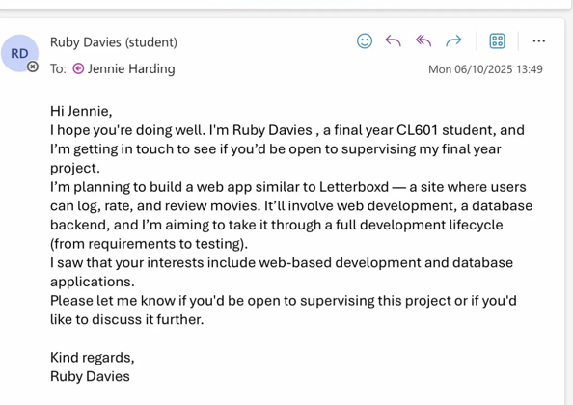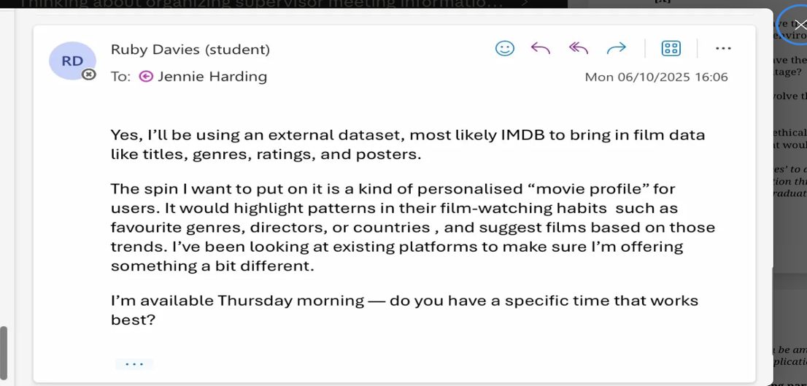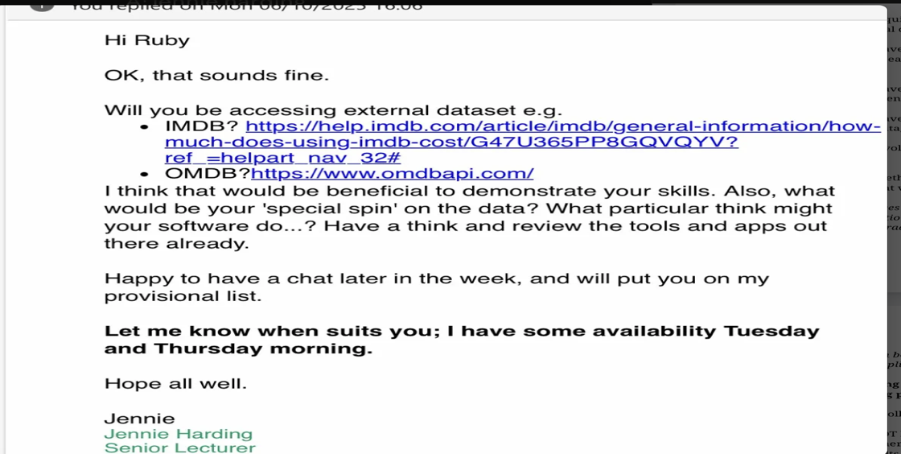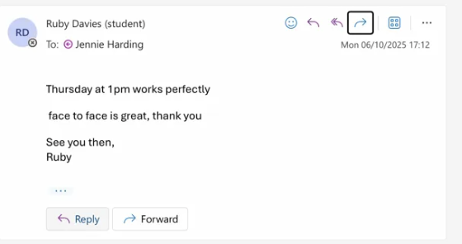

A.2.2 Group Meeting Organisation
On 11th November 2025, Jennie emailed all supervisees to organise weekly group meetings via Teams. A weekly Q&A drop-in slot was established for Mondays, with 1:1 meetings available by appointment approximately once a fortnight. The group meeting schedule was confirmed via Microsoft Teams on 14th November 2025.
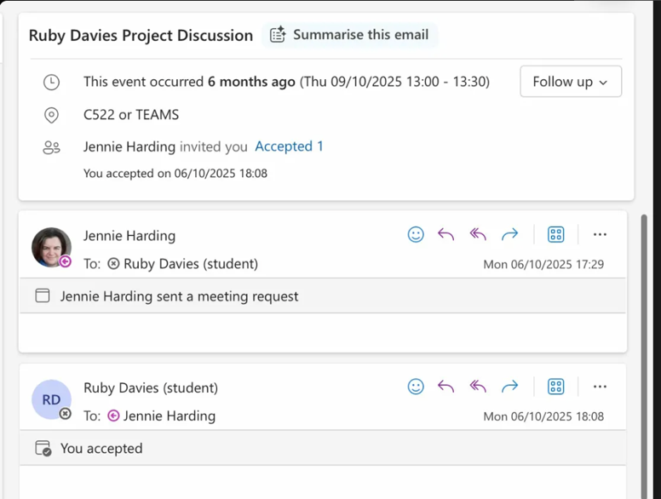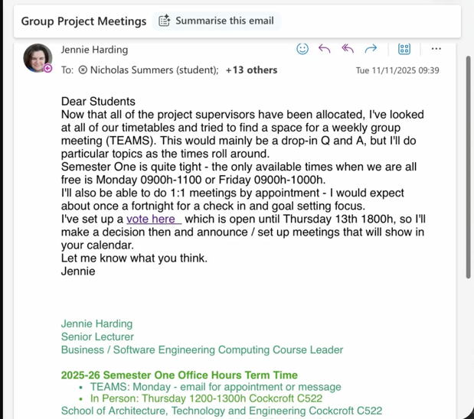
A.2.3 Viva Organisation
On 15th December 2025, Jennie emailed students with available viva slots, to be arranged with second reader Sarah Swartwood. Ruby responded on 17th December 2025 confirming the 10:00 slot on Wednesday 21st January 2026. The viva was held in person at Mithras House G10.
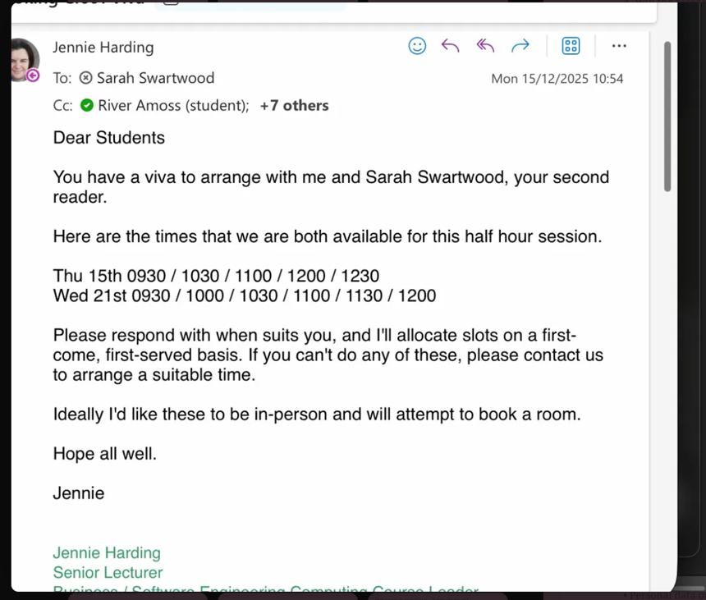
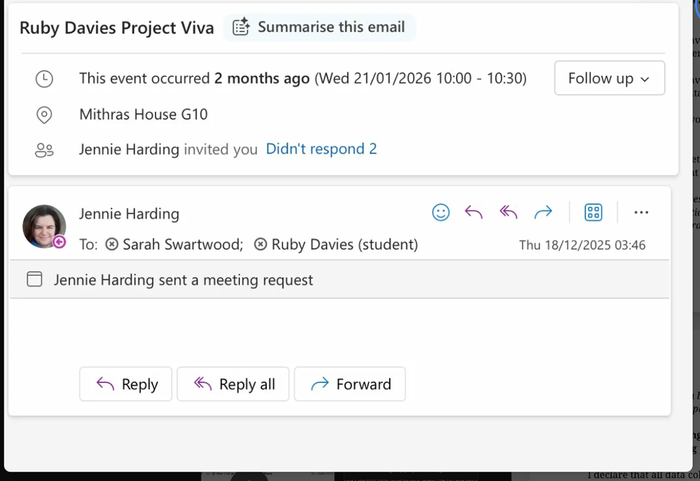

A.2.4 Semester Two Meetings
On 5th February 2026, Jennie announced the Semester Two drop-in schedule — a weekly optional half-hour session for Q&A, with 1:1 meetings also available. On 10th March 2026, a reminder was sent confirming the Monday drop-in meetings (10:30–11:00 via Teams) and noting leave dates in April.]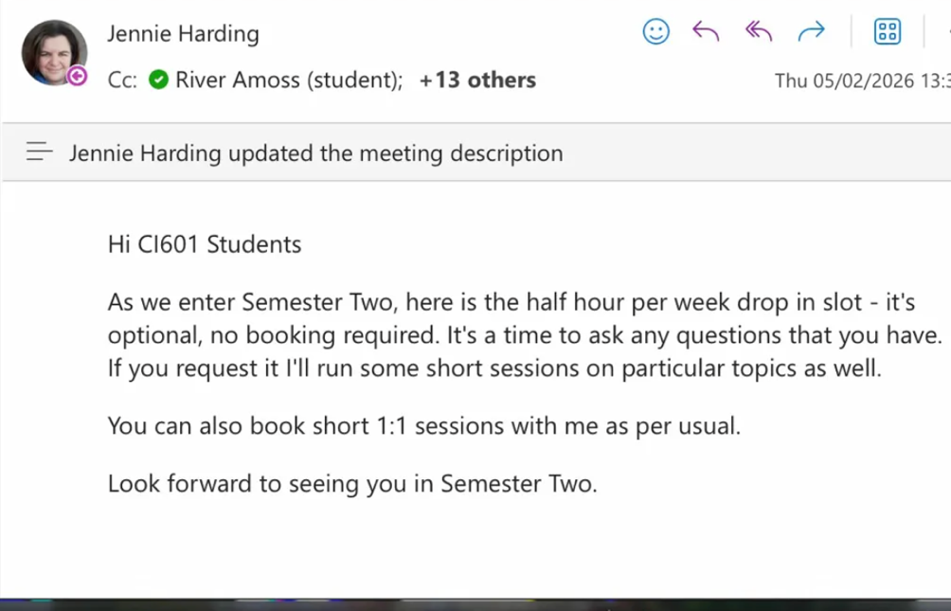
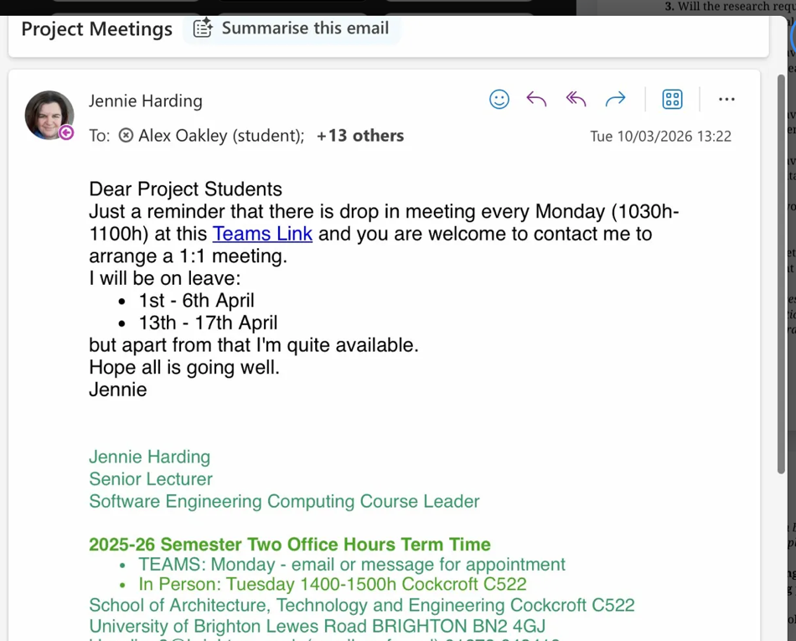

APPENDIX B: ETHICS CHECKLIST
The following checklist was used to determine whether the project falls within the scope of the University’s Research Ethics Policy, and whether ethical review was required (see section 3 of the Research Ethics Policy for further information on the types of research that falls within its scope).
School of Architecture, Technology and Engineering
Student Name: Ruby Davies
Project Title: Cinescope

1. Will the project involve the participation of humans (e.g. interviews, surveys, focus groups, observations, photography, audio or video recording, physical activity or invasive/intrusive procedures)? Yes [X] No [ ]

2. Will the research involve the use of bodily materials derived or obtained from humans? Yes [ ] No [X]

3. Will the research require access to, collection of or use of (non-personal) sensitive or confidential data? Yes [ ] No [X]

4. Does the research have the potential to expose any person, whether or not participating in the research, to physical or psychological harm? Yes [ ] No [X]

5. Does the research have the potential for significant negative impact on or damage to the natural environment? Yes [ ] No [X]

6. Does the research have the potential for significant negative impact on culture or cultural heritage? Yes [ ] No [X]

7. Will the research involve the use of or study of animals of any kind? Yes [ ] No [X]

8. Are there any other ethical issues raised by this research project that in the opinion of the applicant would warrant ethical review? Yes [ ] No [X]

If you have answered ‘yes’ to any questions from 3 to 8, then an individual research ethics application through BREAM would be necessary. This is not practical for an undergraduate project. You should discuss with your supervisor how data collection can be amended to fit under the umbrella of the module-wide research ethics application without compromising your project.

Start date (if recruiting participants): 21 October 2025
End date (if recruiting participants): 12 June 2026

I declare that all data collection will be covered by the module-wide research ethics application.
I confirm that I will NOT be collecting:
• Personal data on vulnerable adults
• Personal data on adults who are not CI601 students (this includes data on things such as names, addresses, photographs of the respondents etc)
• Personal data that could identify the respondents
• Personal data that is classified as sensitive

I understand that I will need to make an individual research ethics application through BREAM if my data collection goes beyond the umbrella of the CI601 research ethics application.

Signed: Ruby Davies

APPENDIX C PROJECT PLAN

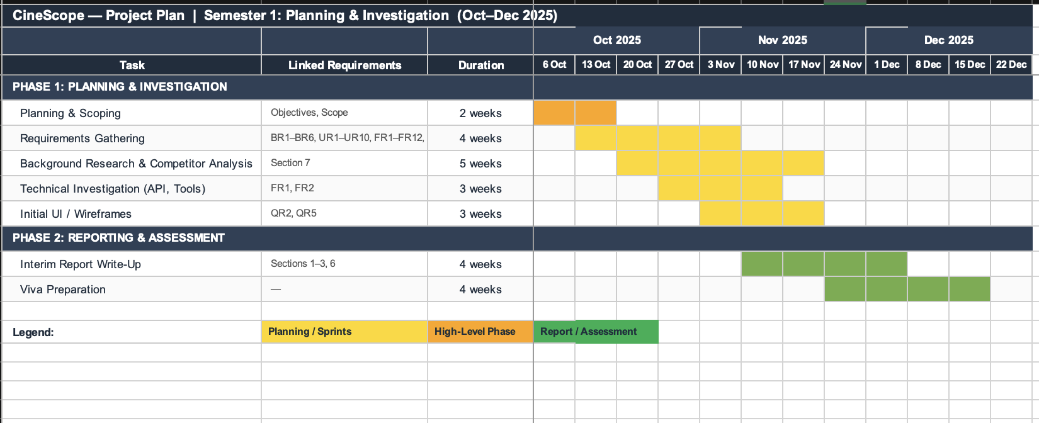

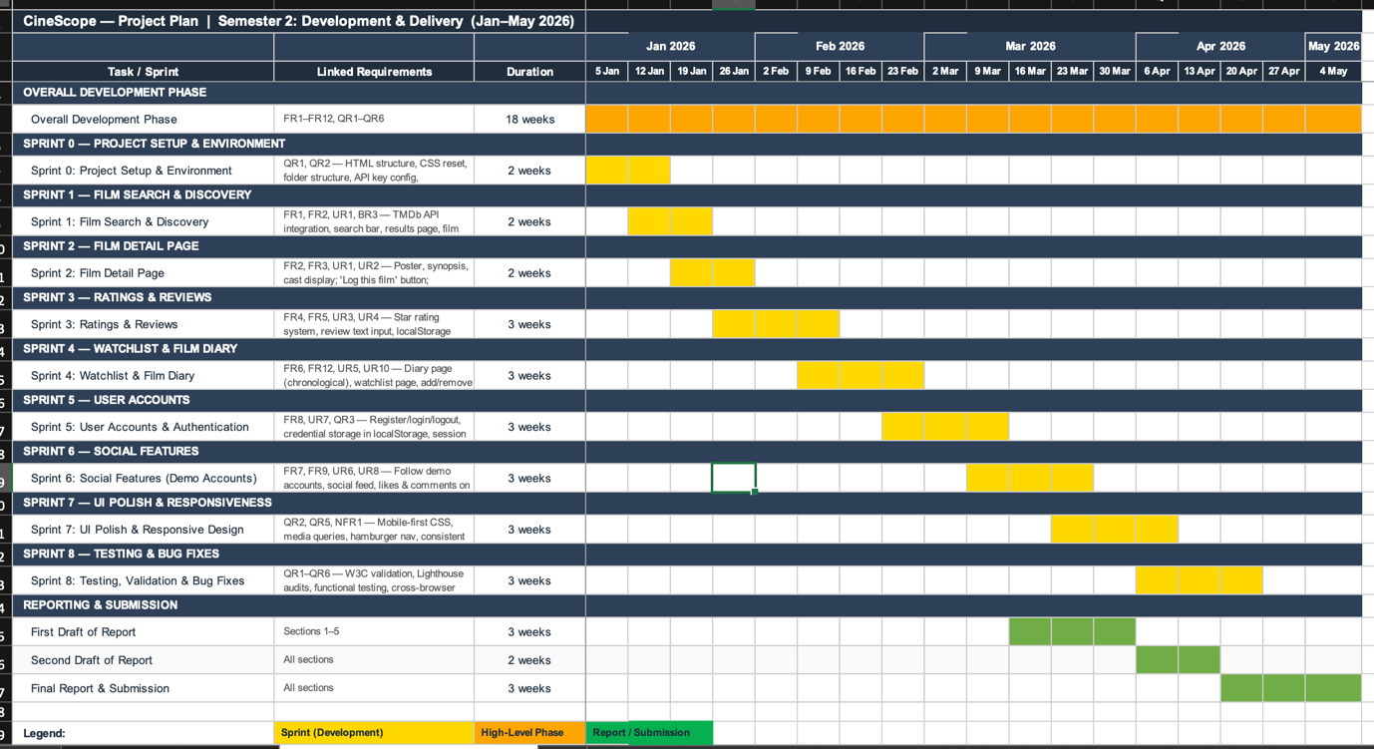

APPENDIX D: WIREFRAMES
The following wireframes were created during the design phase to guide the development of key application pages.
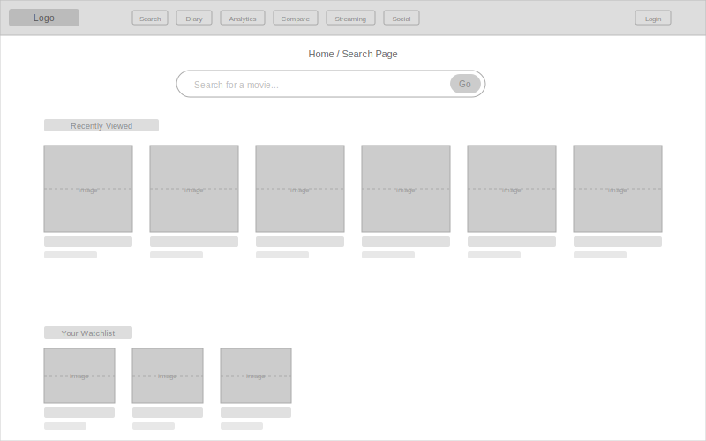
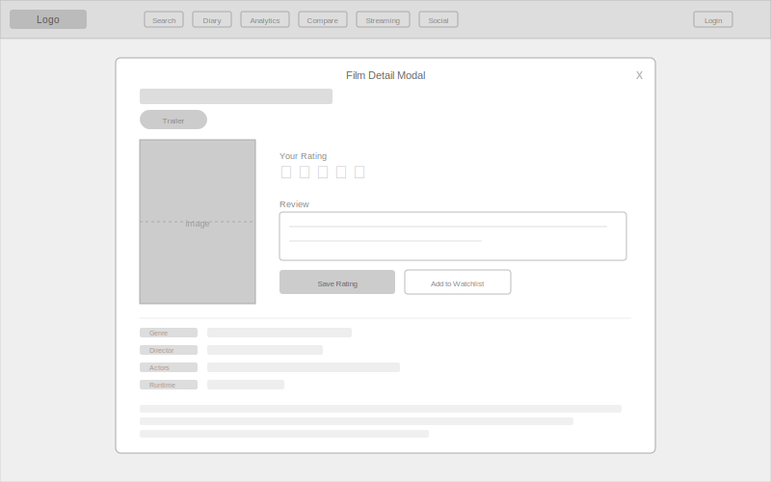]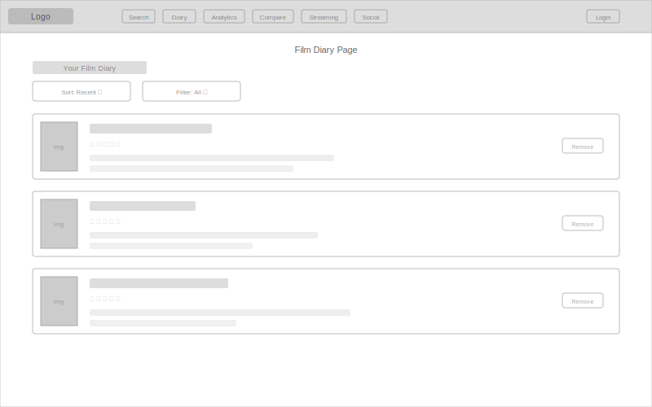
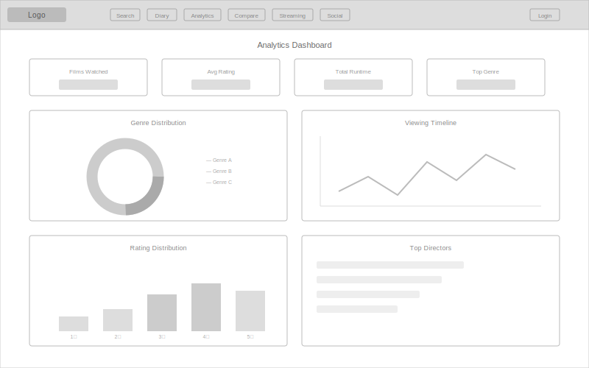
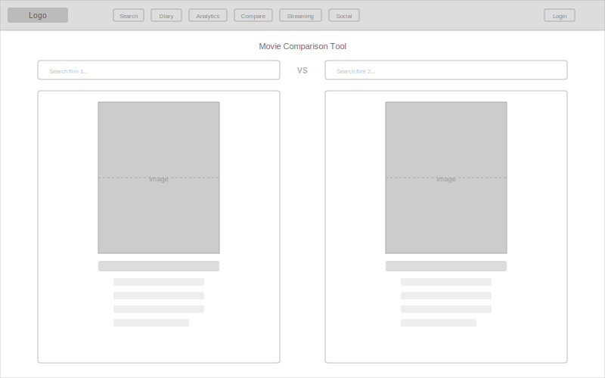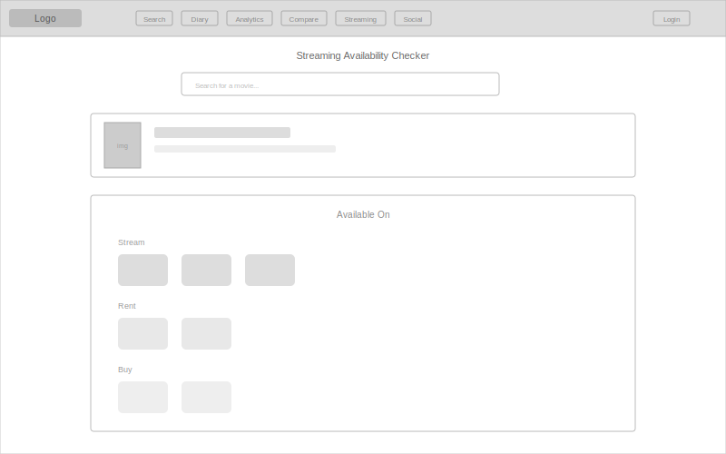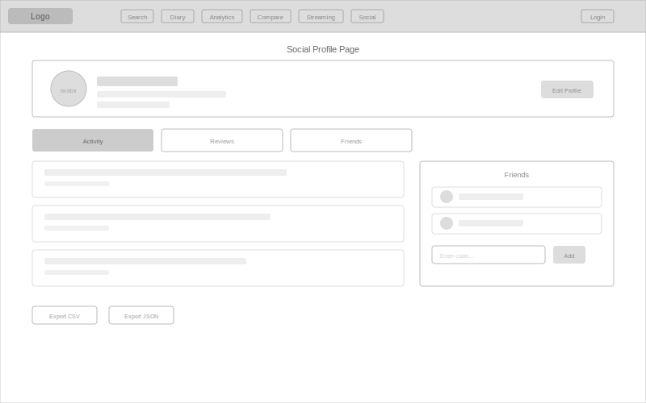

APPENDIX E: TECHNICAL DOCUMENTATION
E.1 Application File Structure
The CineScope application is organised as a client-side single-page architecture with the following file structure:
cinescope/
├── index.html (Home/Search page)
├── diary.html (Film Diary page)
├── analytics.html (Analytics Dashboard)
├── compare.html (Movie Comparison Tool)
├── streaming.html (Streaming Availability Checker)
├── social.html (Social Profile page)
├── css/
│ └── styles.css (Global stylesheet)
├── js/
│ ├── app.js (Core application logic)
│ ├── navbar.js (Dynamic navbar injection)
│ ├── diary.js (Diary page logic)
│ ├── analytics.js (Chart.js visualisations)
│ ├── compare.js (Comparison tool logic)
│ ├── streaming.js (Streaming checker logic)
│ └── social.js (Social/profile logic)
└── img/ (Static image assets)
E.2 API Integration Reference
CineScope integrates with two external APIs:
OMDb API (https://www.omdbapi.com/) — The primary data source for film metadata. Two endpoints are used: the search endpoint (s= parameter) returns a paginated list of matching titles with basic information (title, year, poster, IMDb ID), while the detail endpoint (i= parameter) retrieves comprehensive metadata for a specific film by IMDb ID, including genre, director, actors, runtime, plot, and ratings from IMDb, Rotten Tomatoes, and Metacritic. All requests are authenticated via an API key passed as a query parameter.
TMDb API (https://api.themoviedb.org/3/) — Used exclusively for trailer retrieval. The /movie/{id}/videos endpoint returns available video content, from which YouTube trailer URLs are extracted and embedded within the film detail modal.
E.3 localStorage Data Schema
All user-generated data is persisted in the browser’s localStorage using JSON-serialised key-value pairs. The following keys are used:
viewedMovies: Array of objects representing logged films, each containing the IMDb ID, title, poster URL, date viewed (ISO timestamp), user star rating (1–5), and optional review text.
watchlist: Array of objects representing films saved for future viewing, each containing the IMDb ID, title, poster URL, and year.
movie_[imdbID]: Cached full film metadata from the OMDb detail endpoint, reducing redundant API calls when revisiting previously viewed films.
search_[query]_[page]: Cached search results from the OMDb search endpoint, avoiding repeated API calls for identical queries.
userProfile: Object containing the user’s display name, bio text, selected avatar emoji, and share code for the social profile system.
friends: Array of friend connection objects storing each friend’s share code and display name.
activityFeed: Array of activity event objects recording user actions (ratings, reviews, friend additions) with timestamps for display in the social activity feed.
darkMode: Boolean flag storing the user’s dark mode preference, applied consistently across all pages on load.
E.4 Local Setup Instructions
To run CineScope locally:
1. Clone or download the project repository to a local directory.
2. Obtain API keys from OMDb (https://www.omdbapi.com/apikey.aspx) and TMDb (https://www.themoviedb.org/settings/api).
3. Insert the API keys into the relevant JavaScript files where the API key constants are defined.
4. Open index.html in a modern web browser (Chrome, Firefox, Safari, or Edge). No build tools, package managers, or server configuration is required as the application runs entirely client-side.
5. For full functionality including API requests, a local development server (such as the Live Server extension for VS Code) is recommended to avoid CORS restrictions on file:// protocol requests.

APPENDIX F: SCREENSHOTS OF THE LIVE APPLICATION
The following screenshots illustrate the final CineScope application across its key pages and features.
[Insert screenshot: Home Page — showing search bar, recently viewed films, and navigation bar.]
[Insert screenshot: Search Results — showing movie card grid returned from the OMDb API.]
[Insert screenshot: Film Detail Modal — showing poster, metadata, star rating, and review input.]
[Insert screenshot: Film Diary Page — showing logged films with dates, ratings, and reviews.]
[Insert screenshot: Watchlist Page.]
[Insert screenshot: Analytics Dashboard — showing Chart.js visualisations.]
[Insert screenshot: Movie Comparison Tool.]
[Insert screenshot: Streaming Availability Checker.]
[Insert screenshot: Social Profile Page — showing profile, friends, reviews, and activity feed.]
[Insert screenshot: Mobile Responsive View (375px) and Dark Mode.]

APPENDIX G: USABILITY QUESTIONNAIRE AND RESULTS
A usability questionnaire was conducted to evaluate user satisfaction and identify areas for improvement. Participants were asked to complete a series of tasks within CineScope and then respond to the following questions.
G.1 Questionnaire
[Insert questionnaire. Suggested questions: (1) How easy was it to search for a film? (1–5), (2) How intuitive was logging and rating a film? (1–5), (3) How useful was the film diary feature? (1–5), (4) How would you rate the overall visual design? (1–5), (5) Did the application respond well on mobile/tablet? (Yes/No), (6) Were any features confusing? (Open), (7) What features would you add? (Open)]
G.2 Results
[Insert summary table of questionnaire responses and any charts/graphs showing participant feedback.]

APPENDIX H: LIGHTHOUSE AND W3C VALIDATION SCREENSHOTS
The following screenshots document the results of Google Lighthouse audits and W3C validation for each page of the CineScope application.
H.1 Google Lighthouse Audits
[Insert screenshot: Lighthouse Desktop Audit — Performance 100, Accessibility 86, Best Practices 96.]
[Insert screenshot: Lighthouse Mobile Audit.]
H.2 W3C HTML Validation
[Insert W3C Markup Validation screenshots for: index.html, diary.html, analytics.html, compare.html, streaming.html, social.html.]
H.3 W3C CSS Validation
[Insert W3C CSS Validation screenshot for styles.css.]

APPENDIX I: TESTING DOCUMENTATION
This appendix contains the complete functional requirement test cases, quality requirement test cases, requirements traceability matrix, and browser compatibility testing results for CineScope.
[Insert the contents of the Functional Requirement Test Cases document here. This document contains test case tables for FR1–FR12 (functional requirements), QR1–QR5 (quality requirements), a requirements traceability matrix, and browser compatibility testing results.]

