Name: Boyalapalli. Margarate
Branch: CSE AI& ML
Roll no: 26000872
Section: CSM-1

ONLINE LEARNING PLATFORM INTERFACE

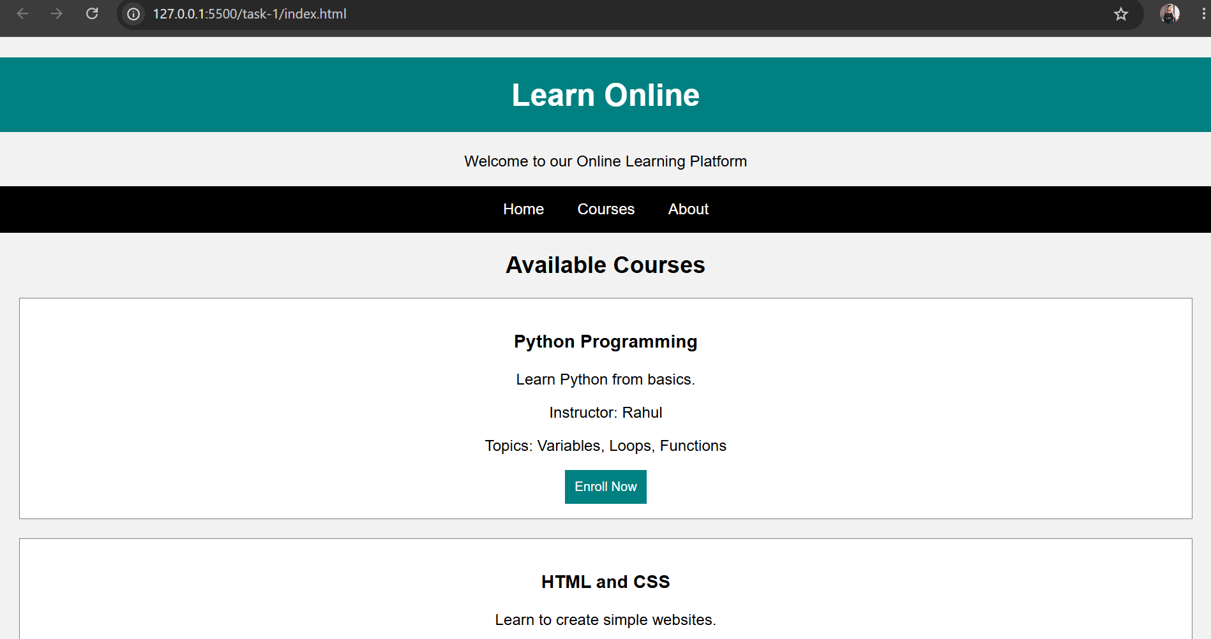

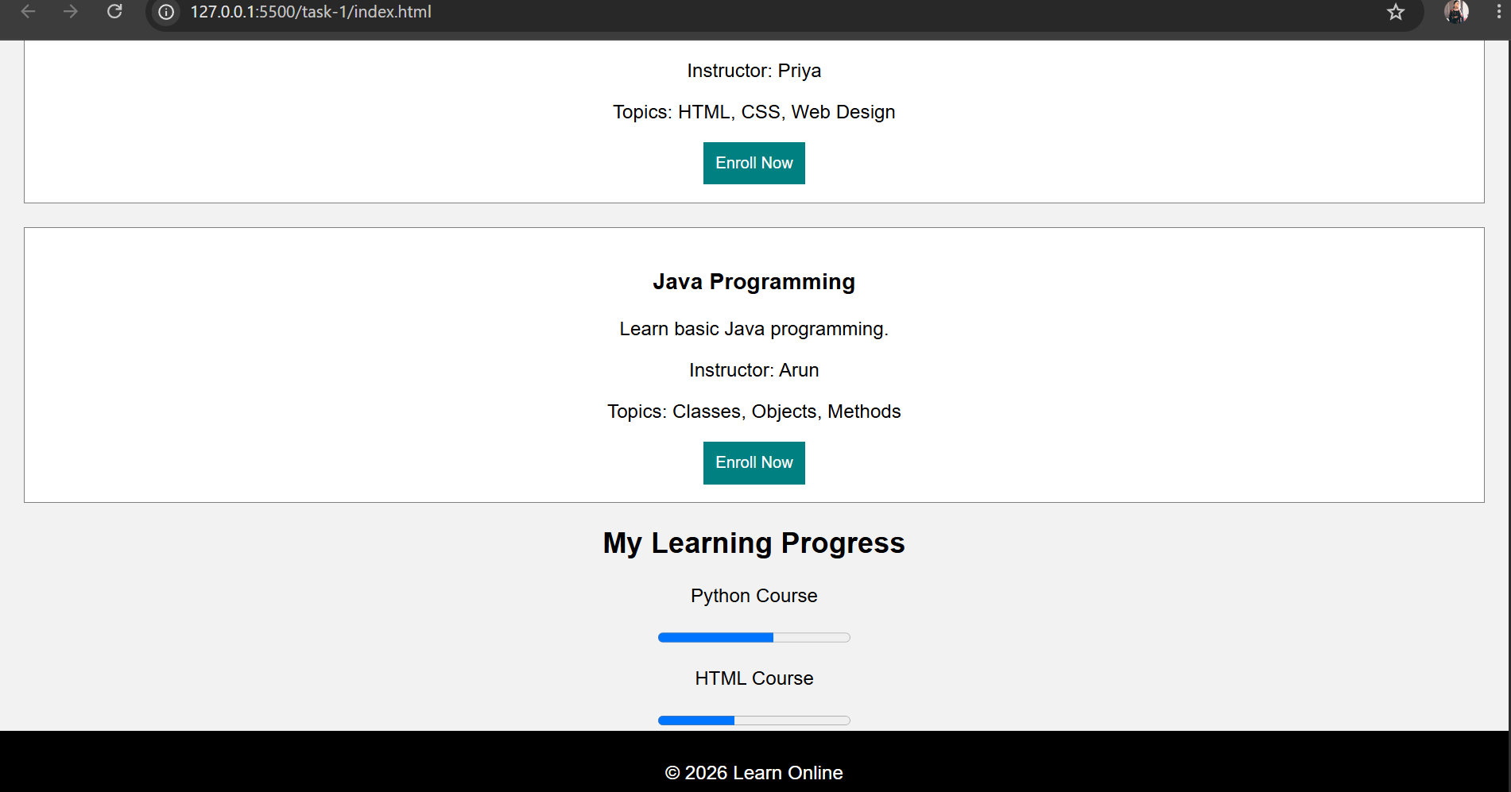

DOCTOR APPOINTMENT BOOKING INTERFACE

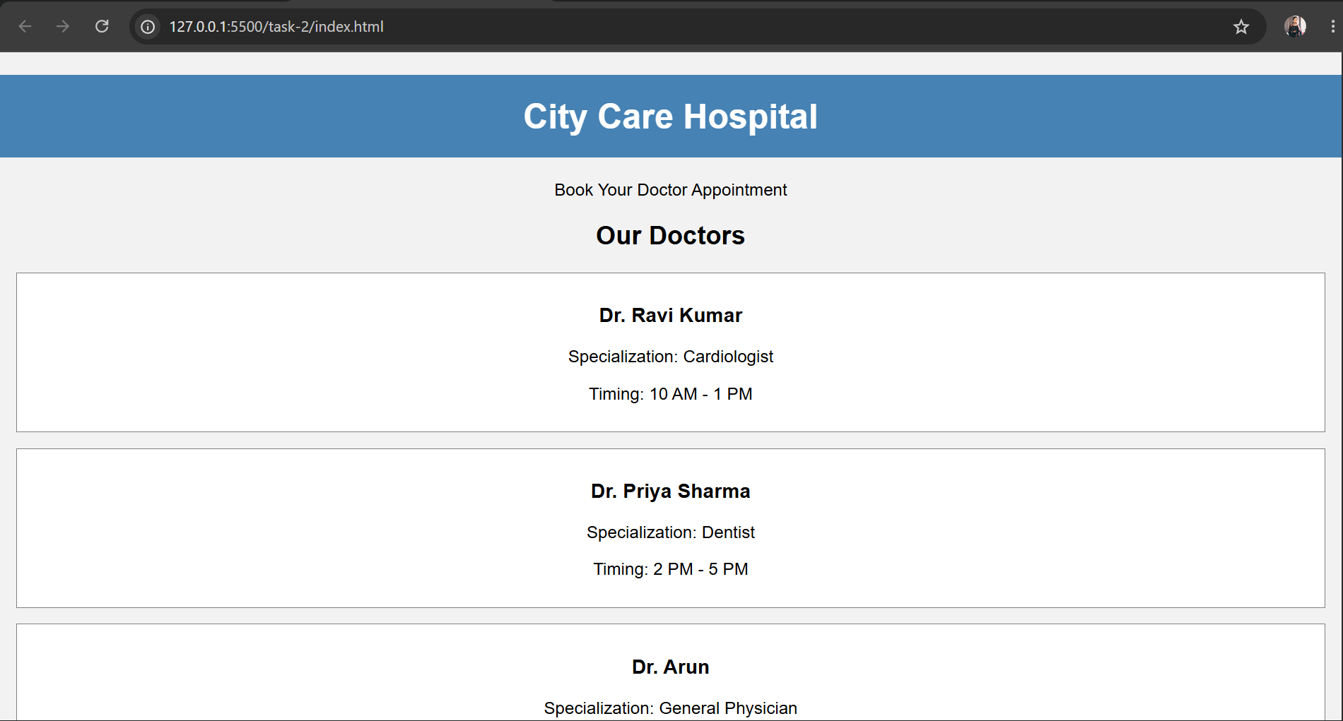

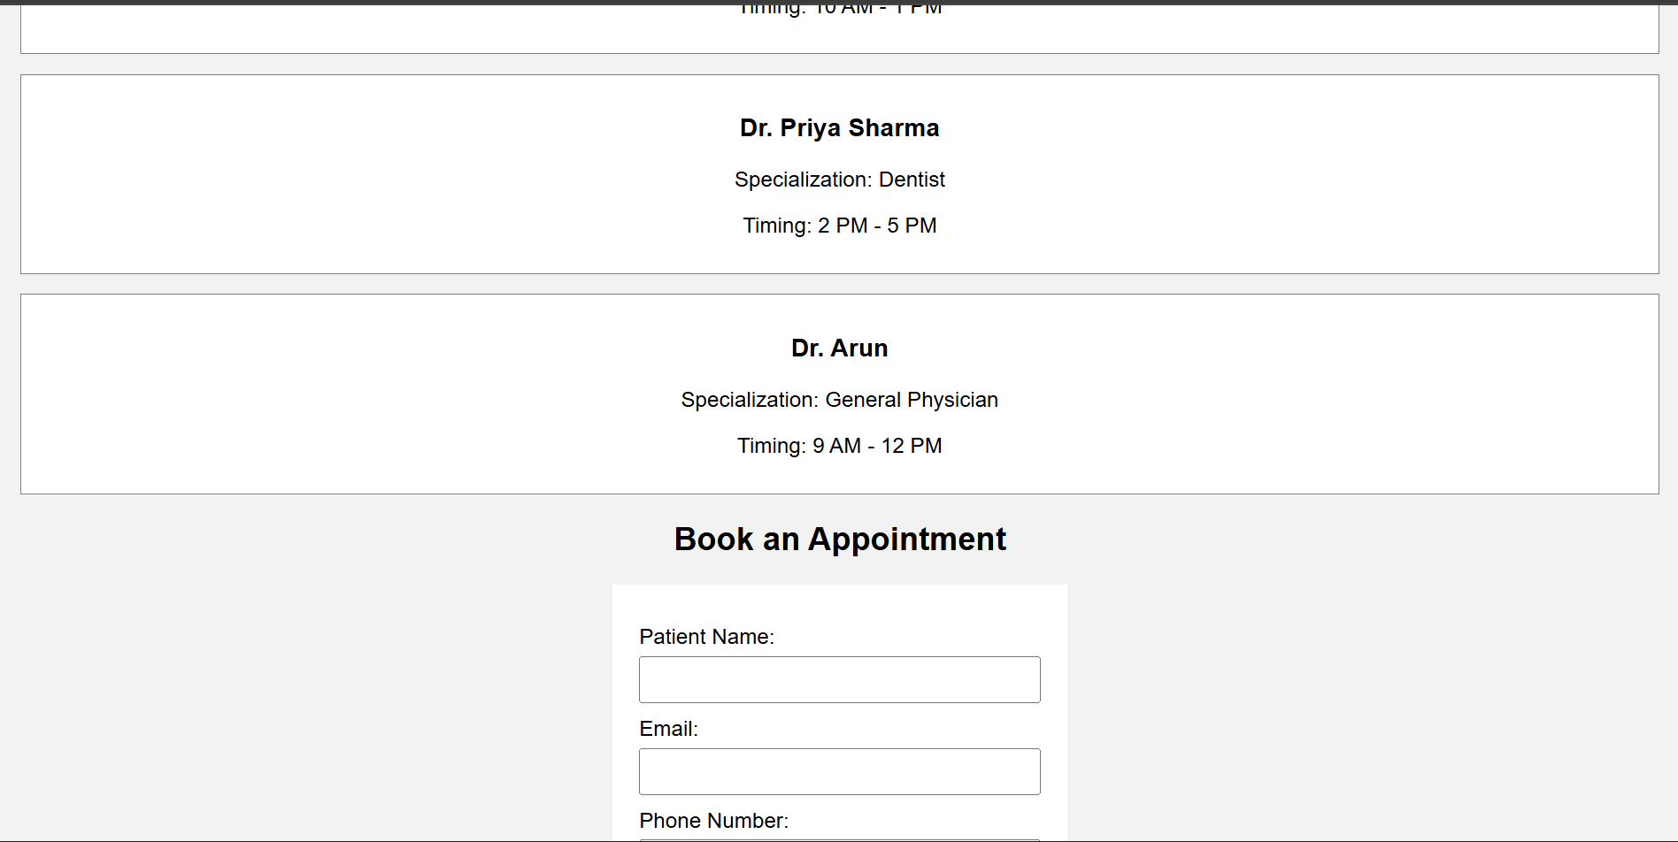

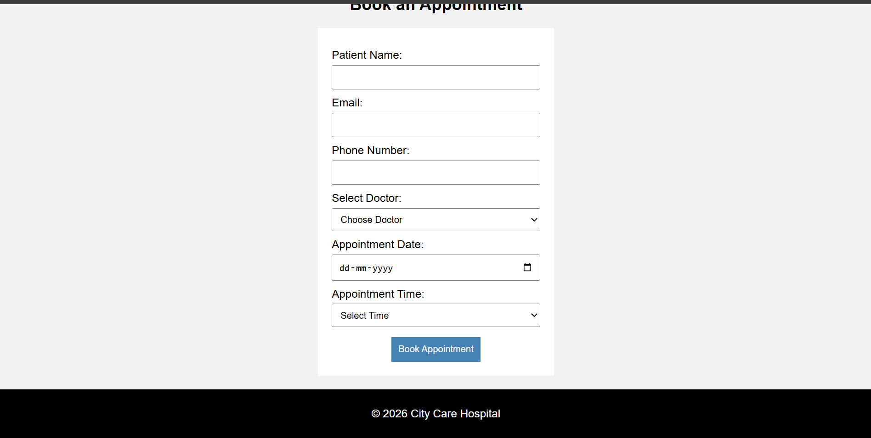

USER REGISTRATION AND LOGIN INTERFACE



