Inroduction
Robotic arm we are making is desktop size Articulated robot with a gripper which can be used to handle very small loads, with 6 (Degree of freedom) DOF.The inspiration for making this robot is from Iron Man movie this is mimature size robot arm which works same as real industrie robots used
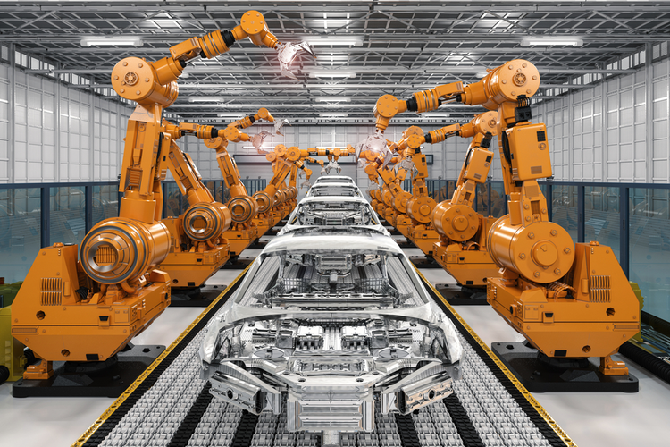  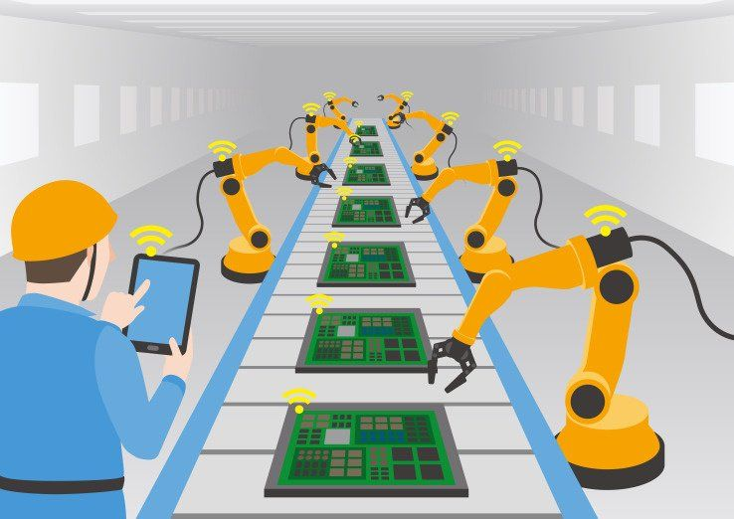 | 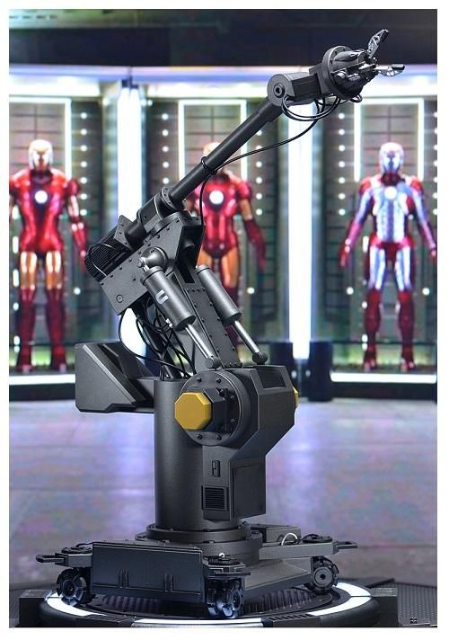

Now a day robots are used for all kinds of work form cleaning to high precision cutting in industries as well as in small scale industries
even for cooking

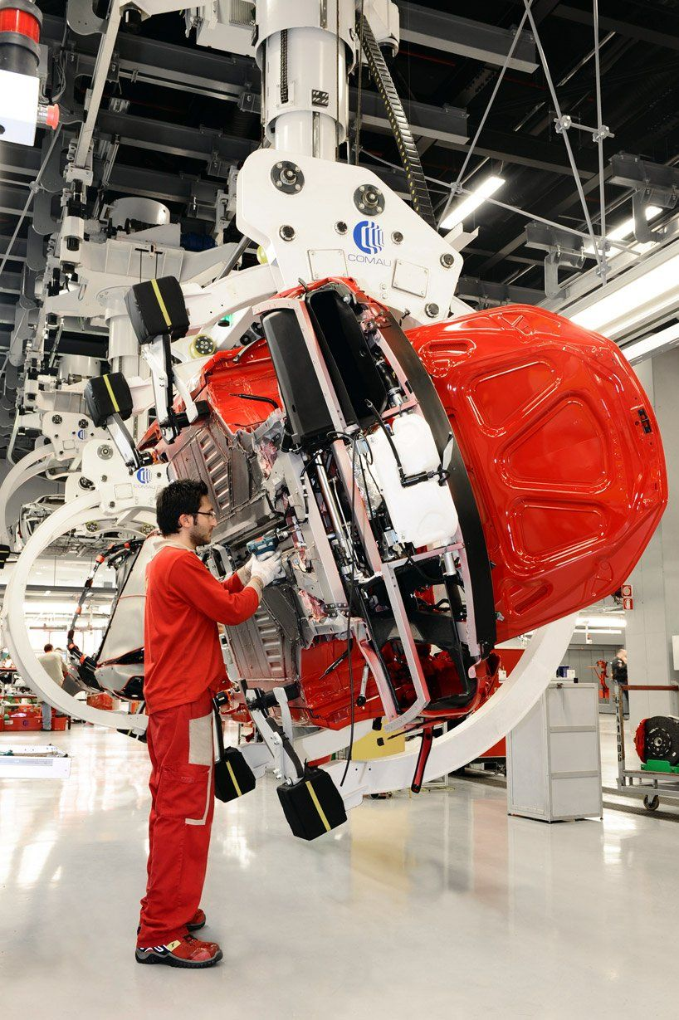 | 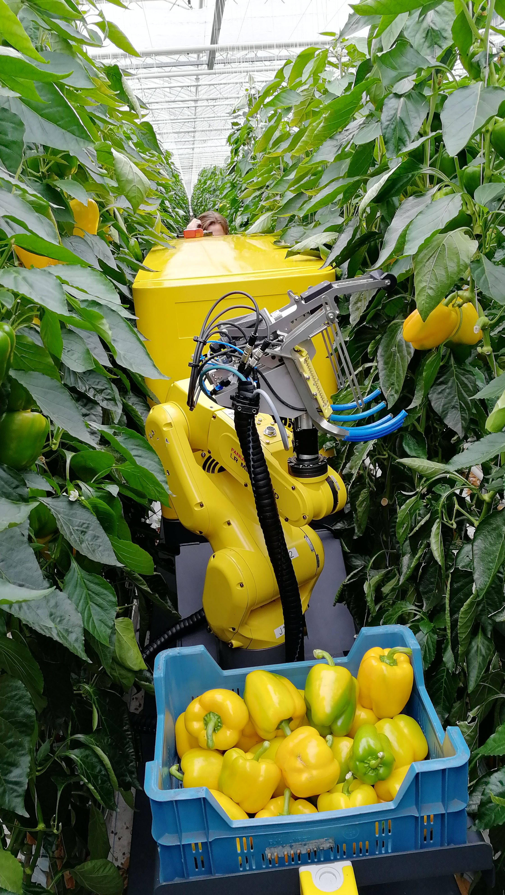
Robot is a mechanical arm, a manipulator designed to perform many different tasks and capable of repeating,useing variable programming. to perform its assigned tasks, the robot can move parts, objects, tools, and special devices by means of programmed motions and points.
Its main function is to move from point to point, as instructed by the controller
In manufacturing industry and nuclear industry, a large fraction of the work is repetitive and judicious application of automation will most certainly result in optimum utilization of machine and manpower. A pneumatic `Pick and Place' Robot has been developed to achieve automation in applications where great sophistication is not needed and simple tasks like picking up of small parts at one location and placing them at another location can be done with great ease

Design
We have found 4 interesting designs on web, based on looks, size, and how easy it is to build.
- A4
- Thor
- Educative 6 Axis Robot Arm
- BCN3D/BCN3D-Moveo
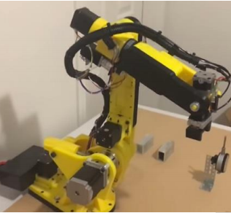 | 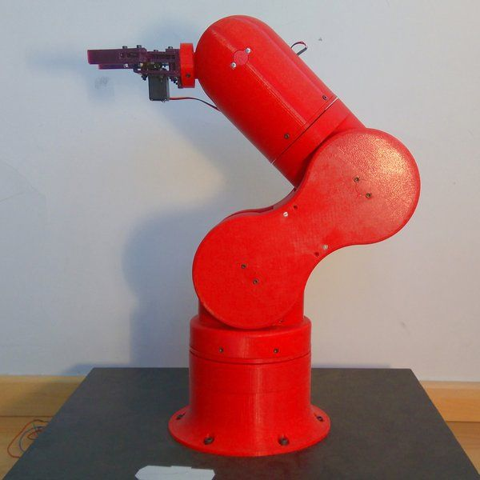
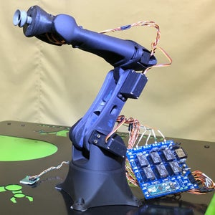 | 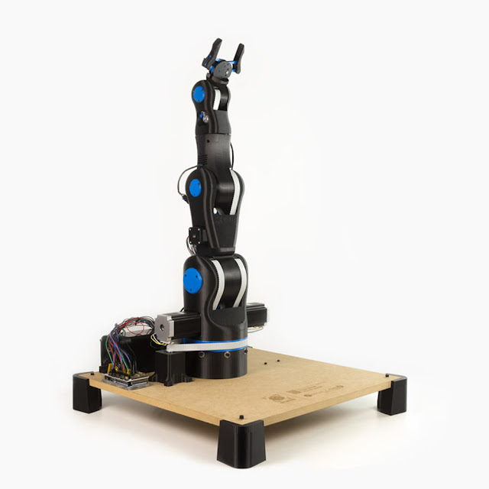

We finalised the Educative 6 Axis Robot Arm project

- All the Materials very accessible
- Can be build with in Rs:30,000 easily
- less complex in design than other 3 projects
- less number of parts than other 3 projects
- Small in size
- prebuild control software ready to use if programing fails
- No need of any specialised motors like in A4 project

The DIY-Robotics educative cell
we have taken only the mechanical core

The DIY-Robotics educative cell is a platform that includes a 6-axis robotic arm,with an electronic control circuit and a programming software prebuild.
This platform is an introduction to the world of industrial robotics.Through this project, DIY-Robotics wishes to offer an affordable but quality solution to all those who would like to learn more about this fascinating field. This project is an excellent opportunity to develop various knowledge and skills in the fields of mechanics, electrical as well as computer science. With the DIYRobotics educative cell, robotics is within everyone's reach has of now explaned above this is fablous project we have taken only the mechanical core of the project and modifing the electrical and useing ROS software for control.

Problems

1. Printed parts is not good has we thought
- we had to re-render .stl file to get 3d parts more accurate finishing
- one parts has been printed without groove to solve we drilled it for groove and somme unaccurate parts needed our hand finishing to fit correctly

2.slippery connection
- Due to FDM printing we can not get exact hole to fit the motor spindle No matter how tight we connect the part to spindle it has eventutialy got into slippery connection so without solving we can't move ahead.
- we solved this by insert nut technique use in carpentry to fasten but we didn't used insert nut.nstred cutted the pulley which come along with motor pack and by using soltring gun to mounted it holes.

