Kamraj

BESIT

Robotic Arm

Project Report

Contents

Figure list 3

1 Inroduction 4

2 lecture review 6

2.1 Technical Term 6

2.2 Robot Anatomy 7

2.2.1 Links 8

2.3 joints and joint notation scheme 9

2.4 Degrees of freedom (DOF) 11

2.5 Arm Configuration 12

2.6 The end effector 12

3 Study Area 14

3.1 Servo Motors 14

3.1.1 Servo Motor Connections 14

3.1.2 Servo Positioning 14

3.2 ESP32 microcontroller 15

3.2.1 features of the ESP32 15

3.2.2 Programming the ESP32 16

3.3 Power 16

3.3.1 Voltage Requirements 16

3.3.2 Voltage Regulation 17

3.3.3 Current Requirements 17

3.3.4 Efficiency 18

3.3.5 Power Supply Basics 18

3.3.6 AC-DC 18

3.3.7 Convert it from AC to DC. 19

3.3.8 Switching power supply (60W) 19

3.3.9 Regulators and Converters 19

3.3.10 Buck converter 20

4 Design and Fabrication 22

4.1 3.1 Overview 22

4.1.1 Articulated Robotic Arm 22

4.2 Our design 23

4.2.1 WE FINALISED THE EDUCATIVE 6 AXIS ROBOT ARM PROJECT 23

4.2.2 THE DIY-ROBOTICS EDUCATIVE CELL 24

4.3 Complaint List 25

4.4 Mechanical Core (Body) 27

4.4.1 links 27

4.4.2 joints 31

5 Result and Discussion 33

5.1 Things that are working 33

5.2 soft upgrade 33

5.3 hard upgrade 33

6 Conclusion and scope for future study 35

7 References 36

# Figure list

Figure 2.1 7

Figure 2.2 8

Figure 2.3 9

Figure 2.4 10

Figure 4.1 Base link 27

Figure 4.2 link 1 28

Figure 4.3:link-2 28

Figure 4.4: link-3 29

Figure 4.5: link-4 29

Figure 4.6:link-5 30

Robotic arm

# Inroduction

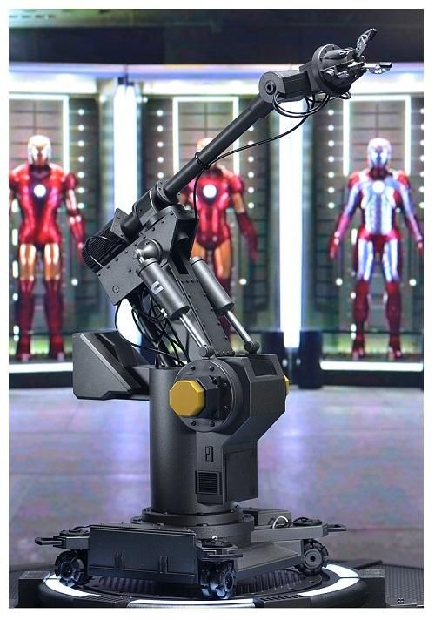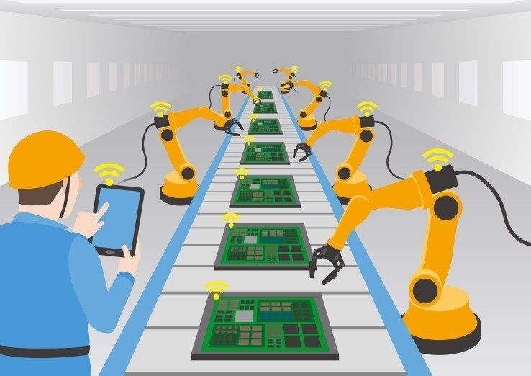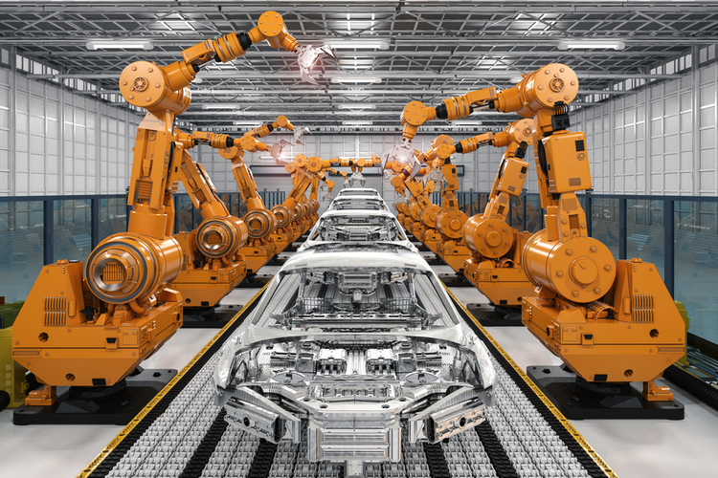Robotic arm we are making is desktop size Articulated robot with a gripper which can be used to handle very small loads, with 6 (Degree of freedom) DOF. The inspiration for making this robot is from Iron Man movie (1) this is miniature robot arm

Robotic arm is a mechanical manipulator designed to perform many different tasks and capable of repeating, using variable programming. to perform its assigned tasks, the robot can move parts, objects, tools, and special devices by means of programmed motions and points.

Its main function is to move from point to point, as instructed by the controller

In manufacturing industry and nuclear industry, a large fraction of the **work is repetitive** and judicious application of automation will most certainly result in optimum utilization of machine and manpower. A pneumatic `Pick and Place' Robot has been developed to achieve automation in applications where great sophistication is not needed and simple tasks like picking up of small parts at one location and placing them at another location can be done with great ease

# lecture review

## Technical Term

* SPEED: Speed is the amount of distance per unit time at which the robot can move, usually specified in inches per second or meters per second. The speed is usually specified at a specific load or assuming that the robot is carrying a fixed weight. Actual speed may vary depending upon the weight carried by the robot
* LOAD BEARING CAPACITY: Load bearing capacity is the maximum weight carrying capacity of the robot. Robots that carry large weights, but must still be precise are expensive.
* ACCURACY: Accuracy is the ability of a robot to go to the specified position without making a mistake. It is impossible to position a machine exactly. Accuracy is therefore defined as the ability of the robot to position itself to the desired location with the minimal error (usually 0.001 inch).
* REPEATABILITY: Repeatability is the ability of a robot to repeatedly position itself when asked to perform a task multiple time. Accuracy is an absolute concept, repeatability is relative. Note that a robot that is repeatable may not be very accurate. Likewise, an accurate robot may not be repeatable.
* WORK ENVELOPE: Work envelope is the maximum robot reach, or volume within which a robot can operate. This is usually specified as a combination of the limits of each of the robot's parts. The figure below shows how a work-envelope of a robot is documented.
* WORKCELLS: Robots seldom function in an isolated environment. In order to do useful work, robots must coordinate their movements with other machines and equipment, and possibly with humans. A group of machines/equipment positioned with a robot or robots to do useful work is termed a work cell. For example, a robot doing welding on an automotive assembly line must coordinate with a conveyor that is moving the car-frame and a laser-positioning inspection robot that uses a laser beam to locate the position of the weld and then inspect the quality of the weld when it is complete (2)

## Robot Anatomy

Figure .

As mentioned in the introduction to the chapter, the manipulator or robotic arm has many similarities to the human body. The mechanical structure of a robot is like the skeleton in the human body. The robot anatomy is, therefore, the study of skeleton of robot, that is, the physical construction of the manipulator structure. The mechanical structure of a manipulator that consists of rigid bodies (links) connected by means of articulations (joints), is segmented into an arm that ensures mobility and reachability, a wrist that confers orientation, and an end- effector that performs the required task. Most manipulators are mounted on a base fastened to the floor or on the mobile platform of an autonomous guided vehicle (AGV). The arrangement of base, arm, wrist, and end-effector is shown in Figure 2.1

### Links

The mechanical structure of a robotic manipulator is a mechanism, whose members are rigid links or bars.

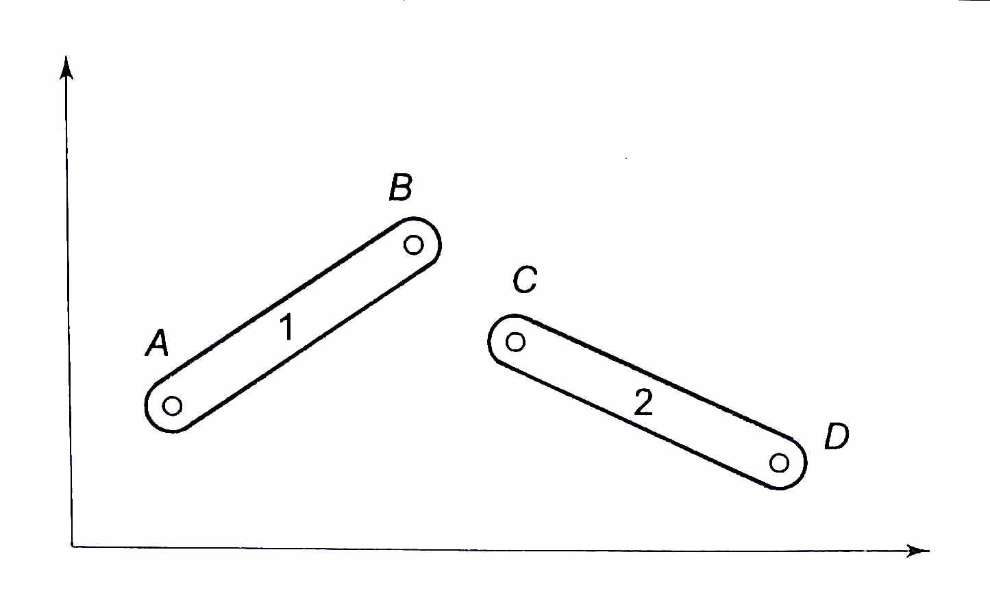A rigid link that can be connected, at most, with two other links is referred to as a binary link. Figure 2.2 shows two rigid binary "links, 1 and 2, each with two holes at the ends A, B, and C, D, respectively to connect with each other or to other links. Two links are connected together by a joint. By putting a pin through holes B and C of links 1 and 2, an open kinematic chain is formed as shown in Fig. 2.3. The joint formed is called a pin joint also known as a revolute or rotary joint. 12 Relative rotary motion between the links is possible and the two links are said to be paired. In Fig. 2.3 links are represented by straight lines and rotary joint by a small circle. Figure 2.2

Figure .

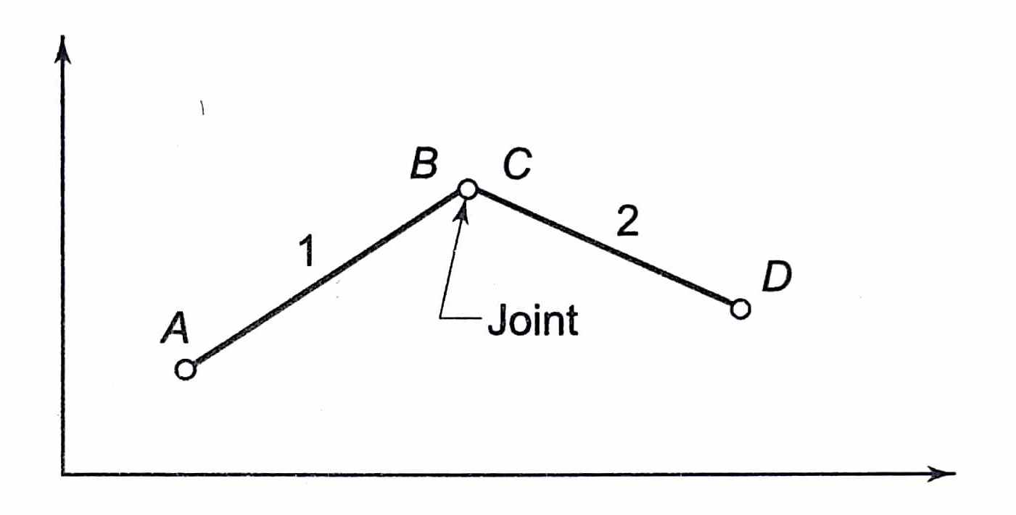

Figure .

## joints and joint notation scheme

Many types of joints can be made between two links. However, only two basic types are commonly used in industrial robots.

1. Revolute (R)
2. Prismatic (P)

The relative motion of the adjoining links of a joint is either rotary or linear depending on the type of joint. Revolute joint: It is sketched in Figure 2.4(a). The two links are joined by a pin (pivot) about the axis of which the links can rotate with respect to each other. Prismatic join': It is sketched in Figure 2.4(b). The two links are so jointed that these can slide (linearly move) with respect to each other. Screw and nut (slow linear motion of the nut), rack and pinion are ways to implement prismatic joints. 13 Other types of possible joints used are: planar (one surface sliding over another surface); cylindrical (one link rotates about the other at 90° angle. Figure 2.4 and spherical (one link can move with respect to the other in three dimensions). Yet another variant of rotary joint is the 'twist' joint, where two links remain aligned along a straight line but one turns (twists) about the other around the link axis, Figure 2.4(d). At a joint, links are connected such that they can be made to move relative to each other by the actuators. A rotary joint allows a pure rotation of one link relative to the connecting link and prismatic joint allows a pure translation of one link relative 10 the connecting link.

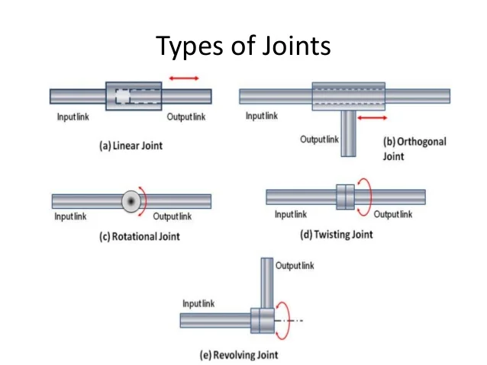The kinematic chain formed by joining two links is extended by connecting more links. To form a manipulator one end of the chain is connected to the base or ground with a joint. Such a manipulator is an open kinematic chain. The end-effector is connected to the free end of the last link as illustrated ill Fig. 1.5. Closed kinematic chains are used in special purpose manipulators such as parallel manipulators to create certain kind of motion of the end-effector. The kinematic chain of the manipulator is characterized by the degrees of freedom it has and the space its end-effector can sweep. These parameters are discussed in next sections.

Figure .

## Degrees of freedom (DOF)

The number of independent movements that an object can perform in a 3-D space is called the number of degrees of freedom (DOF). Thus, a rigid body free in space has six degrees of freedom- three for position and three for orientation. These six independent movements pictured in Fig. 2.5 are: 14 (i) Three translations (T1, T2, T3), representing linear motions along three perpendicular axes, specify the position of the body in space. (ii) Three rotations (R1, R2, R3), which represent angular motions about the three axes specify the orientation of the body in space. Note from the above that six independent variables are required to specify the location (position and orientation) of an object in 3-D space, that is. 2 x 3 = 6. Nevertheless, in a 2-D space (a plane), an object has 3-DOF-two translator and one rotational. For instance, link 1 and link 2 in Fig. 2.2 have 3-DOF each.

Consider an open kinematic chain of two links with revolute joints at A and B (or C), as shown in Fig. 2.6. Here, the first link is connected to the ground by a joint at A. Therefore, link I can only rotate about joint I (J I) with respect to ground and contributes one independent variable (an angle), or in other words, it contributes one degree of freedom. Link 2 can rotate about joint 2 (12 respect to link 1, contributing another independent variable and so another DOF. Thus, by induction, conclude that an open kinematic chain with one end connected to the ground by a joint and the farther end of the last link free has as many degrees of freedom as the number of joints in the chain. It is assumed that each joint has only one DOF. The DOF is also equal to the number of links in the open kinematic chain. For example, in Fig. 2.6, the open kinematic chain manipulator with two DOF has two links and two joints. The variable defining the motion of a link at a joint is called a joint-link variable. Thus, for an n-DOF manipulator n independent joint-link variables are required to completely specify the location (position and orientation) of each link (and joint), specifying the location of the end-effector in space. Thus, for the two-link, in turn, 2- DOF manipulator in Fig. 2.6, two variables are required to define location of end-point, point D.

## Arm Configuration

The mechanics of the arm with 3-DOF depends on the type of three joints employed and their arrangement. The purpose of the arm is to position the wrist in the 3- D space and the arm bas following characteristic requirements. • Links are long enough to provide for maximum reach in the space. • The design is mechanically robust because the arm has to bear not only the load of workpiece but also has to carry the wrist and the end-effector. According to joint movements and arrangement of links, four well-distinguished basic structural configurations are possible for the arm. These are characterized by the distribution of three arm joints among prismatic and rotary joints, and arc named according to the coordinate system employed or the shape of the space they sweep. The four basic configurations arc:

1. Cartesian (rectangular) configuration - all three P joints.
2. Cylindrical configuration - one R and two P joints.
3. Polar (spherical) configuration - two R and one P joint.
4. Articulated (Revolute or Jointed-arm) Configuration - all three R-joints.

## The end effector

The end-effector is external to the manipulator and its DOF do not combine with the manipulator's DOF, as they do not contribute to manipulability. Different end effectors can be attached to the end of the wrist according to the task to be executed. These can be grouped into two major categories:

1. Grippers
2. Tools

Grippers are end-effectors to grasp or hold the workpiece during the work cycle. The applications include material handling, machine loading-unloading, pelletizing, and other similar operations. Grippers employ mechanical grasping or other alternative ways such as magnetic, vacuum, bellows, or others for holding objects. The proper shape and size of the gripper and the method of holding are determined by the object to be grasped and the task to be performed

For many tasks to be performed by the manipulator, the end-effector is a tool rather than a gripper. For example, a cutting tool, a drill. a welding torch. a spray gun, or a screwdriver is the end-effector for machining, welding, painting, or assembly task, mounted at the wrist endpoint The tool is usually directly attached to the end of the wrist. Sometimes, a gripper may be used to hold the tool instead of the workpiece. Tool changer devices can also be attached to the wrist end for multi-tool operations in a work cycle.

# Study Area

## Servo Motors

Servo motors are geared DC motors that have an integrated servomechanism with a feedback loop to allow precise positioning of the motor shaft. A high gear ratio allows a small servo to have an impressive torque rating. Most servos are limited in rotation to either 180 or 270 degrees, with 180-degree servo motors being more common. There are specially modified servo motors that can rotate beyond 360-degrees.

Servo motors come in a wide range of sizes and can be controlled either with an analogy PWM signal or with a digital I/O signal

### Servo Motor Connections

Most analogy servo motors like the MG90 use a 3-wire color-coded cable for interfacing. Although the color-coding is not an official standard many manufacturers use the same-coloured wires:

Orange – The PWM servo control input. This is a logic-level signal, and most servo motors can accept 3.3-volt logic as well as 5-volt logic. Some models, especially 270-degree rotation servos, use a White wire for this connection. Red – The servo motor power supply input. Generally 5-6 volts DC, but be sure to check first. Brown – The ground connection. On some servo motors, this is a Black wire.

### Servo Positioning

Analog servo motors use PWM, or Pulse Width Modulation, to control the motor shaft position.

The PWM signal is usually about 50Hz, which is a period of 20ms. Within that period the pulse width is varied, a shorter pulse positions the servo towards the zero-degree mark while a longer one moves the motor shaft towards the 180 (or 270) degree position.

The pulse is continually applied to the control lead on the motor, locking the shaft into the desired position. (3)

## ESP32 microcontroller

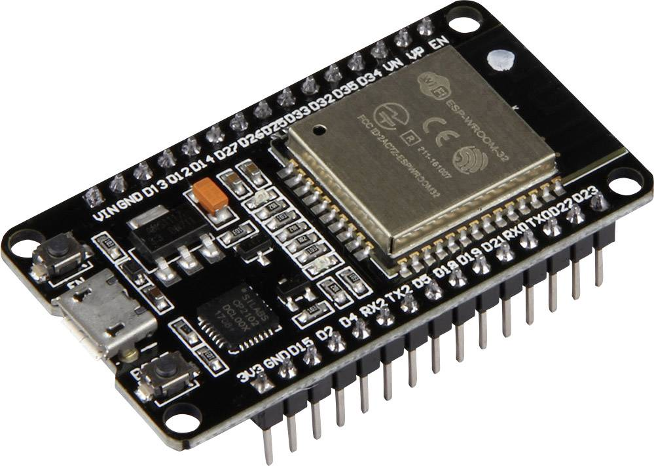The ESP32 is actually a series of microcontroller chips produced by Espressif Systems in Shanghai. It is available in a number of low-cost modules

### features of the ESP32

* 16 PWM outputs independently (pulse width modulation).
* Wi-Fi
* offers both Bluetooth and BLE (Bluetooth Low Energy)
* operating in an ultra-low-power mode
* Up to 18 12-bit Analog to Digital converters.
* Two 8-bit Digital to Analog converters.
* 10 capacitive touch switch sensors.
* Four SPI channels.
* Two I2C interfaces.
* Two I2S interfaces (for digital audio).
* Three UARTs for communications.
* Up to 8 channels of IR remote control.
* An integrated Hall-effect sensor.
* An ultra-low-power analogy preamp.
* An internal low-dropout regulator.

### Programming the ESP32

The ESP32 can be programmed using many different development environments. Code can be written in C++ (like the Arduino) or in Micro Python

To make use of all of the ESP32 features Espressif provided the Espressif IoT Development Framework, or ESP-IDF (4)

## Power

Electronic devices like ESP32’s require “logic level” voltages to function. These “logic level” voltages come in two flavours – the traditional 5 volts DC that is also known as “TTL level” voltage and the power-saving 3.3-volt DC supply that is used in many low-powered devices. In both cases the voltages need to be regulated fairly precisely to avoid damaging components

### Voltage Requirements

There are several standard voltage levels that our robot might require

* 3.3 Volts DC – This is a common voltage used in low-powered digital devices
* 5 Volts DC – This is the standard TTL voltage used by digital devices
* 6-8 Volts DC – Often used for DC and servo motors.
* 12 Volts DC – Also used with DC motors as well as many stepper motors
* 48 Volts DC – Used in professional audio gear as a “phantom supply” for microphones

### Voltage Regulation

Logic level voltages need to be very precisely regulated. For example for TTL logic to function correctly the supply voltage needs to be between 4.75 and 5.25 volts, any lower will cause the logic components to stop working correctly and any higher can literally destroy them.

Other supply voltage requirements are less stringent. Power supplied to motors, LEDS. Voltage regulation for line powered devices is not that difficult as the input voltage to the regulator circuitry is fairly constant. However, battery powered designs provide a much greater challenge as battery voltage levels will fluctuate as the battery discharges.

Devices that can be powered by both line voltages and batteries often have additional circuitry for charging the batteries when the device is being line powered. Depending upon the battery technology employed in the design this can range from a simple to very complex charging circuit.

### Current Requirements

The power supply voltage level is not the only specification that must be taken into account when designing a power supply for your project. Just as important is to determine the current requirements of the project.

Unlike voltage requirements the current that a project consumes is not always a static value. Motors, LED and other displays, speakers and other transducers can cause the current draw to fluctuate and you need to design your power supply to accommodate the “worst case” situation where every motor, indicator and sounder is being operated at full capacity.

### Efficiency

Another important aspect of voltage regulator design is efficiency. The regulator or voltage convertor itself will consume some electricity that could otherwise have been used to power up your project.

Efficiency goes hand in hand with heat production, an inefficient regulator design will dissipate its excess energy as heat. Unless you’re deliberately trying to heat up your circuitry this is not a good thing! Heat is one of the greatest enemies of electronic components and if your regulator gives off a lot of heat, you’ll need to work out ventilation and perhaps heat sinking into your design.

No design is 100% efficient so some heat production is to be expected. By overrating the components in your design, you can keep this minimized.

### Power Supply Basics

The function of a power supply is, of course, to supply power at the correct voltage and current levels to meet the requirements of your project. The energy to run the power supply can come from a number of sources – batteries, solar cells, AC power and others.

The voltages we need for our little robotic arm is DC or Direct Current.

### AC-DC

As our robot require DC current at much lower voltages you’ll need to do two things before you can employ the power from your wall outlet:

Reduce the voltage to a lower level.

### Convert it from AC to DC.

In a conventional linear power supply the AC voltage is first passed through a transformer which lowers it substantially, it is then converted to DC.

In a modern switching power supply (like the one in your desktop computer) AC voltage is directly converted to high-voltage DC and this is used to drive a high-frequency oscillator. The high-frequency AC produced by this oscillator is then passed through a small transformer and the low voltage output from that is converted to DC.

Either way at one point we need to convert the AC into DC.

### Switching power supply (60W)

Input: 240V 1.6A output: 12V 5A

### Regulators and Converters

Regardless as to whether your DC voltage was derived from AC or whether it is from battery chances are that it won’t be the correct voltage for your application. You’ll need to change the voltage to the desired level (i.e., 5 volts and 7volts) and you need to ensure it stays at that level even if the input voltage changes.

We can do this a few ways using either regulators or convertors.

### Buck converter

Buck work using something called a “flywheel circuit”. In operation a transistor is switched on and off and its output is fed through an inductor (coil) and then to a capacitor. As the transistor is switched on and off the capacitor charges and discharges the energy that is stored in the coil. The period or frequency that the switching occurs at determines the output voltage. buck converter is used in situations where the desired output voltage is lower than the input voltage.

#### LM2596

is a step-down voltage regulator, also known as buck convertor, mainly used to step down the voltage or to drive load under 3A. It carries the remarkable load and line regulation and is available in fixed output voltages including 3.3V, 5V, 12V. It also comes with a customized output version where you can set the output voltage as per your requirement.

##### SPECIFICATIONS

Adjustable output voltage

Input Voltage :3-20V

Output Voltage Range 1.23-15V

Output current: Rated current is 2A, maximum 3A (Additional heatsink is required).

Referred from: (5), (6)

# Design and Fabrication

## 3.1 Overview

### Articulated Robotic Arm

An articulated robot is a robot which is fitted with rotary joints. Rotary joints allow a full range of motion, as they rotate through multiple planes, and they increase the capabilities of the robot considerably. An articulated robot can have one or more rotary joints, and other types of joints may be used as well, depending on the design of the robot and its intended function. With rotary joints, a robot can engage in very precise movements. Articulated robots commonly show up on manufacturing lines, where they utilize their flexibility to bend in a variety of directions. Multiple arms can be used for greater control or to conduct multiple tasks at once, for example, and rotary joints allow robots to do things like turning back and forth between different work areas. These robots can also be seen at work in labs and in numerous other settings. Researchers developing robots often work with articulated robots when they want to engage in activities like teaching robots to walk and developing robotic arms. The joints in the robot can be programmed to interact with each other in addition to activating independently, allowing the robot to have an even higher degree of control. Many next generation robots are articulated because this allows for a high level of functionality. Articulated robots can have arms and legs which allow them to move and manipulate a wide variety of objects. Some are designed as console units with arms, where the unit remains in place in a fixed position and the arms are used to perform tasks. Others may wheel, slide, or move in other ways so that they can navigate spaces of varying sizes. In a medical lab, for example, an articulated robot might be used to deliver and carry samples around the lab.

The robotic arm is a vertical articulated robot, made of the following components:

* Six revolute joints
* Six links
* End gripper

## Our design

We have found 4 interesting designs on web based on looks, size, and how easy it is to build.

### WE FINALISED THE EDUCATIVE 6 AXIS ROBOT ARM PROJECT

BASED ON

* All the Materials very accessible
* Can be built with in Rs:30,000 easily
* less complex in design than other 3 projects
* less number of parts than other 3 projects
* Small in size
* prebuild control software ready to use if programming fails
* No need of any specialised motors like in A4 project

### THE DIY-ROBOTICS EDUCATIVE CELL

The DIY-Robotics educative cell is a platform that includes a 6-axis robotic arm, with an electronic control circuit and a programming software prebuild.

This platform is an introduction to the world of industrial robotics. Through this project, DIY-Robotics wishes to offer an affordable but quality solution to all those who would like to learn more about this fascinating field. This project is an excellent opportunity to develop various knowledge and skills in the fields of mechanics, electrical as well as computer science. With the DIY Robotics educative cell, robotics is within everyone's reach has of now explained above this is fabulous project we have taken only the mechanical core of the project and modifying the electrical and using ROS software for control.

referred: (7), (8), (9), (10),

## Complaint List

|  |  |  |
| --- | --- | --- |
| ID | Name | Quantity |
| 1 | 3D-PRINTED PARTS | NA |
| 2 | NODE MCU ESP32 | 1 |
| 3 | 9G METAL GEAR MICRO SERVO | 2 |
| 4 | SERVOMOTOR MG995 | 4 |
| 5 | BUCK CONVERTER LM2596 | 3 |
| 6 | SWITCHING POWER SUPPLY (60W) | 1 |
| 7 | PWM DRIVER PCA9685 | 1 |
| 8 | Wires | NA |
| 9 | 2 CORE ROUND 26 AWG 1 METRE |  |
| 10 | 7 COLOUR 2.5 METER |  |
| 11 | JUMPER STRIPS F-F, M-M, M-F | 3 |
| 12 | POWER JACK | 1 |
| 13 | BREAD BOARD | 1 |
| 14 | DUPONT MALE AND FEMALE | 3-4 |
| 15 | PCB | 1 |
| 16 | M2 NUT AND BOLTS | 20 |

## Mechanical Core (Body)

Robotic mechanism which consists of a series of segments called links which are joined together (rotating or sliding relative to one another) for the purpose of grasping and/or moving objects (pieces or tools)

### links

The static material, which connects the joints of an arm together. Thereby a kinematical chain is formed.

E.g., In a human body, the links are the bones

All links are designed to 3D-Print

#### Base Link (LINK-0)

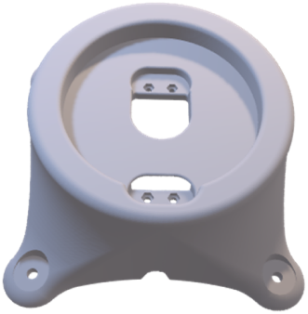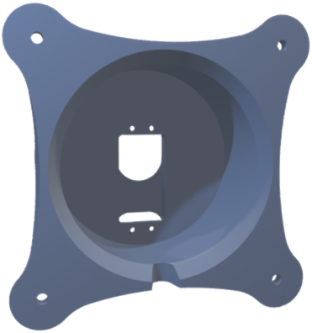The stationary base structure of a robot arm that supports the first joint

Figure . Base link

A cylindrical cup like structure having flange with 4 holes at bottom and circular slot on top to insert link-1[4.4.1.2] with pockets and cut-outs for mounting motor

#### link-1

Figure 4.2 link 1

A U-shape like structure having cylindrical guide to fit on circular slot of Base-link [4.4.1.1]. At one end circular cut-out to guide the link-2 [4.4.1.3] and on other end place to fit the motor.

#### 472link-2

Figure .:link-2

link 2 is divided into part-M and part L3, where part-M having the slot to mounting the servo motor of link-3and hole for link-1 servo axil, part L3 having the guid and slot for link-1 and 3. both the parts are joined together by means of pair of M2 nut and bolt in middle

#### link-3

Figure .: link-3

It is a semi-ellipse structure which support the link-4 which acts like elbow and same as other links we seen before it has cut-outs for motor mounting guide for next link and previous.

#### link-4

Figure .: link-4

A Y like structure divided into 2 sub parts. Upper part and lower part which is for simply supporting link 5 and for aesthetics but the upper part as main job which is to hold link 5 and connect with link 3’s servo.

#### link-5

Figure .:link-5

It is a last link which acts like wrist to the robot were end effector is connected. Like other links it is not holding only 1 servo it has to hold two micro servos one for link 5 and another one for end effectors.

### joints

A part of the robotic arm, which allows a rotation and/or translational degree of freedom for a links to end-effector

There are many types of joints we can use or design for getting different types of work envelope we are plant to use only revolt type of joints with 0-180 degrees rotation which is also known as articulated configuration robotic arm

All here joints are simply made up with only servo motors (**MG90 and MG995**) but to get high performance and stability more complex mechanism made up using planetary gears, spindles and hubs, belt and pulleys, bearings

#### MG995

|  |  |
| --- | --- |
| Specifications | |
| Model | MG995 |
| Weight(gm) | 55 |
| Operating Voltage (VDC) | 4.8 ~ 7.2 |
| Operating Speed @4.8V | 20sec/60° |
| Operating Speed @6.6V | 16sec/60° |
| Stall Torque @ 4.8V (Kg-Cm) | 10 |
| Stall Torque @6.6V (Kg-Cm) | 12 |
| Operating Temperature (°C) | -30 to 60 |
| Dead Band Width ( μs) | 1 |
| Gear Type | Metal |
| Rotational Degree | 180º |
| Length (mm) | 40.5 |
| Width (mm) | 20 |
| Height (mm) | 44 |

#### MG90

|  |  |
| --- | --- |
| Specifications | |
| Model | MG90s |
| Weight(gm) | 13.4 |
| Operating Voltage (VDC) | 4.8V to 6V (Typically 5V) |
| Operating Speed @4.8V | 20sec/60° |
| Stall Torque @ 4.8V (Kg-Cm) | 1.8 |
| Max Stall Torque @ 6V (Kg-Cm) | 2.2 |
| Gear Type | Metal |
| Rotational Degree | 180° |

# Result and Discussion

The robot we made is moving with bit vibration on joint 1 and 2, sometimes it self-drives when any one of the joints is not able to move by any means like high load, holding it when moving, etc. causes self-driving.

## Things that are working

* Robot is Moving
* Controlled by webpage in LAN by means of Phone or PC

## soft upgrade

* Record and Play Function
* Improve control algorithm for joint 1 and 2 to reduce vibration
* Relay to Power ON and OFF servos
* Replace full control software with ROS and Raspberry Pi to
  + Implement reverse or forward kinematics
  + Get more control and flexible

## hard upgrade

* Add the bearing at joint 1,2,3 and 4 to
  + reduce vibration and load on motors,
  + improve speed and load capacity
* Replace MG995 with TD-8120MG at joint 2 and 3 to
  + Increase load capacity up to 500g
  + Reduce vibration
* Replace Servo with Stepper motors and planetary gearbox to
  + get 360-degree continuous Rotation,
  + Increase load capacity up to 2-3Kg.

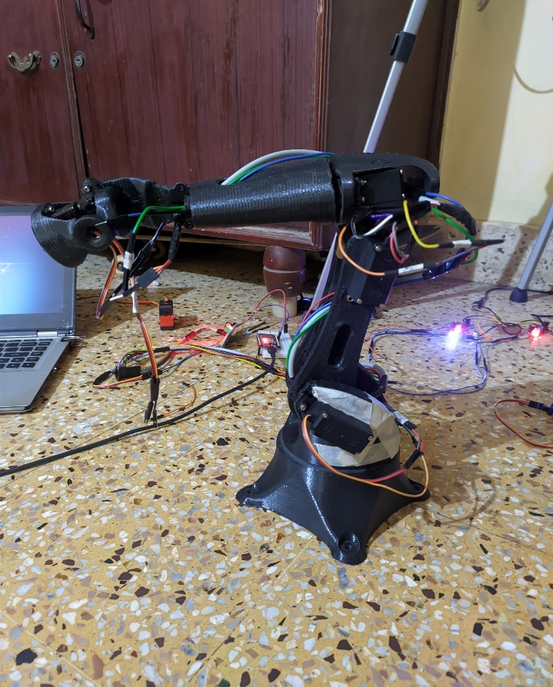

# Conclusion and scope for future study

The aim of this project is to build Experimental desktop size robotic arm which can serve as a “helping hand” thru it is not achieved fully. If we can make this arm with this time and money and without applying any high math and engineering knowledge.

We can see that robotic arm has become like a printer we use in home. In future very soon these types of robotic arm will be like a toy that kids play. Due to rapid development of internet, 3D-PRINTING, AND of course OPEN-SOURCE community.

Robots are already beginning to replace humans in places like delivery, lifting, cleaning.so era of robots is here be prepared.

# References

1. **Favreau, Jon.** *Iron man.* 2008.

2. **Robotics Terms. *Motoman.* [Online] https://www.motoman.com/en-us/about/company/robotics-glossary.**

**3. esp32-servo. *dronebotworkshop.* [Online] https://dronebotworkshop.com/esp32-servo/.**

**4. esp32-intro. *DroneBot Workshop.* [Online] https://dronebotworkshop.com/esp32-intro/.**

**5. powering-your-projects. *DroneBot Workshop.* [Online] https://dronebotworkshop.com/powering-your-projects/.**

**6. Andreas Spiess. *youtube.* [Online] https://www.youtube.com/watch?v=DLQ1E5pDcBU.**

**7. DIY-Robotics educative cell package. *diy-robotics.* [Online] https://diy-robotics.com/educative-robot-cell-free-package/?utm_source=Vid%C3%A9o%20YouTube%20(version%201%20longue)&utm_medium=Lien%20dans%20la%20description&utm_campaign=DIY-Robotics%20-%20educative%20cell%20package.**

**8. *hackaday.* [Online] https://hackaday.com/.**

**9. *Github.* [Online] https://github.com/.**

**10. *randomnerdtutorials.* [Online] https://randomnerdtutorials.com/.**