## 一、理论基础-马科维茨资产组合理论

假设资产组合有n种风险资产，它们的收益率是随机变量 $r_{1},r_{2}……r_{n}$。投资者投资此 $n$ 种风险资产的权重为 $W=(W_{1},W_{2},……W_{N})$，其中实数 $W_{i}$ 代表第i种证券的价值在总价值中所占的比重，因此， $W_{1}+W_{2}+{……W}_{n}=1$。两种资产收益率的协方差记为 $σ_{ij}=COV\left(r_{i},r_{j}\right),i,j=1,2,……n$，相应的协方差矩阵记为 $\sum{{(σ_{i,j})}_{m×n}}$：

$$\sum{{(σ_{i,j})}_{m×n}}=\left[\begin{matrix}σ_{1,1} & ⋯ & σ_{1,n} \\ ⋮ & ⋱ & ⋮ \\ σ_{n,1} & ⋯ & σ_{n,n}\end{matrix}\right] (1)$$

则，组合收益率为：

$$r_{p}=\sum_{i=1}^{n}{W_{i}r_{i}} (2)$$

组合方差为：

$$σ_{p}^{2}=W^{T}\sum{W}=\sum_{i=1}^{n}{W_{i}^{2}}σ_{i}^{2}+\sum_{\begin{aligned}i,j=1 \\ i≠j\end{aligned}}^{n}{W_{i}}W_{j}σ_{ij} (3)$$

风险资产 $i$ 对组合方差的边际贡献是：

$$\frac{∂σ_{p}^{2}}{∂W_{i}}=\frac{∂\left(\sum_{i=1}^{n}{W_{i}^{2}}σ_{i}^{2}+\sum_{\begin{aligned}i,j=1 \\ i≠j\end{aligned}}^{n}{W_{i}}W_{j}σ_{ij}\right)}{∂W_{i}}=2W_{i}σ_{i}^{2}+2\sum_{j=1,j≠i}^{n}{W_{j}σ_{ij}}=2\sum_{j=1}^{n}{W_{j}σ_{ij}}=2COV\left(r_{i},r_{p}\right) (4)$$

风险资产i对组合标准差的边际贡献是：

$$\frac{∂σ_{p}}{∂W_{i}}=\frac{1}{2σ_{p}}\frac{∂σ_{p}^{2}}{∂W_{i}}=\frac{COV\left(r_{i},r_{p}\right) }{σ_{p}} (5)$$

**结论**：每种风险资产对组合标准差的边际贡献是其与组合的协方差与组合标准差之比。

进一步探讨风险资产对组合标准差的成分贡献：

$${conponent_contribution}_{i}=W_{i}×\frac{∂σ_{p}}{∂W_{i}} (6)$$

加总各风险资产对组合标准差的成分贡献可得：

$$\sum_{i=1}^{n}{{conponent_contribution}_{i}}=\frac{\sum_{i=1}^{n}{W_{i}}COV(r_{i},r_{p})}{σ_{p}}=\frac{COV(r_{P},r_{p})}{σ_{p}}=σ_{p} (7)$$

**结论**：各风险资产对组合标准差的成分贡献之和即为组合标准差。

## 二、程序设计

### （一）收益率数据获取

#### 1.从yahoo获取价格数据

#输入的股票代码

symbols <- c(input$stock1,input$stock2,

input$stock3,input$stock4,input$stock5)

#输入始末时间带入

prices <-getSymbols(symbols,src = 'yahoo',from = input$date_start,

to = input$date_end,auto.assign = TRUE,warnings = FALSE)%>%

map(~Ad(get(.)))%>%

reduce(merge)%>%

`colnames<-`(symbols)

#### 2.讲价格数据转换为tibble格式的月度收益率数据

asset_returns_dplyr_byhand <-

prices%>%

to.monthly(indexAt = "lastof",OHLC = FALSE)%>%

tk_tbl(preserve_index = TRUE,rename_index = "date")%>%

gather(asset,returns,-date)%>%

group_by(asset)%>%

mutate(returns = log(returns)- log(lag(returns) ))%>%

spread(asset,returns)%>%

select(date,symbols)%>%

slice(-1)

### （二）构建指定期间的资产对组合标准差成分贡献方程

#### 1.给定收益率和权重计算资产对组合标准差的成分贡献

component_contr_matrix_fun <- function(return,w){

# create covariance matrix

covariance_matrix = cov(return)

# calculate portfolio standard deviation

sd_portfolio<-sqrt(t(w)%*%covariance_matrix%*%w)

# calculate marginal contribution of each asset

margin_contribution<- w%*%covariance_matrix/sd_portfolio[1,1]

# multiply marginal by weights vecoter

conponent_contribution<-margin_contribution*w

# divide by total standard deviation to get percentages

conponent_percentages<-conponent_contribution/sd_portfolio[1,1]

#convert the type

conponent_percentages%>%

as_tibble()%>%

gather(asset,contribution)

#### 2.计算给定区间的资产对组合标准差的成分贡献

##function for calculating interval sd

interval_sd_by_hand<- function(return_df,start=1, window=24 ,weights){

#funtion 参数赋值是默认值

# start =1

# window<-24

# return_df<-asset_returns_dplyr_byhand

start_date <-

return_df$date[start]

end_date <-

return_df$date[c(start+window)]

return_to_use <-

filter(return_df,date>=start_date&

date<end_date)%>%

select(-date)

w<-weights

component_percentages <- component_contr_matrix_fun(return_to_use,w)

results_with_date <-

component_percentages%>%

mutate(date = ymd(end_date))%>%

select(date,everything())%>%

spread(asset,contribution)%>%

mutate_if(is.numeric,function(x) x*100)

### （三）计算风险资产对组合标准差的成分贡献

#### 1.整个时间区间上资产对组合标准差的成分贡献

asset_return_xts <-asset_returns_dplyr_byhand()%>%

tk_xts(date_var = date,

silent = TRUE)

w <- c(input$w1/100,input$w2/100, input$w3/100, input$w4/100, input$w5/100)

port_vol_contr_total_builtin <-

StdDev(asset_return_xts, weights = w, portfolio_method = "component")

symbols <- c(input$stock1, input$stock2, input$stock3, input$stock4, input$stock5)

percentages_tibble_pre_built <-

port_vol_contr_total_builtin$pct_contrib_StdDev %>%

tk_tbl(preserve_index = FALSE) %>%

mutate(asset = symbols) %>%

rename('risk contribution' = data) %>%

mutate(`risk contribution` =

round(`risk contribution`, 4) * 100,weights = w * 100) %>%

select(asset, everything())

#### 2.给定窗口条件下滚动时间期间的资产对组合标准差的成分贡献

asset_returns_dplyr_byhand <- asset_returns_dplyr_byhand()%>%

tk_xts(date_var = date,

silent = TRUE)

asset_returns_dplyr_byhand<-asset_returns_dplyr_byhand%>%

tk_tbl(preserve_index = TRUE,rename_index = "date")

w <- c(input$w1/100,input$w2/100,

input$w3/100, input$w4/100, input$w5/100)

window <-input$window

##rolling function

portfolio_vol_components_xts<-

map_df(1:(nrow(asset_returns_dplyr_byhand)-window),

interval_sd_by_hand,

return_df = asset_returns_dplyr_byhand,

weights=w,

window= window)%>%

tk_xts(data_var = date,

silent = TRUE)

（四）结果可视化

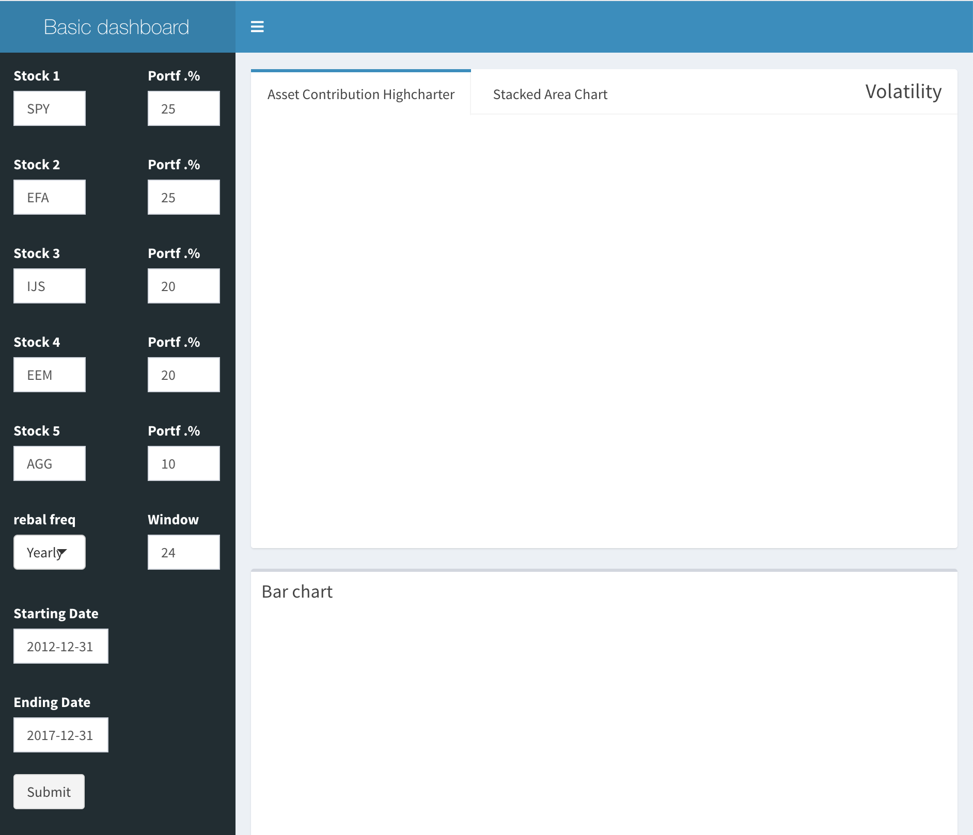

本小组提供了一个可交互的页面，可以根据用户需要获得相应的图表进行分析。

<https://rucquant.shinyapps.io/10-Conponent-Contribution-to-Standard-Deviation/>

（1）24个月为窗口的折线图和堆积面积图

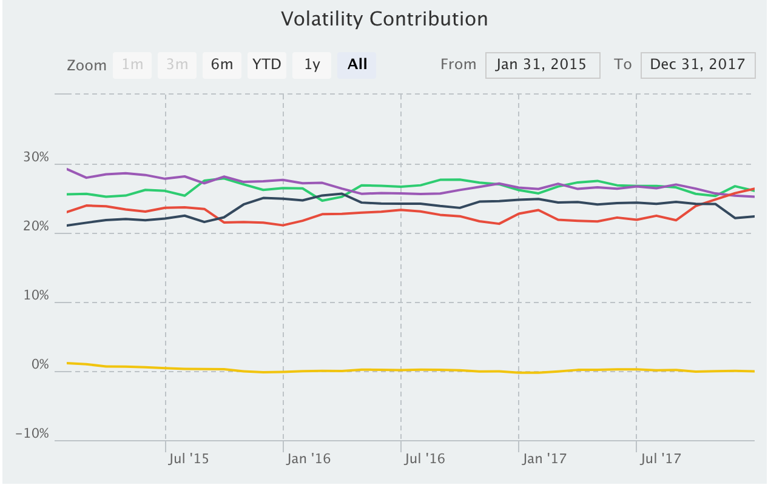

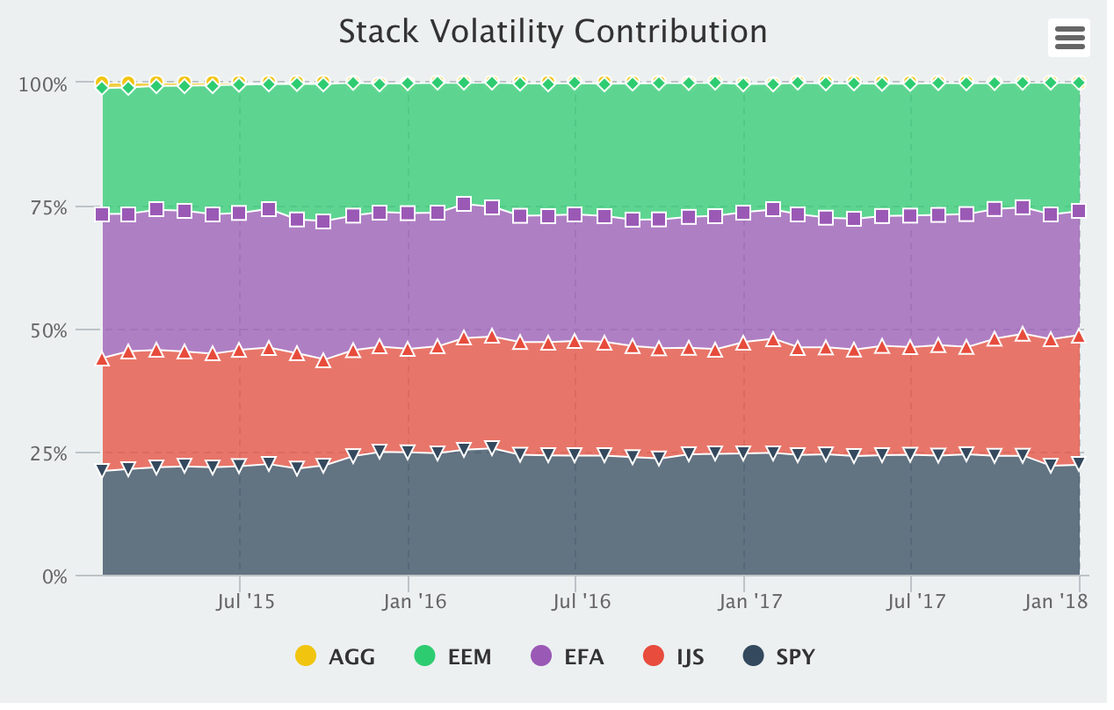

（2）整个时间区间的资产对组合标准差成分贡献的柱状图

