R语言大作业

目录

一、实现功能 2

1、蜡烛图 2

2、柱形图 2

3、树图 3

4、折线图 3

5、表格 4

二、代码实现 4

1.蜡烛图代码 4

2.柱形图代码 4

3.树图代码 5

4.折线图代码 6

5.表格代码 7

## 实现功能

#### 1、蜡烛图

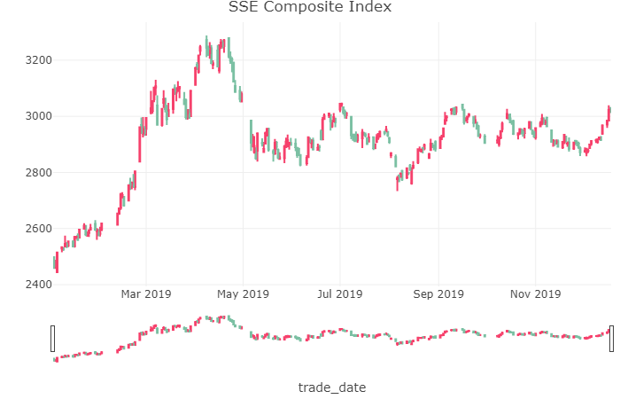

#### 2、柱形图

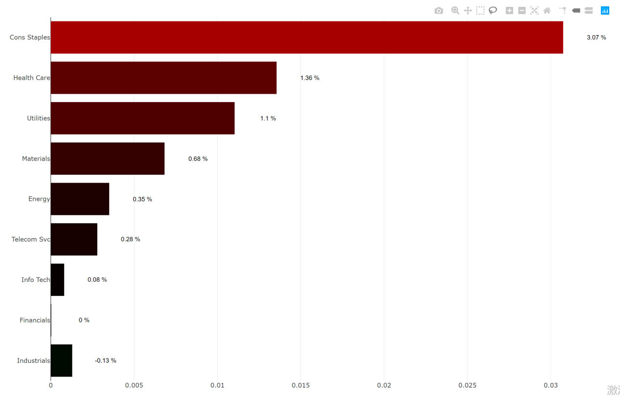

#### 3、树图

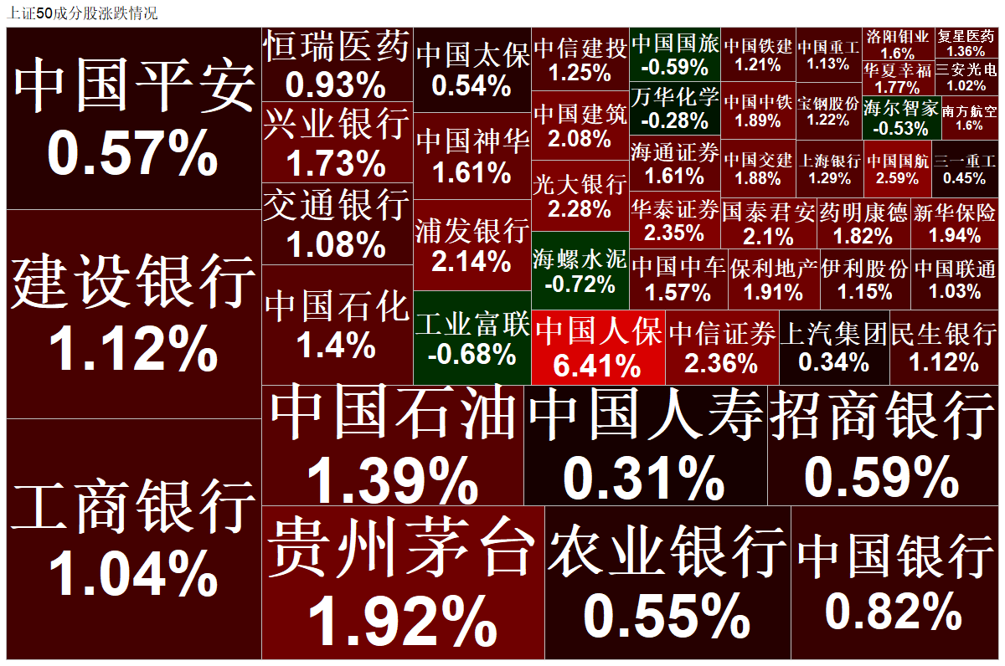

#### 4、折线图

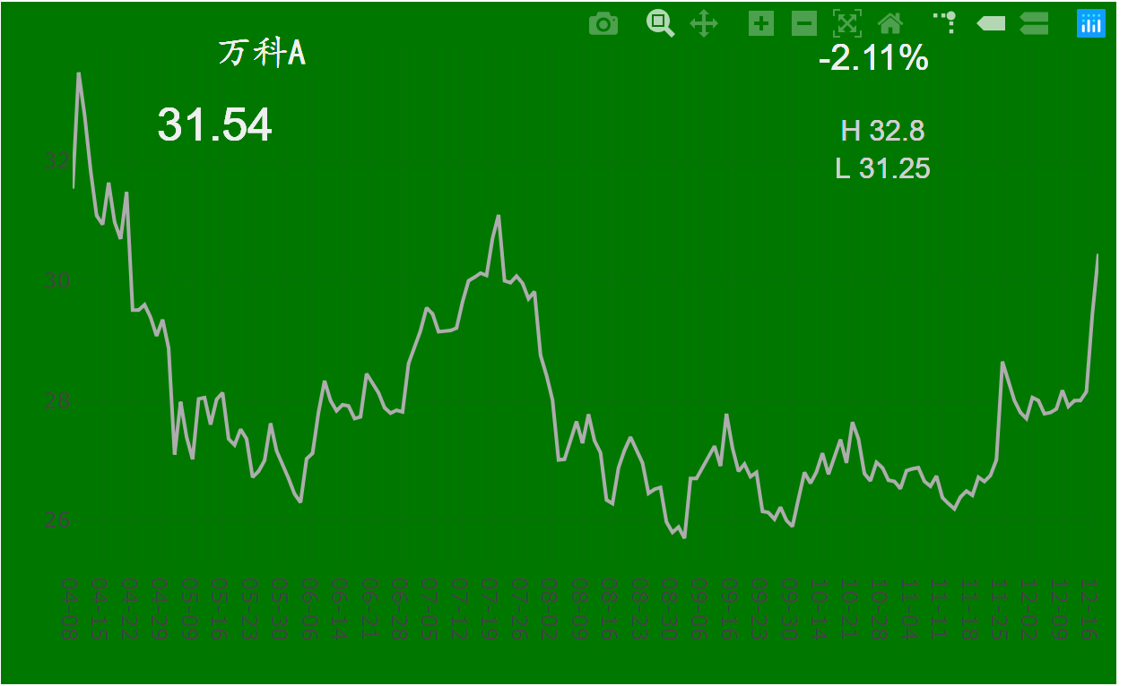

#### 5、表格

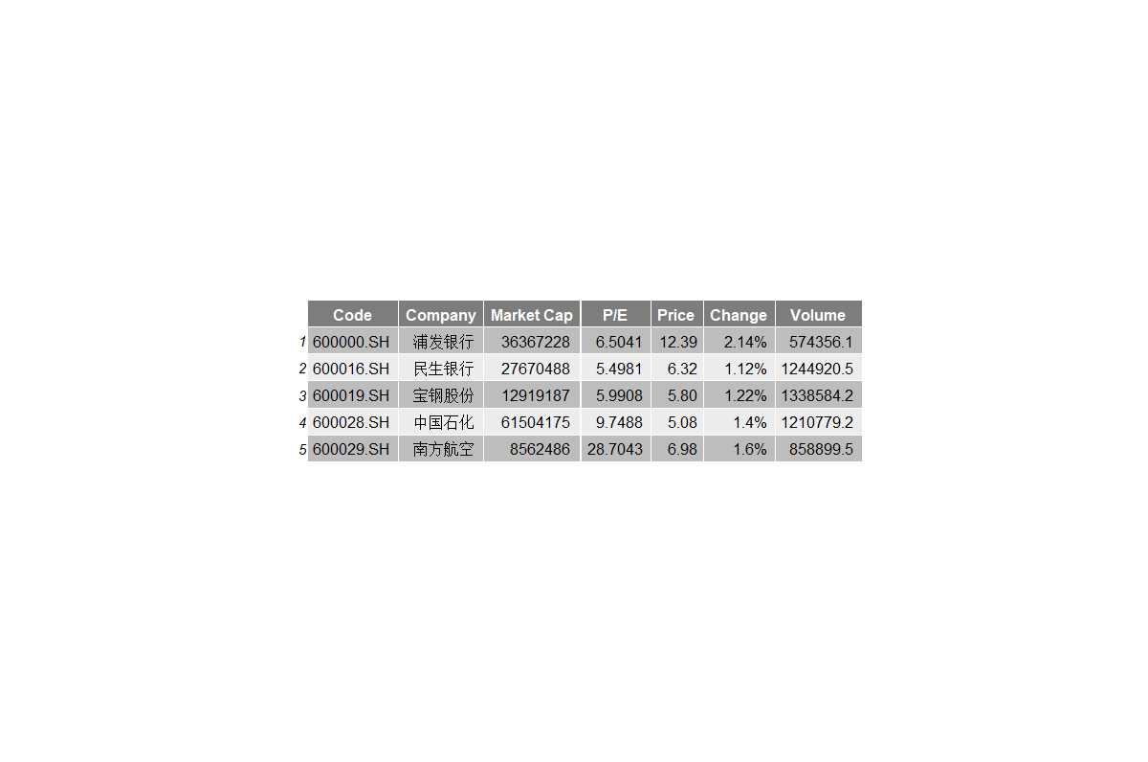

## 代码实现

#### 1.蜡烛图代码

candlestick <- function(stock_code="000001.SH",start_date = '20190101', end_date = today) {

Index <- tushare(api_name = "index_daily", ts_code = stock_code , start_date = start_date, end_date = today,

fields='trade_date,open,high,low,close')

Index$trade_date<-as.Date(Index$trade_date,"%Y%m%d")

#设置涨跌颜色

i <- list(line = list(color = '#f6416c'))

d <- list(line = list(color = '#7bc0a3'))

SSE_candlestick <- Index %>%

plot_ly(x = ~trade_date, type="candlestick",

open = ~open, close = ~close,

high = ~high, low = ~low,

increasing=i,

decreasing=d) %>%

layout(title = "SSE Composite Index")

SSE_candlestick

}

#### 2.柱形图代码

barchart <-function(start_date = as.character(as.integer(today)-5),

end_date = as.character(as.integer(today)-4),

industy_index_code=c('000908.SH','000909.SH','000910.SH',

'000912.SH','000913.SH','000914.SH',

'000915.SH','000916.SH','000917.SH'),

row_names = c("Energy","Materials","Industrials",

"Cons Staples","Health Care","Financials",

"Info Tech","Telecom Svc","Utilities")

){

industy_r <- data.frame()

#9个股票的收益率

for (code in industy_index_code){

ind_index <- tushare(api_name = "index_daily", ts_code = code, start_date='20180830',end_date =today)

industy_r[code,"returns"] <- ind_index$close[2]/ind_index$close[1] - 1

}

row.names(industy_r)<- row_names

color <- function (x){

if (x > 0){

return(sprintf("rgb(%d,0,0)",floor(255*(1-exp(-x*30)))));

}

else if (x<=0){

return(sprintf("rgb(0,%d,0)",ceiling(255*(1-exp(x*30)))));

}

}

industy_r["color"] = map_chr(industy_r$returns, color)

industy_barchart <- plot_ly(y = reorder(row.names(industy_r), industy_r$returns),

x = abs(industy_r$returns),

marker =list(color = industy_r$color),

type = 'bar',orientation = 'h') %>%

add_annotations(xref = 'x1', yref = 'y',

x = abs(industy_r$returns)+0.002 , y = row.names(industy_r),

text = paste(round(industy_r$returns*100, 2), '%'),

font = list(family = 'Arial', size = 12, color = 'rgb(0, 0, 0)'),

showarrow = FALSE)

return(industy_barchart)

}

#### 3.树图代码

treemap <- function(data=SSE50){

color <- function (x){

if (x > 0){

return(sprintf("rgb(%d,0,0)",floor(255*(1-exp(-x*30)))));

}

else if (x<=0){

return(sprintf("rgb(0,%d,0)",ceiling(255*(1-exp(x*30)))));

}

}

rgb2hex <- function(rgb){

rgb <- strsplit(substr(rgb,5,nchar(rgb)-1),',')[[1]]

rgb <- as.integer(rgb)

rgb <- as.character(as.hexmode(rgb))

hex <- "#"

for (i in rgb){

if (nchar(i) == 1){i <- paste0('0',i)}

hex <- paste0(hex, i)

}

return(hex)

}

data["color"] = map_chr(data$returns, color) %>% map_chr(rgb2hex)

ggplot(data, aes(area = mv, label = names)) +

geom_treemap(fill = data$color) +

geom_treemap_text(fontface = "bold", colour = "white", place = "centre",

grow = TRUE) +

ggtitle("上证50成分股涨跌情况")

}

#### 4.折线图代码

line_chart <- function(code='000002.SZ'){

Wanke <- tushare(api_name = "daily", ts_code = '000002.SZ', start_date = '20190405', end_date = return_cal_dates[1])

Wanke_return = Wanke$close[nrow(Wanke)]/Wanke$pre_close[nrow(Wanke)] - 1

Wanke_name <- list(…………

Wanke_change <- list(…………

Wanke_HL <- list(…………

xref = 'paper',

yref = 'paper',

x = 0.84,

y = 0.80,

xanchor = 'right',

yanchor = 'middle',

text = ~paste0("H ",Wanke$high[nrow(Wanke)],"\nL ",Wanke$low[nrow(Wanke)]),

font = list(family = 'Arial',

size = 16,

color = '#cfcfcf'),

showarrow = FALSE)

Wanke_plot <- plot_ly(Wanke, y=~close,x=~paste0(substr(trade_date,5,6),'-',substr(trade_date,7,8)),

type = 'scatter', mode = 'lines',

line = list(color = '#adadad')) %>%

layout(paper_bgcolor=to_color(Wanke_return), plot_bgcolor=to_color(Wanke_return),

xaxis = list(title = ""),

yaxis = list(title = "", range=c(min(Wanke$close),max(Wanke$close)*1.5 - 0.5*min(Wanke$close))),

margin =list(autoexpand = TRUE, r=10,l=10))%>%

layout(annotations = Wanke_name)%>%

layout(annotations = Wanke_price)%>%

layout(annotations = Wanke_change)%>%

layout(annotations = Wanke_HL)

return(Wanke_plot)

}

line_chart()

#### 5.表格代码

chart<-function(data=SSE50_basics_new){

data <- head(data,5)

tbody.style = tbody_style(color = "black",

fill = c("#bdbdbd","#ededed"), hjust=1, x=0.9)

ggtexttable(data,

theme = ttheme(

colnames.style = colnames_style(color = "white", fill = "#7d7d7d"),

tbody.style = tbody.style

))

}

chart()