 | Title | CLIENT Firewall Review
 | Reviewer | ADD CLIENT POC NAME, ADD ADVISOR POC NAME
 | Review Date | Aug 19, 2024 12:00 PM

Objective
To ensure firewall rules and configurations are appropriate, effective, and align with the organization’s security policies and SOC 2 control requirements.

Part 1: Procedure

Inventory
- Identify all firewalls (hardware, virtual, cloud-based) in scope.
- Include perimeter firewalls, internal segmentation firewalls, and cloud security groups.

Evidence/Artifact Collection
- Current firewall configuration, including data/timestamp
- Change logs since last review (if applicable)

Part 2: Review Results

Inventory
- List of in-scope firewalls (all types)

Firewall Rules
- ADD REVIEW EVIDENCE SCREENSHOTS OR EXPORTED RULES, INCLUDING DATE/TIMESTAMP

Review Results and Action Items
- Firewall rules requiring changes
Scope Item | Rule Name or ID | Owner | Reason for change | Completion Date or link to ticket

Part 3: APPROVAL
By signing this form, I certify that I have performed the access review for the systems above and that the necessary action items have been completed.

Electronic Signature: * NAME Date: DATE.
First and Last Name
*☐I understand that checking this box constitutes a legal signature.

Part 4: SECONDARY APPROVAL
Note: Reviewers cannot review their own access. Utilize the section below for proof of second review.
By signing this form, I certify that I have performed the access review for the systems above and that the necessary action items have been completed.

Electronic Signature: * NAME Date: DATE
First and Last Name

Appendix A: Example Evidence
EXAMPLE EVIDENCE - TO DELETE
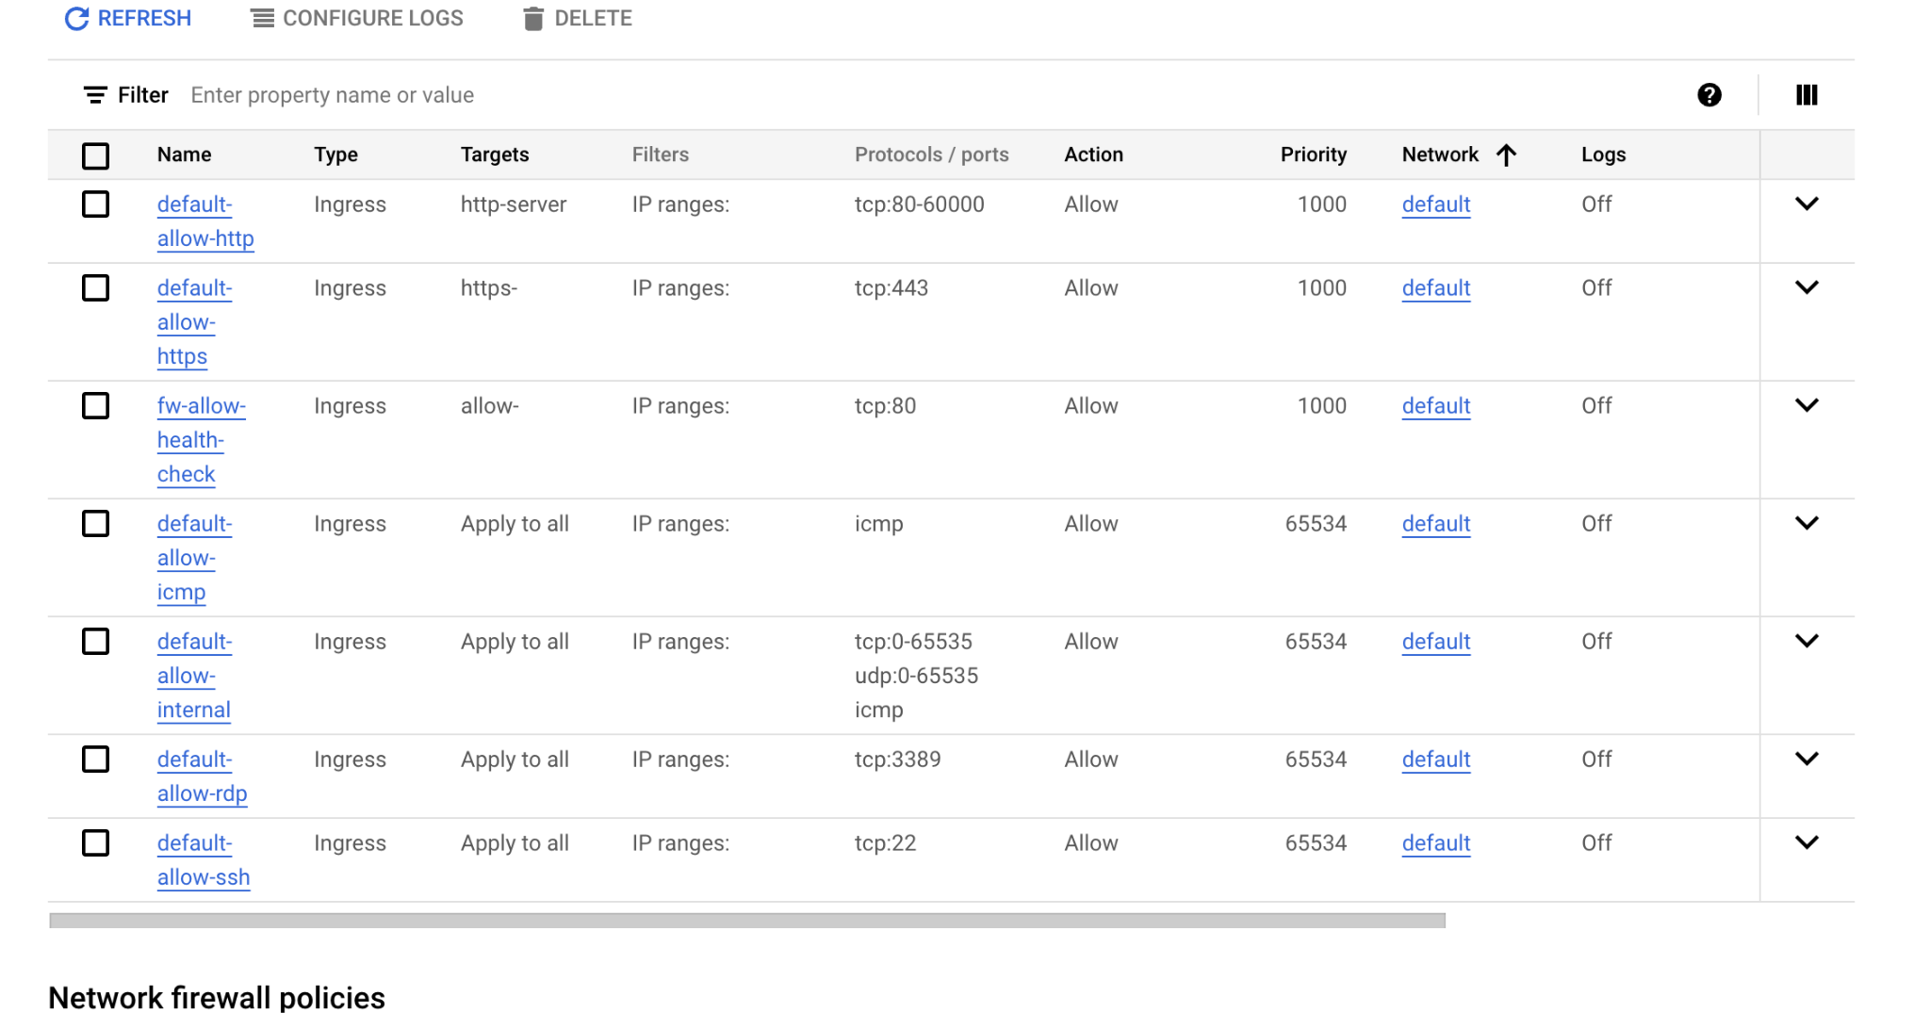

Document History
Version | Date | Description | Written by | Approved by
1.0.0 | [TODAYS DATE] | Initial Version | [Name] | [Name]

