**Trio - Chess**

Ogadinma Njoku

Rucha Bhatawadekar

**INTRODUCTION**

We want to develop a software using which three people can play chess on a hexagonal chessboard. The software will be able to accommodate three players and to validate the moves played by them without compromising any of the rules or strategy.

Problem Statement**:**

To validate the moves played by all the three players on a hexagonal chessboard in order to lead a legitimate game resulting in announcing the rankings of the involved players.

Requirements:

All pieces move as in the standard chessboard but adapted to the rules of the game. Adjacent cells of the same color form the board's "diagonals"; adjacent cells of opposite color form the board's "orthogonal" (vertical and horizontal). The objective of chess is to put your opponents in checkmate - to leave them with no remaining valid moves or capture their king.

Pieces: 1 king, 1 queen, 2 bishops, 2 knights, 2 rooks, and 8 pawns; a total of 16 pieces for each player. Total 48 pieces. Each type of piece has its own method of movement and capture, which is explained in further sections.

The game is opened by red chess pieces set at the base labeled with A-H. Next, in a clockwise movement, the game continues the pieces white (A-L) and then black pieces (H-L).

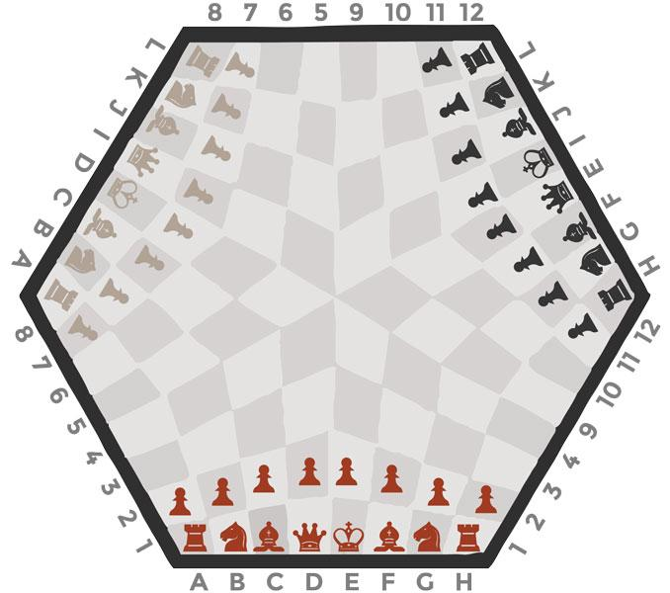

Figure (1)

Movements:

* *King***:** The king moves in any direction (horizontally, vertically, or diagonally) a maximum of one square per turn.

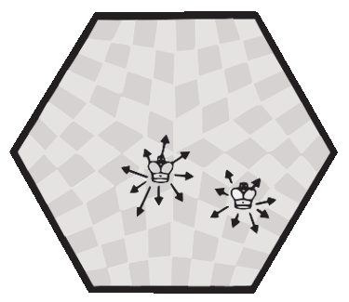

Figure (2)

* *Queen*: The queen moves in any direction (horizontally, vertically, or diagonally) any number of unoccupied squares per turn.

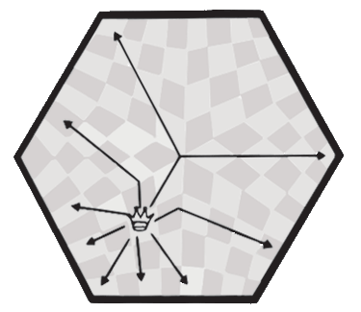

Figure (3)

* *Rook:* The rooks move horizontally and vertically any number of unoccupied squares per turn.

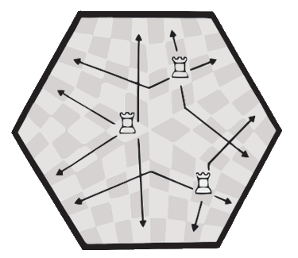

Figure (4)

* *Bishop*: one of two pieces of the same color that may be moved any number squares diagonally, so far there is no other piece blocks its way. One-piece always remains on White squares and the other always-on Black.

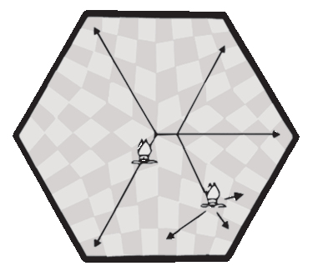

Figure (5)

* *Knight:* This piece can move 1 space vertically and 2 spaces horizontally or 2 spaces vertically and 1 space horizontally. This piece looks like a horse. This piece can also jump over other pieces.

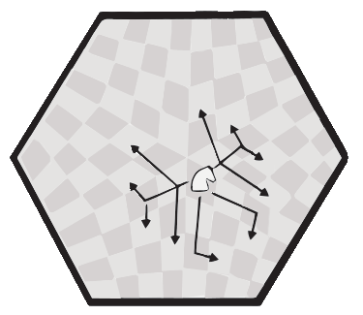

Figure (6)

* *Pawn:* One of eight men of one color and of the lowest value usually moved one square at a time vertically and capturing diagonally.

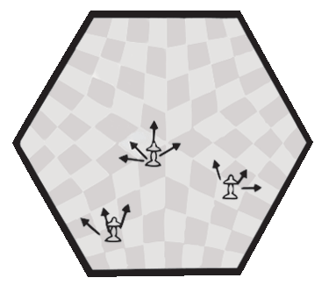

Figure (7)

* *Castling:* to move the king two squares horizontally and bring the appropriate rook to the square the king has passed over. Castling may only be done if the king has never moved, the rook involved has never moved, the squares between the king and the rook involved are unoccupied, the king is not in check, and the king does not cross over or end on a square attacked by an enemy piece.
* *En Passant:* En Passant is a unique capture technique that only pawns may observe. When a player moves a pawn forward 2 squares in one move and an opponent's pawn is directly adjacent horizontally to the destination square, the opponent's pawn may immediately capture the player's pawn as if the player's pawn had only moved one square forward. The opponent still advances diagonally forward, leaving it where the player's pawn would have been had it only moved one square initially. This is the only legal chess move where a capturing piece does not end up where the captured piece was. En passant must occur as the move immediately following the player's 2 square advance or the ability to do so is lost.
* *Pawn Promotion:* Once a pawn proceeds through the center and reaches the first rank again, it must be promoted into a queen (often called "queening"), a rook, a knight, or a bishop ("under promotion") of the player's color.
* *Check:* [A player is considered in "check" if his or her king is immediately threatened by an opponent's piece](http://3manchess.com/tutorial/). This is a warning that if you do not move your king out of the way, or do not otherwise block the opponent's attack on your king, [you will be in "checkmate" and will lose the game](http://3manchess.com/tutorial/).
* *Checkmate:* Checkmate is finalized at the start of your turn if there is no legal move for you to make, or after your king has been captured. Your king may not move into check in any circumstance, so if on your turn you have only your king remaining and he is surrounded by positions which place him in check, you are in checkmate.
* *Stalemate:* A situation in which a player’s king is not in check, but that player can make no move. This then results in a stalemate, which is a draw.

**ROLES AND RESPONSIBILITIES**

|  |  |  |
| --- | --- | --- |
|  | Ogadinma Njoku | Rucha Bhatawadekar |
| Developer | ✔ | ✔ |
| Tester | ✔ | ✔ |
| Documentation | ✔ | ✔ |
| Designer | ✔ | ✔ |
| Customer Representative | ✔ | ✔ |

Table (1)

**METHOD**

Software:

Programming language: Python version 3.8

Python libraries: python-chess (release 0.30.1)

Operating System: Window 10

Review Process:

We will do code reviews and we choose an informal approach for the reviews

Both the teammates will be equally responsible for the reviews and resolving issues uncovered by the reviews.

Build Plan:

We will be using Github Repository and planning to have builds at least four times a week.

**VIRTUAL AND REAL WORKSPACE**

We will be working remotely on our personal computers.

**COMMUNICATION PLAN**

* The team communication meeting will be weekly for a review of the project and progress report.
* The status report/meeting will be bi-weekly as planned to enable the team to discuss issues of concern about the project.

**TIMELINE AND MILESTONES**

Feb 13, 2020 - Basic game board and pieces   
Feb 20, 2020 - Pawn movement   
Feb 27, 2020 – King (Check) and Rook movement   
Mar 5, 2020 – Bishop and Queen movement  
Mar 12, 2020 – Knight movement   
Mar 19, 2020 – Capturing pieces by Pawn and King  
Mar 26, 2020 – Capturing pieces by Rook and Bishop  
Apr 2, 2020 – Capturing pieces by Queen and Knight  
Apr 9, 2020 – Castling, En passant, Pawn Promotion (Optional)  
Apr 16, 2020 – Checkmate   
Apr 23, 2020 - Stalemate  
Apr 30, 2020 - Buffer  
May 7, 2020 – Buffer

**TESTING PLAN**

We are planning to follow test-driven development since we have all the requirements

**RISKS**

The software will accept an invalid move and the game will continue.

**ASSUMPTIONS**

The labeling will be done according to the figure (1)

|  |  |  |  |
| --- | --- | --- | --- |
|  | Red | White | Black |
| King | K1 | K2 | K3 |
| Queen | Q1 | Q2 | Q3 |
| Rook | R1.1, R1.2 | R2.1, R2.2 | R3.1, R3.2 |
| Bishop | B1.b, B1.w | B2.b, B2.w | B3.b, B3.w |
| Knight | N1.1, N1.2 | N2.1, N2.2 | N3.1, N3.2 |
| Pawn | P1.1 – P1.8 | P2.1 – P2.8 | P3.1 – P3.8 |

Table (2)

No time limits for moves will be considered in this version

**BIBLIOGRAPHY**

* http://3manchess.com
* <https://www.ymimports.com/pages/how-to-play-three-player-chess>